North Village
Who lives there?
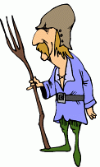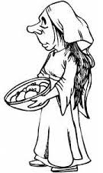

How many livestock?
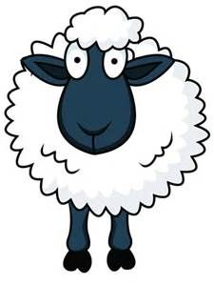

How many ploughs?
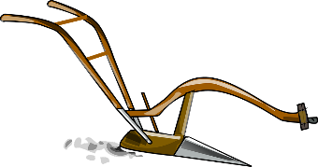

 | 1066 | 1086
Value of the land? | £80 | £1
Who owns the land? | 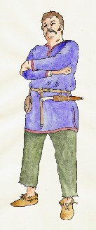  An Anglo- Saxon Lord | 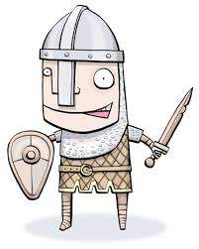  A Norman Lord

North-East Village
Who lives there?

How many livestock?

How many ploughs?
0

 | 1066 | 1086
Value of the land? | £40 | £0
Who owns the land? | An Anglo- Saxon Lord | A Norman Lord

North-West Village
Who lives there?

How many livestock?

How many ploughs?
0

 | 1066 | 1086
Value of the land? | £50 | £10
Who owns the land? | An Anglo- Saxon Lord | A Norman Lord

Midland Village
Who lives there?

How many livestock?

How many ploughs?
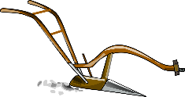

 | 1066 | 1086
Value of the land? | £80 | £120
Who owns the land? | An Anglo- Saxon Lord | 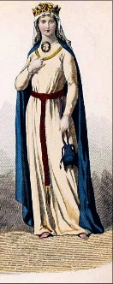  A Norman Lady

South Village
Who lives there?

How many livestock?
How many ploughs?

 | 1066 | 1086
Value of the land? | £100 | £120
Who owns the land? | 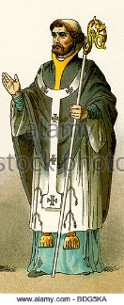  An Anglo- Saxon Bishop | 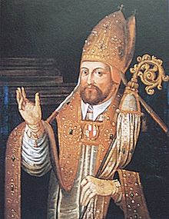  A Norman Bishop

South-East Village
Who lives there?

How many livestock?
How many ploughs?

 | 1066 | 1086
Value of the land? | £150 | £200
Who owns the land? | An Anglo- Saxon Lord | A Norman Lord

South-West Village
Who lives there?

How many livestock?
How many ploughs?

 | 1066 | 1086
Value of the land? | £200 | £250
Who owns the land? | An Anglo- Saxon Lord | A Norman Lord

