What does Hardwick Hall reveal about the Elizabethan period?

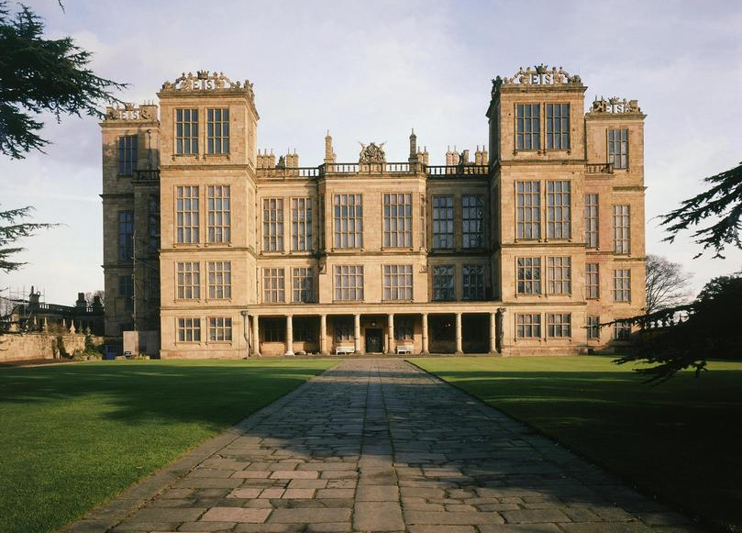
Aspects to be considered:
Site
- Location
- Function
- Structure
- Design
People
- People connected with the site e.g. the designer, originator and occupants
- How the design reflects the culture, values, fashions of the people at the time
Historical context
- How important events/developments from the depth study are connected to the site.
Welcome to the historic environment site study
This is part of your British Depth Study on Elizabethan England. You will be expected to use your knowledge from your study of Elizabethan England. There will be one 16-mark essay on the exam paper that will test you on this topic.
Sample questions:
‘The main change that Elizabethan manor houses demonstrated was the greater prosperity of their owners.’ How far does a study of Hardwick Hall support this statement? Explain your answer. You should refer to Hardwick Hall and your contextual knowledge. (16 marks)
‘The main reason for building a stately home in Elizabethan times was to demonstrate the successful career of its owner.’ How far does a study of Hardwick Hall support this statement? Explain your answer. You should refer to Hardwick Hall and your contextual knowledge. (16 marks)
Important!
- You will have 20-25 minutes to write your essay in the exam.
- You will be expected to refer to the whole site.
- You will write about the site then, not now.
A* answers:
Top level answers will be complex explanations focused on the question concept that lead to a sustained judgement. There will be lots of accurate and detailed knowledge used to support all assertions. It will be clear that the student has a very good understanding of the topic. As ever, aim to make three clearly substantiated argument points. The essay will need an introduction that sets out the argument and a well-developed conclusion.
Let’s look at a question like an A* candidate…
‘The main change that Elizabethan manor houses demonstrated was the greater prosperity of their owners.’ How far does a study of Hardwick Hall support this statement? Explain your answer. You should refer to Hardwick Hall and your contextual knowledge. (16 marks)

It’s got CHANGE as the key historical concept!

It’s got growing WEALTH as the key topic concept!
It needs a JUDGEMENT about to what extent Hardwick Hall shows this.

It’s worth a lot of marks and requires a carefully planned essay.
My answer needs strong arguments supported by specific and precise detail.

What does Hardwick Hall reveal about the Elizabethan period?

We need to break our big question into smaller questions…
- What were Bess’ motives for building Hardwick Hall?
- Why did Bess build this Hall in Derbyshire on the Hardwick site?
- Why was Hardwick built as it was?
- What was the function of all the different features of Hardwick Hall?
- What are the distinctive features of Hardwick Hall?
- What was commented upon at the time?
- How is the design or layout of Hardwick Hall different from other Elizabethan Houses?
- What technology was used to build Hardwick Hall?
- What message was Bess giving via her building of Hardwick Hall?
- What was Hardwick Hall used for?
- Who lived and worked at Hardwick Hall?
You must be able to answer all of these questions in detail before you go into the exam room!

At the same time we need to think about Hardwick Hall using different historical concepts. To help with that her are some concept focus questions:
CHANGE AND CONTINUITY
- What sort of change was there at Hardwick Hall?
- What stayed the same at Hardwick Hall?
- How much change was there at Hardwick Hall?
- When did change happen at Hardwick Hall?
- How much change was there at Hardwick Hall within the Elizabethan period?
- What was the pace of change at Hardwick Hall?
- Who brought about change at Hardwick Hall?
- What prevented or slowed change at Hardwick Hall?
- Why was there change at Hardwick Hall?
- What does the change at Hardwick Hall reveal about the Elizabethans?
- What was the impact of change at Hardwick Hall?
CAUSATION:
- Why was there change at Hardwick Hall?
- What do the causes reveal about the Elizabethans?
CONSEQUENCE:
- What was the impact of change at Hardwick Hall?
- What do the consequences reveal about the Elizabethans?

You must be able to answer all of these questions in detail before you go into the exam room!
Who was Bess of Hardwick?
Elizabeth, known as Bess, was born in a small manor house on the site of Hardwick old Hall in 1527. Her father was a gentleman who owned a few hundred acres. He died within a year of Bess’s birth. He left each of his daughters a small sum of money, about £26. When Bess became a teenager she went into the service of Sir John Zouche, head of a great Derbyshire family. This would have been normal practice for the children of Tudor gentry.
Who did Bess marry?
First she married her cousin, Robert Barlow, from another Derbyshire, gentry family was also in the household. Bess looked after him when he was ill at the Zouche family home in London. Their family thought that it was a good idea for them to marry which they did in 1543. Unfortunately Robert died a few months after the wedding. As his widow, Bess inherited a third of his income, which was £66 a year by 1588. At the time this would have been a respectable sum of money but not a fortune.
Bess was a childless widow and she continued to serve in a noble household by attending the Marchioness of Dorset, the mother of Lady Jane Grey. Here she met Sir William Cavendish, an elderly and rich government official. He had made a lot of money during the Dissolution of the Monasteries, and now owned much land and properties scattered over 5 counties. He fell in love with Bess and, after their marriage, to please his new wife sold all his property and consolidated his wealth by buying new property in Derbyshire and Nottinghamshire, including the house and estate of Chatsworth in 1549. Bess had 8 children with Sir William Cavendish. Bess had a talent for organisation and hard-work. She administered the estates and ran a large household while having eight children in nine years. Her role took in managing the beehives that produced the honey and beeswax from which the candles for lighting were made, to overseeing bear-brewing, cheese-making and deciding how much wool to spin or sell.
William Cavendish died in 1557 leaving Bess with Chatsworth and a large amount of property. In 1559, 2 years later, she married again this time to Sir William St Loes. Sir William was a rich landowner with property in Devon and Cornwall, who had already been twice married. As Sir William’s family name was older and better established than the Cavendish’s, it was another step up the social ladder for Bess. Furthermore, the marriage brought with it access to court as Sir William was a favourite courtier of Queen Elizabeth and Captain of her Guard. It is possible that the Queen was present, as she ‘named the day’ of marriage. It’s also possible that William required her permission to be absent to marry. For part of their time, the couple lived in the South-west at a place called Sutton Court. Here Bess built a new parlour. Bess’ third marriage lasted only 5 years, until the winter of 1564, when Sir William died. It left Bess very wealthy. She was on the marriage market again and represented quite a wealthy catch. There was much gossip at court about whom she might marry next.
Bess’s fourth marriage, in 1567, was spectacular. Her husband was 40 years old and the head of one of the oldest, and richest families in England. He was George Talbot, the 6th Earl of Shrewsbury, a widower with 6 children. Bess became Countess of Shrewsbury. George Talbot had inherited a large amount of money and used it to become even richer. He had a vast amount of agricultural land, owned coal mines and glassworks, iron foundries and ships. Most of his land was also in the Midlands and it complemented the properties already owned by his new wife, Bess.

An independent-minded, talented business woman
By this time Bess had experience of managing and developing estates. Surviving portraits do not show a great beauty. It seems that charisma, intelligence and an ability to work hard made Bess stand out. Bess’s marriage to the Earl of Shrewsbury soon ran into trouble when, early in 1569, he was given the job of guarding Mary Queen of Scots. Bess made things worse when she arranged the marriage of her daughter, Elizabeth, to Charles Stuart, the brother of Mary Queen of Scots’ ex-husband, Lord Darnley thus creating a claim to the English throne for any of their children. Bess had arranged this without her husband’s approval and much to the fury of Queen Elizabeth. Shrewsbury thought that his new wife was risking his good relations with the Queen for the sake of her own family. And there were troubles as Shrewsbury had to fund the imprisonment and guarding of Mary, Queen of Scots from his own resources. His wealth was also being drained by the large amounts of money that Bess was spending on the remodelling of Chatsworth house. Bess and Shrewsbury had their first serious row in 1577 and by 1584 the marriage had broken down completely. It is also possible that Shrewsbury had some sort of illness that made him unpredictable and paranoid. He wrote letters to the Queen and her Ministers about Bess in the mid-1580s. Despite the busy affairs of state at this time, the Queen and her Ministers took an interest and defended Bess.
As their relationship worsened, Shrewsbury and Bess argued over the ownership of Chatsworth which the Earl of Shrewsbury wanted to keep as his family home. In 1581 Bess’ brother had died in prison and in debt. That meant that his estate at Hardwick had gone to the Crown. In 1583, deciding that she needed to have an independent home, Bess bought the house and property at Hardwick where she had grown up. She bought it from Chancery for £9,500. From 1585 to 1590 she enlarged and remodelled the old house, which is known as Hardwick Old Hall. She took her granddaughter, Arbella Stuart (who had a claim to the throne) to live with her there.
Shrewsbury died in 1590 leaving Bess, in her early 60s, one of the richest people in England. The 1590s was not an easy decade for England as a whole, but it was good for Bess. She had vision, energy and lots of money and she wanted a home of her own for a comfortable old age and to befit her granddaughter who could possible become Queen. She also wanted a place grand enough to entertain the highest in the land, possibly even the monarch. Bess started to lay the foundations for a new larger, grander house a few yards away from Hardwick Old Hall, even before Shrewsbury was dead. Bess had decided that she would concentrate her efforts on the place where she had been born. She was content to leave Chatsworth to her eldest son Henry, who had taken her husband’s side during the marital quarrel, and whom she heartily disliked. Her new home at Hardwick which she spent the next 13 years building and furnishing would eventually go to her favourite son, William, after she died in 1608.
The man most responsible for the design of Hardwick Hall was Robert Smythson. He had been working for Bess on the remodelling of Hardwick Old Hall. She altered his design for the new Hardwick Hall only slightly, though this does show that ultimately the choices were all Bess’.
Bess moved into the new Hardwick Hall on Monday 4 October 1597, two years before it was completed. It may have been her 70th birthday. Life at Hardwick was pleasurable, with musicians, games, plays and dancing. The beautiful gardens had pavilions for quiet and there were woodland walks. Bess’ initials ‘ES’ could be seen for miles. Meanwhile, Bess was still purchasing more land. She always kept close account of all her extensive riches.
Clever quote: Robert Cecil is supposed to have quipped: ‘Hardwick Hall, more glass than wall!’
An extract adapted from a lecture about Bess of Hardwick by Mary S Lovell (2006).
What sort of person was Bess of Hardwick?
Bess was an affectionate woman, with a dynamic personality who loved her family and friends and was loved in a romantic sense by at least two of her four husbands. She was ambitious for her family, and became a high achiever in what was very much a man’s world. She was also intelligent, loyal, shrewd, a brilliant financier, a fulfilled woman and self-confident in her achievements. She possessed great charisma, and made friends easily, being well liked and respected by those in her circle.
Who were Bess’ friends?
Bess was no great beauty so how was it that she managed to attract four highly personable, rich and eligible men as husbands? How did she manage to have a Parliamentary bill against her squashed after the death of her second husband, William Cavendish? How did she survive over 50 years at the centre of the snake pit that was the Tudor Court, remaining good friends not only with the Queen but with the key figures of the age? These included William Cecil, Robert Dudley, and Sir Francis Walsingham, all of whom often lent her their support. Would they have done so had she been the shrew that history painted her as. I quote what Queen Elizabeth said about her, ‘I assure you there is no lady in this land that I better love or like.’
Was Bess just lucky?
Shrewsbury’s death left Bess free to do as she wanted. She not only had her own properties returned to her - those of Barlow, Cavendish, and St Loes, but now she was also entitled to a widow’s dower of 1/3 of the annual income from the massive Shrewsbury estates. After the Earl died, this income would come in annually while there were also the Earl’s savings, making her mega rich by the standards of the day.
However, Bess improved on that situation greatly over the next 15 years when, as she had no husband to impede her, she considerably increased her fortune. Even before the Earl died, Bess had started thinking about building another great house, Hardwick Hall, adjacent to her own family home. Her household accounts reveal that she ran her financial affairs like a modern-day tycoon. There were five separate parts to Bess’s business dealings; farming, sheep and cattle farming, mining; she had mines and foundries, quarries for stone and slate, she also had factories for brick and glassmaking. She dealt with land, renting property and leasing land and, financially, she loaned money. She was always happy to lend money to any scheme she thought might prosper but she never loaned a groat without a mortgage to secure the agreement, so if the scheme failed, and quite a lot did, she had land or property to compensate her, because then as now, you couldn’t go wrong with property.
She had many natural assets on her own land, including timber slate, stone, lead, and bricks which she used for her own building projects. This was just as the great building boom of the English Renaissance began to take off so she began selling these to others, making herself yet more money. For example, the new Hardwick Hall needed acres of glass for the revolutionary design. Unfortunately, the only glass supplier in the area was her estranged son-in-law, Gilbert Talbot, now the Earl Shrewsbury, who was fighting Bess over the widow’s dower which he couldn’t afford to pay. Because of the quarrel he refused to supply her with glass, so Bess set up her own glassmaking factory and her business prospered.

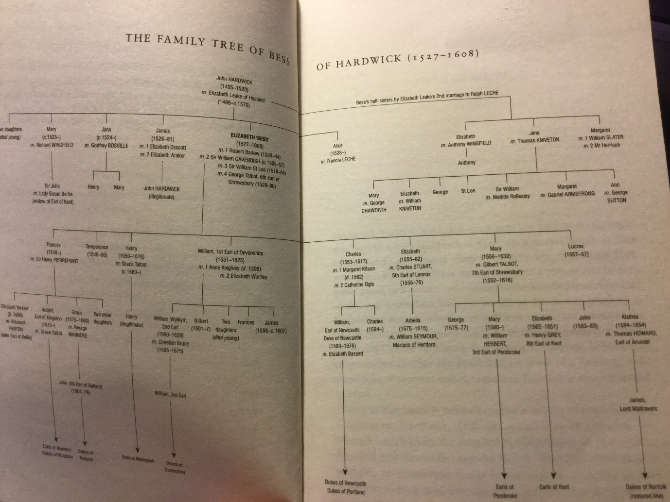

‘The amazing life of Bess of Hardwick’
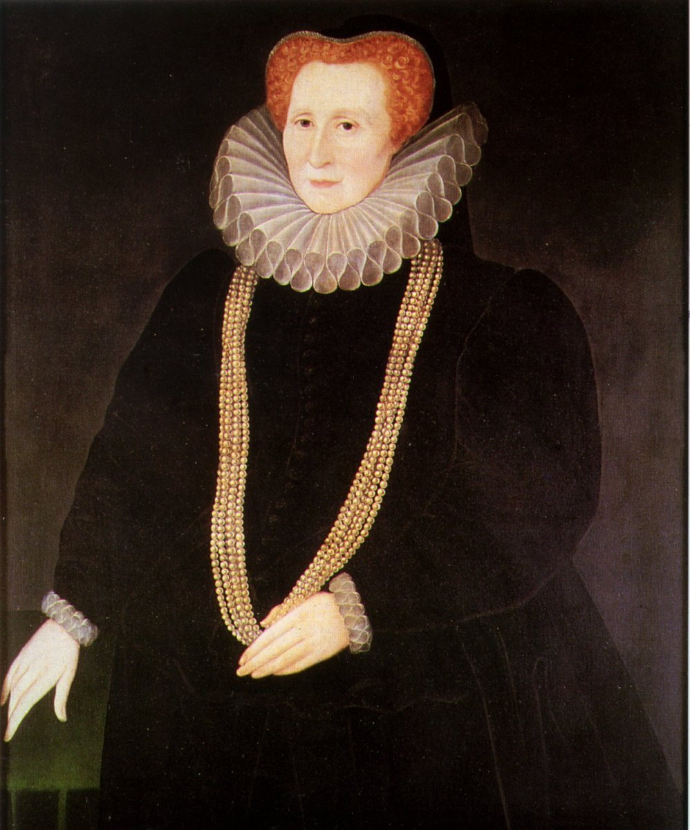
- an early lost play by William Shakespeare
Character list:
Bess of Hardwick – a powerful, rich, talented landowner
Robert Barlow – Bess’ first husband and cousin, died young

The Plot Summary

Why is Hardwick Hall where it is?
It is in Derbyshire, 150 miles north of London
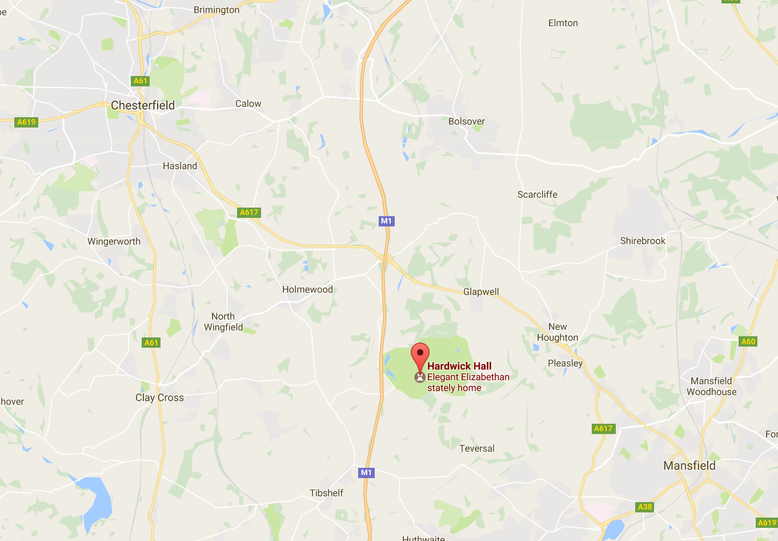
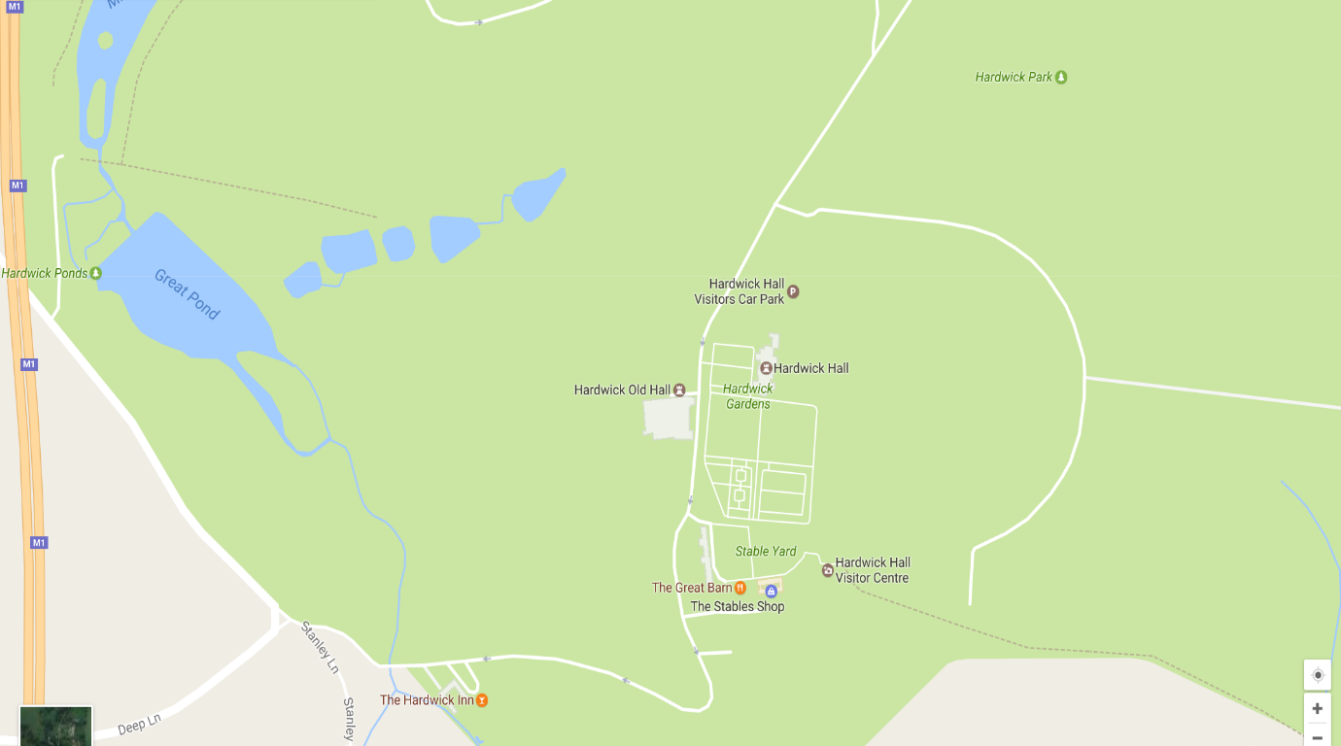
Bess was born in the Old Hall. Later, her brother lived in it, but she always kept an interest. In the 1570s she leant him money so that he did not have to sell it. In 1581 Bess’ brother had died and Hardwick Hall was owned by the Crown. In 1583, her marriage to Shrewsbury was in a bad way. She decided that that she needed to have an independent home. Bess bought the house and property at Hardwick where she had grown up for £9,500. The place where she was born was now entirely her estate and she could do as she liked with it. At this time she lived in the Old Hall, which had had a few extensions since her childhood. On the estate she had all the building materials she needed and all the workshops for production, meaning she only had to pay for labour.
What building experience did Bess have?
During her second marriage, Bess and William began to rebuild Chatsworth House (their version of the house no longer exists). The project was to take 30 years to complete. Even as it was being built, it was a design that was not very fashionable. It looked a bit fortress like compared to the more fashionable Renaissance houses being built in the South at this time.
When Bess was married to Sir William St Loes (her third marriage), for part of their time the couple lived in the South-West at a place called Sutton Court. Here Bess built a new parlour.
By 1570 Bess had experience of managing and developing estates. She was living at Chatsworth at this time. However, her elder brother, James, still lived in the ancestral home of Hardwick Hall. He had no legitimate children and his sister was wealthier than he was. Bess lent him money to avoid Hardwick being sold. Perhaps, at this time, she was thinking that one of her younger sons might be provided with the place. She does seem to have really liked the project management work of building and decorating houses.
How did she start at Hardwick?
At first Bess remodelled the Old House to include inside walking areas, places from which to watch hunting on the estate, and it incorporated old rooms into new. The Hill Great Chamber was designed to entertain people of high rank, had spectacular views across the countryside on three sides and had bright, modern decoration. This could be a prototype for the later ideas of the New Hall. However, she needed space away from her son William’s family and there were limits to what could be done to make it fashionable. Bess had money, energy and a talent for big projects. She was ready for the challenge of a new building.
Why did Bess build at Hardwick Hall?
She needed a home of her own

She had money and liked to spend it on buildings

She needed a house fit for her ambitions

THINK! What does Hardwick Hall reveal about the Elizabethan period?
How far does Hardwick Hall reflect trends in Elizabethan house design? - 1

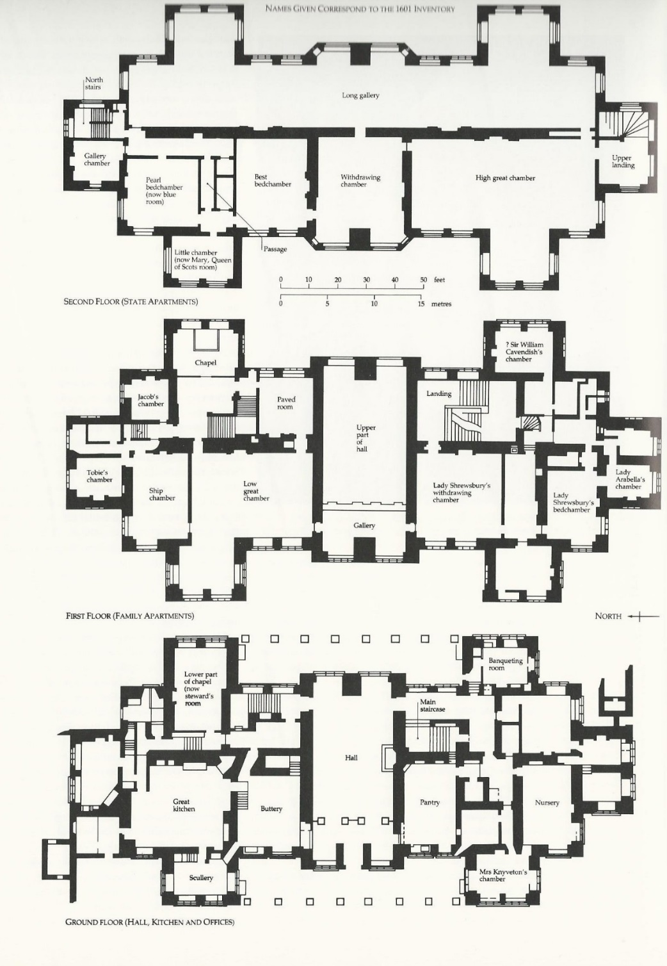
The layout of Hardwick Hall

Comfort and privacy
Houses in specific places at the centre of estates were no longer the communal centres of villages, expected to house local people. England was also peaceful and so there was no need to build defensively. Nobles and gentry could therefore build on their land with a view to comfort and style, rather than thinking about security and the public. Servants quarters were set away from those of the owner. More rooms allowed more privacy. A great chamber replaced the communal hall as the main room.
Q: How far is the new Hardwick Hall an example of this building trend? Annotate the diagram on p10
Symmetry
There was an increasing preference for symmetry. The Renaissance style was inspired by classical civilisation, where there was much use of symmetry. Anyone who adopted symmetry was showing a cultured mind and refined taste. There were many houses from the 14th century onwards that were essentially symmetrical in appearance. They were built on an E or an H shape. This symmetry included having symmetrical entrance facades (the main fronts of buildings). External elevations (the vertical sides of buildings) were designed to express the form and hierarchy of rooms inside and also to make an exciting silhouette. From the 1580s, houses that had inward facing symmetry now projected their symmetry to the outside facades. This made it impossible to work out the interior layout or function of rooms from the outside. It also meant that there was no need for internal courtyards.
Q: How far is the new Hardwick Hall an example of this building trend? Annotate the diagram on p10
The plan of a House
The symmetry of the outside facades made it less necessary or fashionable to have an internal courtyard. This led to the adoption of the double or triple piles. That is, rows of rooms sometimes with one, or two, corridors between them. Before the 1540s buildings were almost always one room deep with a single pitched roof.
Q: How far is the new Hardwick Hall an example of this building trend? Annotate the diagram on p10
The Great Hall
Despite the increasing popularity of double pile houses, most continued to be planned round a hall. But the nature and position of the Great Hall was changing. They had been rooms which were symbols of the lord’s feudal duty to tenants and where the owner carried on a public life. The Great Hall at Burghley, built in 1578, was the last to have an open timber-work roof, ending an English tradition that had lasted unbroken since the Romans. Increasingly halls had flat plastered ceilings such as the one at Audley End. After 1600 most were built, as at Montacute, Somerset (c. 1590) of only one storey rather than the double height. The double or triple pile allowed another innovation, which was to turn the great Hall through 90° and place it in the middle of the house running from front to back. This is what Robert Smythson built at Hardwick Hall in 1590. These new halls were more practical, warmer and, due to wall fireplaces, less smoky. Single-storey halls opened up new possibilities in planning the upper stages of the house as there was no longer a major interruption on the first floor. This enabled first floors to be approached by elegant staircases that often lead to the great chamber directly above the hall.
Q: How far is the new Hardwick Hall an example of this building trend? Annotate the diagram on p10
How far does Hardwick Hall reflect trends in Elizabethan house design? - 2
Hardwick Hall from the west
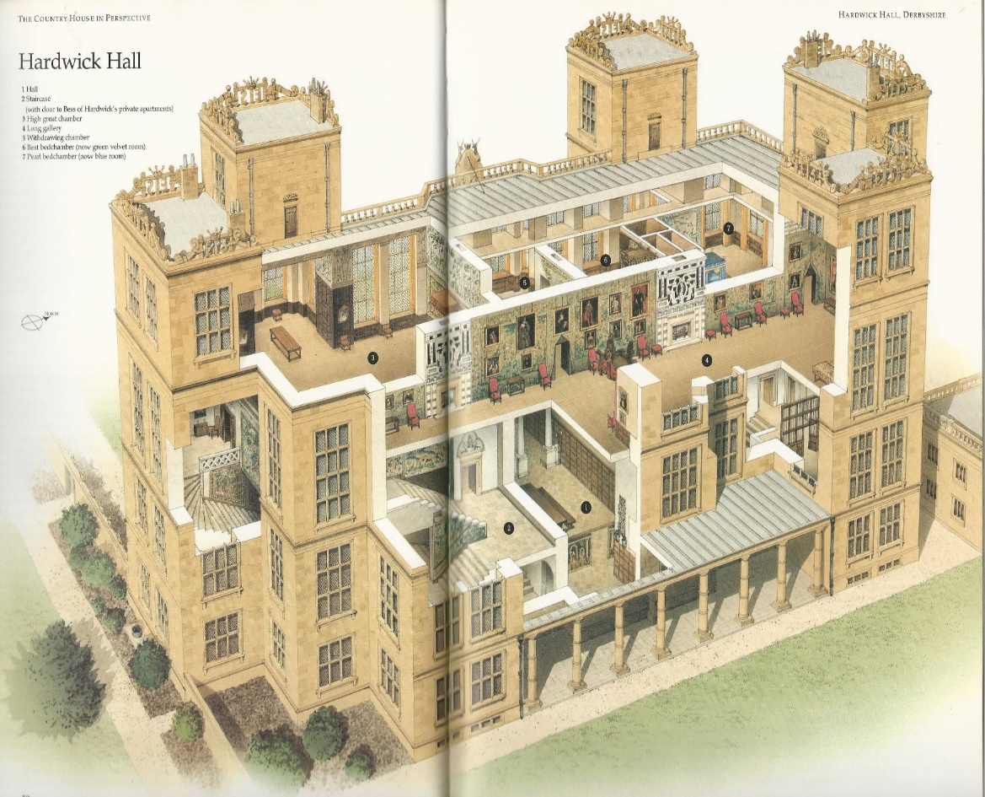
Artist’s cutaway view
Roofing materials and technology
In the early Elizabethan period, a double row of rooms needed double pitches, M–shaped with a valley gutter between them. Later Elizabethan houses had broad lead roofs that could cover a double or triple pile, with gently stepped, flat roofs leading to gutters around the edges. These could be walked on and there could be rooms accessed from the roof. During the Dissolution of the Monasteries, the lead market was flooded with reclaimed roofing and the English lead industry was all but destroyed. However, demand soared from the 1560s, with the increasing adoption of the double pile (with big lead rooves), and the rise in weapons making. This increased demand was met by technological advances pioneered in the Mendips of Somerset, and then adopted in the lead fields of Derbyshire where the invention of smelting mills with waterwheel powered bellows and tall chimneys transformed the industry. In Derbyshire production increased from 300 fothers (1 fother = 1000+kg) a year in 1572 to over 3,000 by 1600. This huge increase in productivity encouraged architectural ambition and the double pile gave a whole new range of possibilities in planning.
Q: How far is the new Hardwick Hall an example of this building trend? Annotate diagrams on p13
Windows
Bay windows, often used in Great Halls, had become popular in other domestic rooms during the 15th century. They added interest to the facades and provided internal spaces for private conversation. During the 16th century they were made into every imaginable shape and size, affecting the plan and silhouette of most great buildings. Late medieval church builders had demonstrated the possibilities of very large windows. In the early 16th century these began to be used in domestic buildings, though use was held back by the cost and availability of glass. Before the reign of Elizabeth, glassmaking in England was almost extinct, and the vast quantities of glass needed for churches, cathedrals and high status houses were imported. A royal patent in 1567 was granted to two Dutch craftsmen, Jean Carré and Anthony Becku, to make window glass. From the 1570s onwards the glass industry expanded to meet the rapidly rising demand for big windows. In the late 1560s around 900 cases of glass were being imported annually but by 1590 there were at least 3000 cases made domestically, wiping out the need for imports. The bay windowed buildings of the 1570s to the 1610s were remarkable. Glass was still expensive and lots of it was a sign of great wealth. On a south facing facade they made rooms very bright and warm, even in spring and autumn; but in winter they made them cold which is why by the 1620s, there was a reaction against big windows.
Q: How far is the new Hardwick Hall an example of this building trend? Annotate diagrams on p13
Long Galleries
Another feature of large houses was the growing popularity of the Long Gallery. Houses were provided with galleries that were attached at one end to the principal living rooms, often supported on arcades or loggias, enabling the occupants to view the surrounding landscape. Galleries at Burghley, for instance, were integrated into the courtyard plan and not discernible from the outside. Many, as at Hardwick Hall, were positioned on the top floor of the house sometimes taking up most of the floor. Between 1570 until the end of the 1620s every house of any pretension had a gallery at least a hundred feet long. These galleries retained their primary purpose of providing a masterly view of the geometrically laid out gardens below, but this increasingly became combined with displaying artworks. Paintings of ancestors and the current family were particularly popular, as were tapestries and sometimes sculpture.
Q: How far is the new Hardwick Hall an example of this building trend? Annotate diagrams on p13
Staircases
The increasing tendency to locate the most prestigious rooms at the top of the house was boosted by a revolution in engineering. Before the 1580s stairs that were not a single straight flight had been built around a solid central newel (post). In the 1580s it was realised that it would be possible to dispense with the newel and replace it with a timber framework. This created exciting possibilities for decoration and spatial effect, but not as exciting as the next development. This was to omit the central framework altogether and cantilever the steps out from the wall, creating an open well.
Q: How far is the new Hardwick Hall an example of this building trend? Annotate diagrams on p13
Gardens and Grounds
Hunting rather than horticulture was fundamental to the setting of most mediaeval houses but from the 15th century, owners increasingly wanted to have more substantial gardens close to their homes for relaxation. Cultivated gardens were normally near to the residential parts in walled enclosures and often contained aviaries or shady bowers covered in vines. Many were combined with fishponds, streams or artificial lakes, and adjacent areas were often planted as orchards. From this time gardens were laid out in square ‘quarters’ surrounded by low fences, and by the 1590s the area devoted to horticulture around the high-status houses was very substantial.
Q: How far is the new Hardwick Hall an example of this building trend? Annotate the picture below.

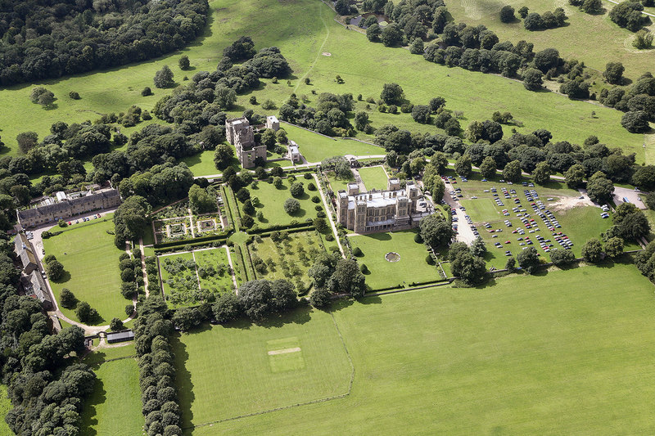
Resource D An aerial photograph of Hardwick Hall and grounds.

Who designed Hardwick Hall?
The man most responsible for the design of Hardwick Hall was Robert Smythson. He had been working for Bess on the remodelling of Hardwick Old Hall. Smythson was an architect and surveyor although he trained originally as a stonemason. At this time in Elizabethan England it is perhaps misleading to use the term ‘architect’ because the role of an architect was only just beginning to be developed. The design of a building was probably the result of several influences, including the patron and family, friends, Smythson and the craftsman at the time. However looking at the way that the design and splendour of Hardwick Hall is so well integrated, it’s hard to avoid the conclusion that Smythson was the inspiration. Bess seems to have admired his Longleat House. She altered his design only slightly, though this does show that ultimately the choices were all Bess’.
Hardwick remains the supreme triumph of Elizabethan architecture. In November 1591 John Rodes, who had carried out much of the external work at a house called Wollaton (designed by Smythson), was employed for the masonry at Hardwick. He was helped by his brother, Christopher, who had also been at Wollaton. Some of the exterior decoration was left to other masons. The marble chimney piece and doorway in the best bedroom was the work of Thomas Accres, a marble carver who had also been at Wollaton. He was probably responsible for much of the remaining marble work throughout the house. So three of Smithson’s principal workmen at Wollaton reappeared at Hardwick. The detail at Hardwick owes much to Flemish pattern books. Other influences are from the Italian Renaissance and the influential architectural writing of Sebastiano Serlio. This is evident in the chimney pieces and fireplaces in the Lower Withdrawing Chamber.
What is distinctive about Hardwick?
The result is a house of great and romantic beauty which its setting adds to the general effect of the house. Externally the house is as rigorously symmetrical as Wollaton. Flemish ornament is seen in the crests on the towers and the use of Bess’s initials on every tower. The loggias are a somewhat unusual feature, because, although not new to England, Hardwick is the first example of a loggia in a house without an internal courtyard. The original plans show the loggia was intended to run right round the house at ground level in a rectangle. A certain amount of improvisation was needed to make the house fit the rigid symmetry of the exterior. Several of the great windows are false with a stone wall behind them, or provide light to 2 floors of low ceilinged rooms instead of one single lofty one.
One of the advantages of putting the best state rooms upon the top floor was their approach could be made very long and magnificent. Another was the splendid views from the windows. And a third was that in quiet seasons they could easily be sealed off and forgotten. The disadvantage was of course their remoteness; the great number of steps that have to be climbed and the route from the kitchen to the high great chamber is an immensely long one. It provided a ceremonial route for what was an essential feature of any grand Elizabethan entertainment, the formal procession of waiters carrying up each course of a meal.
No discussion of Hardwick can ignore the influence of its builder as Bess was not the sort of person to leave the details of her house to others. Many of the idiosyncrasies are due to her, such as the increased height of the towers in the middle of the building. It is clear she had a passion for height, light, squareness, and symmetry but one only has to compare the old with the new Hardwick to see how Smythson transformed her somewhat crude ideas into a work of art.
An extract adapted from ‘Robert Smythson and the Elizabethan country house’ by Mark Girouard (1983)
Interpretations of Hardwick Hall
Bess and the style of Hardwick Hall
Bess was been shown to be aware of court tastes but was to have been detached from them by distance, age, gender and possibly education. From 1568, Bess was only an occasional visitor to court and relied heavily on other people to inform her of changing tastes. Bess chose to fill her house with a very rich visual and intellectual decorative scheme. This suggests that she wished to imitate some aspects of the prevailing courtly taste for deeply allusive and metaphorical imagery. This was to test and amuse her visitors whilst displaying sophistication.
Hardwick was created towards the end of a very long life, and whilst it is often seen as representing the last years of the sixteenth century, it has been shown that many of the contents had been made earlier in the 1570s for Chatsworth. William Cavendish probably had a considerable influence on his younger wife’s development of a sense of style, of what was suitable for people climbing the social ladder, and of what could be achieved with a lavish display of possessions.
The choice of Smythson as architect suggests a desire to be modern but to stay with the favoured architect of her own immediate circle. The furnishings display the same concern to be luxurious without being ostentatious or financially extravagant. Despite her great wealth, Bess did not spend a large amount on them, re-using old items where possible and spending prudently where new purchases were necessary. Hardwick was not created to be the house of a dynasty or of a queen, it was created to be the monument of one woman. However, whilst seeking this immortality, Bess remained cautious, she `would not have any superfluity or waste of anything, preferring 'that which is needful and necessary'.
Gillian White (2005), PHd theses, History of Art, University of Warwick (adapted)

‘Nikolaus Pevsner: the Life’ by Susan Harries (2012) Pevsner spent his life writing about the architecture of England.
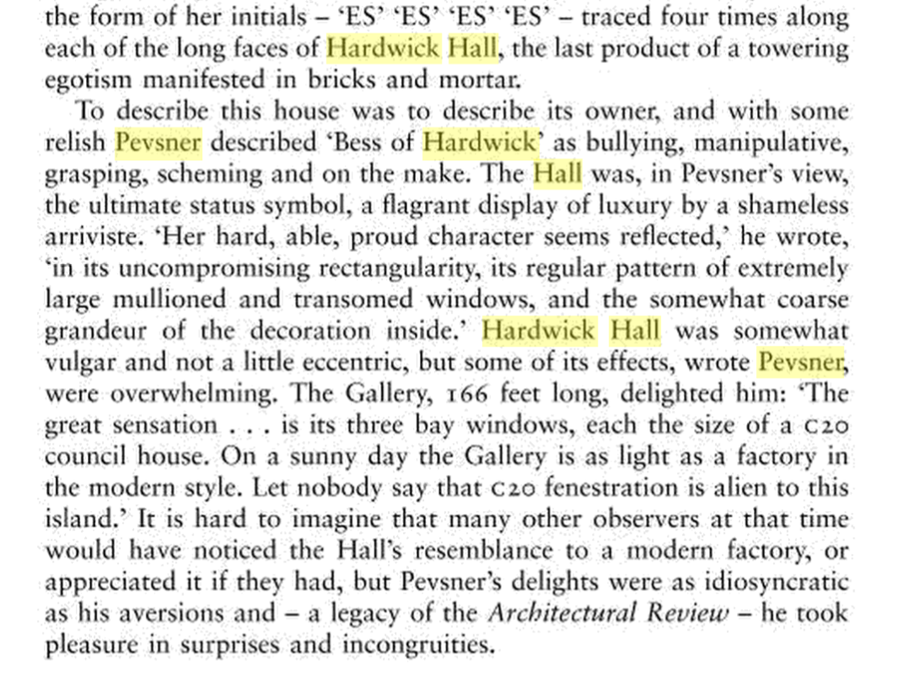
Q: How similar are these two interpretations?
How typical was Hardwick Hall?
From Ladybird ‘The Story of Houses and Homes’ (1963)
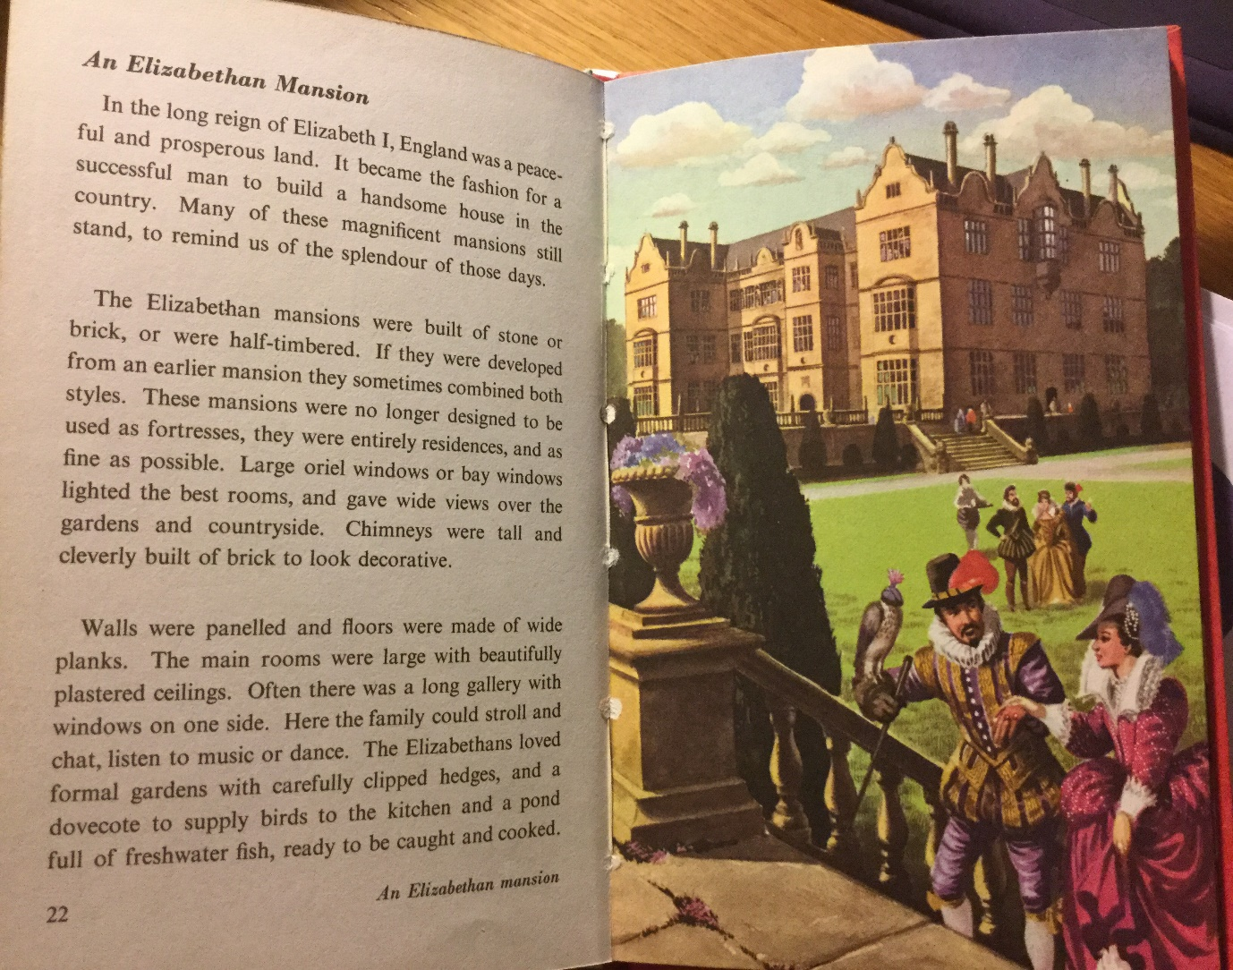
Reading this, do you place Hardwick Hall at the ‘cutting edge’ of Elizabethan stately home building, or is it one of many?
Manor House built in the 1590s by Christopher Grey
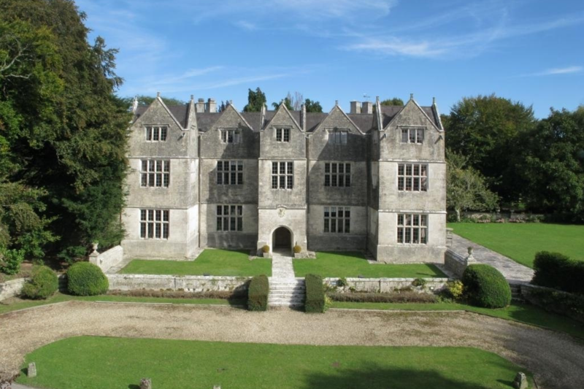
What similarities and differences can you spot between these house and Hardwick Hall?
Burghley House, built by William Cecil, mostly in the 1560s
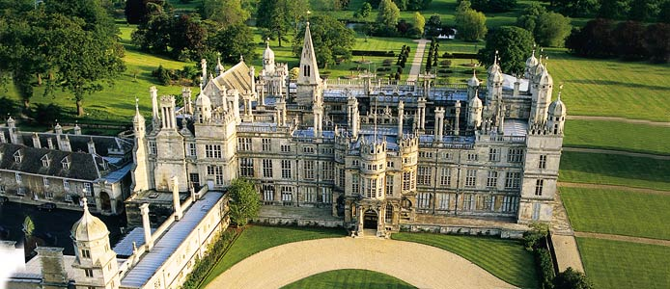
Why is it unsurprising that Burghley House, built in the 1560s, is grander than Hardwick Hall?

Our visit to Hardwick Hall
First impressions
Look very carefully at the west front. Answer the questions below.
How is the building symmetrical?

What do you notice about the height of each storey?

How to you know it’s Elizabeth, Countess of Shrewsbury’s house?

Which floor would be for servants, which for Bess and her household, which for visiting royalty?

Remembering that the Old Hall was not a ruin in Bess’ time, how do the two houses compare?

Robert Cecil is supposed to have said: ‘Hardwick Hall, more _________ than wall!’
Your first walk through Hardwick Hall
You are now going to take a first walk through part of Hardwick Hall. You are not going to stop for long in the rooms. You are trying to experience arriving at the house as a very important visitor. We will look at the rooms in detail later.
Imagine you are a noble visitor arriving from court, where you have heard much about this new house belonging to the Dowager Countess of Shrewsbury. You have arrived into the house passed the gatehouse, symbolic of a medieval castle. Now walk across the Hall (in most houses, this is where you would be hosted), turn left and straight up the great stairs to the second floor (not the first – the one at the top). Notice Bess’ rich furniture and windows as your route turns. At the top enter the ‘High Great Chamber’.
- What is your impression?
The Long Gallery is one of the longest you will have seen. Peer out of the windows and view Bess’ estate. Then explore the 'Withdrawing Chamber' beyond leading to your 'Best bed Chamber' and its associated service rooms. Notice you have taken several turns to get here. These were rooms fit for royalty to stay in.
- How does this all make you feel as a visitor?
- Make a few notes of your first impressions…

Where did Hardwick ‘come from’?
Hardwick was made from local materials from Bess’s own properties which were in turn used by local craftsmen. Wood came from trees that grew on Bess’ land and the glass and the iron from her glassworks and ironworks at Wingfield. Lead came from her workings at Winster or Aldwark, and the stone from her quarries at Ashford in Derbyshire. This meant that building was swift and she only had to pay for labour. Bess had surrounded herself with good and intelligent servants whom she managed well. All of this meant that she never had to sell land, controlled much of the local economy and prospered. When Bess returned from London in the summer if 1592 the walls of the New House had reached the top floor. She was still improving the Old Hall at the same time. Whilst in London, Bess had shopped to furnish her new home. She bought the Gideon Tapestries from the heir of Sir Christopher Hatton for the long gallery. She needed these as the plaster work was not fine and there was no panelling. Gold and silver plate and cloth of gold and silver are also in her accounts. Many items came from her other houses and were things collected over a long life.
- As you walk around note down a few examples of evidence of Bess’ use of local materials in abundance to show her control and wealth.

Part of the central hall fireplace, made of local materials
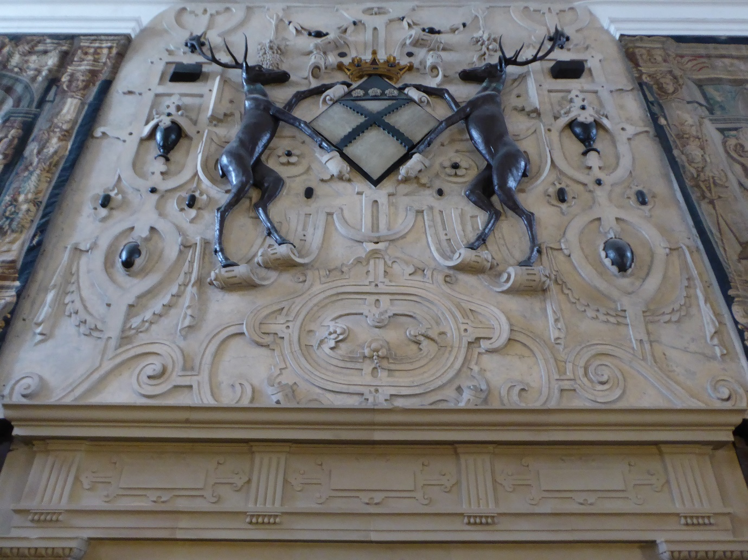
In what ways does Hardwick showcase Elizabethan building and architecture?
The new Hardwick Hall had 46 rooms (excluding service rooms) and thus was smaller than Chatsworth, with 97 rooms. There were 14 bedchambers at Hardwick, though the Old Hall could also be used for lesser guests. Now tour the Hall in your own time and complete pages of this guide.
The Hall
The decline in the medieval function of the hall is not unique to Bess' house. The practical function of the hall had been downgraded from the heart of the aristocratic household to one of a serving area. However the entrance hall at Hardwick is still a large space calculated to impress the visitor by its size. The screen in the hall marks a symbolic division between the public and private areas, where the mistress could not only observe but, more importantly, be observed. The walkway over the hall was added from plans to building stage to allow easy access from one side to the other of the family rooms.

Note an example of something here that is typical of any fashionable Elizabethan building.

Note an example of something specific to Hardwick Hall in the central hall
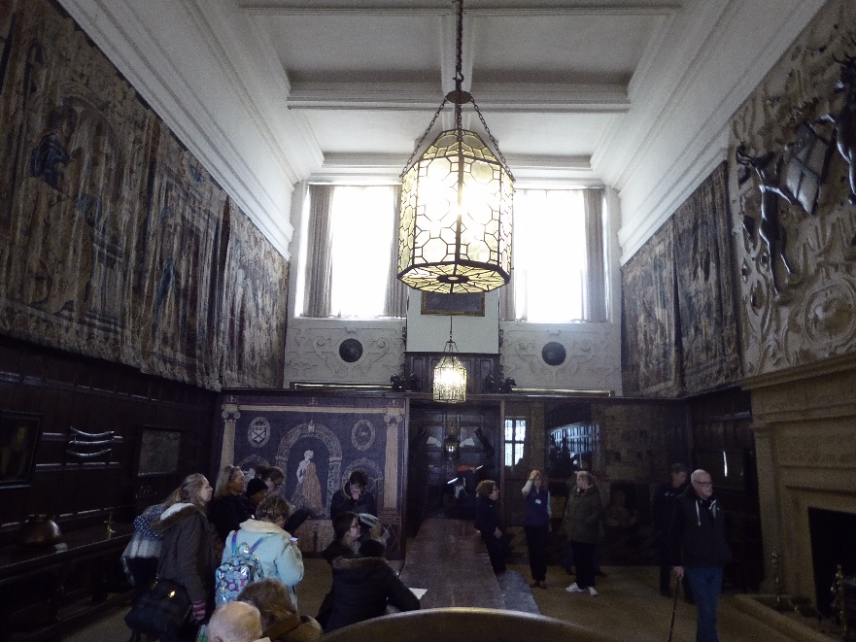

Second floor
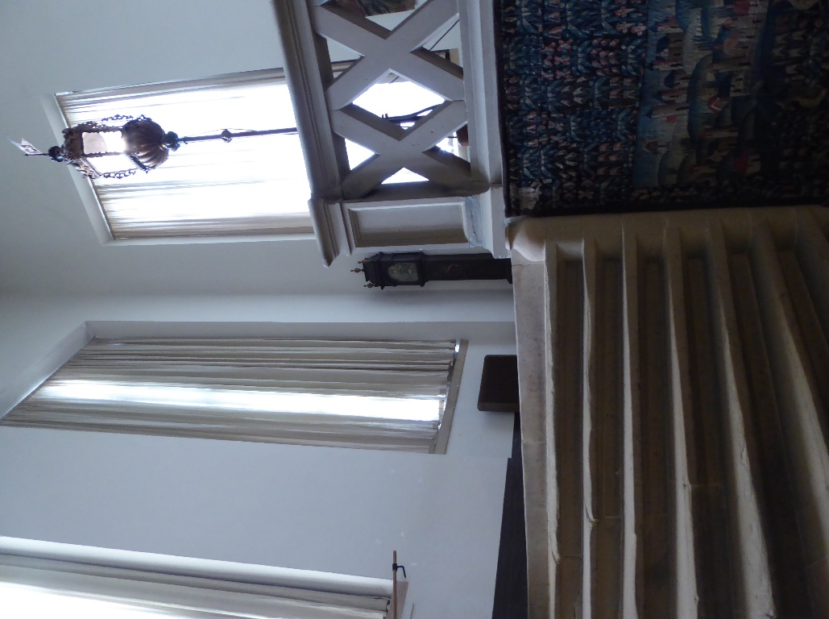
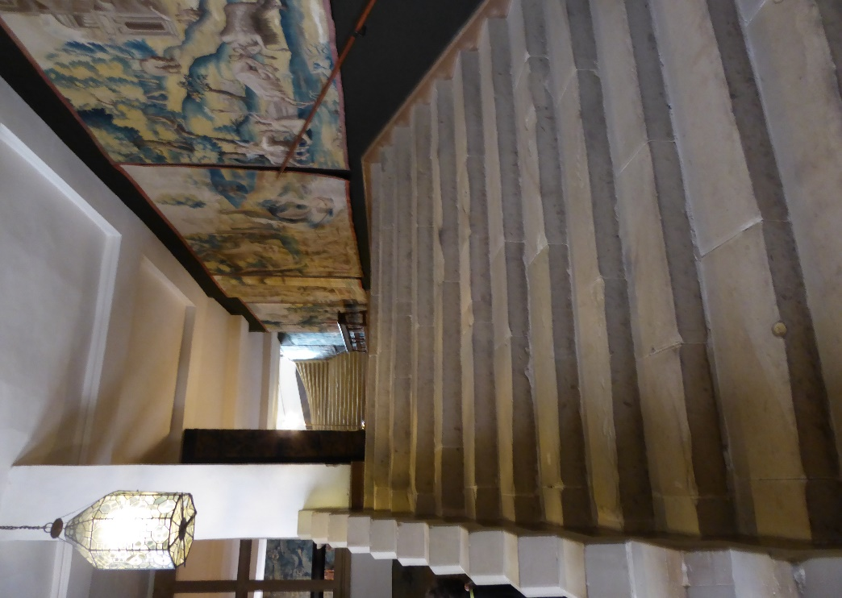
The Grand Visitors’ Staircase
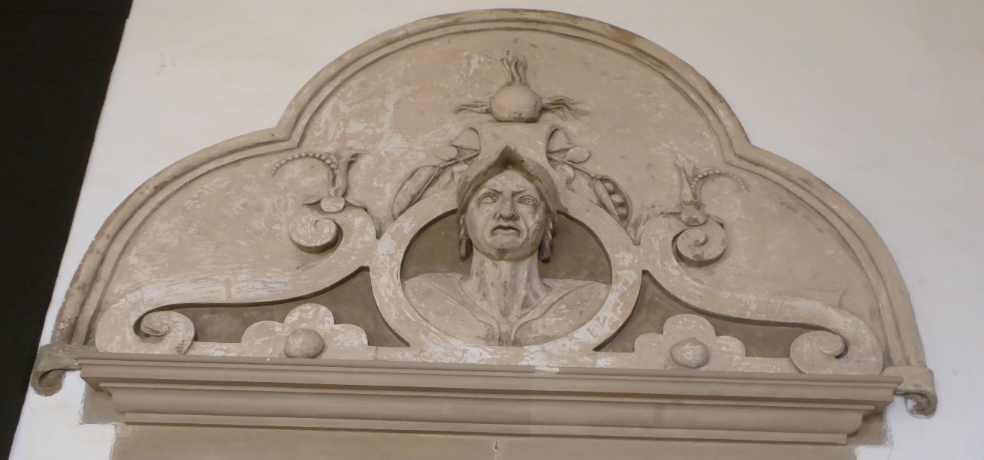When you see a face like this above the door it is original and means ‘Don’t Enter!’ (but you can!)

High Great Chamber
Note down the features in this room that give it a grand and public status.

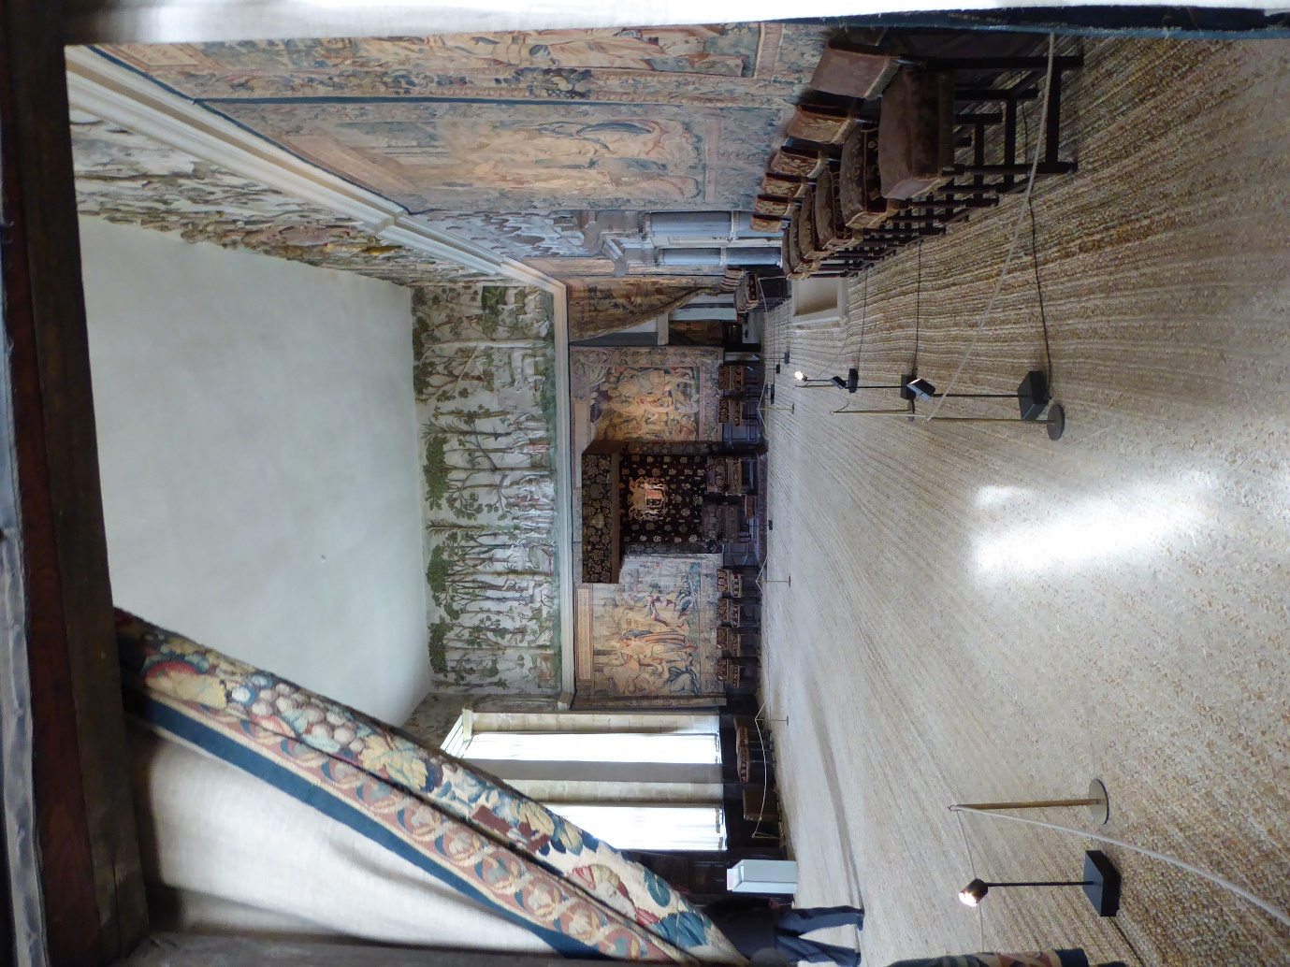

DYK? the Great Staircase was ‘out of bounds’ even to family, when important visitors were staying!
The Long Gallery
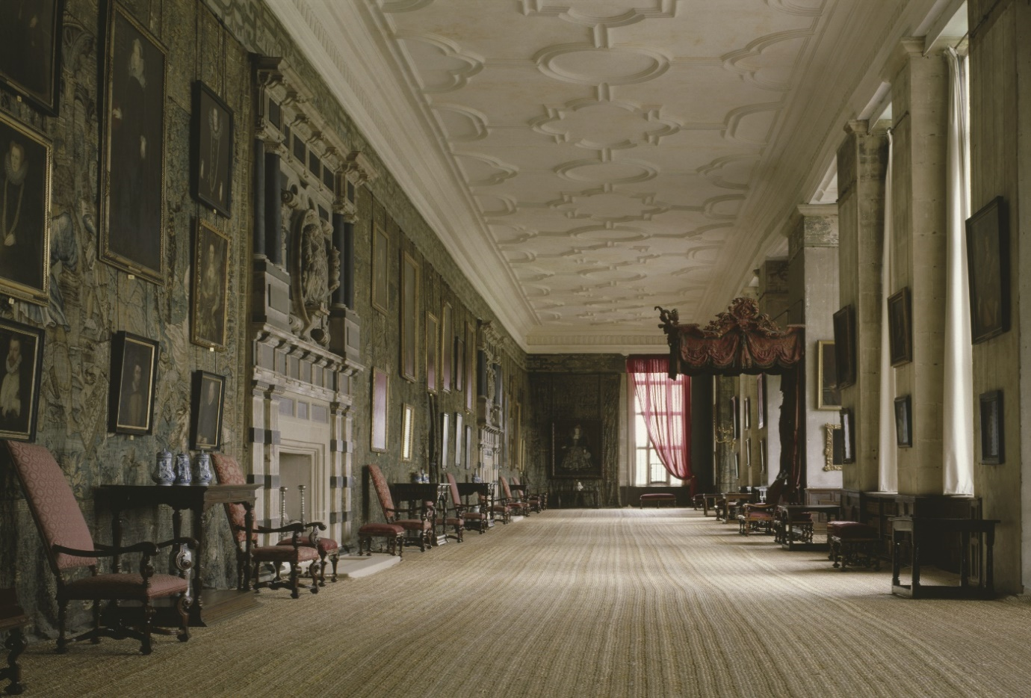
A photograph of the Long Gallery at Hardwick Hall.
What is impressive about this room?

Inventory 1601
In Bess’ day this room contained two square inlaid tables, it was covered with carpets, there were three chairs, three low stools, a footstool, two forms, tow mirrors, a little ivory table and a fire screen. Each window had a window seat with richly embroidered cushions.
- What do you notice about the amount of furniture?

Go to the first floor…
Bess’s rooms. As with most contemporary aristocratic houses, Bess's accommodation at Hardwick Hall consists of a withdrawing chamber, bed chamber and inner chambers. Only family were allowed in here. Note that none of the original beds survive and much other furniture has been added later. The 1601 inventory lists rich wall hangings, tapestries, carpets and stools, forms and chairs in the living area.
As you walk around this area make some notes about how different these rooms are to the formal, public rooms. How is that affected by their purpose? What impression do you get of Bess and her world from these private family quarters?

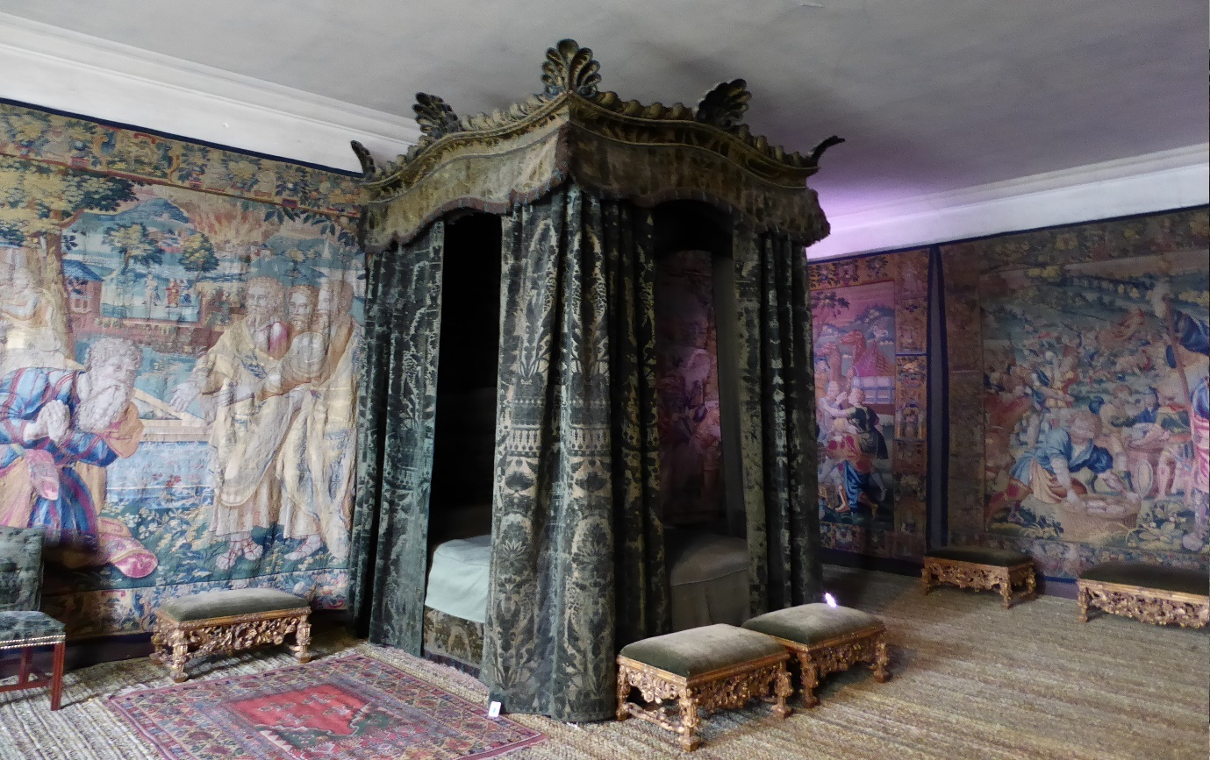

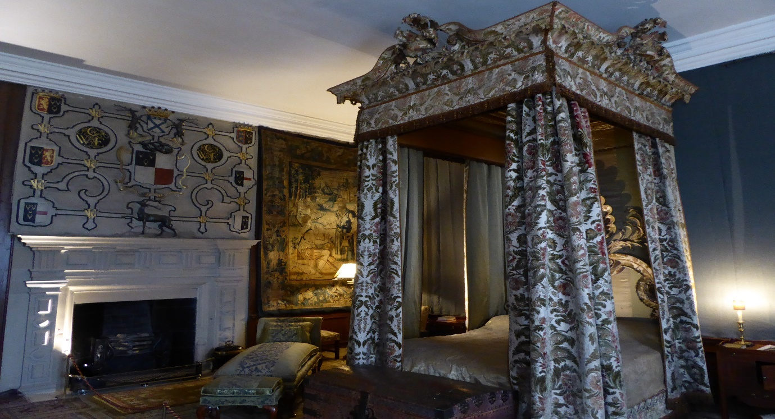
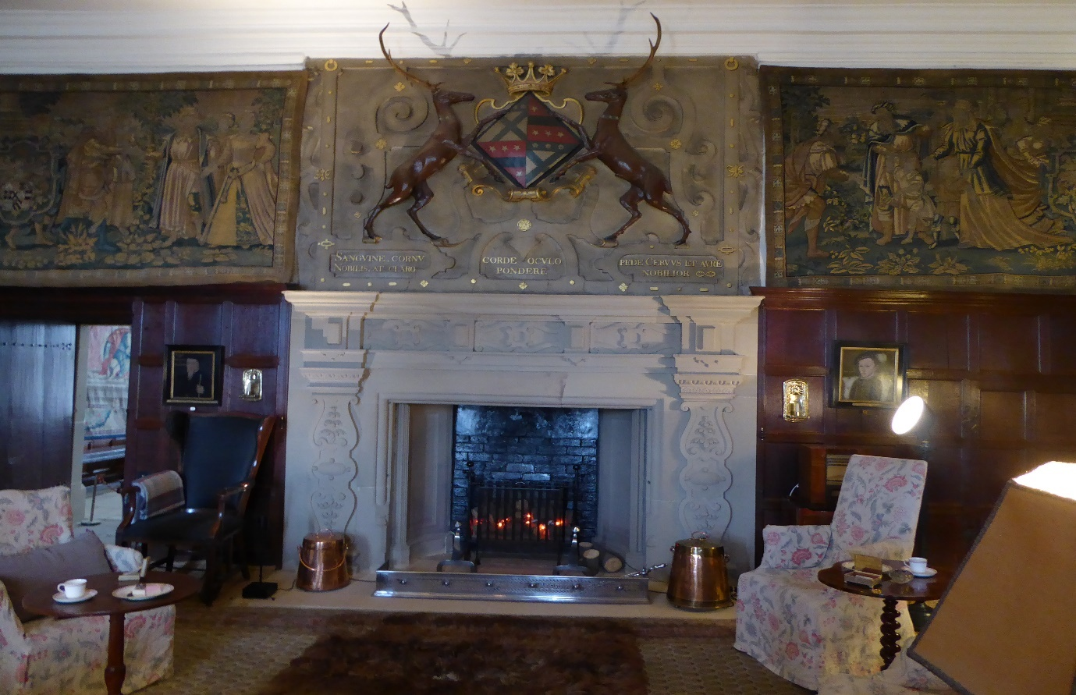

Again, note an example of something unique to Bess and something typical of any fashionable Elizabethan building.

The Chapel
The lower part of the Chapel served most of the household whilst the upper part was reserved for Bess and family, and provided an area where they could worship in private, as the Queen did at Hampton Court. In 1601 Bess had an embroidery of the crucifixion and three pictures of the Virgin Mary.
What does this suggest about Bess?

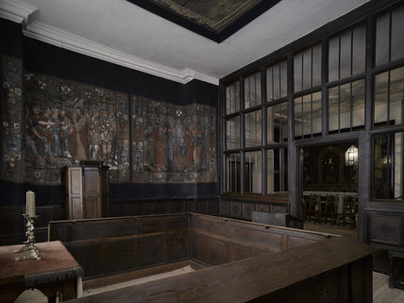
Bess at Hardwick
Bess’s household varied between thirty and forty people based at Hardwick. This was not a particularly large household but it had to operate within appropriate social codes, which were reflected in the divisions of space within the house. Hardwick, like other grand Elizabethan households, was organised like a little court with Bess at the centre and round her radiated three circles which were her own immediate family, the upper servants, and the lower servants.
Bess was a strong-minded patron, whose taste, and practicality, led to the changes. The addition of loggias, for example, may be considered a choice based on a sense of fashion, whilst the rearrangement of rooms owes more to domestic practicality.
As she got older, Bess probably spent much of the winter months in her bedchamber. It would have been easier to keep warm. There was no library at Hardwick. This is not surprising as Bess had received only the basic formal education of a girl of the lower gentry. Books were expensive and not where her interests lay. She was a woman of the world and not an academic.
What evidence can you see around you that supports this paragraph?

Fixtures and fittings…
Royal coat of arms
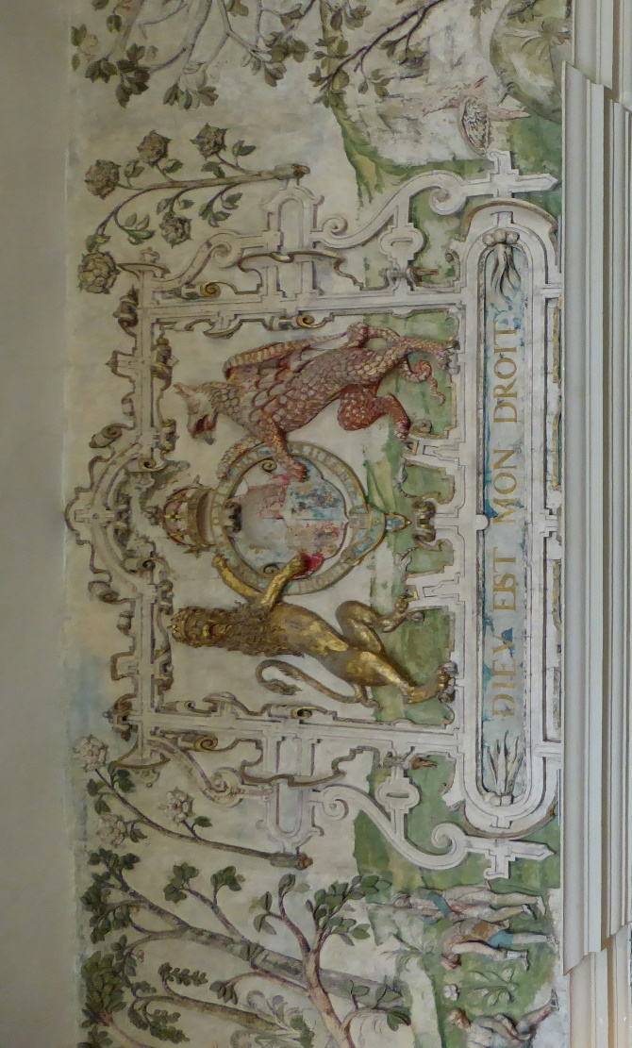
Whose is this coat of arms in the High Great Chamber?

Wall hangings
Bess possessed a large collection of wall-hangings. Tapestries followed a hierarchy, with those containing silk or metal thread displayed in the rooms of highest status. Coarser wool tapestries serve for lesser rooms. At Chatsworth there had been elaborate panelling to decorate the walls and the lack of it at Hardwick, either through choice or, more likely, through financial necessity, meant that Bess had to go on a major tapestry-buying spree during her last visit to London in 1591.
Here are examples of this hierarchy. Which rooms are they in? Note the rooms and say how the tapestries are different from each other.
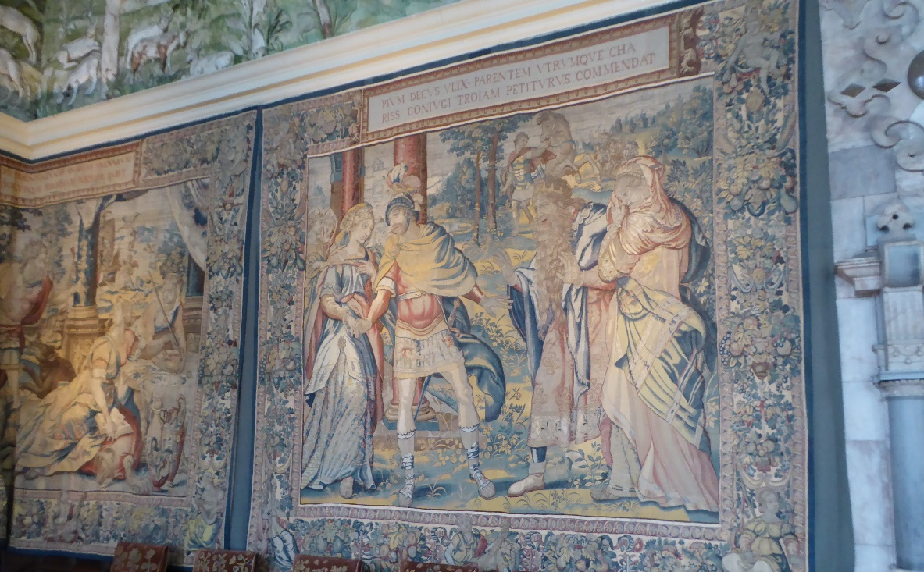
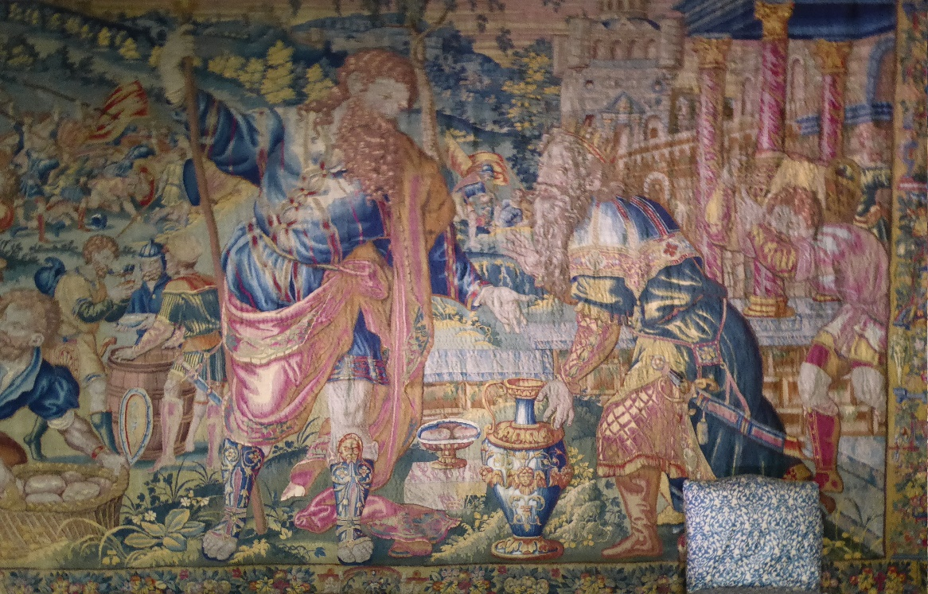

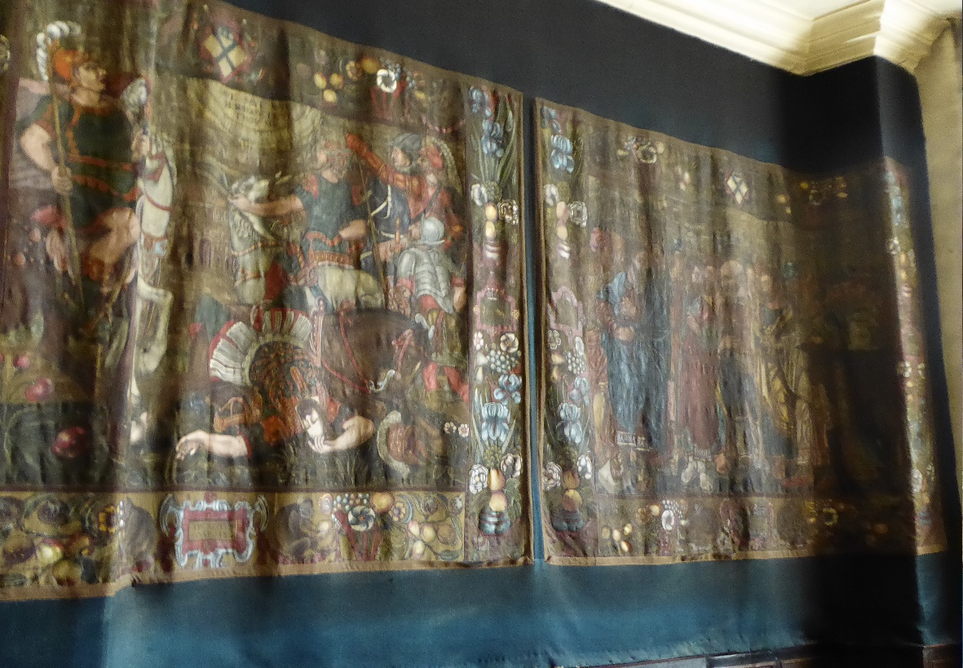

What stories are told in the tapestries, who is represented?

Carpets
Study of Bess's carpets shows that she had one of the larger collections of the period, although well behind the royal collection and Robert Dudley’s. As with many of her contemporaries, the bulk of her collection consisted of Turkish carpets but she was unusual in the number of needlework and richly decorated fabric carpets which she owned. These also reveal a hierarchy with needlework carpets at the top, followed by the fabric examples. Carpets were also used by her to emphasise the status of certain pieces of furniture, especially the best bed, and certain chairs which she, or her most important guest, might occupy.

Beds
Beds dominate the room especially when hung with textiles. As well as having a practical function, beds could be used for displays of wealth, social status, and taste. The beds at Hardwick in 1601 show that the hangings were more important than the beds themselves, although it is apparent that gilded beds were chosen for the best bedrooms: an effect of magnificent display is created with rich fabrics, varied ornament and eclectic mixing of textures, colours and styles, although this does seem a little old-fashioned.
A painting by William Henry Hunt in 1820 of the Mary Queen of Scots room at Hardwick Hall.
- Why do you KNOW that Mary Queen of Scots never stayed here?
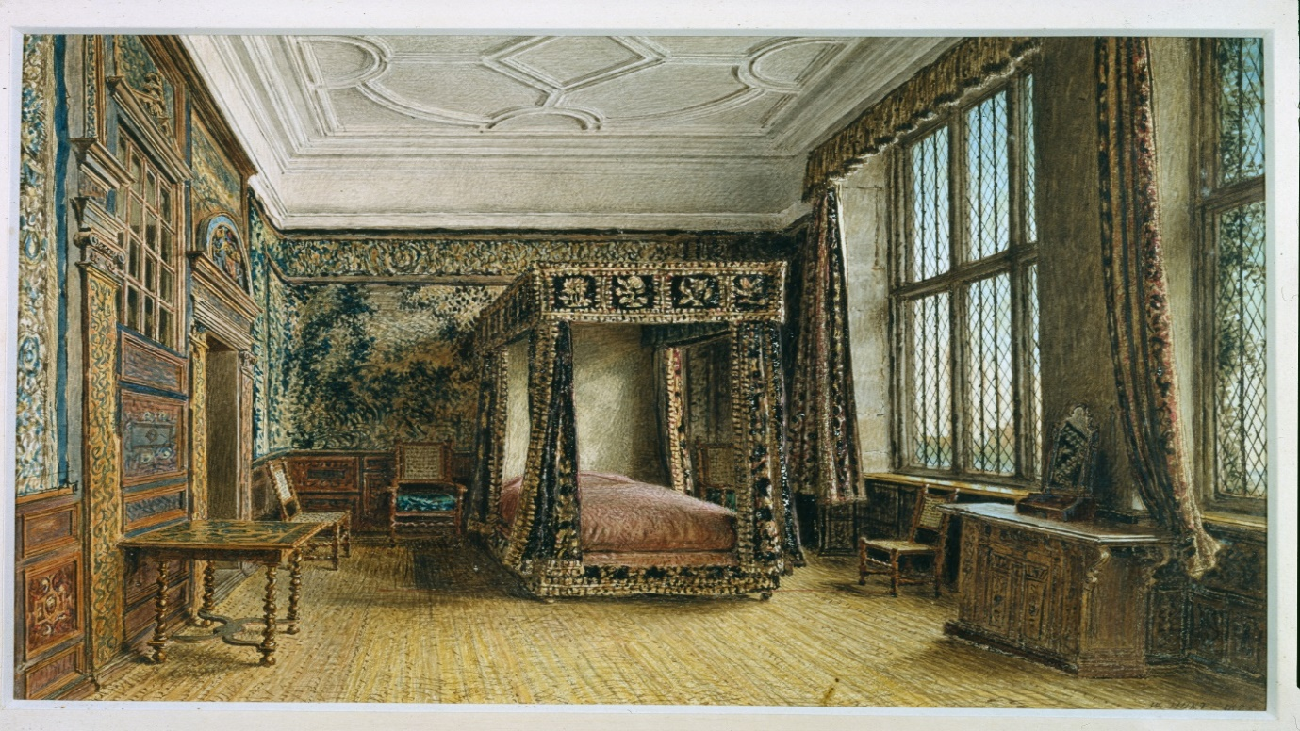

Furniture
Bess put a high value on her French furniture. For example amongst the wealth of inlaid stools are six ‘French stools’ which form a set. Although Bess may have diminished the impact of this set by dividing it amongst three rooms, she may have gained a greater audience by sharing it out in this way. Bess’ fondness for French furnishings was a taste she shared with Robert Dudley. The French furnishings show that for much of the most ostentatious furniture Bess was reliant on pieces remaining from Chatsworth House of twenty years earlier. For general, everyday furniture, however, the accounts reveal a great deal was made at Hardwick, as if Bess were acknowledging that the demonstration of status required quantity as well as quality. Bess's expenditure was not lavish and represents careful evaluation of costs against benefits. Bess used hierarchies of materials in the furnishings to reinforce the hierarchies established by the architecture, the public and private spaces and to send clear social messages.

Pictures
Bess was not a connoisseur, but she is revealed as an owner who was fully aware of the potential of pictures as part of a great house's furnishings. She did not believe 'as for most Elizabethans, pictures were primarily wall furniture'.
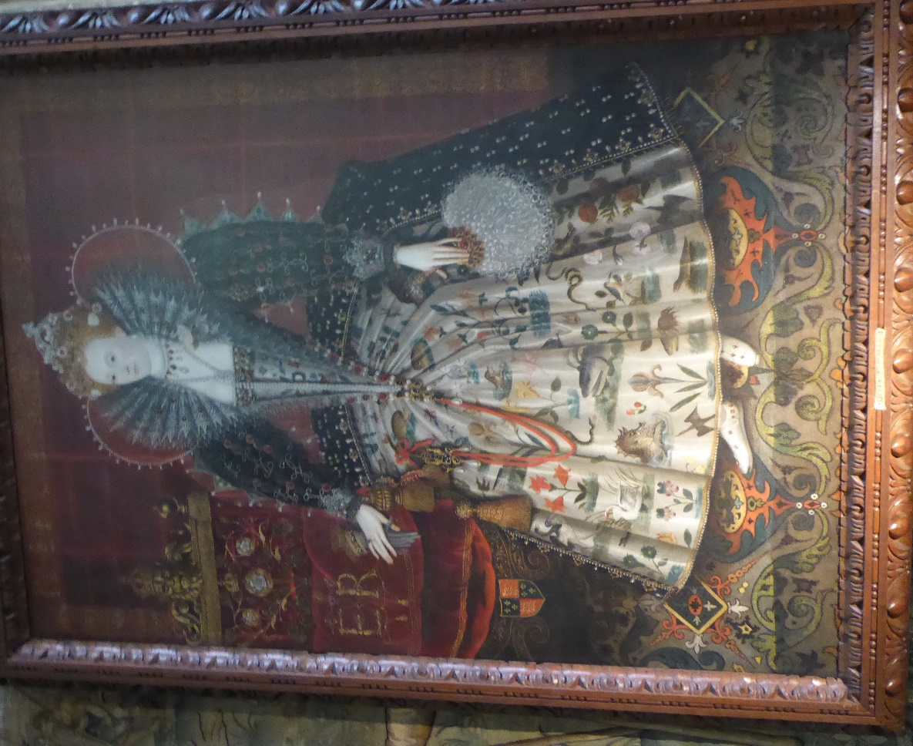
An artist’s impression of the inside of Hardwick Hall.
- A mystery?! – where is this room in the house?
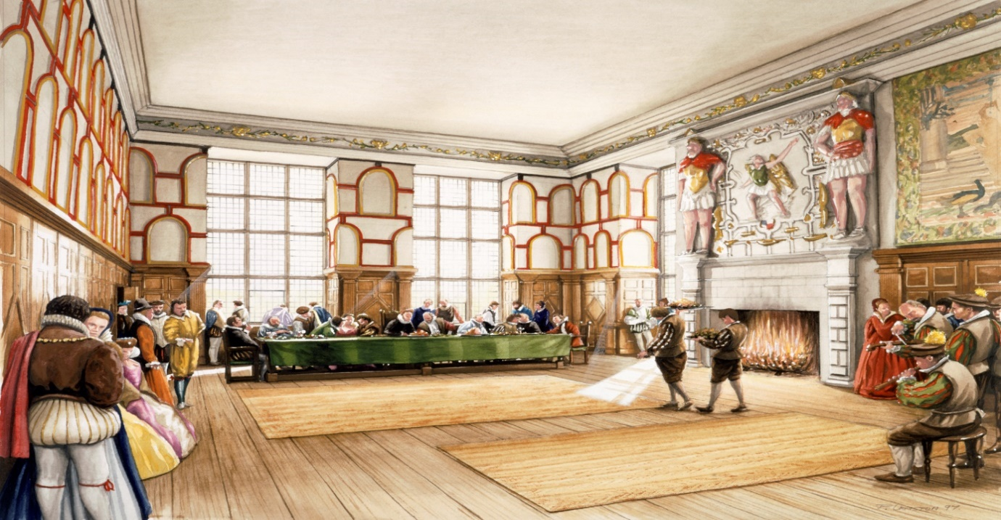

What messages did the paintings, heraldry and wall hangings send to people?
Bess varied the decorative themes according to the different audiences to be found in the different social spaces of her house. The Lowe Great Chamber gives an emphatic message about Bess's family. A portrait of Bess herself is joined by pictures of her husbands and children. The only ‘intruders’ into the family circle are Queen Elizabeth, Lord Burghley and the Virgin Mary. These pictures give a very clear statement of family authority and continuity, with four generations of the family being represented.
- Go and find the pictures being referred to here – do you agree?
It is significant that family identity is asserted in a room which had a number of functions and was probably one of the busiest in the house. Thus the message would be received there by a great number of people, most of them Bess's social inferiors. Bess uses heraldry throughout the house to back up the statement about the identity of Bess, and her Hardwick family lineage. Bess celebrates Queen Elizabeth but at the same time, shows herself as a good subject of her Queen. Bess views Queen Elizabeth as a figure of authority and power, as shown clearly in the full-length portrait.
- Make sure you go and look at this evidence
Simple statements of ancestral and continuing authority, were suitable for the lowest status public areas. She wished to be identified with an educated, courtly world which would understand and delight in references and allusions to classical literature and mythology and to current fashions in imagery. So these more intellectually challenging themes (such as the story of Ulysses) are explored in the high status areas of the second floor, where they would be seen by the educated and courtly upper class visitor, able to understand their messages.
- Can you see the evidence of these distinctions in different parts of the house?

