Picturing the past
Making the most of visual interpretations

Michael Riley

Look and Learn History Picture Library http://www.lookandlearn.com

Street scenes

The Rose Theatre and Bankside, by Peter Jackson
Walk through the painting with a friend – what details do you notice?

A Southwark street, by Ivan Lapper
What do you see, smell, hear?

- Share your enjoyment of specific pictures and your admiration for particular illustrators
- Use pictures of street scenes to create curiosity and to build a sense of period
- ‘Let the history breathe’ and help students to develop a respect for people in the past

A late-medieval street scene in Look and Learn
What details did the artist include to show that towns were unhealthy places?

Enquiry: Did anyone really care about health in medieval England?

- Use an outdated visual interpretation as the starting point for a particular enquiry, then build students’ knowledge of recent research and changing interpretations

Archaeological illustrations

Housesteads Latrines
How were they used?

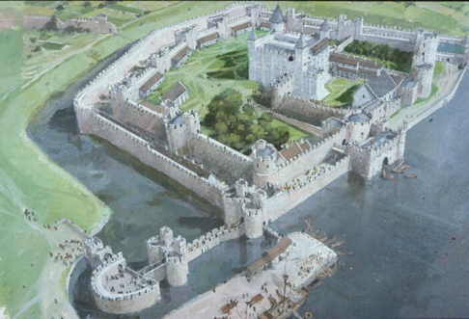

The Tower of London, by Ivan Lapper
What has changed since 1300?

Wharram Percy, by Richard Lea
Compare archaeological illustrations

- Challenge students to relate the illustration to the archaeology
- Use archaeological illustrations to develop an understanding of change over time
- Build an understanding of the techniques used by archaeological illustrators

Imagining national events

The Body of Harold by Ford Maddox Brown, 1844
How do we know that Maddox Brown’s sympathy was with the Saxons?

The Conqueror comes to London, by Cecil Doughty. An illustration in Look and Learn, c.1970
How did Cecil Doughty make the Normans look dominant and forceful?

A Saxon village by Ron Embleton c.1970
How did Ron Embleton portray the impact of the Norman Conquest on the Saxons?

Enquiry: A ‘truck-load of trouble’: What was the impact of the Norman Conquest on the English?

The Boyhood of Raleigh by John Everitt Millais, 1870
Why do you think many people in Victorian Britain admired Millais’s painting?

The colony at Roanoke in the winter of 1585-86. The front page of Look and Learn, November 1962
How does the illustration give a false impression of Raleigh’s achievement in North America?

A trade card issued by the Liebig Meat Extract Company in 1922
Do you think it matters if interpretations of history like the trade card present a false view of the past?

- Help students to analyse a visual interpretation by focusing on the viewpoint of the artist
- Develop an understanding of the context in which a picture was produced and the reasons for a particular portrayal
- Challenge students to use the knowledge they have built through an enquiry to criticise a visual interpretation

