How did a protest transform lives?
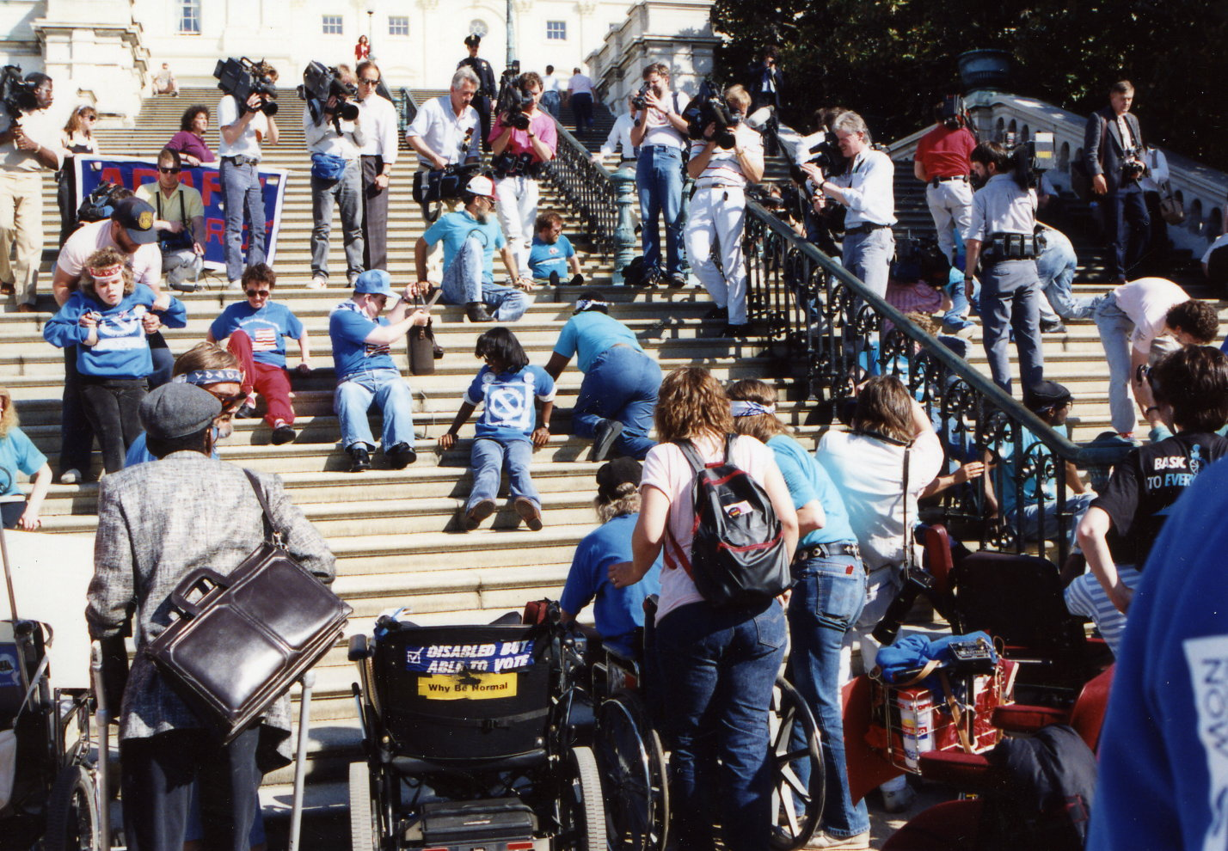
What is happening in this picture?
Look carefully at the photograph above. What can you see? It was taken on the 12th of March 1990. You can see that a few adults and children were capturing a lot of media attention. This event was known as ‘The Capitol Crawl’. The Capitol building is the central building in the capital of the USA, Washington DC. It is the equivalent of the Houses of Parliament in the UK. These people were staging a protest. As people with disabilities they could not get into the Capitol building on their own except by slowly crawling up the steps. By showing this fact to the world they were making a big statement. Their protest was not just about being excluded from the Capitol building itself. The problem of getting into The Capitol (the centre of democracy in the USA) was a symbol for all the many ways that people with disabilities were excluded from everyday life. They were excluded because society viewed them as the problem. They were arguing that it was the responsibility of government and society to help people with disabilities by removing the barriers that prevented them being full citizens. This was a very powerful idea and it has helped to transform the way we think about disability in the UK. The Capitol Crawl is now seen as a turning point moment in the history of disability.
What is the back story?
In countries such as the USA and the UK, there was a long history of shutting people with disabilities away in hospitals and places called asylums. Disability was often regarded as something shameful. People with disabilities were not seen as being as good as other people. Today we have a very different view, but this did not change automatically. Historians who study disability think that there were some important factors that brought about change.
Firstly, many people with disabilities protested. The 1990 Capitol Crawl is a famous example. There were many others. For example, people with learning disabilities in hospitals in the UK successfully protested for the right to vote in 1981.
Secondly, the wars of the 20th century had changed attitudes to disability. Many men who survived the fighting were left permanently disabled. These veterans of war were a challenge to the idea that people with disabilities were people who should be looked down upon.
Thirdly, after the Second World War the United Nations made its Declaration of Human Rights in 1948. Many countries signed up to this Declaration. The European Convention on Human Rights of 1953 guarantees these rights for Europeans. Groups of people who had been discriminated against were able to use this change in culture and law to campaign for equality. This did not happen immediately for everyone. At the Capitol Crawl, one of the speakers said: “What we did for civil rights [for black people] in the ‘60s, we forgot to do for people with disabilities.”
What happened as a result?
The Capitol Crawl was the final campaign that led to the Americans with Disabilities Act that was passed in 1990. It protected people from discrimination based on disabilities in all areas of public life, including jobs, schools, transportation, and public and private places that are open to the general public. In the UK similar laws were passed from the 1990s. In 2010 the Equality Act was introduced to protect the rights of individuals and advance equality of opportunity for all. It was designed to promote a fair and more equal society.
THINK!
- This is a story about fighting for equality. The way we think about people has changed over time.
- This change over time has causes. Historians study how people and events connect and relate to each other to cause change. Turning point moments are points in time that lead to a specific change.
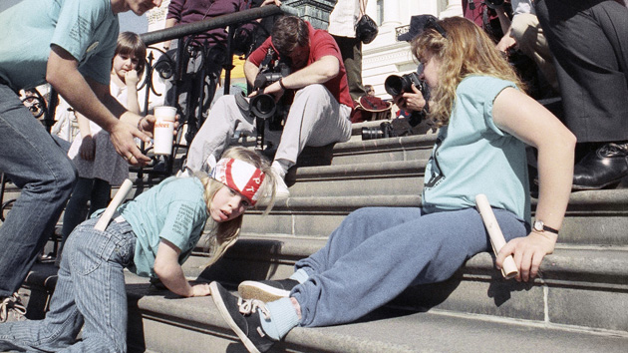
Over to you!
One of the most powerful images of the Capitol Crawl is this one of Jennifer Keelan. She has cerebral palsy and at the time she was an 8-year-old girl. She shouted: “I’ll take all night if I have to!” Now an adult, she has talked about the protest and you can find out more using an internet search.

Teacher notes: ‘How did a protest transform lives?’
What is a slot-in?
A slot-in is a short story from the past that is rich in historical concepts. You can use a slot-in as part of a longer sequence, or as cover work, or in those moments where you need something short.
The concept focus of this enquiry
The enquiry question here is: ‘How did a protest transform lives?’ The story the students will read is written to show that events have causes and consequences. The focus is upon a turning point moment in the recent history of disability. Students are introduced to this term through reading the text. It is written to hook the students interest via the use of an arresting and yet complex image.
At the same time, the story introduces students to the idea of symbols of democracy in the UK and the USA. It also engages them with the concepts of human rights and equality.
Curriculum links
We have a duty to reflect the past of diverse people in our history curriculum. We also have such a restricted amount of curriculum time to teach a large amount of past. This story could be slotted-in to your curriculum as part of a sequence on:
- civil rights,
- the USA post 1945,
- British society post 1945,
- People and protest through time.
Activity suggestions
You might just want students to read this story, make a connection to a wider topic and move on. However, you might decide to use this material for a whole lesson with activities. You could:
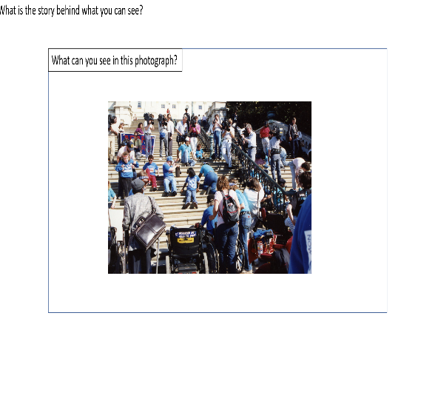
- Use the main photograph first and put in inside an inference diagram. You could ask students to identify what they can see. This means they will be practising their close observation of a source. You could then ask them what they need to know to make sense of the image.
- You could then tell students the ‘What is happening in the picture?’ story, or give them the text to read. Students could then link what they have seen in the image to the historical context. This enables students to practise using a source as evidence by setting it in its historical context.
- Working with the back story, students could design avatars to represent each of the three causes that historians feel are important. They could then summarise each cause in a single sentence by its avatar.
- Students could write a paragraph to summarise their answer to the question.
- You could add a citizenship angle to this by challenging students to take note of all the evidence around them of responses to the legislation to make society more accessible to people with disabilities.
- Finally, slot-ins always have an ‘over to you’ section. These are to encourage students that learning is ongoing and something that they should be taking responsibility for.
Misconceptions to dispel
Students, understandably, often take for granted that the world around them is as it has always been. This slot-in should help to dispel the misconception that people with disabilities have always been regarded as full citizens. At the same time, many people with disabilities feel that their campaign for equal rights is ongoing. Students should also reflect that change for minority groups does not just ‘happen’. Years of campaigning to change attitudes are often involved, at great cost to the people involved in campaigning, even when the conditions are favourable for change.
Extra background for teachers
The history of disability is rarely taught in schools and not much taught in universities. However, it is a growing area of research. European attitudes to disability changed fundamentally in the period following the Reformation. While societies in the Middle Ages had associated disability with the Devil’s work, the need to ‘save one’s soul’ by being good to the poor had resulted in a social contract where the giver also gained from help and support given to a person with disabilities. The ideas of philosophers about the mind and body, principally Descartes, resulted in a shift in attitudes to see the person with disabilities as someone who was a less than perfect human. The industrial age saw an even greater shift to the idea of the machine-like qualities of a human, with ‘weaknesses’ to be ‘improved’. At the same time, increasing numbers of people began to work outside the home to timetables and demands set by others. All of these changes served to demean and alienate disability from the ideal of human society. As stated in the back story text for students, attitudes began to change as a result of the World Wars and the assertion of Human Rights in the 20th century. 1980 as ‘The United Nations Year of Disability’ was another turning point moment in the recent past, both in terms of the protests that it sparked and the focus that it gave upon issues.
Where to link to
The Open University has a learning disability history site. The National Archives, Historic England and Scope also have good resources on the history of disabilities. Every year there is a Disability History month in the UK.

