Why might Tudor kings and queens have taken advice from fools?
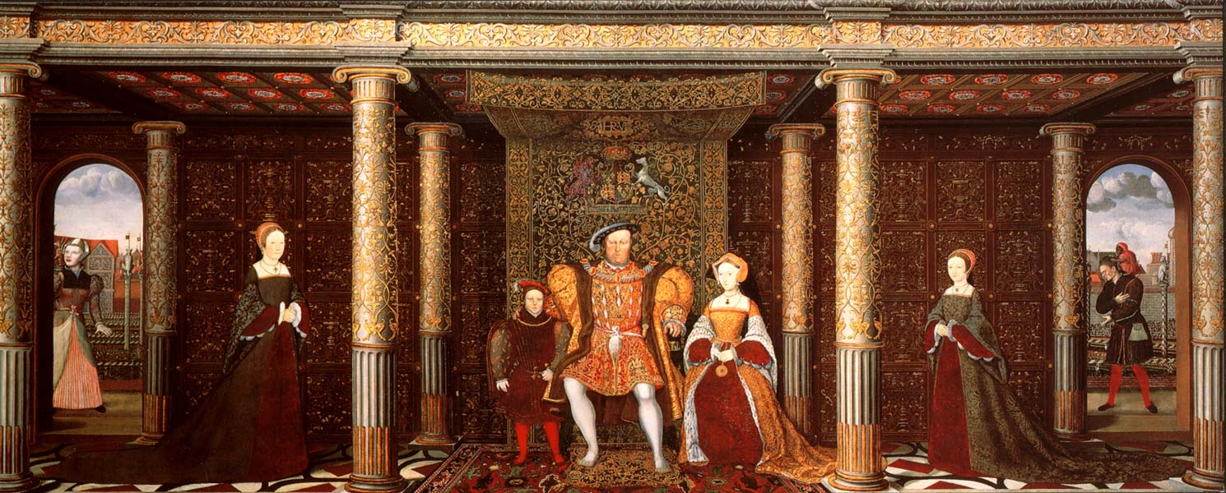

What do these pictures reveal?
This image appears in classrooms and textbooks around the country. Yet we rarely notice the two characters hidden at the back of the picture. They are clearly important enough to the Tudors to appear in this painting of the family. But who are they and what was their relationship to the Tudors?
On the left-hand side is a woman who appears to be bald and who has a confused expression. She is thought to be ‘Jane the fool’ who had originally ‘belonged’ to Anne Boleyn and then was passed to Mary Tudor and finally to Katherine Parr. Jane was probably what the Tudors termed a ‘natural fool’. Today we would describe Jane as a person with learning disabilities. On the right of the picture is another fool. This man is believed to be Will Somers who enjoyed a close relationship with Henry throughout the King’s reign. Will is pictured with his pet monkey who is picking lice from Will’s head. Will is also believed to have been a natural fool who made Henry laugh and offered him truthful observations when nobody else dared to do so. Both Will and Jane were given an allowance for clothing and care. Their heads were shaved to show they had the job of court jester. We know that, as Henry grew older, and became more and more bad tempered as the result of the pain in his ulcerous leg, he relied more and more on Will to make him laugh.

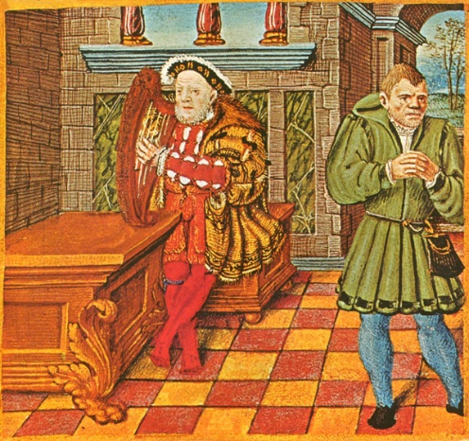
This image shows an aged King Henry with only Will for company. Clearly, the fools were a very important part of the Tudor household. They seem to have been exempt from punishment, however outrageous their behaviour. (Henry probably only threatened to kill Will once - when he was rude to Anne Boleyn!) What does the Tudors’ relationship with their fools reveal about their attitudes to people with learning disability? Firstly, it shows that the Tudors recognised that some people had learning disabilities and were beginning to categorise types of disability. Jane and Will are described as natural fools suggesting they were born with their disabilities. It also reveals that people with learning disabilities were integrated into society rather than shut away. It seems that the kings and queens used the fools for companionship. They were established members of the household and continued to be cared for despite a change of king or queen. It seems that the natural fool had the ability to speak the truth to the monarch in a way that other people could not. Perhaps this was refreshing in a court full of people trying to flatter to win favour. The fools were probably thought to be innocent, childlike and therefore closer to God than others.

THINK!
- How many reasons connected to the question can you find in the text above?
- How does the writer make it clear that she is not certain that some of the ideas she suggests are true?

OVER TO YOU!
A historian called Suzannah Lipscomb has written an article called ‘All the King’s Fools’ about the role of Will Somers. You can find it online. There is also more you can read about Will Somers on a blog called ‘timesofthetudors’. You could also search for other portraits of Tudor fools that still exist. The picture at the start of this enquiry is in the Royal Collection. You can see it if you visit Hampton Court Palace near London.
Teacher notes: ‘Why might Tudor kings and queens have taken advice from fools?’
What is a slot-in?
A slot-in is a short story from the past that is rich in historical concepts. You can use a slot-in as part of a longer sequence, or as cover work, or in those moments where you need something short.
The concept focus of this enquiry
The enquiry question here is: ‘Why might Tudor kings and queens have taken advice from fools?’ This slot in is written to make it clear to students that images from the past can reveal evidence useful to historians. This evidence may not be obvious in an image and may require contextual knowledge in order to understand it. The image will enrich students’ sense of period relating to the Tudor Court. At the same time, it is written to make explicit the tentative language that historians use to make explicit when they are inferring and making hypotheses that may be contested. It is also written in a way that shows students how to suggest reasons relating to the question.
Curriculum links
We have a duty to reflect the past of diverse people in our history curriculum. We also have such a restricted amount of curriculum time to teach a large amount of past. This story could be slotted-in to your curriculum as part of a sequence on:
• the Tudors,
• using artworks as evidence,
• British monarchs,
Activity Suggestions
You might just want students to read this story, make a connection to a wider topic and move on. However, you might decide to use this material for a whole lesson with activities.
You could:
- Print out copies of smaller versions of the royal portrait. Start by asking students to label and identify the individuals in the painting. Hopefully you will start to get questions about the individuals in the back of the portrait. Discuss what is curious about their depiction, how are they portrayed differently from the royal family? Students may suggest that they are more animated and show more expression.
- Reveal who the characters are. Ask students to write down three questions they would like to know. At this point you can share the information above and see how many questions the students can answer.
- Next discuss wider questions as a class:
  - What does the presence of fools tell us about Tudor attitudes to disability? Draw out if they were positive or negative.
  - Ask students if we would be surprised if the Queen used a fool today? If we would be surprised what does that tell us about how attitudes to people with learning disabilities have changed?
  - Why do we think the Tudors kept fools? What does this reveal about the loneliness of kingship?
- If this slot in is part of a sequence of lessons on Henry VIII, you could then ask students to compare images of Henry over his lifetime. The image of Henry and Will Somers near the end of his life contrasts well with the image of Henry in his prime. You could ask students to arrange a series of images of Henry onto a timeline and use their historical knowledge to add captions and events.
- You could also use this picture as part of a mini thematic on attitudes to disability over time. This has been created and can be found on the www.yorkclio.wordpress.com site.
Misconceptions to dispel
Attitudes to disability have not been constant across time. Students might also assume that Tudor society would have been crueller to people of disability than today. The reality is more complex. Particularly, in the early part of the period, there was still a strong sense that the privileged of society needed the disadvantaged in order to be able to treat them well so that they would earn their place in heaven. Remember that for Christians Jesus made it clear via the Bible that the poor were blessed.
Students may have picked up a clownish image of the fool from the representations they have seen. However, the Tudor fools seem to have had a different function. They spoke truths that would be unsayable by anyone else to their monarchs. You could say they ‘spoke truth to power’.
Extra background information
It is hard to understand why the Tudors would have allowed Will and Jane such intimate access to their lives. However, they clearly valued, liked and felt a strong loyalty to their fools. The fool’s position in society seems to have been elevated as a result of them being seen as more childlike and thus nearer to God. The fool was not corrupted with worldly cares and were therefore in a unique position to speak the truth.
Where to link to?
Historic England has published materials on its website about disability and the Tudor Court. This includes the work of the historian Suzannah Lipscomb.

