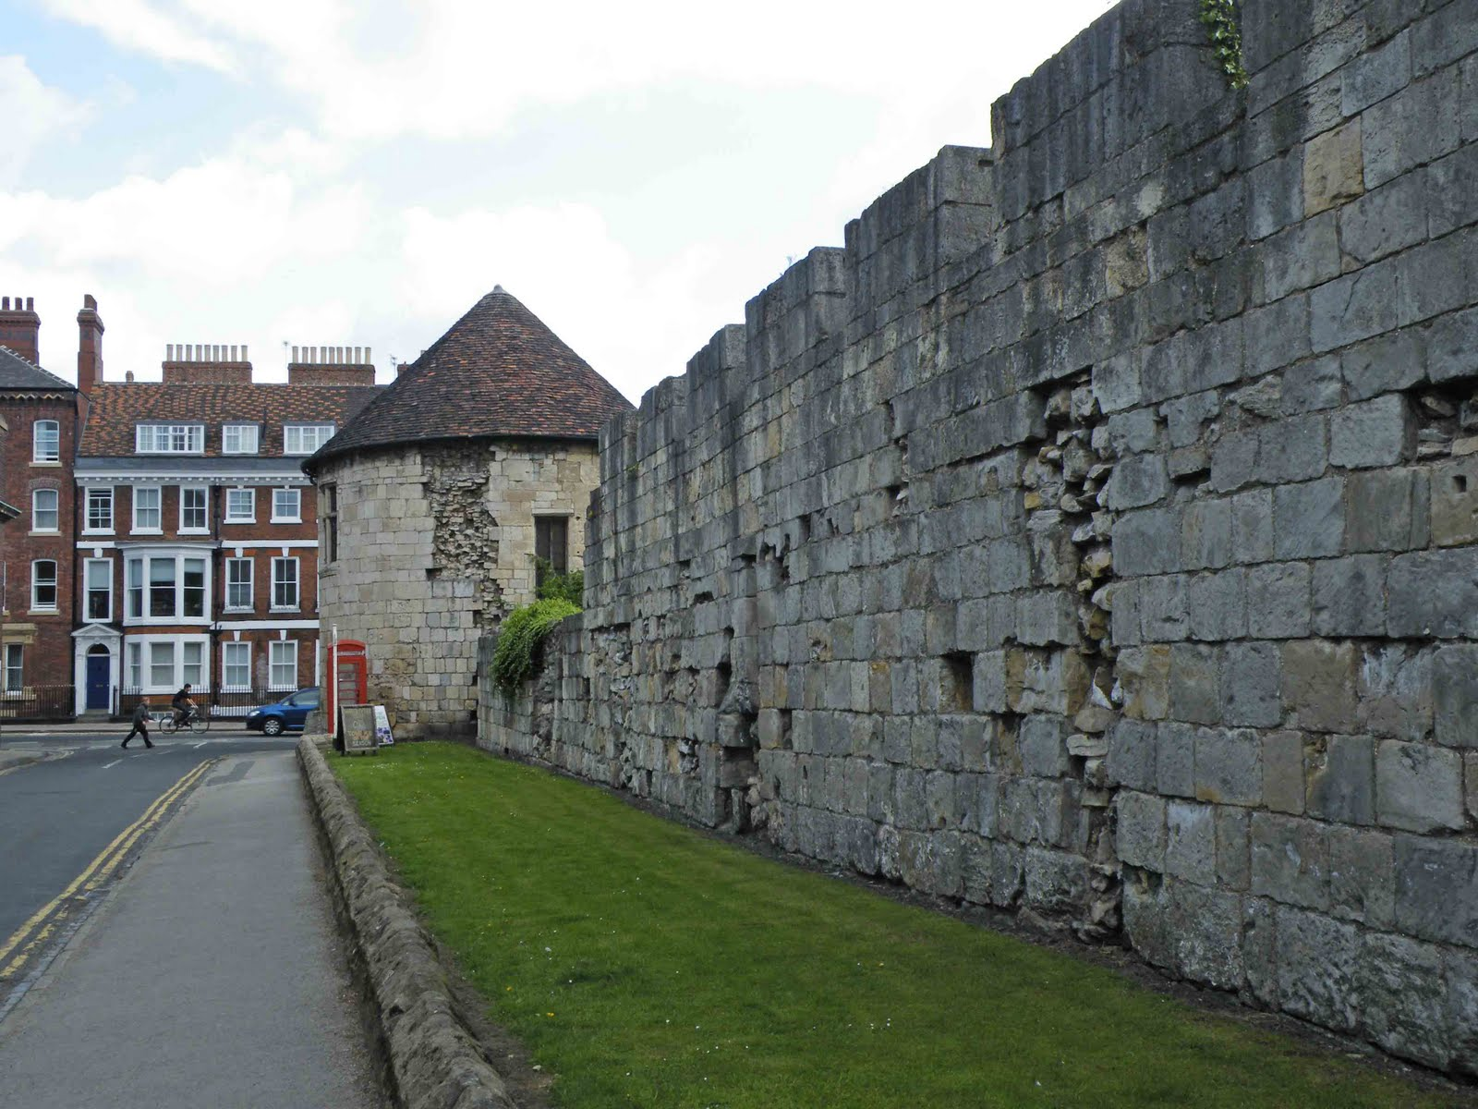
What is the story behind the damage to York’s Walls?
What do you notice in this photograph?
Study this photograph very carefully. It shows a section of the city walls in York and St Mary’s Tower. What words and phrases can you use to describe what you can see?
What happened to this section of the Walls?
The damage you can see in the stonework of the wall and tower happened during the English Civil War. In 1644 the Royalists supporting King Charles I were defending York against the Parliamentarians. This was a siege. The guns of the attackers damaged the City Walls. Parliament’s soldiers put a mine under St Mary’s Tower. The mine exploded under the foundations and it was almost totally destroyed. That left a gap in the walls and the Parliamentary soldiers were able to fight their way into the city. They got to King’s Manor before they were pushed back by the royalist soldiers of the King. Many were injured and killed. The Tower was quickly rebuilt with thinner walls and was not rebuilt very well.
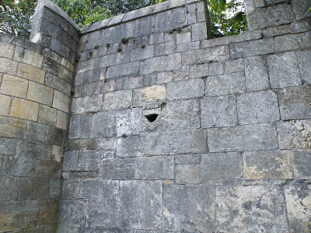
In this smaller photograph you can see a gun loop. It was probably added in preparation for the 1644 siege of York. Gun loops would have been added to various parts of the city's walls, to enable the defenders to fire their muskets at the attacking soldiers.
What is the bigger story?
In 1642 a civil war broke out between King Charles I and his Royalist supporters and the supporters of Parliament on the other. People had to choose sides. The City of York was in the hands of supporters of the King and Charles lived in the city for a few months. The City Council had to sell the city’s silverware in order to help the King and life was hard. Things got worse. In April 1644 Parliament’s army put York under siege. Food in the city was rationed to preserve supplies. From June the Parliamentary army began to fire its canons at York and to destroy the suburbs. It was in the month of June that St Mary’s Tower was blown up. However, the city held on until the defeat of the army that was supposed to relieve York at the Battle of Marston Moor on the 2nd July 1644.
For the few days after the battle, wounded royalist soldiers made their way to York. Ordinary citizens took the change to escape. Shortly afterwards York surrendered to Parliament. Thomas Fairfax, leader of the Parliamentary Army, forbade his troops from destroying York’s churches. This is an important reason why York today has such a precious treasure of medieval stained-glass.
York remained in the hands of Parliament. King Charles was defeated and in January 1649 he was executed. England had no monarch for 11 years. Although King Charles II was restored in 1660, it was soon clear that Parliament was powerful. In 1688 James II, successor to Charles II, was forced out and replaced by King William II and Queen Mary because he would not rule with Parliament. The power of the monarch has declined ever since.
THINK!

- How are the York Walls evidence for the Civil War in the 17th century?
- How important do you think it is that people remember this past?
- How does knowing the historical context help you to appreciate the York Walls?

Over to you!

You can find out more about the stories behind York’s Walls or the English Civil War by searching for the history of York online. The BBC website is often a good place to start for basic historical information too.

Teacher notes: ‘What is the story behind the damage to York’s Walls?’
What is a slot-in?
A slot-in is a short story from the past that is rich in historical concepts. You can use a slot-in as part of a longer sequence, or as cover work, or in those moments where you need something short.
The concept focus of this enquiry
The enquiry question here is: ‘What is the story behind the damage to York’s Walls’ The concept focus is using sources as evidence. The York Walls can be used as evidence for the impact of the English Civil War. At the same time, knowing the historical context helps students to understand the Walls as a source of evidence. Both of these ideas are explored in this slot-in.
Curriculum links
This story could be slotted-in to your curriculum as part of a sequence on:
- local York history,
- the 17th century English Civil War,
- using source as evidence.

Activity suggestions
You might just want students to read this story, make a connection to a wider topic and move on. However, you might decide to use this material for a whole lesson with activities. You could:
- Print off copies of the picture at the top and ask students to write words and phrases around it to describe what they can see.
- Dramatically tell the story of the damage to the Tower during the failed foray by Parliament’s troops.
- Get students to research the impact of the Civil War on York to set the source in context.
- Practise a source question, such as ‘How useful as the York Walls for understanding the impact of the Civil War on the city?’

Misconceptions to dispel
The York Walls were much restored by the Victorians. Many of the ‘medieval’ features that we see today were created for early tourism to York.
The Walls never stretched all the way around the city. They are as complete as they ever were. They survived attempts to destroy them in the early 19th century and now make York one of the few cities in Europe with complete, surviving walls.

Extra background for teachers
In 2008 mass graves from the time of the Civil War was found outside Walmgate Bar. They contained the bones of 113 men. They seem to have been Parliamentarian soldiers and they probably died from typhus fever. Records show that Lord Fairfax’s men were camped in the area at the time. The bones of the men show that their diet contained a lot of seafood. It is known that many of Fairfax’s men were from Hull.
Right up until the end of the 19th century, more British men died of disease during times of war, than died as a result of fighting. Laying siege to a city would have involved men living in rough conditions that were ripe for the spread of infectious disease.
The Parliamentary army set up canon on Lamel Hill close to where the University of York now stands. There was damage to the Walls on this eastern side of the city, which was also later repaired.
The English Civil War marks the last time when York’s Walls were used for defence. By the later 18th century they were in disrepair and their were calls to tear them down. A campaign to save them was launched, but not before three of the barbicans on three of the four major gateways were lost.
Today York’s Walls are a Grade 1 listed building and a major tourist attraction.

Where to link to
There is a useful website for all things from this period called stuartsonline. The National Archives also has a section on the English Civil War.

