Why have York’s City Walls survived?
York City Walls used to mark the boundary of the city and the start of its authority. They provided defence and they were used to collect tax from people coming in to sell goods at York markets. However, by the end of the 17th century the Walls were no longer needed for any of these purposes. They began to crumble and people began to talk about getting rid of them. Most city’s in England had walls. Most got rid of their walls. Why have York’s Walls survived?
The City Council wanted to get rid of them
In 1800 the City Corporation (as the Council was called then) decided that the Walls were costing too much money. They did not want to bear the expense of repairing them. Therefore they petitioned Parliament for permission to take them down. Parliament refused permission, not least because of opposition voiced by York Minster. However, in 1807 the Corporation announced its intention to destroy one of the smaller towers, Skeldergate Postern. The Archbishop of York disagreed with this decision. He took the Corporation to court, claiming that he would not be able to collect his tolls (a tax) at the time of the annual fair. He won his case, but then be died and the Corporation removed the Postern in 1808.
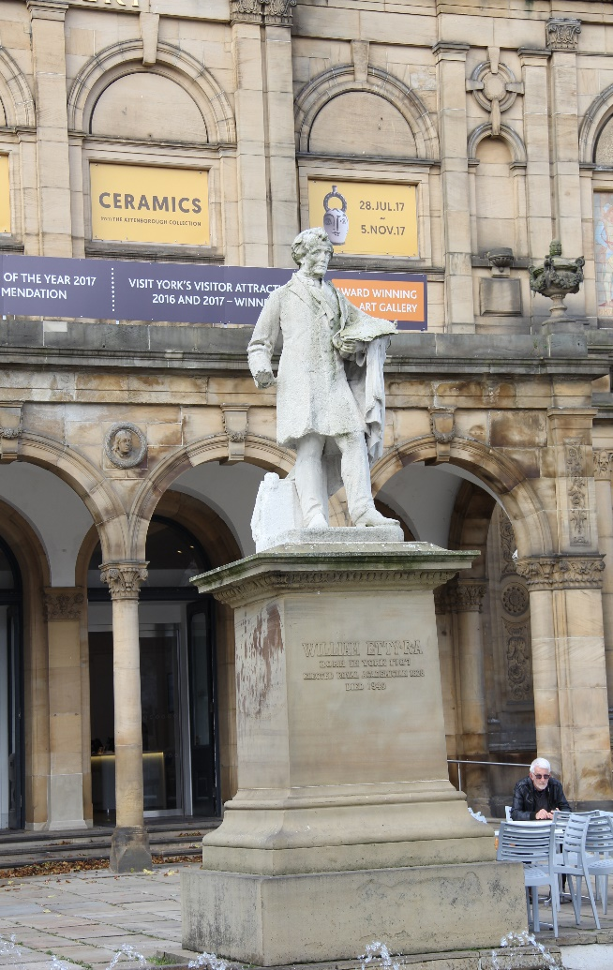
Another legal case was brought against the Corporation in 1811 to try to get them to stop demolition. By this time they had also taken part of the barbican off the front of Micklegate Bar. They said it was a health and safety hazard. The population of the city was rising rapidly and the city centre was becoming cramped and dangerous. Locals used the Walls as a toilet and stole stone so that they were dangerously unstable too. Stagecoaches could not easily get through the bars (gateways) and so York was losing trade as a valuable stopping off point on the road between London and Edinburgh.
A public campaign to save the Walls was launched in 1824. It got the support of local newspapers. However, by 1826 three of the barbicans of the four major gateways and two other postern towers had been demolished. A local artist of national fame joined the campaign. His name was William Etty. (The picture is of his statue is outside York Art Gallery). He wrote to the local newspapers arguing to save the Walls and he gave money to the campaigns to save them. He also encouraged his influential friends to get involved in the campaign.
Local people were divided on the issue. Some of them wanted to keep the Walls as they were already attracting tourists to York. Others felt that their businesses were being hampered by the difficulty they caused for people trying to get into and out of the city.
In 1838, despite Etty’s protests, two large arches were cut through to allow the trains of the York and North Midland Railway Company to access a station inside the Walls. A new station was soon built outside remain, but the two arches remain to this day.
Public opinion changed
The first comprehensive plan for the Walls restoration had been drawn up by the York Footpath Association in 1829. York people donated money to restore the Walls and work began with the restoration of a section south of the river from North Street to Skeldergate postern.
Even so, by about 1855 the Local Board of Health was demanding the removal of the Walmgate walls on the grounds of hygiene problems. By this time, public opinion was firmly behind keeping the Walls and the Corporation rejected the idea and instead set about repairing this section.
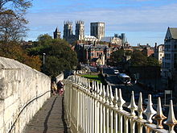
The section between Layerthorpe Postern and Monk Bar was then restored between 1871-72. The final section was restored at the end of the 1880s and since then the whole circuit of the walls has been maintained by the council as a public walk.
Today York Walls are a Grade 1 listed building and a major tourist attraction. They give great views, including of York Minster. It is now unimaginable that they would be demolished.
THINK!

- How many different reasons can you find to explain why York Walls survived?
- What do you think was the role of each of the causes in the survival of the Walls?

Over to you!
If you are lucky enough to live in York, why not walk the Walls one weekend?

Teacher notes: ‘Why have York’s City Walls survived?’
What is a slot-in?
A slot-in is a short story from the past that is rich in historical concepts. You can use a slot-in as part of a longer sequence, or as cover work, or in those moments where you need something short.
The concept focus of this enquiry
The enquiry question here is: ‘Why have York’s City Walls survived?’ The concept focus is causation. The York Walls survived for many reasons. The students should be able to identify these within the text. They include the actions of individuals, the rise of tourism, the changing of public opinion, the actions of Parliament and the raising of money via campaigning.
Curriculum links
This story could be slotted-in to your curriculum as part of a sequence on:
- local York history,
- the industrial revolution

Activity suggestions
You might just want students to read this story, make a connection to a wider topic and move on. However, you might decide to use this material for a whole lesson with activities. You could:
- Print off maps of York and the Walls at different stages in history and get students to identify the places and problems being mentioned in the text.
- Help students to set the story in its wider context by providing them with more information about York in the 19th century, for example about George Hudson and the rise of the railways, about York as a social centre and about the development of the chocolate industry.
- Develop a role play of a meeting of the City Corporation where students take the parts of citizens discussing the pros and cons of demolishing the Walls.
- Use the story as a model for looking at how historians talk about causes.

Misconceptions to dispel
Historians do not rank causes. Questions such as ‘which was the most important reason?’ are very hard to answer if you set about asking students to rank causes. How will they make a reasoned decision? A more helpful approach is to encourage students to develop language with which to describe the role of causes and how they inter-relate to cause change.
Where to link to
For help with teaching causation read Teaching History and follow the YorkClio blog.

