What different stories could the York Walls Red Tower tell?

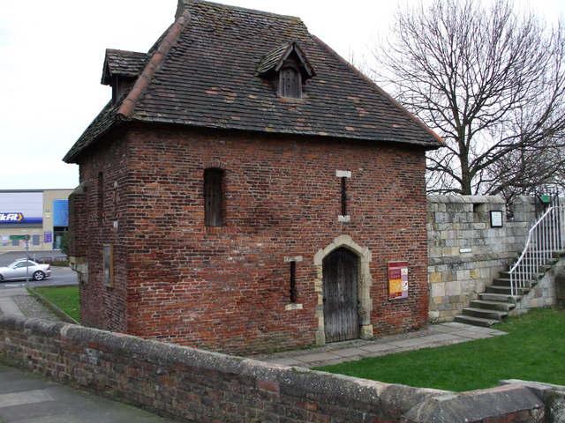
What is the Red Tower?
The picture shows the Red Tower. It is part of the York Walls and dates back to 1490. It is unusual because it is the only brick built tower on the medieval city walls. It was a watchtower built to defend the city at the time of Kings Richard III and Henry VII. It is actually built of stone below ground level and it used to have a flat lead roof and battlements so that a watch could be kept on the surrounding area. The Victorians made it look as it is today.

What happened as a result of the building of the Tower in brick?
The City Corporation of York decided that they could not afford to build the tower in stone. Instead they asked the local guild of Tilers (roofers and bricklayers) to build it. This made the Masons’ Guild very angry. They controlled all stone work in York. The rest of the York Walls were built of stone. A vicious feud began between the two guilds. The tilers complained that there their tools were being broken and stolen and they asked for protection from the Corporation.
In 1491, a tiler named John Patrick was murdered. Two masons were charged with his murder. One was a leading official of the Masons’ Guild, William Hindley. He was arrested and put in prison. However, he seems to have been totally unashamed about this. It is reported that he employed a man to shout news of his imprisonment through the streets of York, so that all who had business with him should know where to find him. The other mason charged was Christopher Horner. It seems that he could not be arrested by the city authorities because he stayed in the Minster area, which was controlled by the archbishop.
Neither Hindley nor Horner was convicted of the murder. The masons probably had so much influence in the city that they were able to protect the men. The tilers were not so powerful. They did finish the Red Tower but no other brick towers were built.

How many different ways has the Tower been used?
In 1644 the Royalists in the City of York were attacked by Parliament’s Army. This is known as the Siege of York. The Red Tower was needed as a watch tower by the Royalist defenders. The Parliamentarians had a canon on Lamel Hill, close to where the University is now to be found. Much damage was caused to the Red Tower and to the walls next to it. When Parliament defeated the Royalists and took over York, they repaired the Tower and made the Royalists pay for the repairs.
However, by 1776 the Red Tower was in ruins, with one wall missing and no roof. It must have been repaired to some extent as we know that in 1800 it was being rented as a stable. At this time it was known locally as the ‘Brimstone Tower’. Brimstone is used in gunpowder and perhaps this had been stored or made there at some time in the past.
The King’s Fishpool was filled in in 1854 and Foss Islands Road was built in the next few years. The Red Tower was restored in 1857-58 by an architect who made it look as it does today. He even put in the ‘arrow-slit’ windows to make it look ‘medieval’.
In early January 2015, the Tower was taken over from the Friends of York Walls by a group of dedicated volunteers and became known as the Red Tower Project, with a vision to bring it back into public use for the benefit of the local and wider community. Many locals and tourists enjoy a walk around the Walls and the Red Tower is one of the landmarks on that tour.

THINK!
- How many different uses has the Red Tower had?
- What do the different uses reveal about change over time in York?
- How could you argue that the Red Tower is important to the story of York?

Over to you!
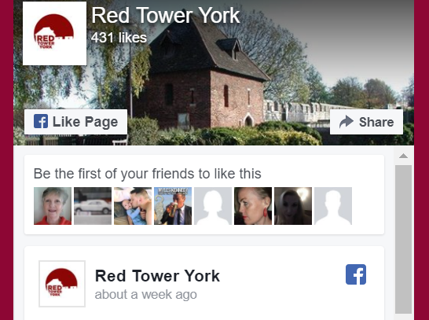
You can find out about the present work to build the future of the Red Tower online. If you are in York you can walk the Walls and you can take part in one of the local events that are organised by the Red Tower team. There are more stories yet to be told!

Teacher notes: ‘What different stories could the York Walls Red Tower tell?’
What is a slot-in?
A slot-in is a short story from the past that is rich in historical concepts. You can use a slot-in as part of a longer sequence, or as cover work, or in those moments where you need something short.
The concept focus of this enquiry
The enquiry question here is: ‘What different stories could the York Walls Red Tower tell?’ The concept focus is change over time. The Red Tower has changed in both appearance and use since it was first built in about 1490. It remains important to the City of York, but for different reasons than were originally intended. Some of the stories from the past contribute to its present role as a community project and tourist attraction.
Curriculum links
This story could be slotted-in to your curriculum as part of a sequence on:
- local York history,
- medieval life,
- the changing historic environment.
Activity suggestions
You might just want students to read this story, make a connection to a wider topic and move on. However, you might decide to use this material for a whole lesson with activities. You could:
- Use the story of the tiler’s murder as a ‘hook’ to engage students with the Red Tower.
- Ask students to design a timeline to describe the changing uses of the Tower over time.
- Get students to do some further research about York at key moments in the history of the Tower.
- Students could design a guide to the Tower for primary school children
Misconceptions to dispel
The Red Tower, and indeed all of the Walls, are much restored by the Victorians. Many of the ‘medieval’ features that we see today were created for early tourism to York.
The Walls never stretched all the way around the city. They are as complete as they ever were. They survived attempts to destroy them in the early 19th century and now make York one of the few cities in Europe with complete, surviving walls.

Extra background for teachers
In 1068, William the Conqueror dammed the river Foss at Fishergate in York. This provided a moat for his new castle and a lake called the ‘King’s Fishpool’. It provided defence and meant that walls were not so necessary on this side of the city. The Red Tower is at the end of a stretch of walls that then restarts at Jewbury, past Layerthorpe Bridge.
The alleged murderer, William Hindley, was the master mason at York Minster at the time. He was responsible for the great screen of statues of the kings of England that is still there today.
There were many guilds in York in the Middle Ages. Each one represented a trade and was responsible for protecting the rights of its members. For example, only members of the stonemasons’ guild were allowed to work as stonemasons in the city. The larger guilds had halls. Some of these survive, for example the hall of the Merchant Adventurers’. (They also still exist as a guild.) The 15th century York Guildhall was a meeting place of all the guilds and housed part of York City Council until the start of the 21st century. The guilds of York also presented the Mystery Plays on wagons around the city on Corpus Christi day. This tradition was at its height in the 15th century, survived the mid-16th century Reformation and was only halted after the Northern Rebellion of 1569.
The York Walls have a long history. They began as a rampart to defend the Roman legionary fortress and today they are a Grade 1 listed building.

Where to link to
You can find more links to York stories on the website of YorkClio.
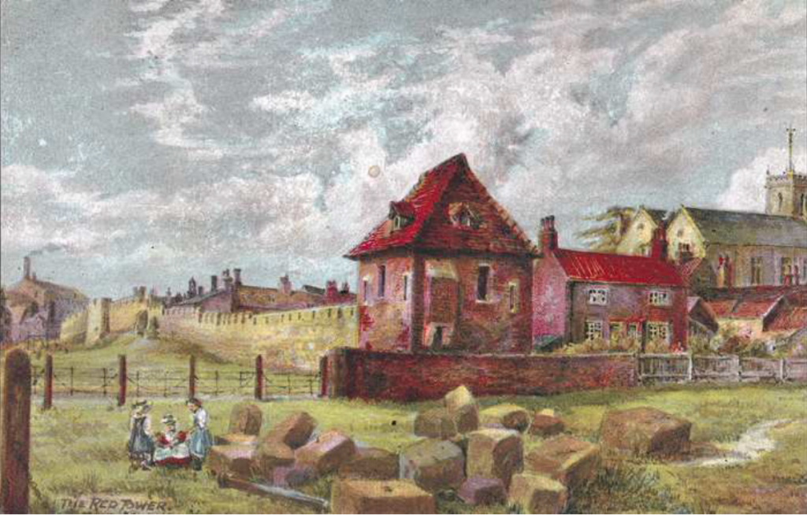Painting of Red Tower in 1860, by Edwin Risdale-Tate (1906).

