What does the story of Benjamin Lay reveal about the early campaigners for the abolition of slavery?
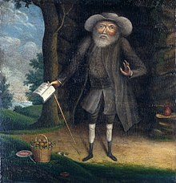
This is a picture of Benjamin Lay painted by William Williams in 1750. He was born in Essex in England in 1682. His family were Christians called Quakers. He was a person with dwarfism and was abused and manhandled because of this. As a child he was shepherd. Then his father apprenticed him to a glove-maker. He didn’t like that and so made his way to London and became a sailor. In 1718 he moved to Barbados and later in his life to Philadephia, USA. He married a woman with dwarfism. He died there in 1759, aged 77, and was buried in an unmarked grave. This was the Quaker custom at the time.
THINK! Paintings were expensive in the 18th century. How does what you have just read make it surprising that a painting was made of Benjamin Lay?
How did Benjamin Lay gain the nickname the ‘Quaker Comet’?
Benjamin Lay was a troublemaker for positive change! He was inspired by how early Quakers had stood up for their beliefs against powerful people. He suffered himself because of his dwarfism. His life at sea and in sea-ports had led him to see slavery and the slave-trade at first-hand. Benjamin was horrified that slavery existed. He was angry at how enslaved people were treated. He believed this was totally against Christian values.
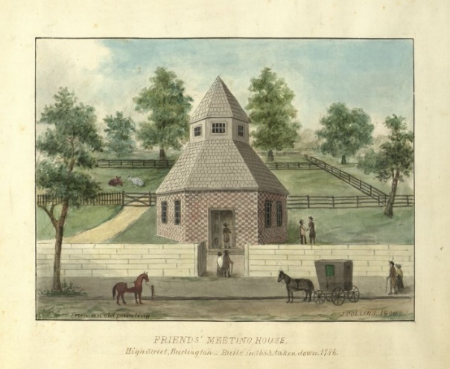
At the time most people disagreed with Benjamin Lay. They simply did not see that owning other people as property was wrong. Even the Quakers at this time saw no problem with slavery. The Quakers were to become hugely important in the story of the abolition of slavery and the slave trade by the later 18th Century, but at the time of Benjamin Lay some of them even owned slaves themselves. Benjamin was determined to shock them into realising what they were doing was wrong with startling tactics.
On the 19th September 1738, he attended a Quaker Meeting for Worship at Burlington, New Jersey. Benjamin knew there were slave-owning Quakers at the Meeting. He was wearing a large coat. Beneath his coat he had hidden a military uniform, a sword and a hollowed-out book with a secret compartment. In the secret compartment was an animal bladder ﬁlled with bright red juice. In the silence of the Meeting he stood up and spoke in a loud voice that slave keeping was the greatest sin in the world. He threw off his coat, revealing the uniform, the book and the sword. To a shocked Meeting he shouted: “Thus shall God shed the blood of those persons who enslave their fellow creatures.” Then he plunged the sword through the book. The secret bladder of juice was punctured and blood-like liquid gushed out. People gasped and people fainted as Benjamin foretold death for Quakers who did not reform and turn against slavery. Having made his point, Benjamin did not resist as he was carried from the building.
What happened next?
Despite being disowned by the Quakers in Philadelphia, Benjamin Lay did not back down. He had taken up the work of a Quaker man called Robert Sandiford, who had died young after also being disowned by the Quakers for his anti-slavery views. He spent the next 25 years campaigning in a similar style, with tactics such as throwing tobacco pipes at Quaker worshippers, disrupting meetings with shouting and writing a book of his views. Slave-owners to him were ‘man-stealers’ and ‘sons of the devil’. His confrontational methods made people talk: about him, his ideas, the nature of Quakerism and Christianity, and, most of all, slavery.
Meanwhile, Benjamin lived simply and started his own farm, making his own clothes and eating as a strict vegetarian. By 1758 he was 76 and in poor health when he received the news that the Quakers in the USA had started to discipline and disown Quakers who traded slaves. Slaveholding itself was still to be permitted by Quakers, but this was a step forward. Benjamin Lay died the following year. 18 years later Quakers also banned slave-owning among their members and engaged in a long campaign for its total abolition from society.
THINK!
- How much courage do you think it took for Benjamin Lay to take a stand against what most people believed in his time?
- Where do you think this courage came from?
- What tactics did Benjamin use to try to change people’s minds?
- What do you think most of us accept without question today that people in the future may look back upon and ask: ‘How could they have thought that was right?’
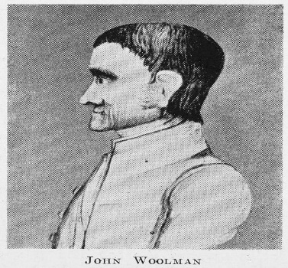
Over to you!
John Woolman was a Quaker from Philadelphia who lived a little later than Benjamin Lay. He also campaigned for his fellow US Quakers to abandon owning slaves. He died in York in the UK.
- Can you find out why, and what he was in York to do?

Teacher notes: ‘What does the story of Benjamin Lay reveal about the early campaigners for the abolition of slavery?’
What is a slot-in?
A slot-in is a short story from the past that is rich in historical concepts. You can use a slot-in as part of a longer sequence, or as cover work, or in those moments where you need something short.
The concept focus of this enquiry
The enquiry question here is: ‘What does the story of Benjamin Lay reveal about the early campaigners for the abolition of slavery?’ The story the students will read is written to show the inspiration and motivations behind a radical campaign for change. Individuals who campaign for change are often vilified at first and change can take many years to achieve.
The story of abolition is often told in the UK through the story of William Wilberforce. However, he only became part of the campaign after it had already gained a wide following. Benjamin Lay is so early in the story of abolition that he laboured to convert other Quakers to the abolition cause. Later in the story of abolition the Quakers became crucial to its success. Benjamin’s story allows a longer view of a complex and lengthy campaign. This abolition campaign makes an excellent study of causation at Key Stage 3. It also has modern resonance with campaigns for change in the 21st century. Students can identify similar ingredients to successful campaigns today: motivating and inspired individuals, shocking evidence, mass support, boycotts of goods, badges of support, and more… In addition, this story makes clear the close links between slavery in North America and Britain’s involvement. At the time of Benjamin Lay the USA did not exist. Even after independence, the trade between the UK and the USA was crucial to the growth of Britain’s Empire. Even after Britain abolished slavery in its own territories, the industrial northern mills were working with slave cotton from the southern USA.
Benjamin Lay was a man with dwarfism. He suffered abuse and manhandling all his life because of this condition. Horrors such as ‘midget villages’ and putting people on show were common practice at the time.
Curriculum links
We have a duty to reflect the past of diverse people in our history curriculum. We also have such a restricted amount of curriculum time to teach a large amount of past. This story could be slotted-in to your curriculum as part of a sequence on:
- Slavery and its abolition,
- The development of the British Empire,
- People and protest through time.

Activity suggestions
You might just want students to read this story, make a connection to a wider topic and move on. However, you might decide to use this material for most of a lesson with activities. You could:
- Use the first part of the ‘slot in’ with the ‘Think!’ as a starter activity
- Students could then put the sub-title ‘Benjamin Lay’ and collect evidence from the text under 4 headings: Personal Qualities, Inspiration, Tactics, Achievements.
- You could then focus on Benjamin Lay as a person with dwarfism. At the time, people with dwarfism were often regarded as curiosities and freaks. Ask students how this knowledge deepens their understanding of his story.
- You could then tell students that the British slave trade was abolished in 1807 and that slavery was made unlawful in British areas of control in 1833 and in the USA in 1865.
- With this information, ask students to read the text again and to come up with questions they would like answering. You can then take these student generated enquiries and explore the history of abolition.
- Finally, slot-ins always have an ‘over to you’ section. These are to encourage students that learning is ongoing and something that they should be taking responsibility for.
Misconceptions to dispel
Change does not just ‘happen’. Years of campaigning to change attitudes are often involved, at great cost to the people involved in campaigning.
Extra background for teachers
The Quakers still exist today. They began as a Christian group who gathered around a man called George Fox. The year was 1652. Three years before, King Charles I had been executed and many radical groups sprang up in the Commonwealth and Protectorate period as a result of the ferment of ideas. Quakers meet in silent worship and anyone in the meeting may feel moved to give spoken ministry. They believe in that of God in everyone and in the UK do not have a set creed or ministers. To ‘let their lives speak’ they try to live simply and in a sustainable way that nurtures peace, equality and trust.
Where to link to
An excellent narrative history of the campaign to abolish the British slave trade and slavery is ‘Bury the Chains’ by Adam Hochschild. Likewise, an excellent biography is ‘The Fearless Benjamin Lay’ by Marcus Rediker. An important read as to why Benjamin Lay’s dwarfism must be kept central to his story is here: http://www.beaconbroadside.com/broadside/2018/04/the-fearless-benjamin-layactivist-abolitionist-dwarf-person.html

