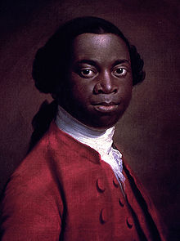
What does Olaudah Equiano’s story reveal about the role of black people in the campaign for the abolition of slavery?
How was Olaudah Equiano made a slave?
Equiano was a former enslaved black person who bought his freedom. In his autobiography Equiano states that he was born in modern day Nigeria (then the kingdom of Benin). He describes his father as having a powerful position in the village and also as an owner of enslaved people. When he was about 11 years’ old Equiano says he was kidnapped and was walked to the coast. Here he was taken by slave ship to Barbados. After arriving in Barbados, Equiano was sent to the English colony of Virginia.
What was Olaudah Equiano’s early experience of slavery?
He was purchased by a naval Captain in 1754 and given the new name Gustavus Vassa (after a king of Sweden). This was the third name Equiano had been given since being captured. On the slave ship he had been called Michael and his first owner had named him Jacob. At first, Equiano refused to answer to the name Gustavas Vassa , but after beatings, he eventually accepted it. He used this name for the rest of his life, except when he wrote his autobiography. For that he used his original name, Olaudah Equiano.
Equiano was forced to work on the British ships. In this period Britain was fighting the Seven Years’ War. (The Seven Years’ War was a global conflict between every Great European Power of the time. Some historians have suggested that it was the first truly ‘world’ war.) Equiano would have witnessed, and fought in, many battles at sea. His job was to haul the gunpowder to the gun decks. In the late 1750s Equiano was sent to England where he was taught to read, write and understand mathematics. He converted to Christianity and was baptised.
THINK!
- Equiano’s name was frequently changed. What effect would this have had on his sense of identity?
- Equiano was taught to read and write. Does this surprise you?
- Equiano converted to Christianity. Why might this have helped him in his struggle to become free from slavery?
How did Olaudah Equiano buy his freedom?
Equiano was returned to the Caribbean in 1762 and worked for Robert King, an American Quaker merchant from Philadelphia. King promised that if Equiano earned £40 he could buy his freedom. In his job Equiano witnessed the poor treatment of enslaved people.
“I used frequently to have different cargoes of new negroes in my care for sale; and it was almost a constant practice with our clerks, and other whites , to commit violent depredations on the chastity (sexual assault) of the female slaves; and these I was, though with reluctance, obliged to submit to at all times, being unable to help them.”
Robert King continued Equiano’s education by helping him read and write more fluently. Equiano began to make money by doing his own trading. With King’s permission, Equiano sold glass tumblers and other items and was allowed to keep the profits. By 1766 he had made enough money to buy his freedom. King urged Equiano to stay on as a partner with him, but Equiano felt that the risk of being re-enslaved was too great in the British colonies.
THINK!
- Robert King was a Quaker. In 1758 the Quakers in the USA had stated that they did not approve of Quakers trading slaves. 10 years after Equiano was given his freedom Quakers banned all slave owning amongst Quaker members. What does this reveal about changing attitudes to slave owning?
- Ask your teacher to tell you about Benjamin Lay the ‘Quaker comet’. How is he linked to Equiano’s story?
Equiano returned to Britain as a free man. He continued to work at sea, even travelling to the Arctic to find a Northern route to India. He also worked with Dr. Charles Irving to invent a process to distil sea water and made a fortune from this invention. The two men became friends and business partners. Irving also used Equiano’s expertise to try to set up a slave plantation in Central America.
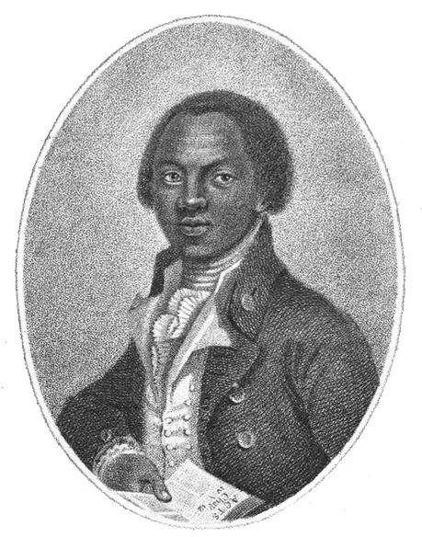
THINK!
- Discuss the activities Equiano was involved in after he had bought his freedom. Do you find these activities surprising?
In the 1780s Equiano became involved in the Abolitionist Movement. This was set up to try to end the trade in enslaved people. Equiano’s fellow abolitionists encouraged him to write his life story. The resulting book was called ‘The Interesting Narrative of the Life of Olaudah Equiano, or Gustavus Vassa, the African’ and was published in 1789. It became a best seller and was translated into Russian, German and Dutch. It was also published in the USA. It was one of the first books narrating the experience of slavery from the African point of view. The book detailed the African ways of life, the terrible conditions on board the slave ships, and the brutality of life in the colonies.
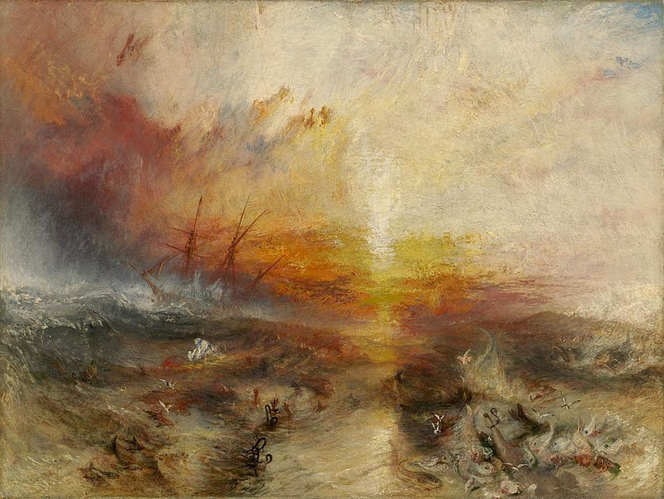
Equiano went on to work closely with Granville Sharp and drew the public’s attentions to the murder of enslaved people on the slave ship the Zong in 1783.
Equiano’s book became very popular and contributed to the abolition debate. Equiano became very wealthy as a result. In 1792, he married an Englishwoman called Susan Cullen. They had two daughters. Equiano died in 1797. His death was reported in the national newspapers. Only one of his daughter’s survived him and she inherited £950 from her father’s estate. This was a considerable sum at the time.
JM Turner’s painting of the Zong.
How do we remember Equiano?
Equiano’s story was forgotten for a long time. It wasn’t until the 1960s that Equiano’s story was re-discovered. The historian Carretta has questioned whether Equiano was really born in Benin, as in two documents he is listed as being from South Carolina. Caretta suggested that Equiano may have made up the accounts of Africa based on his knowledge from other enslaved people’s experiences. However, other historians, such as Hochschild, point out that the rest of the autobiography is ‘scrupulously accurate’ and this suggests that Equiano is an extremely truthful narrator.
THINK
- What effect did the publication of Equiano’s autobiography have?
- Does it matter if Equiano was not born in Africa?
- What does Equiano’s life reveal about the experience of being a free black person in Britain at the end of the 18th Century?
- Can you summarise how Equiano’s significance to the story of slavery and its abolition has changed over time?
- Why do you think Equiano’s story is remembered today but forgotten before the 1960’s?
Over to you!
Why not do some internet research about other black people who were part of the slavery abolition movement?
Teacher Notes
What is a slot in?
A slot-in is a short story from the past that is rich in historical concepts. You can use a slot-in as part of a longer sequence, or as cover work, or in those moments when you need something short. A slot-in in an excellent way of adding diversity to your lessons.
The concept focus of this enquiry:
The enquiry question here is: ‘What does Olaudah Equiano’s story reveal about the role of black people in the campaign for the abolition of slavery? The story shows how Equiano was able to communicate the experience of being a slave through a powerfully written and best-selling first-hand account. His book made an important contribution to the campaign for the abolition of slavery. The story of the abolition of the slave trade is often told through the lens of the white campaigners such as Clarkson, Wilberforce and Sharpe. Frequently schools will only be able to spend one or two lessons on the topic. Equiano may be mentioned, but his role is reduced to simply publishing an autobiography.
The abolition campaign makes an excellent study of causation in Key Stage 3.
Equiano’s story is also useful to the History teacher in highlighting the role played by religion in bringing about the abolition of slavery. There is a nice link to another slot-in on the abolitionist Benjamin Lay. Lay was a Quaker dwarf who was responsible for challenging the Quaker community in Philadelphia to give up owning people as slaves. When we look at who granted Equiano his freedom we notice it is a Quaker who came from Philadelphia who was trading in the Caribbean. There is a good causal link to explore with students here, showing how changing values can be translated into practical action.
Giving students a rich sense of period
When we dig deeper we realise that Equiano’s story is far more complex than just sharing his life story. Equiano’s father was a slave owner. Equiano himself helped buy people as slaves with his business partner and friend. He served in the British navy and was involved in the action of the Seven Years’ War. He was a successful inventor and merchant and he wrote a highly praised autobiography, despite having received very little formal education. He was a successful immigrant to Britain who was respected by his peers. He had a mixed race marriage. All these facets of Equiano’s life enhance students’ understanding of period and show that 18th century society was far more complex than it first appears.
Use the story to challenge assumptions that all white people in the past were racist.
Equiano was sent to England to be educated and stayed with the sister-in-law of his owner. However, Equiano was still sold on when it suited his master. Yet, the relationship between Robert King and Equiano also had positive aspects. He allowed and enabled Equiano to earn money alongside his regular job and wanted him to become a partner in the business once he was freed. You could also point out the 10-year friendship and business partnership between Dr Charles Irving and Equiano.
Historical significance
Equiano’s story was largely forgotten until the 1960s. What changed? The 1960s were a time of democratisation in History. There was a new desire to investigate the pasts of diverse people. There were new universities. There were newly independent African countries joining the United Nations. Historians started paying more attention to first-hand accounts and other source material that revealed the pasts of diverse people. Equiano’s story provides us with a rare first hand testimony of living through slavery. Society has also changed and we are increasingly uncomfortable about telling a narrative of the abolition of slavery without reference to black campaigners such as Equiano and Mary Prince. What does the revival of Equiano’s story reveal about our changing attitudes to race and equality in the 20th and 21st centuries?
Curriculum links
- Slavery and its abolition
- People and Protest over time
- Georgian society
Activity Suggestions
You might just want to get students to read the story for homework, make a connection to the wider topic and move on. However, if you decide to use the material for a lesson you could:
- Use the first part of the ‘slot-in’ with the THINK! activity as a starter.
- Students could then put the title The Life of Olaudah Equiano and create a timeline of his life. Headings could consist of: Life before slavery, Capture, Early Experiences of Slavery, Freedom, Life after Slavery, Campaign for the Abolition of slavery. You could ask students to identify turning points in Equiano’s life. When are the worst points? When might he feel most happy?
- Students could also colour code the key factors influencing Equiano’s life: Religion, War, Economics, Individuals, Empire and add these to the timeline.
- You could also use Equiano’s story as part of a study in historical significance. Teach about how the British slave trade ended and about Wilberforce, Clarkson, Sharpe, Heyrick, Equiano etc. Then get students to debate who was most significant in the campaign to abolish slavery. They’ll need to agree some criteria for assessing the significance first. Equiano doesn’t have a statue in Britain. Wilberforce and Clarkson do. Should he have? Hold up the SHP Year 8 textbook. Equiano is on the cover! Should he be?
- Finally, the extracts from Equiano’s autobiography itself are excellent. You can find extracts already broken down into gobbets on the Spartacus Educational website listed below. Use these to enrich your teaching of the Middle Passage and life as an enslaved person.
Misconceptions to dispel:
History is complex and messy! Not all white people were racist. Black people also owned people as slaves. Black people were able to live successfully as free men in 18th Century Britain, but less easily in the British colonies where there was too high a risk of kidnap and re-enslavement.
Extra background information for the teacher.
James Walvin has written extensively on Equiano and was part of the first group of historians in the 1960s and 70s using primary sources from the Caribbean to reveal more about life on the plantations. He has written many books on the topic including: The trader, the Owner, the Slave: Parallel lives in the Age of Slavery (2007) A Short History of Slavery (2007) Slavery to Freedom (2007).
Bury the Chains by Adam Hochschild is an excellent narrative of the abolition campaign.
The BBC website has a good basic summary of Equiano’s life http://www.bbc.co.uk/history/historic_figures/equiano_olaudah.shtml
For a more detailed summary and excellent extracts from Equiano’s autobiography use the Spartacus Educational website: http://spartacus-educational.com/Sequiano.htm
Other autobiographies from ex-slaves include:
Offobah Cugoano, a friend of Equiano. His autobiography which was published in 1787. It was sent to King George III but failed to convince the King to support the abolitionist cause.
Mary Prince’s book was published in 1831 and is called: The History of Mary Prince, A West Indian Slave. Mary was also helped by a religious movement (in her case the Moravian Church) to get freedom.

