What is so surprising about a picture in a prayer book?
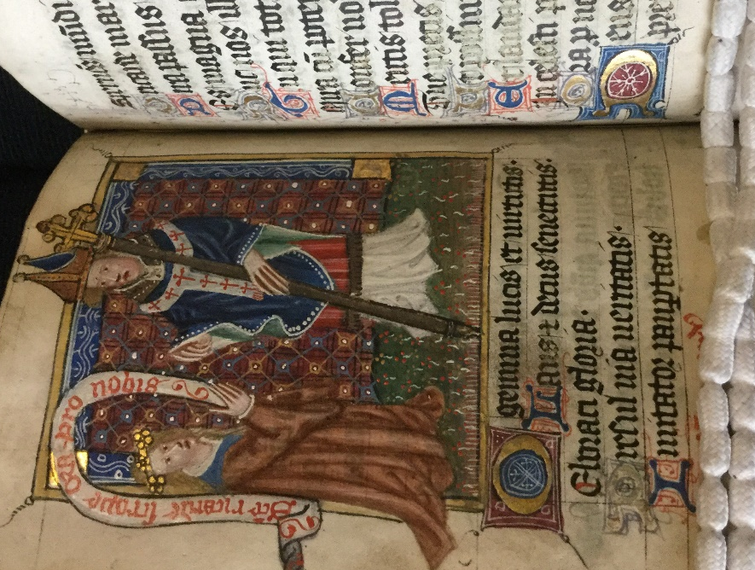
Look carefully at the picture. It is from a very valuable medieval prayer book that you can find in the York Minster library. Some people travel long distances to see books like this and to admire the artwork of these rare books produced by hand. The man standing is an Archbishop of York. You can tell this by the white pallium with red crosses he wears around his neck. So, what is so surprising about a man kneeling before an Archbishop? The Archbishop of York was one of the two most important men of the Christian church in medieval England. Religion was very important then. That’s not what makes this surprising. This Archbishop was called Richard Scrope. Before this book was made he had been executed by orders of the King for rebellion. It is surprising that a man who had rebelled against the King was seen as a person so holy that he should be prayed to for help to get to heaven.
Why did a King execute an Archbishop?
There is still an Archbishop of York today, but archbishops are not in danger of being executed by the government. However, in the Middle Ages archbishops were very powerful and often got involved in politics.
Richard Scrope was the third son of Henry, Lord Scrope of Masham in North Yorkshire. It was typical for younger sons of nobles to become leading churchmen. By 1398 he had risen to the position of Archbishop of York and was a special representative of the Pope in England. In 1399 he gave his support to the new King Henry IV. Henry had seized the throne and ordered the murder of King Richard II.
After just a few years the northern lords became unhappy with Henry IV’s rule. In 1403 the King had to fight to save his throne when the Earl of Northumberland, Henry Percy, allied against him with Owain Glendower of Wales. He won, but in 1405 Percy rebelled again. This time Archbishop Scrope joined in. He called on the people of York to rise up and fight against King Henry’s high taxes, high spending and his treatment of the Church.
The Archbishop, with the Earl of Norfolk, raised an army of over eight thousand York citizens and country people on Shipton Moor just north of York. It was not an impressive fighting force and Earl Henry Percy did not bring his army to join them. Instead, King Henry IV marched his army to York to meet them.
The two armies met on Shipton Moor and King Henry was cunning. He spoke with Archbishop Scrope and got him to agree that they would both send their armies away and settle their differences by talking and feasting. Scrope agreed. Henry had tricked him. Scrope was arrested and put on trial for treason in front of the King in the Archbishop’s palace by the Minster. He was executed in a field outside the city walls, in the area near what is now Bishopthorpe Road. The King allowed his body and head to be buried in York Minster, but he was the first churchman to be executed under the King’s law and the action divided the city.
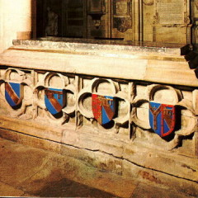
So how did Scrope’s picture get into a prayer book?
Soon after he was executed, people began to come to pray at his tomb. They left coins as offerings of worship. King Henry was angry and ordered that a pile of logs should be put up to block access to the tomb. He was worried Scrope could become some sort of saint and used as a focus for opposition in the North to his rule. However, King Henry IV was also a religious man and he became ill soon afterwards. He developed leprosy and some people said it was due to his execution of Scrope. Then, in 1407 the newly built York Minster central tower collapsed. King Henry sent his own master stonemason to help with rebuilding. His son King Henry V needed support for his wars in France in 1415, so he ordered the removal of the logs blocking the tomb. By 1419, the number of coins being left at Scrope’s shrine were more than at any other tomb in England, except for that of St Thomas Becket in Canterbury Cathedral. Scrope had become an unofficial, popular saint.
Who got interested in Scrope’s story?
In the 1590s Londoners loved to go to the playhouses to be entertained. The great actor and playwright William Shakespeare was always on the look out for a great story that would bring in the public to performances. He looked to the stories of England’s later medieval kings for inspiration. In his play ‘Henry IV part ii’ he included the story of Scrope and Henry’s trick.
THINK!
- How does knowing the story behind the picture make it more interesting?
- What have you learnt about the church and the monarchy in 15th century England from reading this story?
- What have you learnt about York from reading this story?
Over to you!
Around us are many old pictures, old statues, old memorials and old buildings. You could choose one and find out about the story behind it. You will then have a better understanding of why it is there and can form your own opinions about it.

Teacher notes: ‘What is so surprising about a picture in a prayer book?’
What is a slot-in?
A slot-in is a short story from the past that is rich in historical concepts. You can use a slot-in as part of a longer sequence, or as cover work, or in those moments where you need something short.
The concept focus of this enquiry
The enquiry question here is: ‘What is so surprising about a picture in a prayer book?’ The story the students will read is rich in detail about the 15th church and monarchy in England. It also has a focus upon York that can be developed if you are teaching near the city. It has been written to include some complex concepts, but they are developed and explained in the text.
Curriculum links
The study of the politics of the Middle Ages can easily become very fragmented. Schools tend to focus on key moments, but there are so many years in between them and no time to teach it all. This story could help. It could be slotted-in to your curriculum as part of a sequence on:
- Medieval kingship – giving a flavour of Henry IV between Richard II of the Peasants’ Revolt and Henry V of Agincourt,
- The church in the Middle Ages – providing a link from Becket to the Reformation in terms of the political role of the church and the idea of saints and pilgrimage,
- A local study of York in the Middle Ages used to keep a narrative flow to the stories on a bigger scale.
Activity suggestions
You might just want students to read this story, make a connection to a wider topic and move on. However, you might decide to use this material for a whole lesson with activities. You could:
- Start with a picture of Scrope’s tomb and the story of people leaving offerings to a level of second only to Thomas Becket in the 14-teens. Students could revise previous learning about medieval Christian religious beliefs, shrines and pilgrimage; including to the shrine of Thomas Becket. Ask: what does leaving offerings at a tomb suggest about what people believed? what sort of person would be the focus of worship?
- Give students the story of Scrope’s rebellion, the trick and his death. Ask them why it seems surprising that he became a saint.
- Add in the information about people’s actions at his tomb immediately after his death, Henry IV’s illness and actions in relation to York Minster, Henry V needing support. Ask students how far this explains the worship of Scrope.
- Students could write a note to Shakespeare explaining the story and why it has good dramatic potential in order to persuade him to include it in one of his plays. This could include the characters he would need to use and descriptions of them. For example: ‘Richard Scrope, Archbishop of York, third son of a Yorkshire noble, one-time ally of Henry who joined the northern rebellion of 1405. He was involved in politics, but local people also seem to have thought he was holy as he was soon worshipped after death.’
Misconceptions to dispel
Students, understandably, often find understanding the medieval church quite hard. Yet understanding that the medieval Roman Catholic church and its beliefs permeated every part of life is essential to an understanding of the period. Students can think that means everyone was holy and pious. Not at all! Medieval people were as diverse in who they were as people and how they behaved as we are. There was corruption and honesty, courage and cowardice, people on the make, people who served faithfully… and so on. Kings were part of this as well as common people, as this story makes clear. It is also important to say ‘the medieval Roman Catholic church’ in your teacher talk. Christian, and specifically Roman Catholic, beliefs and practices today are not exactly the same as they were.
Extra background for teachers
The prayer book talked about is technically a Book of Hours, known as the Bolton Hours. These were the most commonly owned prayer books among the well-to-do laity in the Middle Ages. A Book of Hours set out the prayers for each liturgical hour of the day. They often included prayers, psalms and masses for holy days, as well as the names of saints and prominent deceased family members. The Bolton Hours may have been made to promote reconciliation after Scrope’s execution. The images in it are partly about the official and public authority of the Church, through its apostles and bishops. On the other, there is an equally strong focus on intimate, family values, represented through the cults of a number of newly popular female saints associated particularly with domestic life. Archbishop Scrope is portrayed as a patron of the chaste and un-wordly.
Where to link to
There is an open access History Today article available via a search for Archbishop Scrope. The York Minster Learning Centre team have a treasure trove of knowledge about York Minster and everything and everyone connected to it. They can be contacted via the York Minster website.

