What can a diary reveal about living through World War Two in Paris?
Paris, 8th August 1943
“My life now is no more than a pause, a stop between two stations. The more I read about the period after the last war, the more I am shamefully pleased that things got back to normal so quickly. I can't listen to the radio adverts urging me to serve. I feel 'out of it'. I haven't done anything to speed up the end of the war. I've only fought a battle to survive, to not die of hunger and mental exhaustion. I have not fought for others. I have had to fight alone for my life. Those who love me are too far away. I don't even have the comfort of fighting shoulder to shoulder for something better against an enemy. For me, the enemy is hunger, cold, the lack of money. … Prisoners are able to say: 'I fought. I was beaten but, all the same, I paid my dues to the country'. I can't say any of that. Nothing. 'What did you do during the war?' 'I tried not to die of hunger'.

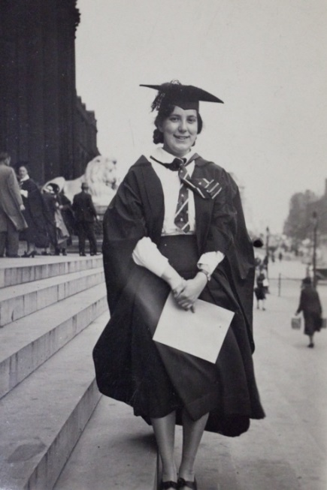
What does the extract reveal?
Read the diary extract above carefully. What words and phrases come to your mind to describe the mental state of the person who wrote it?
The diary this extract comes from was written by a woman called Madeleine Blaess. At the time of writing she was 25 years old and a university student trapped in occupied Paris in the Second World War. Paris, and the rest of northern France, was occupied by Germany. The ‘last war’ she refers to is World War One. By 1943 Madeleine had been trapped in Paris since 1940. She was French by birth, but her home was York. She went to school at the Bar Convent and her family were still in York in 1943.
What does the extract reveal about what it was like to live in an occupied city in wartime?
How had Madeleine become trapped?
Madeleine gained a first-class degree from the University of Leeds in 1939. She decided to study further at the Sorbonne University in Paris. Her extended family lived in France. No one was expecting France to be invaded, but it was in just a few weeks in May/June 1940. Madeleine could not get back home to York. At the same time, because of her French origins, she was free to continue living in her flat. But she was alone. On 1st October 1940 she began her diary as if speaking to her family, ”I am writing this for you because I can no longer send you letters. … I have been wanting to do this for a long time because it is a way to feel closer to you”.
Why is her diary interesting?
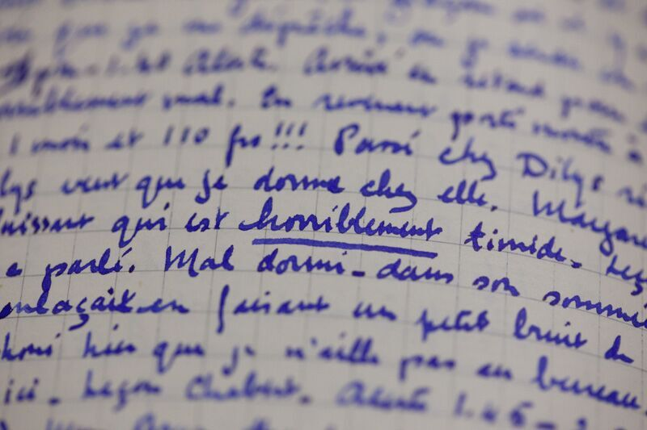
Firstly, it is the only known diary written by a British student in occupied France. Madeleine also wrote regularly and frequently in a style that described everyday life in detail. From her we learn the important truth that life in wartime for most civilians in occupied Paris was boring, repetitive and focused on struggling to find enough food, enough money, enough fuel to keep warm in winter and to avoid infectious disease. She shows us that stories of high drama and resistance are unusual. Her diary is not the stuff that films are made of, but it’s real.
She was also a young woman pursuing an academic career in a world where women were still expected to aspire to be wives and mothers. As such, she had a support group and network of other young women in the same position. One friend was the bookseller, publisher and owner of the famous Parisian bookshop and library called ‘Shakespeare &Co’. Two other friends were Françoise Bernheim and Hélène Berr. On Tuesday 29 September 1943 Madeleine writes: ‘Went for tea to Hélène's. Met her sister, her father, her mother. Her father is very nice. She has a superb violin - and a beautiful Chinese quilt.’ Less than six months later, Hélène was arrested and deported to Auschwitz. By May 1945 both she and Françoise were dead; killed because they were Jewish in the Nazi organised genocide now known as the Holocaust.
We know that Madeleine was involved in forging documents for the resistance towards the end of the war, but her diary says little about this or the fate of her friends. After the Allied Normandy Landings on D-Day in 1944 she writes in more detail about the war, including an hour-by-hour account of the Liberation of Paris in August 1944 as it happened around her.
What happened to Madeleine?
Madeleine survived the war and returned home to York in February 1945. She became one of very few women in the 1940s to take up a university teaching post, when she was appointed to a lectureship in the French Department at the University of Sheffield in 1948. She worked there until her retirement in 1983. When she died in 2003 her Occupation diary and letters were found amongst her personal papers hidden underneath her bed.
THINK!
- What have you learnt from this story about living in an occupied country in wartime?
Over to you!
You can find about more about Madeleine Blaess via a website about her and a film on YouTube. Why not read other stories of women in wartime? You could read Hélène Berr’s ‘Journal’, or ‘A Woman in Berlin’, or ‘Rutka’s Notebook’, or Anne Frank’s very famous diary.
Teacher notes: ‘What can a diary reveal about living through World War Two in Paris?’
What is a slot-in?
A slot-in is a short story from the past that is rich in historical concepts. You can use a slot-in as part of a longer sequence, or as cover work, or in those moments where you need something short.
The concept focus of this enquiry
The enquiry question here is: ‘What can a diary reveal about living through World War Two in Paris?’ The story the students will read is written to show how dramatic events were experienced by ordinary people. Students will gain a sense of period and a better understanding of the diversity of experience of the Second World War. The story is one which students can identify with. It can serve to make large impersonal events more human.
Curriculum links
We have a duty to reflect the past of diverse people in our history curriculum. We also have such a restricted amount of curriculum time to teach a large amount of past. This story could be slotted-in to your curriculum as part of a sequence on:
- Home Front in World War Two,
- The Holocaust,
- World War Two and Nazi Occupation,
- York people in the 20th century.
Activity suggestions
You might just want students to read this story, make a connection to a wider topic and move on. However, you might decide to use this material for a whole lesson with activities. You could:
- Set up a contrast between the experience of Madeleine Blaess and women in Britain during World War Two. How might her life have been different if she had made it home to York in 1940?
- Set up a contrast between the experience of Madeleine Blaess and women living under Nazi occupation in Eastern Europe and/or women in Berlin at the end of the war. While living under occupation was hard in France. It is generally accepted that the racial element to the conflict in the east, made the experience of occupation there even worse.
- To do either of these, you could set the material as pre-reading and then ask students how other experience compare and contrast to that of Madeleine Blaess.
- You could do some evidence work. For example, bring in other oral and diary testimony and asking students to consider what such accounts add to our understanding of World War Two and what the limitations of such accounts may be.
- The story could start a research project and you could use it to get students to generate their own enquiry questions that they wish to answer about life under Nazi occupation.
- You could ask students to notice how many stories of women they can find in their textbooks. Students could write a paragraph to summarise their answer to the question and pitch it to a textbook editor to argue why Madeleine Blaess’ story should be included.
- Finally, slot-ins always have an ‘over to you’ section. These are to encourage students that learning is ongoing and something that they should be taking responsibility for.
Misconceptions to dispel
Most students are understandably ignorant about what life for citizens was like under Nazi occupation. They are likely to guess that it was more dramatic than it was and yet to underestimate the dangers of cold and hunger and infectious disease at the time. They are also likely to assume that the experience was the same in all countries that were occupied. This is not the case (see above).
Also, in the case of France, there is a tendency for the narrative to jump from Dunkirk to D-Day and for France not to be mentioned in between. This story helps to connect the narrative in a way that enables students to see the impact on people.
Extra background for teachers
Madeleine Blaess wrote a diary that is very much in the Anglo-Saxon style. It was the custom in France at the time for young academic and literate women such as her to write emotional and stylised diaries to showcase their intellect and develop their critical reflection. Madeleine writes instead in the a style more akin to the UK’s Mass Observation Survey, reporting everyday details with a factual tone.
Hélène Berr was a gifted violinist from a well-to-do Jewish French family. As such, she was not in the first group of Jewish people to be targeted by the French collaborating authorities. There were many Jewish people in France who did not have French citizenship. They were targeted for deportation first. An example would be the famous Russian-born novelist Irene Nemirovsky. She and her husband were both deported to Auschwitz and gassed in 1942. The most infamous event in the story of the Holocaust in France is that of the Vel’ d’Hiv when French police rounded up over 8000 Jewish people in Paris and held them in terrible conditions in a velodrome in the heat of the summer of 1942 before deporting them. Between 1942 and 1944 76,000 Jewish people were deported from France. They were about 25% of the total Jewish population and most of these people were not French citizens.
Where to link to
Madeleine Blaess’ story can be found on a website about her and a film on YouTube. Her diary is published online via White Rose Press. Hélène Berr’s ‘Journal’, ‘A Woman in Berlin’, ‘Rutka’s Notebook’ and Anne Frank’s diary are examples of other diaries that could be used for comparison.

