The Historic Environment topic for 2019
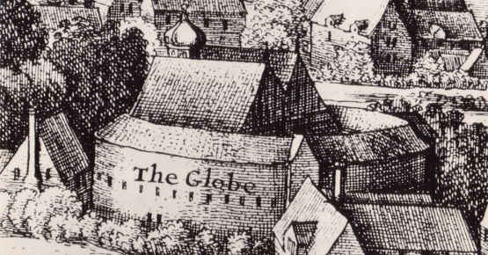
The Globe Theatre

Name: _________________________________

Welcome to the historic environment site study
This is part of your British Depth Study on Elizabethan England. You will be expected to use your knowledge from your study of Elizabethan England. There will be one 16-mark essay on the exam paper that will test you on this topic.
Sample questions:
‘The theatre reflected wider changes in Elizabethan society.’ How far does your study of the Globe Theatre support this statement? Explain your answer. You should refer to the Globe Hall and your contextual knowledge. (16 marks)
(secular theatre, Puritans, wealthy patronage to show status, fear of vagrants, aging Queen and rebellion)
‘The main reason for supporting theatre in Elizabethan times was to show off wealth and connections.’ How far does a study of The Globe support this statement? Explain your answer. You should refer to The Globe and your contextual knowledge. (16 marks)
(wealthy patronage to impress queen, protest, pleasure, great work, no religious plays)
Important!
- You will have 20+ minutes to write your essay in the exam.
- You will be expected to refer to the whole site.
- You will write about the site then, not now.

A* answers:
Top level answers will be complex explanations focused on the question concept that lead to a sustained judgement. There will be lots of accurate and detailed knowledge used to support all assertions. It will be clear that the student has a very good understanding of the topic. As ever, aim to make three clearly substantiated argument points. The essay will need an introduction that sets out the argument and a well-developed conclusion.
Let’s look at a question like an A* candidate…
It’s got Elizabethan SOCIETY and CULTURE as the key topic concept!
‘Changes in theatre reflected wider changes in Elizabethan society.’ How far does the study of the Globe Theatre support this statement? Explain your answer. You should refer to the Globe Hall and your contextual knowledge. (16 marks)

It’s got CHANGE as the key historical concept!

It needs a JUDGEMENT about to what extent The Globe shows this.

It’s worth a lot of marks and requires a carefully planned essay.
My answer needs strong arguments supported by specific and precise detail.

Our BIG Question: What does The Globe Theatre reveal about the Elizabethan period?
We need to break our big question into smaller questions…
- What were Burbage’s motives for building The Globe?
- Why did Burbage build the Globe by the Thames on that site?
- Why was The Globe built as it was?
- What was the function of all the different features of The Globe?
- What are the distinctive features of The Globe?
- What was commented upon at the time?
- How was the design or layout of The Globe different from/similar to other theatres?
- What technology was used to build The Globe?
- What status did The Globe have in society?
- What was The Globe used for?
- Who worked at and visited The Globe?
At the same time we need to think about The Globe using different historical concepts. To help with that her are some concept focus questions:
CHANGE AND CONTINUITY
- What sort of change did The Globe represent?
- What continuity did The Globe represent?
- When did developments happen at The Globe?
- How much change and development was there at The Globe within the Elizabethan period?
- What was the pace of change at the time?
- Who brought about change at The Globe?
- What prevented or slowed change?
- Why was there change in Elizabethan theatre and how does The Globe show this?
- What does the The Globe reveal about the Elizabethans and their world?
- What was the impact of change on The Globe?
CAUSATION:
- Why was there change at The Globe?
- What do the causes reveal about the Elizabethans?
CONSEQUENCE:
- What was the impact of change on The Globe?
- What do the consequences reveal about the Elizabethans?
You must be able to answer all of these questions in detail before you go into the exam room! They are designed as a checklist to make sure you have thought about The Globe and what it tells us about Elizabethan England from every possible angle.
Theatre in England had been very different
Pictures of modern reconstructions of the York Mystery Plays on waggons
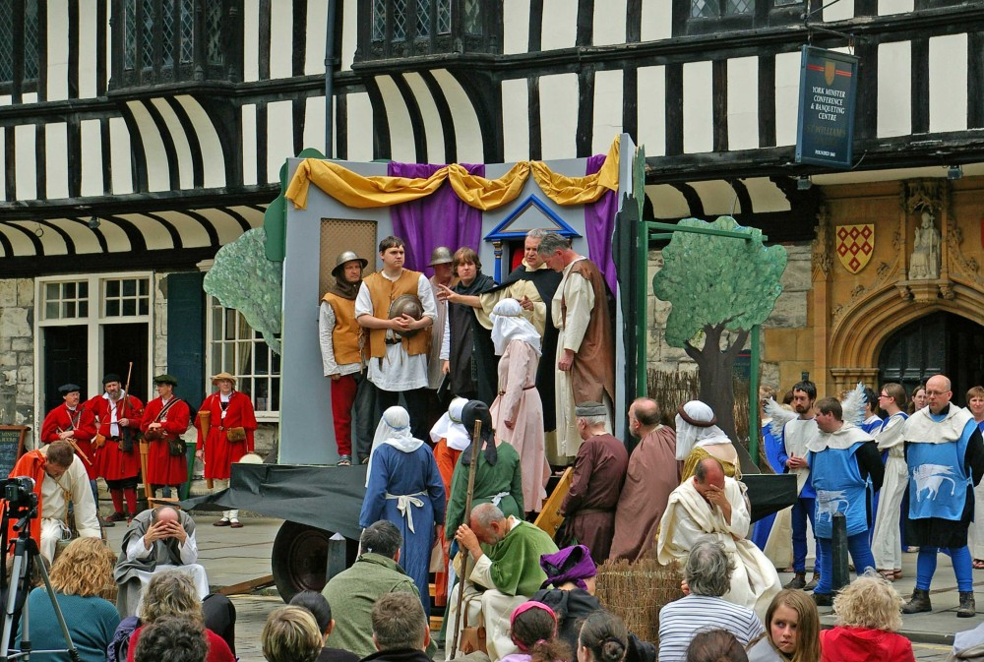
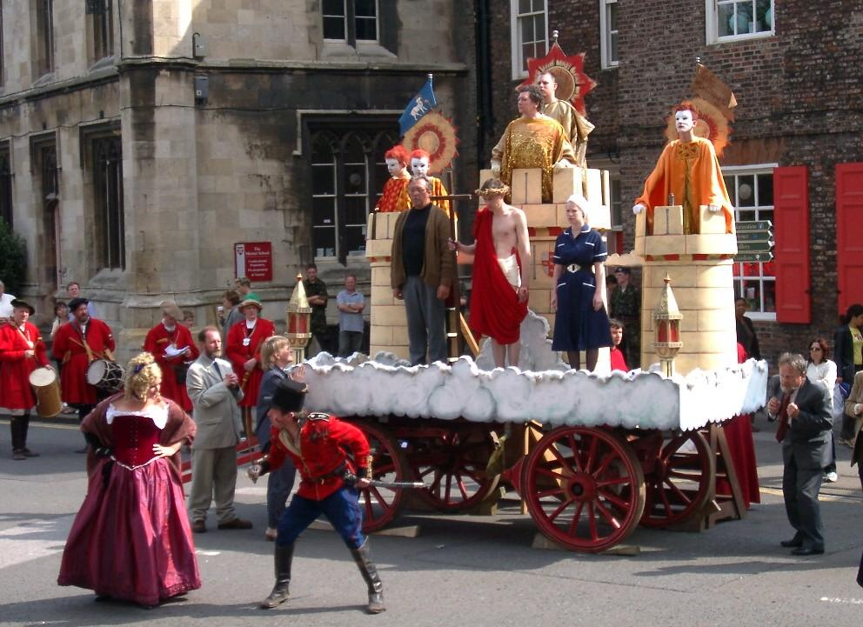
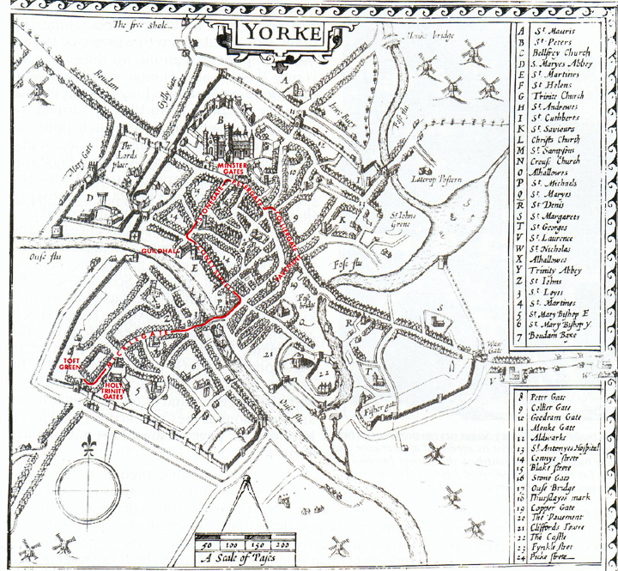
What can you infer about theatre in England the Middle Ages?

The route typically taken by the waggons on Corpus Christi Day
After the 1569 Northern Rebellion, the York Mystery (or ‘Miracle’) Plays were banned because of their close connection to Roman Catholicism.
The first changes in Elizabethan theatre
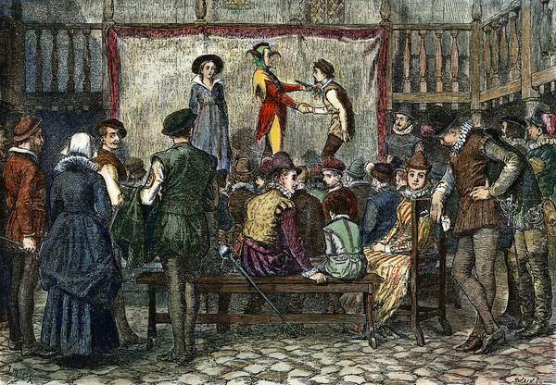
During the 1560s a non-religious style of theatre emerged with performances usually taking place in the courtyards of inns.
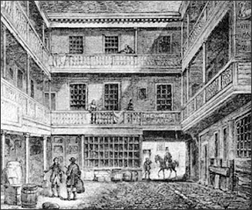
Artist’s impression of a courtyard performance. Engraving of an inn courtyard.
Companies of players would travel throughout northern Europe, performing at fairs and festivals. In England, they required a license of perform to avoid their arrest as ‘vagabonds’.
The first London theatre was the ‘Red Lion’ in Whitechapel.
John Brayne appears to have turned an existing building into a theatre at some point in or before 1567. It was in Stepney, south of Mile End Road, north of the City boundary. With one exception ('The Story of Samson', from 1567), nothing at all is known about the names or even the types of plays performed here, nor do we know anything about the playwrights or theatre companies who would have worked here. It had a purpose-built 40’ x 30’ stage raised 5’ above the audience and offered a London home to touring companies but was little different from the previous tradition of playing in the courtyards of inns. As it was so far outside the city walls on open farmland, it was a long way for audiences to travel, particularly in winter.

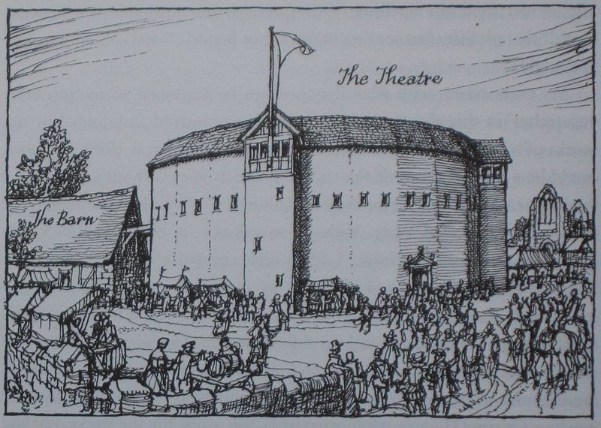
Burbage and ‘The Theatre’
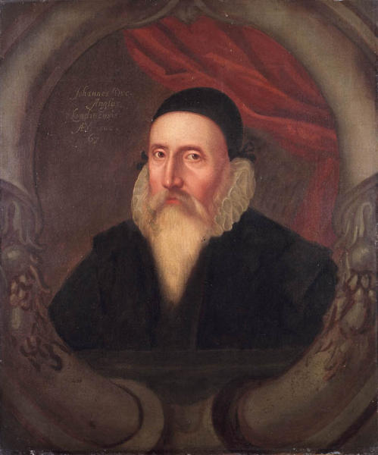
The second purpose-built theatre called ‘The Theatre’. It was built in 1576 by James Burbage, with help in its design from the scholar and architect, Dr John Dee who, as an expert on ancient Greece and Rome. Dee advised on its Coliseum-like design. (the ruins of the Coliseum are in Rome). John Dee was an English mathematician, astronomer, astrologer, occult philosopher and adviser to Queen Elizabeth I.
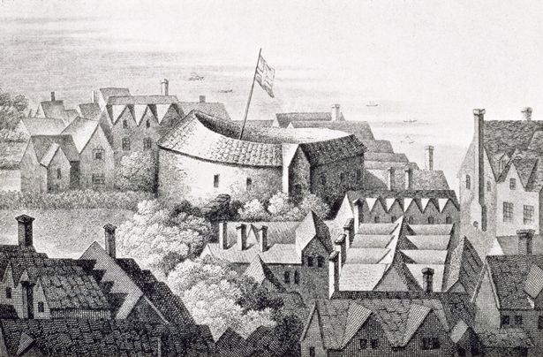
The following year another theatre, ‘The Curtain’, opened close by. (Shakespeare was here at first! Burbage also used it.) The Theatre and The Curtain were outdoor amphitheatres modelled on inn courtyards or animal baiting rings both of which had surrounding galleries. At these theatres the stage jutted into a yard where people stood while others sat in galleries around the outside.
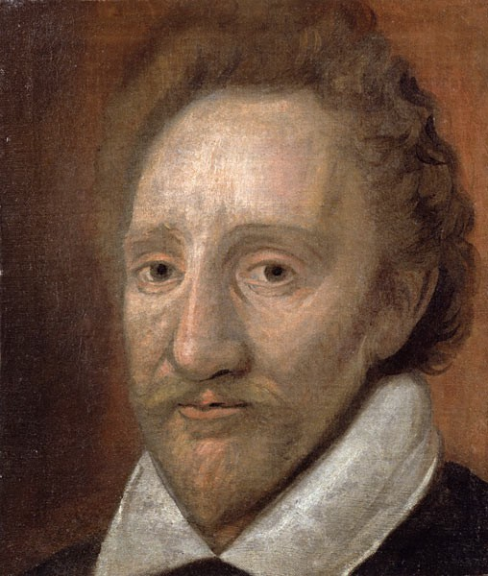
This is the model Burbage was to use at The Globe.
James Burbage: carpenter, turned actor and theatre entrepreneur. One of the most famous men in Elizabethan theatre.
In 1572, as leader of a company of actors, Burbage asked for the Earl of Leicester`s protection and patronage and in 1574 the Earl obtained from Queen Elizabeth I a licence for a theatrical company, which would bear his name – ’The Earl of Leicester’s* Men’. This licence allowed Burbage and his sons, Cuthbert and Richard, as servants of the Earl, ‘to use, exercise, and occupy the art and faculty of playing comedies, tragedies, interludes, stage plays, and such other like as they have already used and studied.’
* Who was the Earl of Leicester? How /why would this be GREAT news for Burbage and team?

STOP! It’s time to start to put together a timeline on the reverse of this page!

What did the authorities think?
The City of London authorities did not want theatres built within the city walls because the Elizabethan theatre had a poor reputation and was thought to encourage crime and disorder. As a result, in December 1574 the Council of London banned plays within the city limits and in 1596 went further by forcing all theatres within the city limits to close and move south of the River Thames. All theatres were also closed in 1593, 1603, and 1608 because of the fear that the large crowds would help spread the bubonic plague.
- Add to your timeline
- What historical knowledge do you have to add more detail to the description of these fears? Write a few notes here…

What was London like in 1599?
- Read this extract. Summarise each paragraph in words and phrases (or one sentence)
An extract adapted from ‘Shakespeare’s London’, by Martin Holmes, published in ‘History Today’ (1964)
Most of Shakespeare’s working life was spent in or around the City of London. By the time he retired, Greater London was beginning to spread beyond its ancient limits. London had been a self-governing, self-administering community before there were kings of all England, so that the city of London was older than the kingdom of which it was the capital. Much of that early administration was still operating in the sixteenth century. The city was divided into twenty-six wards, each of which had its Alderman and lesser ward officials. It was not the King’s officers who kept the peace in London, but the Londoners themselves – the constables and watchmen appointed by the ward authorities from among their own citizens – and the Lord Mayor and Aldermen held their own courts to uphold the regulations of their city.
My summary:

Disturbances that became riots would not be dealt with by the city administration but by the Star Chamber, a judicial committee of the Privy Council appointed to handle cases of riot and sedition. However, government intervention was to be avoided wherever possible, and everyone preferred to keep their misbehaviour within the city’s jurisdiction. This, rather than the influence of Puritanism, explains the long-standing banning of playhouses within the city walls. Quite simply, playhouses attracted crowds, and crowds attracted pickpockets, bullies and other undesirable characters who caused quarrels which, if they took place in a crowded part of a crowded city, could only too easily become widespread disorder that did no good to anybody and merely reflected badly on the character and administration of the neighbourhood. Such things were better left to the districts outside the city walls, where the population was thinner, crowds were fewer and any minor disturbance was more likely to sort itself out without spreading to the respectable territory of the City Fathers.
My summary:

London had always been a great commercial city. As it prospered a huge amount of the world’s wealth was concentrated into the small space of its closely-packed business houses. Every square foot of land was valuable – far too valuable to be sacrificed to road-widening – so the streets and lanes remained narrow, in spite of the increasing amount of larger, faster traffic that was being thrust into and through them by the ever-increasing demands of commerce. As a result, it was the London tradesmen, from the wealthy merchant to the small shopkeeper, who Shakespeare wrote for, and his mercantile audience would have recognised much that was contained in his plays whatever their setting.
My summary:

Old Capulet in `Romeo and Juliet` is supposed to be a Veronese nobleman, but to all intents and purposes he is a fussy and self-important London merchant, bustling round and making a great to-do about the running of his household. The tragic brawl that drives Romeo into banishment, and the still more tragic accident that delays the Friar’s letter of explanation, would have a real meaning for audiences who knew from experience what happened when street-quarrels developed into riots and what precautions had to be taken when there were rumours of plague about. For Shakespeare and his audiences, this was a reminder in play form of the almost supreme power wielded by London`s civic authorities.
My summary:

A Londoner`s civic responsibilities are also touched on, for example, in `Measure for Measure`, where an elderly and inefficient constable is shown to have no official status and no qualifications whatever, but to have been appointed by householders who would rather pay an inadequate deputy than take their own turn at civic duty. This state of things would be familiar enough, and amusing enough to the London play-goer of the time, but Shakespeare makes it clear in the play that the situation is wrong and must be put right. Shakespeare may make fun of a London abuse, but he is not prepared to accept it.
My summary:

The London citizen also had responsibilities within his own household and these are reflected in Shakespeare`s History plays. As the head of a business, he would have journeymen and apprentices under him who slept in his house, fed at his table and for whose welfare, progress and good behaviour he was responsible. As a result the London merchant was well qualified to appreciate the problems of King Henry IV, both in his rise to power, by taking over a kingdom that was rapidly going to ruin under incompetent management, and in his relations with his rather disappointing son. A businessman following the career of Richard II as outlined in Shakespeare`s play would notice, and be critical of, Richard’s readiness to put so much of the kingdom into debt. King Richard is shown to be like the inefficient head of an old-established business, raising money by mortgaging his assets and endangering his capital and stability.
My summary:

Similarly, many London merchants watching the play would wonder if the results of their careful management, hard work, occasional doubtful dealings and sharp practice, would be frittered away in frivolity or worse by those they left their business to. Shakespearean London gave its inhabitants every chance to understand, and share, the anxiety of a businessman about the possibility of his sons getting into bad company, or not being up to the task of administering the property his father has built up for them. Looked at from this angle, many of the Histories give us a surprising insight into the mind of that serious, self-respecting mercantile community that was Elizabethan London.
My summary:
Map of London from the time
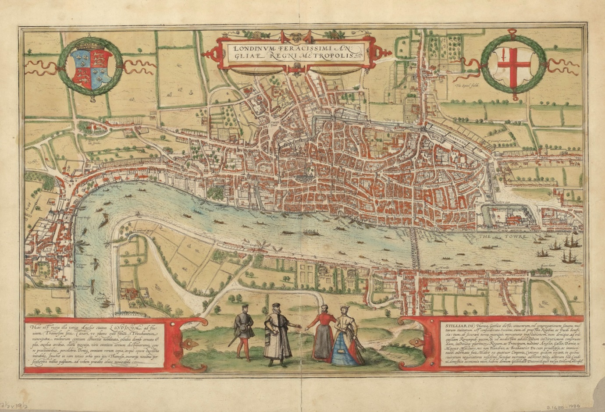
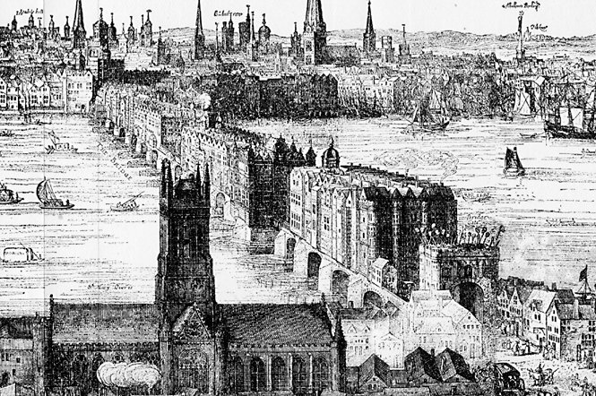
Old London Bridge, with the church that is now Southwark Cathedral in the foreground and the City of London across the river (notice the heads!)
View of the St Paul’s Cathedral and the City of London with the South Bank theatres of Southwark in the foreground. The Tower of London was downstream and beyond that, the port. The City of Westminster was upstream. Wherries (boats) ferried richer passengers.
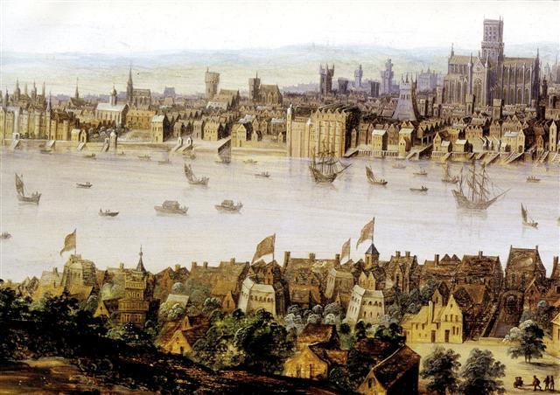

Frank Lapper’s artistic interpretation of an early modern street scene
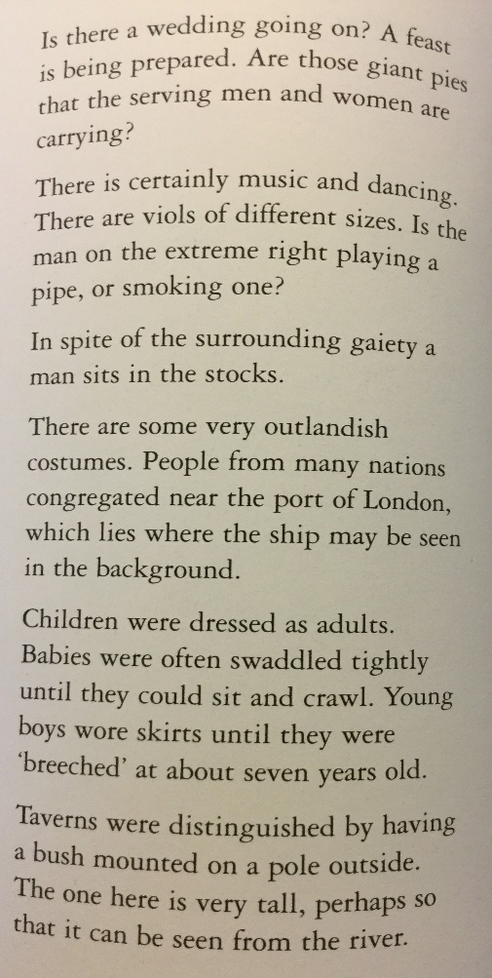
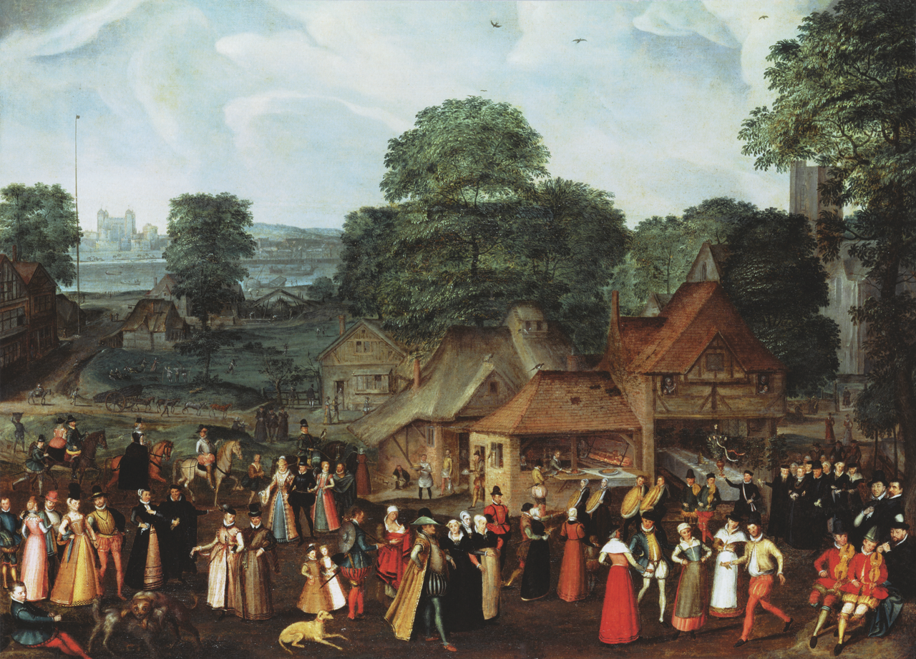
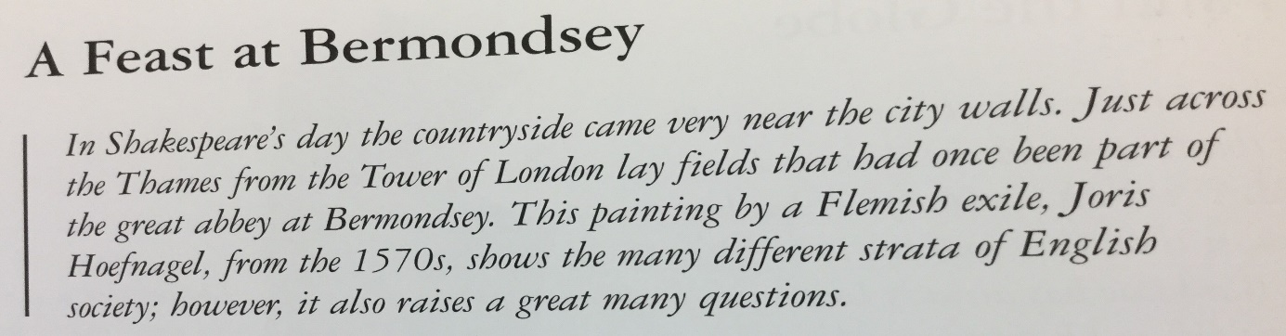
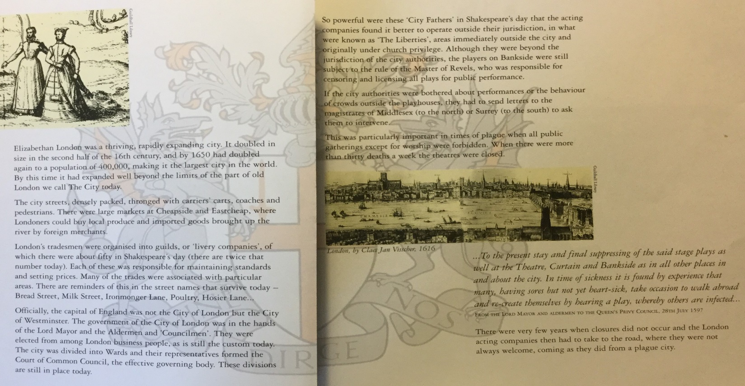
Text from the Globe Theatre Guidebook
Using everything you have seen, read, remembered and thought about… write yourself a summary of London in the 1590s:

The beginning of The Globe
In 1587 a man called Philip Henslowe had built The Rose theatre on the south bank of the Thames in Southwark. This was accessible over London Bridge, but outside the City Walls and therefore free from the jurisdiction of the City authorities. Several others sprang up., including The Swan in 1595 and The Globe in 1599.
Burbage’s 1576 theatre, named ‘The Theatre’, was built in Shoreditch, just outside the city limits to the north east of London. Unfortunately, it was built on land which belonged to a Puritan*, Giles Allen and when the lease ran out Allen refused to renew it. In 1596 Burbage built a new playhouse in the Blackfriars’ Hall, but local residents objected to it. The Burbages stood to lose everything that they had invested in ‘The Theatre’ but James knew there was a clause in the lease which said that what was on the site belonged to him. Knowing that Allen would be away over Christmas at his country house in Essex, Burbage and his actors, along with labourers, dismantled the theatre in the dead of a freezing, snow-covered December night under the watchful eyes of Master Carpenter Peter Street. He made sure that the timbers were carefully marked so that the theatre could be reassembled later. One of Burbage’s actors at the time was William Shakespeare.
* What do you know about Puritans that helps you to understand this?

- What can you learn from this story about the character of James Burbage?

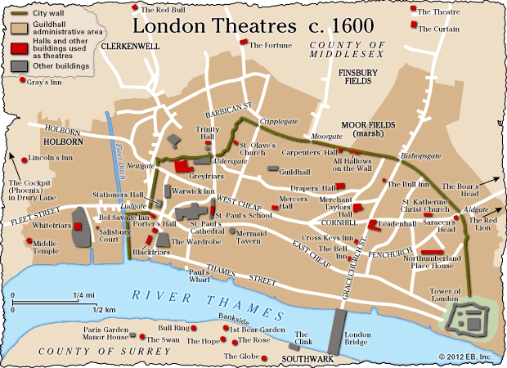
The timbers were reassembled on Bankside in Southwark on the south bank of the River Thames in 1599 with the money for the new theatre, called `The Globe`, being put up by the Burbage sons - Richard and Cuthbert, and ‘shared’ with four actors from the company, Thomas Pope, John Heminges, Augustine Phillips, and William Shakespeare. The first play to be performed in ‘The Globe’ was probably Shakespeare’s ‘Julius Caesar’, as a tourist called Thomas Platter recorded in his diary on 21 September that, ‘we witnessed an excellent performance of the tragedy of the first Emperor, Julius Caesar’.
How was the Globe built?
Reusing the timbers of The Theatre was not only economic, it was also a good building technique. The long-lived timber would have become seasoned until it was as hard as iron. From brick foundations, the oak timbers were then filled in with lath and plaster. The Globe had 20 sides and a diameter of 99 feet. The part roof was made of thatch.
The Globe could hold over 3000 people. The stage was 5 feet high and roofed over to protect actors and their costumes. There was a balcony above the stage, and a trap door in the centre. Behind the stage, the actors entered and exited from the tiring house, from where the performances were managed. Everything was beautifully coloured. There was a different play every afternoon. There would have been workshops for props and costumes.
Peter Jackson’s artistic interpretation of the Globe theatre on Bankside
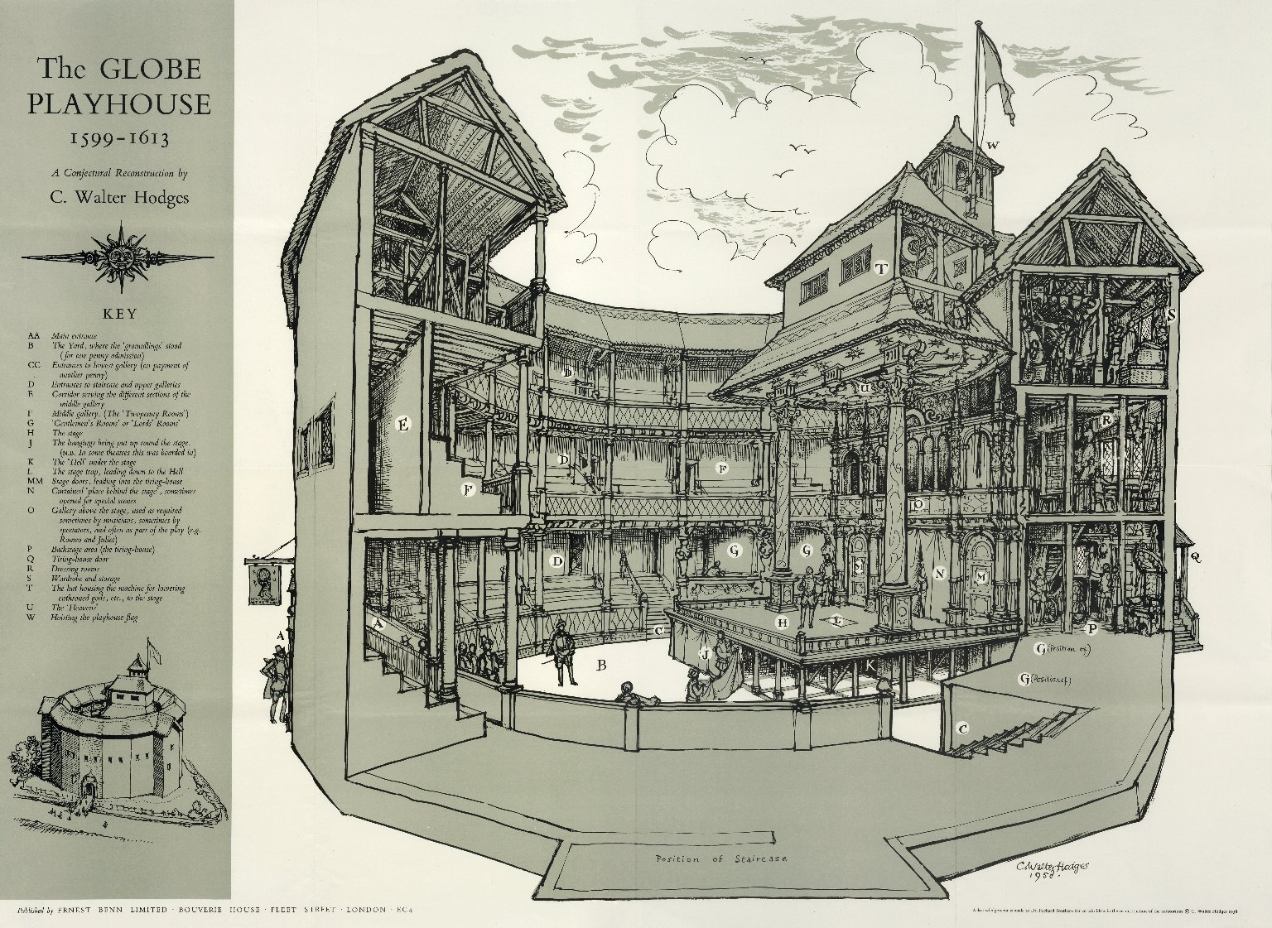
A cutaway drawing of The Globe theatre

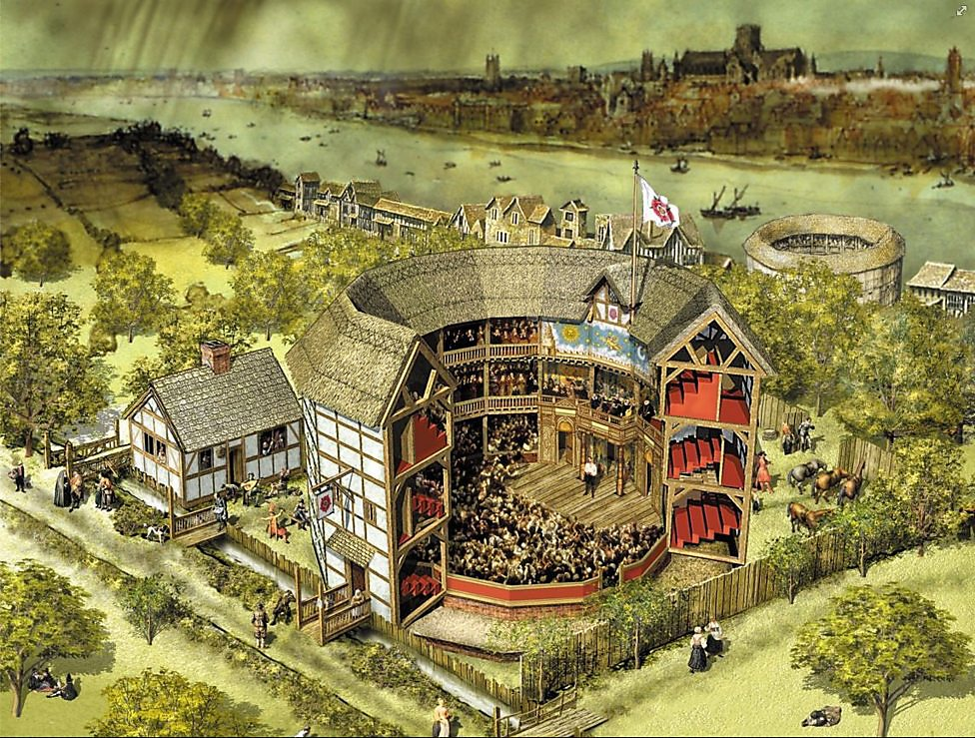
An artist’s cutaway drawing of The Rose theatre
Who performed plays?
Plays were performed by companies of actors. Actors who contributed money to the company were called ‘sharers’ and received a share of the profits from performances. Other actors called ‘hirelings’ were paid a weekly wage, while boys who played the women’s roles were ‘apprentices’ and were paid very little.
There were also companies of young boy actors attached to cathedrals and churches who performed more refined plays and charged a higher entrance fee than the adult theatres. They performed in playhouses which were entirely covered and held up to 1000 people. The earliest of these was the Paul’s Theatre used by St Paul’s boys from 1575 to 1590 and the first Blackfriars Theatre, used by the Chapel Children from 1576 to 1583. These theatres were permitted within the city walls.
We know from Shakespeare’s plays and lists that survive that the company also contained musicians. Music was used to set the scene for battles, parties, love, drama… Brass and woodwind instruments were most suitable for The Globe, as an outdoor theatre.
“If music be the food of love, play on! Give me excess of it!” (Opening lines of Twelfth Night).
In 1583 the Earl of Leicester’s Men lost some of their best actors to a new company put together by Sir Francis Walsingham. It contained 12 of the finest actors in the country and was to be the Queen’s own troupe of actors called the ‘Queen’s Men’. The Earl of Leicester was unlikely to complain about the loss of his players to the Queen’s patronage as Walsingham was a close ally of Leicester`s, and Leicester’s Men had been working, in spirit if not in fact, almost as a royal company for some years.
Between 1592 and 1594 the theatres were closed because of the plague and when they reopened the actors’ companies had reorganised and many had amalgamated.
The Lord Chamberlain’s Men
A strong new theatrical company emerged from these years under the patronage of Henry Carey, Lord Hunsdon, and took their name, ‘The Lord Chamberlain’s Men’, from the office he held. William Shakespeare joined this company as an actor and principal playwright in 1594, writing on average two new plays a year for them. Led by the Burbages, in 1599 they moved to The Globe.
The biggest rival to `The Lord Chamberlain`s Men` was another company that emerged in the later Elizabethan period – ‘The Admiral’s Men’. Originally known as ‘Lord Howard’s Men’ after their patron Charles Howard, Lord Howard of Effingham, the company changed its name to ‘The Admiral’s Men’ in 1585 when he became England’s Lord High Admiral. They played at the Rose Theatre which was built in 1587 and was the first theatre to be built on Bankside in Southwark, South London. Unlike ‘The Globe’ which was unique in being owned by and built for actors, ‘The Rose’ was built by a businessman, Philip Henslowe. It was at the ‘Rose Theatre’ that William Shakespeare’s plays were performed after he may have been first hired as an actor. The Admiral’s Men were led by Edward Alleyn who had married Henslowe’s daughter in 1594. Henslowe made so much money from the Rose that they were able to build ‘The Fortune’ theatre which they moved to in 1600.

Why was Patronage so important?
The Lord Chamberlain and the Lord High Admiral were patrons. The protection of courtly patrons was important to theatre companies because a 1572 Act of Parliament threatened to punish, ‘common players and minstrels not belonging to any Baron of this realm as they shall be judged to be rogues, vagabonds and sturdy beggars.’ For someone like the Earl of Leicester, being the patron of a theatre company also had its advantages. When the company toured areas of the country where he had connections, Leicester hoped that theatregoers would be favourably reminded of him and he naturally expected some reflected glory from a successful theatre company that bore his name. Also, as the audience paid to see the play, the theatre company was self-financing.
Note! Notice patronage works for both parties.
An important reason for the Privy Council to approve some theatre companies was so that they could practise plays before they were performed for the Queen during the Christmas season. From 1578 the professional theatre companies were controlled by the Lord Chamberlain’s office, through the Master of the Revels, who licensed those that were thought suitable for performing before the Queen at court. The patronage of the Lord Chamberlain gave Burbage, Shakespeare and co regular invitations to perform for Her Majesty.
The approval of the Queen and Privy Council no doubt convinced many Protestant leaders in the church and local government that play-going was an acceptable recreation. Although there is no evidence that the patrons of theatre companies used them to further their political careers directly, the fact that Privy Councillors patronised theatre companies suggests that they found the role useful, perhaps as a way of shaping public opinion but also as a way of gaining favour with the Queen.

- Time to revisit your timeline and add new dates to it!

- What was special about The Globe?

- Define patronage.

- How did patronage help the men of The Globe?

Attending the Elizabethan theatre
Different coloured flags were displayed above the theatre to indicate the type of play that would be performed. White flags suggested a comedy, red signalled a historical play, and black was for a tragedy. The play usually started at 3 o’clock with the blowing of a trumpet. Theatres could accommodate over 2000 people and were immensely popular. It has been estimated that 15,000 people visited the theatre each week in 1595 when there were only 2 theatres open and that the figure approached 25,000 twenty-five years later when there were 6 theatres. The population of London provided a highly varied audience and although not all would have been able to read and write, others were well-informed and sophisticated. The newly-established Elizabethan theatre and its audiences had an appetite for plays that needed satisfying. Henslowe’s company, for example, were producing 35 new plays a year. Without the protection of patrons and the support of the London public, the achievements of the Elizabethan theatre would have been impossible. The playwrights and actors held in low esteem in the early part of the reign had, by its end, risen socially and responded to the aspirations of their audience and the Elizabethan age.

An extract adapted from ‘The Time Traveller’s guide to Elizabethan England’, by Ian Mortimer, (2012).
How do you decide which theatre to go to? As with a modern production you will want to watch the best and most famous performers. Many Londoners flock to see the clowns. Richard Tarlton, for example, who plays with ‘The Queen’s Men’ at ‘The Curtain’, is a crowd puller. He can reduce the audience to tears simply by putting his head out between the curtains and pulling faces. Some gentlemen and ladies who regard the theatre as brutish and coarse will only go to see performances by the companies of boys drawn from the choristers of the Chapel Royal and St Paul’s Cathedral. These companies are more socially refined and the venues are roofed over. Their plays aren’t bad either. Ben Johnson writes for them regularly. However, it is to the actors of the two main companies that you will be drawn. The Lord Chamberlain’s men have Richard Burbage, who takes the lead in many of Shakespeare’s plays. The Lord Admiral’s men have Edward Alleyn: a very tall and powerful man who roars his part as he crosses the stage. With such actors, a playwright can compose the part to suit the actor’s strengths. If you really want to see an all-star cast, go to ‘The Curtain’ in 1598 to see the production of Ben Jonson’s ‘Every Man in his Humour’ with William Shakespeare playing Kno’well, supported by the other leading men of the Lord Chamberlain’s company, among them Richard Burbage, Augustine Phillips, John Hemmings, Henry Condell and Will Kempe.
Let’s say you want to go to the theatre for an afternoon performance. If you’re heading to the Swan, the Rose or the Globe you will cross London Bridge, or take a boat across the river and then walk through Paris Garden. All sorts of people will be heading in the same direction: working men in groups, shop owners, gentlemen, and householders’ wives accompanied by their servants or husbands, foreign tourists, boys and girls. As you approach the theatre you will notice that the buildings all seem to be round but in fact they are polygonal – the Globe is 20 sided, the Rose 14 sided. Whichever one you choose, you can expect to queue with over 2,000 other people to get in. You will see people standing wearing hats and with pipes in hand, women in their headdresses, everyone chatting, with an eye open for people they know. Entrance costs a penny, which allows you to stand in an uncovered area in front of the stage (hence the need for a hat). Around the yard are 3 galleries where you can stand or sit undercover. It is an extra penny to stand here and another penny again for a place upstairs. If you’re feeling rich, you might hire a box for sixpence. This gives you the best chance of seeing the stage and being seen by the crowd.
When the trumpets sound most people quieten down, waiting for the play to begin. If you are sitting in the gallery you will have a clear view of the stage as it projects out from the far side of the round enclosure. Leading actors will come right out along this platform and deliver their lines directly to the crowd. So too will a clown like Will Kempe, when he wishes to improvise or make ‘a scurvy face’. There are 2 large columns, both elaborately painted which support the roof that covers the back of the stage. Behind them is the ‘tiring house’ where the actors dress (or ‘attire’) themselves. Above the tiring house is a gallery which is useful for scenes such as the balcony scene in ‘Romeo and Juliet’, but which is sometimes let out for those spectators who want to be seen. Note how few props are used and although, for example, ‘A Midsummer Night’s Dream’ cannot be performed without a donkey`s head, most of Shakespeare’s plays are performed without props. The costumes, however, are splendid. There is a low murmur of voices throughout the play as women shoulder their way through the crowd, selling apples, nuts and bottles of beer. People are constantly on the watch for pickpockets, and any chance encounter that might be to their advantage. Unlike during a modern theatre performance, you will find many people chatting away during the play. Some speeches, however, do get the full attention and silence of the audience. At other points in the play the sound of a cannon or of rolling thunder from above will make you jump. The latter effect is made by rolling cannonballs across the gallery roof.
Elizabeth’s reign sees the beginnings of a new type of drama. The playwrights have an awareness of a changing world that sets them completely apart from the Middle Ages. Not for them the out-of- date traditions of miracle and mystery plays, or of writing only to please the wealthy. A great new culture is appearing here on the banks of the River Thames mixing Marlow’s questioning of the very existence of God and Shakespeare’s poetic and philosophical meditations with the madrigals and airs, the scientific and geographic discoveries, the sense of history and the Renaissance ideas that signal a new age. These playwrights are the spokesmen for the mass of newly educated townsmen who have never had a voice. And Shakespeare above all others meets the challenge of the age by holding up a mirror to mankind and showing people what they really are – and not what they think they are in the eyes of God. This is something truly original and one of the reasons the rabble in the theatre yard falls quiet and strains to hear the words of the great speeches.
- What does this source reveal about The Globe and the culture of England at the time of Elizabeth?

An artist’s interpretation of a performance at The Globe
- Annotate the picture with the evidence the artist has used to create his interpretation

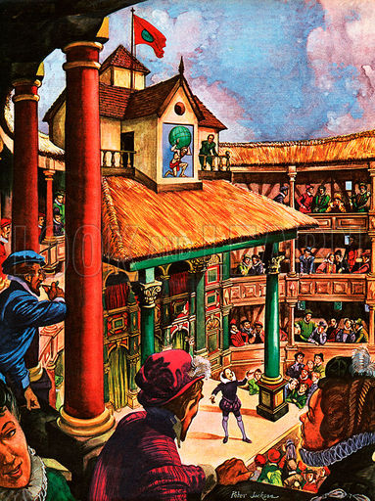

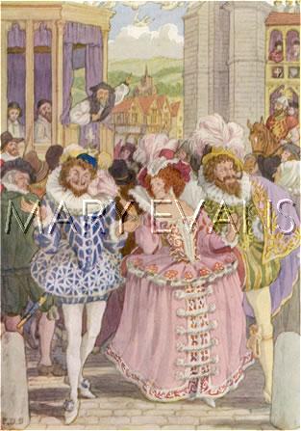
Puritans against the theatre
A modern illustration showing a church minister criticising Elizabethans on their way to the theatre.
John Stockwood, a Puritan preacher said in a London sermon in 1578, ‘Will not a filthy play, with the blast of a trumpet, call together a thousand when an hour’s tolling of a bell brings to the church only a hundred people?’

The power of the Play – Censorship in Elizabethan times
Although Queen Elizabeth enjoyed plays as ‘harmless spenders of time’, her Privy Council realised the potential of plays for propaganda or treasonable slander which is why all plays had to be approved (censored) by the Master of the Revels before performance or publication.
In 1597 a play ‘the Isle of Dogs’, written by Thomas Nashe and Ben Jonson, and performed by the Earl of Pembroke’s men at the Swan Theatre in Bankside, was immediately banned by the Privy Council and three of the actors arrested. No copies of the play survive but it was thought that the satirical comedy had made slanderous comments about the Queen.
The early history of ‘Richard II’ also suggests that plays had political power. A play that dramatised the deposing of a king was seen as so potentially subversive to the state that the first three editions were published without the abdication scene. Plays also had a part in the Essex Rebellion of 1601 that arose from the rivalry at Court between the Essex and Cecil factions. Shakespeare admired Essex who had been sent to Ireland in the spring of 1599 and hoped that the Earl would return from Ireland as successfully as King Henry had returned from the Battle of Agincourt in France in his play `Henry V` first published in 1600.
The Globe and Essex’s Rebellion
An extract adapted from ‘Art made tongue-tied by authority – Elizabethan and Jacobean Dramatic Censorship’, by Janet Clare, (1999).
In June 1599 the Archbishop of Canterbury and the Bishop of London banned the printing of English history without the Privy Council first agreeing, and emphasised that no satire or play should be printed without its authority. This restriction was imposed immediately after the controversial publication of John Hayward’s ‘The First Part of the Life and Reign of King Henry IV’, which resulted in the banning of the book, the trial of its author, and his imprisonment for 3 years. The initial objection was that the book was dedicated to the Earl of Essex. Hayward added the dedication after the book had been licensed as a way of avoiding literary censorship.
Essex, opposed by the powerful Cecil faction at Court, was in the Queen’s disfavour even before he left in July 1559 for his ill-fated campaign against the Earl of Tyrone in Ireland. According to one observer it was ‘muttered at court that he and the Queen have each threatened the other`s head; undoubtedly all kindness is forgotten between them.’ At Hayward’s trial in February 1600 he was interrogated by Lord Chief Justice Popham in a way that showed that the Crown was more worried about how the history had been written than its dedication to Essex. Hayward was accused of distorting the history of Henry IV to criticise Elizabeth’s own Irish campaign – the authority for it, and the heavy taxation to pay for it. Popham commented ‘this history would be very dangerous to come amongst the common people’.
By the time of Essex’s trial in February 1601, which followed his failed rebellion, it was generally accepted that Hayward had written a history which mirrored the Earl’s career and Essex`s opponents used this to draw up the charges against him. In a speech to the Star Chamber, Robert Cecil gave his version of Essex’s plan which involved a pact with Tyrone who would land in England with 8000 men to ‘put the Queen aside, and make everyone a prey to Irish soldiers.’ Yet Cecil’s vivid exaggeration of what was really an uncoordinated rebellion gained support from Hayward’s history which told of the deposing of King Richard II by Henry IV. Although Essex denied any treasonable intention against Queen Elizabeth and rejected Cecil’s allegations, it made no difference. The Elizabethan government was therefore able to exploit Hayward’s history for its own purposes as evidence against Essex and the objectives of his rebellion. Hayward’s History had proved useful ammunition for those who sought to destroy the Earl of Essex.
Essex and his faction had, of course, played into the hands of their accusers by watching a performance of Richard II by ‘The Chamberlain’s Men’ on the eve of their rebellion. That they chose to begin their uprising by crossing the river to ‘The Globe’ to attend a play showing the successful removal of a monarch was entirely consistent with an uprising which, according to one historian, was more suited to the stage of ‘The Globe’ than the streets of London. But their attendance made real the fears that lay behind the censorship of plays - that the stage was capable of fuelling rebellion. Although we may realise the hopeless theatricality of Essex’s attempt to seize power, at the time its defeat was seen as a deliverance from national disaster. The Privy Council ordered sermons against Essex`s rebellion to be given which recalled the fate of Richard II, and concluded that Essex posed a greater threat to the country than anything that had happened since, including the Northern Rebellion of 1569 or the Spanish Armada of 1588.
It was, of course, beneficial for the Cecil faction to exaggerate the danger from Essex as a means of showing both its loyalty to the Queen and, by implication, its approval of the proposed succession of James VI of Scotland. Curiously, the involvement of ‘The Chamberlain’s Men’ in the events leading to Essex’s desperate bid for the Crown did not produce any reprisals against the professional theatre. Although Augustine Phillips, one of the actors, had to testify to Sir Edward Coke that pressure to perform the play came from the Essex faction, the company were not charged. According to Phillips, ‘The Chamberlain’s Men’ were not keen to perform the play because it was so old and so long out of use that they anticipated only a small audience for it. However the fee of 40 shillings, ‘more than their ordinary takings’, won them over and they staged the play. Sir Edward Coke was persuaded that the theatrical company performed for financial reasons and that they were not accomplices in Essex`s schemes. Since the House of Commons had withheld their support from what was an exclusively aristocratic uprising, the government may have seen no reason to penalise the popular theatre by placing further restrictions on its operations.
In other respects, though, Essex’s downfall did have consequences for dramatic censorship as for several years there was increased vigilance towards plays which might revive memories of his popular appeal. Playwrights had to be careful what they wrote about and dealing with the careers of royal favourites was clearly a topic to be treated with caution.

Shakespeare and The Globe

An extract adapted from ‘1599 – A year in the life of William Shakespeare’ by James Shapiro (2005).
The Globe Theatre was critical to Shakespeare’s artistic breakthrough. Had plans to remove the timbers of the theatre and transport them across the river fallen through, the history of English literature would have been very different. Until the building of ‘The Globe’, audiences could expect to see more or less the same kinds of drama performed at all theatres. This was now no longer the case, as with the completion of ‘The Globe’ in 1599, individual theatres were increasingly identified with particular kinds of play. Having removed raucous jigs and improvisational clowning, ‘The Chamberlain’s Men’ succeeded in positioning themselves somewhere between the popular offerings of rival adult companies and the more up-market offerings of the boy companies associated with cathedrals such as St Pauls. They could only do this because of the breadth of Shakespeare’s appeal – his ability to write plays that were intellectually rigorous, yet pleased all.
My summary

This fresh start at ‘The Globe’ motivated Shakespeare to challenge both actors and spectators (after 1599 Shakespeare stopped calling playgoers ‘auditors’ and switched to ‘spectators’ perhaps signalling that his was a theatre that would offer more in the way of visual spectacle). He started placing greater demands on his leading players: the physical and psychological challenge of playing a role like Hamlet was daunting even for a star like Burbage. Audiences, too, would be challenged – and rewarded – with more difficult language, more complex characters, and on occasion, with provocative and experimental plays, like ‘Troilus and Cressida’.
My summary

Question planning
‘The theatre reflected wider changes in Elizabethan society.’ How far does your study of the Globe Theatre support this statement? Explain your answer. You should refer to the Globe Hall and your contextual knowledge. (16 marks)
(secular theatre, Puritans, wealthy patronage to show status, fear of vagrants, aging Queen and rebellion)

‘The main reason for supporting theatre in Elizabethan times was to show off wealth and connections.’ How far does a study of The Globe support this statement? Explain your answer. You should refer to The Globe and your contextual knowledge. (16 marks)
(wealthy patronage to impress queen, protest, pleasure, great work, no religious plays)

Epilogue
In 1613 during a performance of `Henry VIII` (written in 1612) a cannon set fire to the thatched roof of the Globe and the building was burnt to the ground. It was speedily rebuilt and reopened in 1614 but was closed again in 1642 by order of a Parliament under Puritan influence. The landowner, Sir Matthew Brend, demolished it on 15 April 1644 and built houses on the site. A replica was built near the original site in the 1990s and open for its first full season in 1997.

A photograph of a performance inside the reconstructed Globe theatre.
