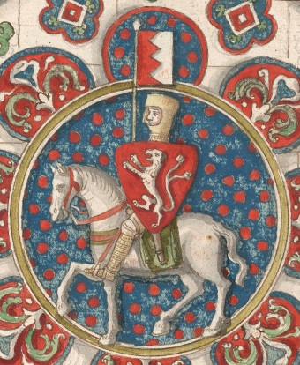
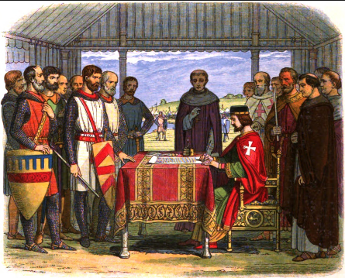
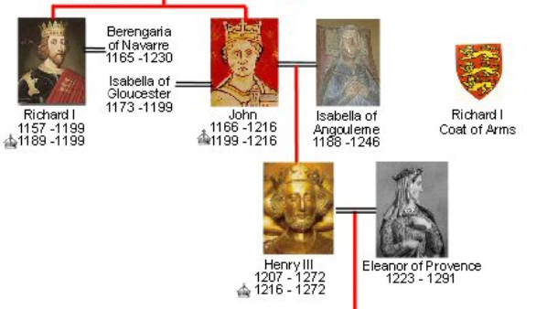

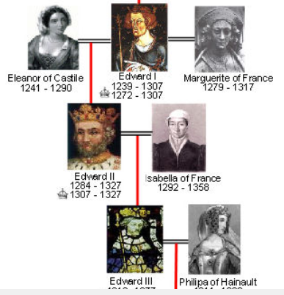

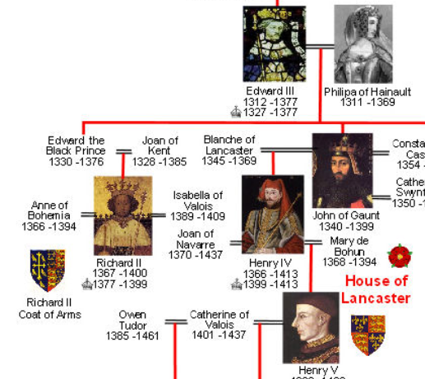
AQA GCSE Revision Booklet
Power and the People
Part 1 - Medieval World
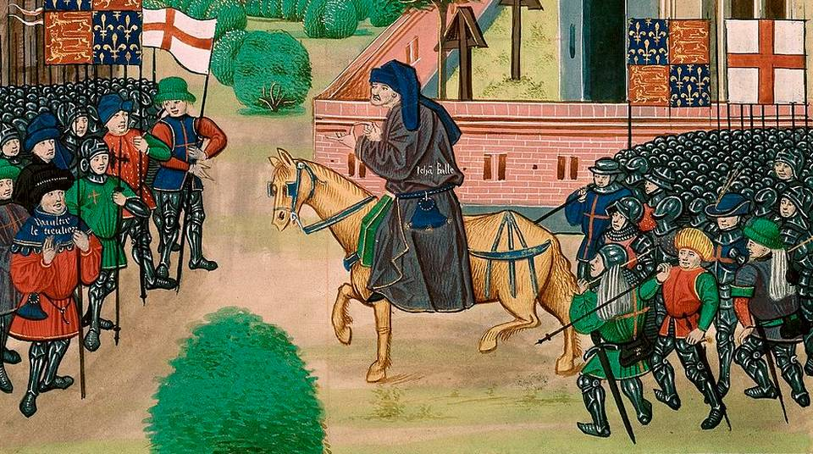

Magna Carta – First Barons’ War
Basic stuff – don’t go into the exam without at least knowing this much!!!
- King John not a very well-liked king. Too many taxes. Rubbish at fighting wars (nickname = Softsword).
- The barons raised an army to threaten to go to war with King John to get him to mend his ways.
- Result = Magna Carta (Great Charter) list of 63 rules for Kings to live by. Gave the barons more say in how the country was run (but not the ordinary folk!)
- Clause 61 said that a group of 25 barons would be created to monitor the king and ensure he stuck to the Magna Carta.
- John signed it on 19th June 1215 at Runnymede but had no intention of sticking to it. He was stalling for time.
- The Barons’ declared war on John and invited the French Prince Louis to be king instead (but they changed their minds when King John died in 1216 and instead they made his son Henry III agree to the Charter.)

A bit more depth on Magna Carta and the First Barons’ War
 | Causes | Events
Individuals  (Don’t use Kings as individuals) | John fell out with the Pope over the appointment of Stephen Langton as Archbishop of Canterbury (top job in the church) - John didn’t want Langton. | The barons put an army together under the leadership of Robert Fitzwalter.  Stephen Langton helped the barons to write the Magna Carta.
War & Violence | John had fought wars with the French and lost all of his land. They called him ‘Lackland’ and ‘Softsword’. The King wasn’t just losing his own land but the Barons’ land in France too. | King John signed the Magna Carta to stop the Civil War but when he went back on his word war was declared. The barons had the support of the French King and John had the support of the Pope. The barons took control of London while John organised his army in Dover. In between these two towns was Rochester Castle which the barons occupied. In Oct 1215, John’s men arrived with 5 siege engines, but these were ineffective against the thick walls of the castle. Then John tried to starve the barons out, but this didn’t work. Eventually John succeeded in mining under one of the castle walls and collapsing it. The siege was over by 30th November 2015. John’s fortunes changed in May 1216 when the French Prince Louis arrived with troops in Kent. John fled Southwest and Louis was able to take control of most of England.
Economic | Richard I (John’s big brother) had left John in debt because of his wars with France.  High taxes – Scutage – knights had to pay this if they wanted to avoid fighting in wars.  The loss of lands in France cost the Barons money. | Magna Carta said lots about money but one of the clauses was, “no scutage shall be imposed on the barons except with the common counsel of the realm” which means that he couldn’t ask for tax without checking with them first through the Great Council.  During the Civil War John took land from the rebel barons and gave it to his supporters.
Government | King John not a very good king and not listening to the Great Council. | On several occasions the barons had drawn up a list of complaints but he refused to change. At Runnymede he had no choice but to sign the Great Charter.  With the support of a Foreign power the barons could have defeated John. Prince Louis was announced [but not crowned] king at St Paul’s Cathedral on 2nd June 1216. Even the Scottish King Alexander II swore allegiance to Louis.  When John died in October 1216 everything changed. They decided to make John’s young son Henry the King and his regent, the Earl of Pembroke called for all Englishmen to defend the country against Louis. Henry III became king and the Magna Carta was reissued. Young Henry had to agree to the conditions.
Religion | As a result of the quarrel over Stephen Langton the Pope banned church services in England – including marriages and funerals. People were afraid that if they didn’t go to Mass regularly they would go to Hell. | Magna Carta said “The English Church shall be free to make its own appointments.”  Stephen Langton – Archbishop of Canterbury was the man who helped the barons to write down the Magna Carta
Ideas | Barons believed that they should be consulted about how the country was run. This conflicted with John’s ideas about the Divine Right of Kings. | Magna Carta said that “No freemen shall be arrested or imprisoned without a proper trial and according to the law of the land.” This is known as Habeas Corpus.
Communication | John was not consulting with the Great Council. | Magna Carta was a written document and it laid down 63 rules for John and future kings to follow.
Chance

Significance of Magna Carta
You must revise at least 2 (and even better 3) different aspects of significance for each event. These can be long-term, short-term, direct, indirect, significance to different social classes or to people in different countries.

Significance to the government of England
It is safe to say that the power of the monarch was limited after the signing of the Magna Carta. However, the King could go against it if he wished. This was true of Henry III’s reign. It was not until 1295, during the reign of Edward I, that there was a parliament that represented people other than the barons.

Significance to the development of Ideas
Habeas Corpus is still a significant right in British Law to this day. Some historians argue that Magna Carta was a base for future freedom and justice, others argue that it was just a negotiation between John and the barons. It was only in the long term that its significance became clear.
Significance to different groups (Short-term significance)
It is widely accepted by historians that Magna Carta was not important to all of the people of England at the time. It only referred to Freemen, such as barons; peasants and villeins were not free. The barons were looking out for their own interests when they drew up the Magna Carta and only included the Church and merchants because they needed to get more support against John. Magna Carta changed nothing for the ordinary people of Medieval England. John was perhaps unlucky that the people who could read and write at the time were churchmen and the Barons so we tend to only hear their side of the story from the source material.
Long-term – wider significance
As the years have passed, Magna Carta has developed greater significance. It applied to more people as they gained their freedom. It introduced the idea that there were some laws that even the king had to follow. After King John died, other kings signed similar versions of the Magna Carta. Magna Carta was used to draw up their constitution when they became independent from Britain in 1776. It influenced the Chartist movement and the Suffragettes. When the Universal Declaration of Human Rights was adopted in 1948, it drew upon Magna Carta, as well as the Bill of Rights (1689) and others, for inspiration.
The Second Barons’ War – Simon de Montfort and Henry III
Basic stuff – don’t go into the exam without at least knowing this much!!!
- Henry III was only 9 when he became King and the barons forced him to agree to the terms of the Magna Carta.
- When Henry grew up (taking full personal control in 1234) he started to behave a bit like his dad and the barons were not happy.
- Simon de Montfort was a powerful baron (his family had come over with the Norman Conquest 1066) and he was married to the sister of King Henry III (Eleanor). He had lost land (in war) and he wanted it back.
- Simon de Montfort led the barons to calling a Great Council in 1258 where the king was required to agree to the Provisions of Oxford.
- The Provisions of Oxford gave the barons more power and led to another civil war known as the Second Barons’ War
- There were two important battles but actually fighting was much more widespread during the Second Barons’ War.
- The Battle of Lewes 1264 was important because Simon de Montfort’s side won and they captured Henry III and imprisoned his son Edward. After this Simon was briefly the ruler of England.
- Whilst Simon de Montfort was in charge he called the Great Council in 1265(not quite a parliament yet) and to boost his support he invited burgesses and knights from every county – these were known as commoners and it’s where our House of Commons comes from (although the peasants and the villeins still weren’t being included). Because of this Simon has been given the title the ‘father of democracy’ but he might not really deserve it.
- The Battle of Evesham August 1265 was important because this time Henry III and his son Edward were victorious. Simon de Montfort was chopped into bits and the bits were sent round the country to serve as a lesson to others.
- Henry ruled until 1272 and never called another meeting of the Great Council. But when Edward became Edward I he had learned from the Second Barons’ War. In 1295 he called the Model Parliament. Lords were invited to attend and the commoners were elected.

A bit more depth on Simon de Montfort and the Second Barons’ War
 | Causes | Events
Individuals | Simon de Montfort led the barons to call for the Provisions of Oxford in 1258.  Richard de Clare (Earl of Gloucester) and other older barons felt that the Provisions interfered too much in their local interests.  Peter de Roches, a French man was Henry’s tutor and adviser. The barons were not keen on his influence. | Simon de Montfort led the barons who called the Great Council against Henry in 1258. During the Great Council meeting, the king agreed to the Provisions of Oxford.
War & Violence | Henry III increased payments to the Pope Innocent IV to help the Pope fight wars in Europe. This meant an increase in taxes for the barons.  In 1230, Henry took his army to Brittany and Gascony. He lost the campaign and returned to England. In 1248, de Montfort went out to France and was successful but Henry was not happy with the amount of force that he was using. When Henry insisted on sending his son Edward to France to be in charge of the campaign instead of de Montfort, Simon was furious. He felt so let down that he considered fighting with the French against the King! | Having rejected the Provisions of Oxford Henry ruled for 3 years before the barons sent for de Montfort. De Montfort returned and started the Second Barons’ War. England was in the midst of another Civil War. De Montfort and his men were victorious at the Battle of Lewes in 1264. De Montfort captured the king and imprisoned his son, Prince Edward.  When de Montfort called a Council in 1265 that included commoners the Barons had had enough and they released Prince Edward who then raised an army. On 4th August 1265 at the Battle of Evesham de Montfort was defeated.
Economic | Taxes were high due to Henry’s support of the Pope’s wars in Europe.  Henry also raised taxes to fund his campaigns to win back the land his father had lost in France. | When de Montfort was in charge the barons felt that they were losing their lives of influence and money.
Government | Henry had close ties with the French, due to his marriage. The barons didn’t like this and they liked it even less when Henry started to allow French men into parliament. | The Provisions of Oxford stated that from that point on a council of 15 barons would be in charge of the Great Council. They would be elected by 24 men: 12 appointed by the king and 12 by the barons. The main points agreed in the Provisions were that foreign members of the royal household would be banished, castles would be held by Englishmen and each county would have a sheriff and taxes would be decided locally. The Provisions gave the barons the majority of power as it said that they could make decisions without the king but the king could not make decisions without them. The Provisions were extended in October 1259, with the creation of the Provisions of Westminster. These reformed local government and many barons resented them. The barons were now divided.  The bickering barons led the way for Henry to reject the Provisions of Oxford. In 1261, the Pope confirmed that Henry could be released from them. He appointed his own men to the council. De Montfort went to France in disgust.  After 3 years of Henry’s rule the barons sent for de Montfort. De Montfort returned and started the Second Barons’ War.  After the Battle of Lewes Simon de Montfort assumed control. Some barons began to get worried that he was too powerful. Not all of the Barons supported the new system of the Great Council (de Montfort had appointed his own friends and allies to the council). Simon reconfirmed Magna Carta and the Provisions of Oxford. In 1265 de Montfort was worried that he was losing his grip and called a meeting of the Great Council to which he invited burgesses and knights from every county. The burgesses represented the growing merchant classes. So ordinary people – sometimes known as commoners – were being heard for the first time.
Religion | Henry was a pious king. The Pope convinced Henry to help him try to remove the royal family of Sicily. When Henry failed to pay the money he had promised to the new Pope Alexander IV, the Pope threatened to excommunicate him (and all of the English with him).  Henry III gave away top jobs in the church to Italian clergy. This stopped English men being promoted in the Church. | The Pope in 1261 intervened and told Henry III that he could be released from the Provisions of Oxford. This allowed him to continue ruling for another 3 years.
Ideas | The barons wanted more influence over how the king was running the country. | The Provisions of Oxford were a significant step because they gave the majority of power to the barons and not the king.  The Provisions of Westminster went further in forcing the barons to listen to their tenants.  De Montfort’s idea to invite commoners to the Great Council was too much for many of the barons to stomach.
Communication | Henry was taking advice from Frenchmen instead of English barons. | When de Montfort appointed his own friends and allies to the Council the barons felt like they were not being listened to.
Chance

Significance of the Second Barons’ War and Simon de Montfort
You must revise at least 2 (and even better 3) different aspects of significance for each event. These can be long-term, short-term, direct, indirect, significance to different classes of people or different countries.
Significance to the government of England
Although the Provisions of Oxford themselves didn’t last they had set a precedent for the barons having more power than the king. The Provisions stated that the barons could make decisions without the king’s presence or approval. Moreover the king could not make decisions without the approval of the Council. The Provisions had a real impact on royal authority.
Simon de Montfort’s Great Council of 1265 was also an important first. By inviting burgesses he was introducing the voices of the commoners to the government of England. Henry ruled from 1265 to his death in 1272 without ever calling another Great Council. However, when Prince Edward became King Edward I, he knew he would have to behave differently. He had learned from his father and his grandfather’s mistakes. When Edward needed money to fight the Scots he knew that he would have to negotiate with the barons instead of demanding the money. Therefore, he called many parliaments to raise the funds required. In 1295 he called what would be known as the Model Parliament. This was the Parliament that most resembles ours today. The lords were invited to attend but the commoners were elected. This was still not perfect as only the elites of society, such as the barons, could voter, and voting was not done in secret.

Significance to the development of Ideas
The Provisions of Oxford made important moves towards the barons having more power than the king. The Provisions of Westminster went even further requiring the barons to listen to the demands of their tenants.
De Montfort’s idea of inviting commoners to the Great Council was an important new idea that would be copied by Edward I.
Edward I had also learned that he would not be able to demand taxation without consulting first with his barons. This was an important step towards later ideas of ‘no taxation without representation’ in the American War of Independence.

Significance to different groups (Short-term significance)
In the short term the Second Barons’ War and Simon de Montfort did not change very much. Simon had a brief period where he was in charge and England was on its way to becoming a Republic BUT that is not what happened in the long run. Henry returned and ruled without the Great Council. For the Barons they had shown the new king Edward I that they would have to be listened to in the future. For the commoners, although some of them were represented in the Model Parliament of 1295 this did not apply to the lowest groups in society. Burgesses were a bit like the middle classes at this time and they had been recognised by the elites as worth listening to. The vast majority of the population would still have been peasants or villeins with very little power or voice in how the country should be run.

Long-term – wider significance
De Montfort’s parliament (Great Council) was not perfect, and parliament and its power would continue to change through the Middle Ages. The king’s power was not totally challenged until the English Revolution when Parliament gained more control than the monarch in 1688. Regardless, what most people agree is that de Montfort was influential in the common man’s growth in power; however, women had to wait a few hundred years more for their voices to be heard.

The Peasants’ Revolt
Basic stuff – don’t go into the exam without at least knowing this much!!!
- The Black Death (1347-1350) killed around half of the population of Europe and poor people were affected more than the rich. This led to a shortage of labour and it changed the relationship between the employers and the employed. Peasants started to move to landowners who would give them better pay and conditions.
- The Statute of Labourers, 1351 was a reaction by the landowning classes to the changes after the Black Death. The Statute said that the peasants had to stay put in their own village (or go back to it) and work for pre-Black Death wages.
- The Hundred Years War between France and England was expensive for the English Kings and led to the introduction of poll taxes. By 1380 every person over the age of 15 had to pay four groats per year to the king. This was a lot of money for a peasant.
- Priests like John Ball and John Wyclif preached that the Church had been exploiting (taking advantage of) the peasants.
- In 1381 the peasants had had enough and started a revolt against the system.
- The leader of the Peasants’ Revolt was Wat Tyler and the king at the time was Richard II who was a child of 14.
- The Peasants’ reached London and murdered some of Richard’s closest advisers. They were more angry with the advisers than with the king to whom they were loyal. They wanted Richard to listen to them and help them.
- Richard II bravely met with Wat Tyler and listened to their demands. He calmed the peasants with promises and many of them went home. When some of the peasants carried on fighting, Wat Tyler met the king again and was killed by one of the king’s men.
- After the revolt Richard did not keep his promises. The rebel leaders were rounded up and hanged.

A bit more depth on Simon de Montfort and the Second Barons’ War
 | Causes | Events
Individuals | John Wyclif and John Ball were priests who preached that the church was exploiting the peasants.  John Bampton was the King’s tax collector.  Thomas Baker said that the villagers would not pay any more.  Wat Tyler was the leader of the Kentish rebels and ultimately the representative of all the peasants to the king.  Robert Hales (the King’s Treasurer) and Simon Sudbury (Archbishop of Canterbury) were the hated advisers to the king. John of Gaunt was the King’s uncle and was doing most of the ruling of England. He was very much hated too. | John Bampton, the King’s tax collector, arrived in Essex to collect unpaid taxes. Thomas Baker said that the villagers would not pay any more. Bampton tried to arrest Baker but was resisted by the villagers. The tax collectors were forced to flee.  Robert Hales and Simon Sudbury were murdered in the Tower of London. John of Gaunt’s Savoy Palace was burnt down but luckily for him he wasn’t in London at the time.
War & Violence | The Hundred Years War (1337-1453) between England and France was expensive. English kings were forced to demand more and more taxes to pay for these campaigns. | The peasants armed themselves and set off towards London, reaching Aldgate on the 13th June. They reached Blackheath on 12th June. Several thousand armed men now threatened the City of London and the Government. Many in London supported the peasants and opened the gates to let them in. The Savoy Palace was attacked and burned to the ground.
Economic | The Peasants were forced by the Statute of Labourers to return to their original farms and work for whatever pay and conditions their landlords chose to give them. Wages were pre-Black Death levels. The peasants had got used to more.  The Poll taxes were being charged every year and by 1380, every person over the age of 15 had to pay four groats a year. This was a lot of money for the peasants and they couldn’t afford to pay the taxes and live. | More and more villages refused to pay the Poll Tax.  The rebels had clear targets in London – royal officials, wealthy churchmen, and records of land ownership and debts were the priority.
Government | The King Richard II was very young and his advisers were very unpopular. Especially his uncle John of Gaunt who was one of England’s most hated landowners. | The King’s hated advisers were murdered – Sudbury and Hales.  The rebels were easily able to get into the Tower of London. The King was only a child and in real danger. His mother was in the Tower of London at the time and the rebels left her alone. They were clearly not trying to remove the royal family.  Prisons were attacked and prisoners released.  Richard II bravely met with the rebels at Mile End. He was presented with a list of demands. Richard promised to talk again on the next day. On 15th June Richard met them again at Smithfield. Wat Tyler made further demands on the king. Some observers said that he was rude and abusive. One of the King’s men stepped forward and stabbed Wat Tyler. For a moment it looked like fighting would break out but Richard rode forward and addressed the peasants directly. He told them to go home, as all their demands would be granted. He said ‘Will you shoot your king? I am your leader, follow me!’ The peasants calmly followed Richard out of London and went home.
Religion | John Ball and John Wyclif argued that the pardons that the church sold to the poor were wrong and that the church should not have so much wealth when others were starving. | The rebels targeted wealthy churchmen in London. They murdered Simon Sudbury the Archbishop of Canterbury. The Kentish rebels freed John Ball from Prison.
Ideas | John Ball said that everyone was equal in the eyes of God and so there should be no rich or poor – everyone should have the same. The King was clearly worried about this challenge to the whole feudal system and locked Ball up in prison. | The Kentish rebels freed John Ball from Prison.  The demands handed to Richard at Mile End included handing over corrupt officials, the abolition of serfdom and unfree tenure, an amnesty for rebels and a return to the ‘law of Winchester’.
Communication | Once the revolt against the poll taxes began in Essex, it’s surprising how quickly communication spread from village to village, and county to county. Armed men banded together for protection and safety. | Word of the protest spread rapidly around Essex.  Richard was remarkably brave in meeting the rebels twice and ultimately it was his actions in talking to the crowd and leading them away that diffused the whole situation.
Chance | It was chance that led to the Black Death spreading across Europe and killing half of the population. This led to peasants tasting a new freedom to move from place to place looking for better working pay and conditions. When the government tried to reverse this change the peasants weren’t happy. | John of Gaunt was lucky to not have been in London at the time.  Richard II was perhaps lucky that his bluff paid off. The peasants could easily have overpowered the king and his men if they had wanted to. Richard was only a boy.

Significance of the Peasants’ Revolt
You must revise at least 2 (and even better 3) different aspects of significance for each event. These can be long-term, short-term, direct, indirect, significance to different classes of people or different countries.

Significance to the government of England
The significance to the government of England was not great. The peasants went home and the King went back on all his promises, this was not new. The leading rebels were also harshly punished. This was not new either. However, Parliament gradually got the message that they should not try to control the peasants’ wages.

Significance to the development of Ideas
Some historians believe that the revolt was unnecessary. They suggest that society was already changing and that serfdom was coming to an end. Socialist historians believe the revolt was significant because it was the first working-class rebellion. This, they believe, marked the beginning of English ideas of freedom. Certainly the ideas put forward by John Ball about all men being equal were revolutionary and were to reappear in the American Declaration of Independence in 1776.

Significance to different groups (Short-term significance)
The revolt was not a total failure. The Poll Tax was never repeated, although there were similar charges, and taxes were never as high again. Worker’s wages began to rise, as the situation from before the revolt was still the same: there was still a lack of workers, so the peasants could demand higher wages. The landowners paid up, as they needed the workers. The demands of the rebel peasants were further realised when some were able to buy their own land, because there was so much unused after the Black Death. This freed them from having to work the lord’s land. Gradually peasants became independent and within 100 years they were freemen.

