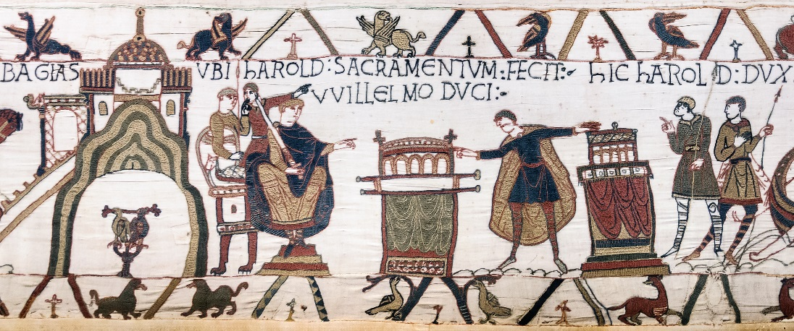
Year 11
Revision Booklet 1 – Paper 2
Norman England 1066-c1100
Conquest and Control
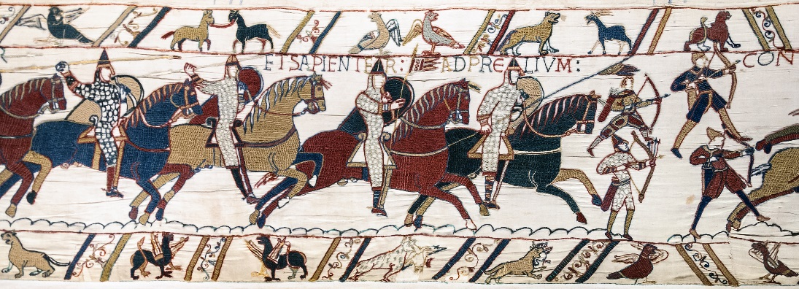

The Succession Crisis in 1066
Question: Explain why there was a succession crisis in 1066? (8 marks)
Top tips
- Write 2 P.E.E. paragraphs in 10 minutes.
- Write about at least two important consequences
- Make sure that you clearly ATBQ!! What was important about……?
- Try to evaluate the level of importance as you go along –
- You should not need to use the first person but assert your viewpoint firmly using detailed evidence to back up your assertions.

Useful phrases for this type of question
There were several consequences…
Also very important was…
It could be argued that…
This was important because…
This was a major change….
Example of possible paragraphs:
- England had a troubled history in the 50 years before 1066:
  - The VIKINGS, NORMANS & the EARLS OF WESSEX were all interested in ruling England:
    - Vikings had invaded in 1013, killed Aethelred, the King and Canute ruled for 20 years. Aethelred’s wife, Emma (of Normandy) and sons (Alfred & Edward) flee to Normandy.
    - Aethelred’s widow, Emma is forced to marry Canute and her sons stay in Normandy, protected by their uncle Richard Duke of Normandy. So, the Normans keep some influence in England.
    - Canute divides England into 4 Earldoms, the Earl of Wessex is the most powerful. (Earl Godwin) In 1063 Godwin dies and Harold becomes Earl of Wessex.
- Edward the Confessor had been a weak ruler:
  - Became King in 1043.
  - Relations between Edward and the Godwins was tense! They rebelled in 1051 and were exiled.
  - The Witan forced Edward to restore Godwin.
  - Edward became less interested in ruling, Harold Godwinson increased his power.
- There were no rules in place for the succession
  - Edward had no children so no heir.
  - Usually a combination of force, luck & powerful friends decided who ruled.
- There were 4 claimants to the throne in 1066:
Edgar Aetheling:
- Age 14
- Nearest blood relative to Edward the Confessor
- BUT no money, no soldiers, no military experience!
Harald Hardraada:
- Experienced ruler: King of Norway for 20 years
- Believed that Edward the Confessor had taken the throne from his father Magnus in 1042
- Good warrior
- Had the support of Tostig (Harold Godwinson’s brother)
William, Duke of Normandy
- Illegitimate son of Richard of Normandy, so he was a distant cousin of Edward the Confessor.
- Strong links between Normandy and Wessex: Trade & marriage of Emma of Normandy to Aethelred and Canute.
- William had helped Edward the C when the Godwins had rebelled in 1051. Edward seems to have promised that William would inherit the English throne.
- Claimed that Harold Godwinson had sworn an oath in 1064 that William would be the next King.
Harold Godwinson, Earl of Wessex
- One of Harold’s major achievements before 1066 was that he put an end to widespread violence and rebellion in Wales on behalf of King Edward.
- Between 1055 and 1063 he and his brother, Tostig, led a series of military campaigns in Wales to end the violence caused by the local princes.
- Harold developed strong links with the church, founding the abbey at Waltham in Essex and going on a pilgrimage to Rome.
- Harold also won allies in the east of England because he made an unofficial marriage (Danish Marriage) with a rich landowner in the region, Edith Swan-neck, (lasted at least 20 years and had at least 5 children).
- However, at the beginning of 1066, Harold made an official marriage (in a church) to a different Edith, sister of Morcar, Earl of Northumbria, and Edwin, Earl of Mercia.
- Harold’s Oath
- The best-known and most intriguing event in Harold’s life before 1066 was his embassy to Normandy around 1064. Nearly half the space in the Bayeux Tapestry is devoted to Harold’s visit. The story only appears in sources produced after 1066. Most English sources do not mention this visit at all.
- The Norman story:-
Around 1064 King Edward sent Harold to Normandy as his ambassador to confirm the King’s promise of the Crown to William.
Harold’s ship was blown off course and he landed on the land of Count Guy of Ponthieu who captured Harold.
When William heard this news he made sure that Harold was freed.
William and Harold got on really well. Harold helped William to fight his enemies and William gave him a suit of chain-mail and a helmet as a reward.
Harold then took an oath – a promise made on religious relics – renewing the King’s promise to William of the English throne. Harold also swore loyalty to William and promised to help him become King.

- One English writer in the early 1100s, Eadmer, does say that Harold went to Normandy, but went on his own initiative to ask William to free two of his family who were being held as hostages there. Eadmer says Harold was then forced by William to take an oath.
- The Norman sources do not even agree on where Harold took the oath but it probably did take place. The Norman accounts are too detailed to be completely made up!!
- Harold was crowned King on 6th January 1066.
- The Witan crowned Harold the day after Edward died.
- This clearly upset the other claimants to the throne!
Question: How convincing is Interpretation A in showing why William had a valid claim to the English throne? Explain your answer using interpretation A and your contextual Knowledge. (8 marks)
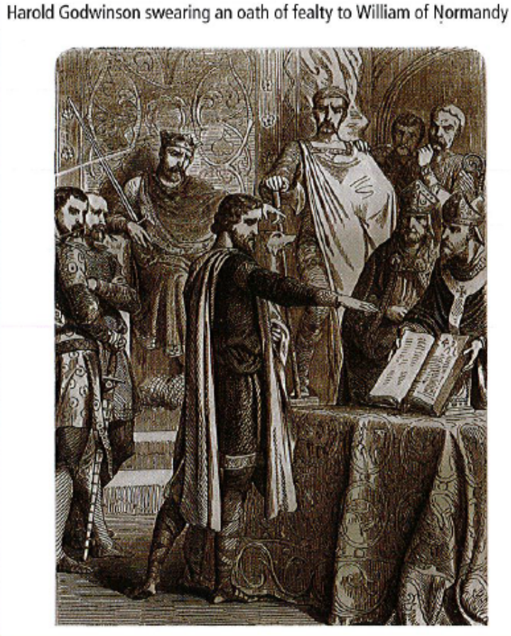
Top tips
- Pick out features from the source and test them against your own detailed knowledge of events.
- Use facts, figures, names and dates to show that the source is convincing or not convincing.
- The source isn’t wrong because it’s an interpretation, so your job is to test how convincingly the historian has used the evidence to support their interpretation.
- 8 marks so spend 10 minutes answering this question.
For example:
The source is convincing in showing why William had a valid claim to the throne.
The Source shows Harold swearing an oath of fealty to William Duke of Normandy. William is shown swearing on the bible. This is convincing because an oath of fealty was considered a sacred promise and this is supported by the bible and the churchmen in the picture. This also corresponds with the picture in the Bayeux tapestry. This is also convincing because William claimed that Harold had visited Normandy in 1064 and had promised under oath to support William’s claim to the throne.
The Source perhaps shows Harold looking less than willing about swearing the oath. This is less convincing because Harold claimed that he had only sworn loyalty to William personally and that he had been sworn to take the oath after he was captured and taken prisoner.

Why did William win the Battle of Hastings?
Question: Explain what was important about the Anglo-Saxon military campaigns between May 1066 and September 1066. [8 marks]

Top tips

- Write 2 P.E.E. paragraphs in 10 minutes.
- Write about at least two important consequences
- Make sure that you clearly ATBQ!! What was important about……?
- Try to evaluate the level of importance as you go along –
- You should not need to use the first person but assert your viewpoint firmly using detailed evidence to back up your assertions.

Useful phrases for this type of question
There were several consequences…
Also very important was…
It could be argued that…
This was important because…
This was a major change….

You may wish to consider two of the following:
- Harold’s army had been released on the 8th September:
  - Impossible to keep 6000 men on the south coast when there was no sign of William. They needed paying & feeding!
  - Harold G went to London and only a few days later Harold G heard that William had moved his fleet along the Normandy coast to wait for a favourable wind.
- The impact of the Battle of Fulford (20th September) on Edwin and Morcar’s armies:
  - Edwin & Morcar gathered an army of 4500-6000 men.
  - Harald H & Tostig had an army of 6000-7500 men & had set up camp in Riccall, south of York.
  - The Saxons had the advantage of high ground and a ford, marshy land & the River Ouse to protect them.
  - However, Harald H managed to cross the ford, push up the bank & also outflank the Saxons.
  - The Saxons were defeated, many drowned in the Ouse & the marshy land. The survivors fled to York.
- The impact of The Battle of Stamford Bridge (25th September) on Harold Godwinson’s army:
  - Harald H had gone to Stamford Bridge to wait for hostages, soldiers & tribute (wealth given as a sign of allegiance)
  - Harold G took Harold H by surprise.
  - Harald H & Tostig were killed.
  - Harold G won.
‘The defeat of the Vikings and the death of Harald at Stamford Bridge was a very important victory for Harold. The Vikings returned home with just 25 ships and …’
- The distance covered by Harold’s army:
  - Harold G had marched the 190 north in 5 days
  - They defeated Harald H but had lost men & were tired.
  - News reached Harold G that William had set sail on 27th September.
  - Harold G had to march south 200 miles in 4-5 days.
‘However, Harold did not have time to celebrate the Saxon victory at Stamford Bridge. News arrived of William setting sail on the 27th September. Harold had to march his men 200 miles south, he had lost men and they were already tired from the battle.’
- The surprise invasion of William:
  - William landed at Pevensey on 28th September
  - Williams troops terrorised the local population
  - William built a castle at Pevensey (they had brought some flat packed!!)
‘This time was crucial for William, he was able to plunder the local area and erect a castle at Pevensey. Meanwhile, Harold was marching south at speed….’

Question: Write an account of why William won the Battle of Hastings.
(8 marks)
Remember that the question wants you to say why William was successful, it is not an account of what happened.
Good connecting words:
- In response…
- As a consequence of…
- This was significant because…
- This increased tension because…

Aim for 2 paragraphs in 10 minutes. You could include:
- How William & Harold had prepared their armies:
Harold:
  - Small band of professional soldiers: The HOUSECARLS
  - If a battle to be fought, called on the THEGNS (lords) to come and fight and bring the FYRD with them (ordinary people)
  - Gathered 6000 men by May 1066 stationed across the south coast.
William:
  - Cavalry, men on horseback. Harold did not have cavalry, his men were used to fighting on foot. 3000 horses.
  - Archers were a key feature of Norman warfare. 7000 soldiers including cavalry & archers.
  - He go the support of the Pope, he was given a PAPAL BANNER to carry into battle.
  - William gathered his army, trained them and waited for a favourable wind. He sets sail on 27th September.
‘This differences in the armies is significant in the final outcome of the battle because William is able to use his cavalry and archers against the English foot soldiers….’
- Harold’s bad luck before the battle:
- Harold waited for 3 months on the south coast for William to arrive. This was expensive and on 8th September he sent them home and he went to London.
- This was bad timing as just days later Tostig and Harald Hardraada were sailing down the north coast from Scotland.
- The Battle of FULFORD GATE 20th September. Earls Edwin & Morcar are defeated by HH.
- Harold had to re-gather his army and march 200 miles north in 1 week.
- HG takes HH & Tostig by surprise at STAMFORD BRIDGE, 25th September.
- HG won, HH & Tostig are killed BUT 3 days later news arrives that William has landed on the south coast.
- Harold has to march south, 200 miles in 4-5 days. He has lost men in battle, they are tired. He has to gather men as he travels south.
‘This bad luck before the battle were significant to Williams’ victory. He has time to prepare his troops whilst HG travels south. HG has also lost men at the Battle of SB and his men are tired from their march south.’
- Events of the battle, leadership, tactics, death of Harold:
- 14th October 1066
- The English seize the hill (Senlac) and the HOUSCARLS form a shield wall. The FYRD are armed with simple weapons like heavy axes, slings etc.
- William has heavily armed Cavalry and he has archers. William is on horseback at huge personal risk.
- The 2 sides are well matched BUT the tactic of ‘feigned retreat’ by the Normans breaks the English shield wall.
- HG is killed and the English realise there is no hope.
‘As a consequence, Williams’s tactics and the death of Harold were crucial in William’s victory. The feigned retreat broke the shield wall….’

William establishes control
Question: Explain what was important about the actions taken by William to establish control of England. (8 marks)
Top tips
- Write 2 P.E.E. paragraphs in 10 minutes.
- Write about at least two important consequences
- Make sure that you clearly ATBQ!! What was important about……?
- Try to evaluate the level of importance as you go along –
- You should not need to use the first person but assert your viewpoint firmly using detailed evidence to back up your assertions.

Useful phrases for this type of question
There were several consequences…
Also very important was…
It could be argued that…
This was important because…
This was a major change….
Example of possible paragraphs:
- Patronage: dealing with the powerful English Lords
- Those who pledged loyalty to William were allowed to keep their land. (Earls Edwin, Morcar & Waltheof)
- Some paid for land, Gospatric paid to be Earl of Northumbria in 1068.
- He seized the land of those who had died at the Battle of Hastings and gave it to the Normans who had fought for him.
- Encouraged English lords to marry Normans.
‘This was important in William establishing control in England because it ensured that he could control all areas of England…’
- Terror:
- 2 weeks after the Battle of Hastings William went to Romney to punish the town for their role in killing Normans. He burned the town and killed key people. ‘This was important because it caused fear and Canterbury, fearful of a violent attack, promised to be loyal to William.’
- The Harrying of the North:
  - 1069 Rebellions in the North captured York.
  - William reacted with mass killings, burning of homes, animals and crops and plundering.
  - Orderic Vitalis claimed that 100 000 were killed. Even if this figure is too high Domesday Book still described lots of places in Yorkshire as ‘waste’ 20 years later.
- Imprisoning & Executing rebellious barons
- Earl Waltheof was beheaded because of his involvement in the Earl’s Revolt in 1075.
- Earl Morcar was imprisoned for life after his involvement in the rebellions in East Anglia 1070-71.
‘As rebellions increased and became more serious and organised William had to use terror to keep control. The Harrying of the North…’
- Military presence: Castle building
- The Normans built castles everywhere they went, particularly in vulnerable areas, so they were strategic.
  - borders with Wales and Scotland
  - the south coast (Pevensey, Dover)
  - Significant towns and cities (London, Nottingham)
  - Rebel areas (York)
- They were also symbolic:
  - Permanent reminder of who was governing!
  - Often they destroyed houses to make space and charged the English taxes to build them and forced the English to build them!
- 1st castles were Motte & Bailey: Cheap and quick to put up.
- Most of these were replaced with stone castles
‘Also very important in William establishing control was military presence, in particular, building castles. These were strategically important…..’

- Concessions
- Offered the Danes generous terms & money if they left England even though they had with a fleet of 240 ships to help the English rebels in 1069.
- Continued to use English for royal writs (instructions from the King)
- Allowed Stigund to remain Archbishop of Canterbury
- Legality: William tried to show he was the legal & rightful king
- Said he had been promised the throne by Edward
- The Bayeux Tapestry shows Harold Godwinson swearing an oath to William.

Question: How convincing is Interpretation A about the importance of castles in early Norman England? Explain your answer using Interpretation A and your contextual knowledge. (8 marks)
Interpretation A: Adapted from Richard Huscroft: The Norman Conquest
Military organisation was therefore crucial to the success of the Norman Conquest. With strong armies, the Kings could defeat their internal & external enemies on campaign. With enduring symbols of military power and might, they could intimidate them into lasting submission. The most potent of such symbols was the castle.
Top tips
- Pick out features from the source and test them against your own detailed knowledge of events.
- Use facts, figures, names and dates to show that the source is convincing or not convincing.
- The source isn’t wrong because it’s an interpretation, so your job is to test how convincingly the historian has used the evidence to support their interpretation.
- 8 marks so spend 10 minutes on this question.
Example: ‘Interpretation A is quite convincing because castles were used to intimidate opposition. They were strategic, ‘could defeat their internal & external enemies’. Wherever there was a major rebellion William would build a castle. He did this at Pickering and York during the Harrying of the North. They were also built in vulnerable areas, including the borders with Wales and Scotland, and the south coast. The building of a castle affected the local population in a number of ways. Often houses were destroyed to make way for the castle to be built. This would show the local population that the Normans were willing to act in a forceful way. Castles also housed troops so the locals would know that if they did try to rebel they risked attack from the troops based in the castle.
Source A is also convincing because it suggests they were symbolic, ‘symbols of military power’. A castle was an imposing building; constructed on a Motte, overlooking the local area it would serve as a constant reminder that the Normans were watching over the local population, this would discourage rebellion.’

