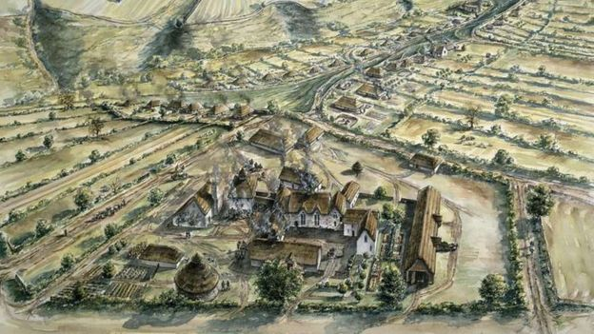
Year 11
Revision Booklet 2 – Paper 2
Norman England 1066-c1100
Life under the Normans
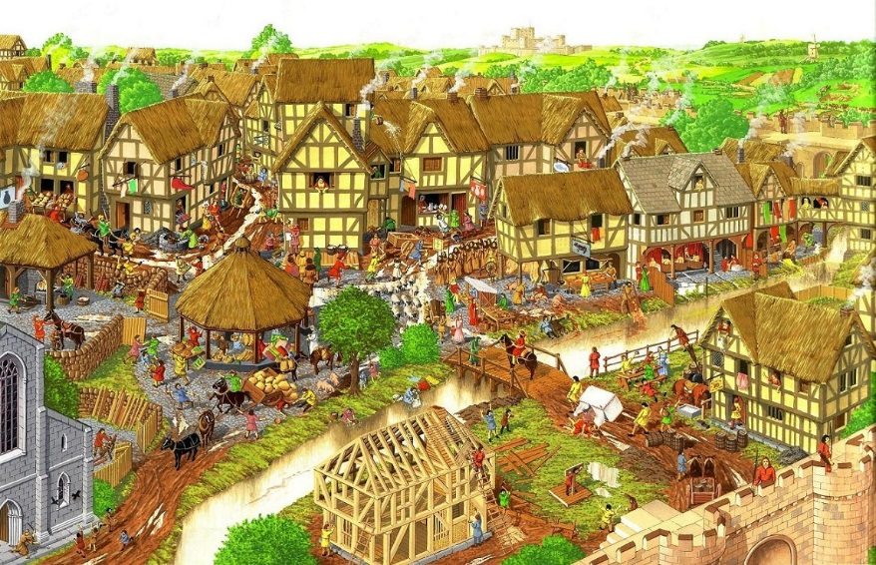

Feudalism & government
Hierarchy under the Anglo Saxons:
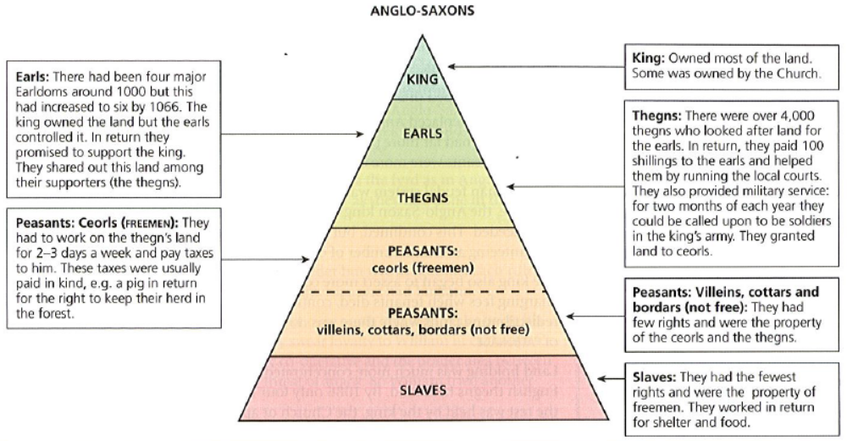
Feudal system under the Normans:
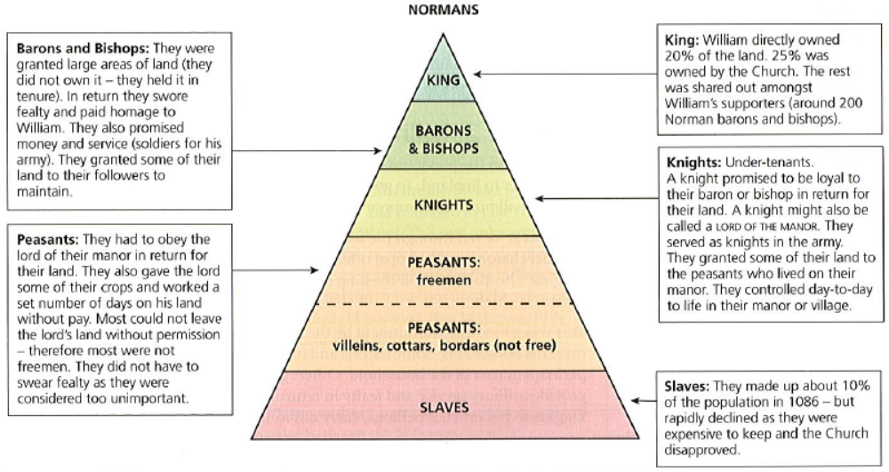

Question: Write an account of the ways in which the feudal system changed under the Normans? (8 marks)
Remember that the question wants you to say how the feudal system changed, it is not an account of what happened.
Good connecting words:
- In response…
- As a consequence of…
- This was significant because…
- This increased tension because…
Aim for 2 paragraphs in 10 minutes. You could include:

- Replacing Anglo Saxon lords and bishops with Normans:
  - William had 200 barons and bishops, mainly Normans who had fought with him at the Battle of Hastings.
- William took over much of the land & made sure no lord could get too much land:
  - In Anglo Saxon England land was in the hands of 6 Earls. They became very powerful. (Earl Godwin)
  - William owned 20% of the land (Edward had only owned 12%), the church owned 25% of the land.
  - William had 200 Norman barons & bishops so they held less land.
  - The barons & bishops did not own the land, they held it in tenure.
  - They also swore fealty & paid homage to William. Anglo Saxon earls had promised to support the King.
  - The Marcher Lords had special powers! For example, they could build castles without the Kings permission & making laws.
- William ensured knights swore fealty & military service was more precise, it was a formal obligation:
  - Each baron offered a certain number of knights.
  - Knights had to carry out military service (c40 days per year). This was different to the Anglo-Saxon Thegns.
  - Knights made an oath to their Lord, this was different.
  - By 1100 there were 5000 knights.
- Little changed for peasants:
  - Had to work for the lord a few days per week
  - Most were not freemen
  - Slaves reduced in number as they were expensive to keep

Norman government & Law:
Question: Explain what was important about the reforms of local & national government for Norman England? (8 marks)
Top tips
- Write 2 P.E.E. paragraphs in 10 minutes.
- Write about at least two important consequences
- Make sure that you clearly ATBQ!! What was important about……?
- Try to evaluate the level of importance as you go along –
- You should not need to use the first person but assert your viewpoint firmly using detailed evidence to back up your assertions.

Useful phrases for this type of question
There were several consequences…
Also very important was…
It could be argued that…
This was important because…
This was a major change….
Example of possible paragraphs:
- The role of the King:
  - William used the coronation ceremony to show how he had God’s approval.
  - 3 x per year when his Great Council met he would wear his crown.
  - His coins showed him wearing a crown.
- The Great Council:
  - Like the Witan before the conquest, William continued to take advice from his leading subjects through the Great Council.
- Patronage:
  - The King could offer land BUT also offices, such as sheriffdoms.
  - The King changed the laws of inheritance. These laws were called Feudal Incidents, this allowed the lord to gather rent from lands for example if a tenant died without heirs or if inherited by a son who was not old enough to own it.
- Government by writ:
  - This continued from Saxon England.
  - Continued to use English.
  - However there were more orders. (change)

- Local government
  - William continued with the efficient Saxon system. England was divided into 134 shires.
  - The power of the sheriff did increase under the Normans and gradually they were replaced by Normans.(change)
  - The Normans created new roles such as the castellans, they looked after royal castles & forests. This role might be performed by the sheriff or the local lord. (change)
- Simplified legal system:
  - Continued with many Saxon features, it worked well and it helped prove that the Normans were legitimate rulers.
  - But William changed it, tried to make it more uniform, simplify it & more consistent across the country.
  - The most important courts continued, they were:
    - King’s court: He was the most important in the justice system. Dealt with serious offences, e.g. Murder.
    - Shire court: Supervised by the sheriff, disputes over land or crimes of violence or theft.
    - Hundred court: Monthly, bailiff in charge. Minor disputes.
  - The Normans introduced a change, a new court:
    - Honourial court (Lord’s court): Lord dealt with his tenants, crimes or property transactions on his land.
  - Law was enforced by a range of people:
    - Constables: power to arrest, break up fights, and prevent fires. Not paid well and many had another job.
    - Watchmen: Most towns had a watchmen, ensured people kept to the curfew. Also able to prevent crime & catch criminals. Usually volunteers or had to do it as a duty, most did not take it seriously.
    - Hue & Cry: Everyone had a duty to raise the alarm if they saw a crime. Everyone who heard the H&C had to help catch the criminal.
    - Tithing: Group of 10-12 freemen. Promised to prevent each other committing a crime. If they failed they were all punished.
    - Mundrum Fine: a new Norman system. If a Norman was killed and the murderer was not found in 5 days then the whole Hundred was fined.
  - Trying of suspects: Cases were brought to court. There was often little evidence so proof was found in other ways:
    - Oaths: Those called to give account had to swear an oath on a holy book or relic. This continued the Anglo-Saxon system but their use declined.
    - Trial by Ordeal: 2 Anglo-Saxon forms continued under the Normans:
      - Trial by cold water: guilty would float and the innocent sink!
      - Trial by hot iron: carry a hot iron in their hand for 3 paces. Hand was bound, after 3 days if it was infected they were guilty, if not they were innocent.
    - Trial by Battle: introduced by the Normans
      - Serious offences.
      - Not used often as the threat usually lead to a confession.
      - If between rich, swords were frequently used.
      - In criminal cases wooden sticks, often with pointed ends were used.
      - Not have to be fight to the death. If one was overcome they could surrender BUT this meant they accepted they were guilty and could be punished by death.
  - Punishment:
    - Serious offences: hanging or mutilation (loss of a limb, blinded, castrated)
    - Compensation: The Anglo-Saxon system of Wergild (all freemen had a price for their life) slowly declined under the Normans.
- The Domesday Book:
  - 1085 William instructed his officials to carry out a survey of all the property & resources of England.
  - The country was divided into 7 circuits, existing information was gathered and officials asked questions. Commissioners visited each Hundred.
  - Findings were presented at the Shire Court.
  - The whole country was not covered: Westmoreland & Cumberland were not controlled by the Normans. London & Winchester were not included.
  - Partially completed in 1086 and presented to William at Salisbury, fully complete under William Rufus.
  - The findings were written up in 2 books, Little and Great Domesday.
  - It was important to sort out who owned the land. Since 1066 land disputes were common & took up court time. Also there was a possible threat of invasion & William may have needed the taxes.
  - More importantly, it would allow William to charge rent and tax people.
  - It marked an important moment in the Norman Conquest, it formally recorded all the changes in power & ownership.
Question: How convincing is Interpretation A about the Norman legal system? Explain your answer using Interpretation A & your contextual knowledge. (8 marks)
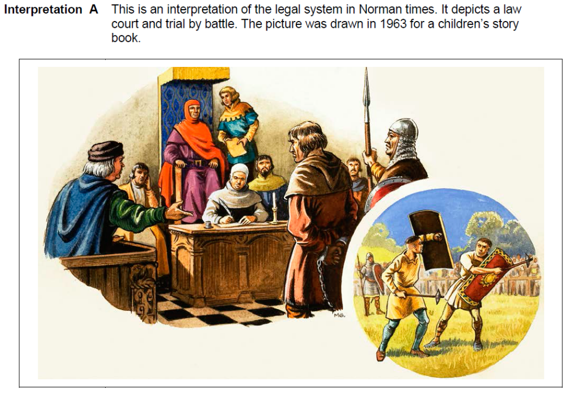
Top tips
- Pick out features from the source and test them against your own detailed knowledge of events.
- Use facts, figures, names and dates to show that the source is convincing or not convincing.
- The source isn’t wrong because it’s an interpretation, so your job is to test how convincingly the historian has used the evidence to support their interpretation.
- 8 marks so spend 10 minutes on this question.
For example:
The interpretation is convincing because it depicts a trial by battle. The Normans introduced duellum which was used to resolve both criminal & civil cases. This was an alternative to some of the established ‘ordeals’ such as trail by water…. Level 2: Simple
It is also convincing because it depicts a formal law court system at work, there were many different types of court in Norman England, not only the Royal Court, but also the various feudal and manorial courts… Level 3: Developed
The paradox of the Norman legal system may be seen reflected in this visual interpretation, in which many of the traits of a modern legal system, such as the emphasis on the presentation of evidence before a judge and trial by jury, sat alongside a brutal, violent and arbitrary system characterised by trail by combat & ordeals… Level 4: Complex

Economic & Social Changes
Question: Write an account of the ways in which the lives of Anglo Saxon villagers stayed the same under the Normans. (8 marks)
Good connecting words:
- In response…
- As a consequence of…
- This was significant because…
- This increased tension because…

Aim for 2 paragraphs in 10 minutes. You could include:
The lives of villagers stayed much the same under the Normans:
- Daily life remained much the same: continuity
  - Daily life revolved around the seasons & the farming year:
    - February: ploughing
    - March: Sowing
    - June: Harvest
  - Most villages had 3 large fields divided into strips.
  - Most common crops: wheat, rye & barley.
  - Cottars had small gardens to grow vegetables.
  - There was common land to graze animals.
  - Houses were dark, damp & smoky.
  - Life expectancy was low, 40 was a good age!
- Diet remained the same: continuity
  - Main food was bread (rye) & pottage (soup)
  - Meat was a treat. Preserved by salting & smoking.
  - Hens for eggs & animals for milk.
  - Water was not safe so most drank a weak beer.
  - Peasant diet was healthier than the rich!
- Work: continuity
  - Most work done by hand, no machines. There were ox-drawn ploughs.
  - Most villagers were peasants although there were some specialist jobs: blacksmith, miller, carpenter. Most jobs stayed the same.
  - Most peasants were villeins. They worked their strips of land in the field and worked days for the lord, ‘week work’ and at harvest time, ‘boon work’.
- Organisation: continuity
  - 90% of population were peasants
  - Most villages were grouped in a manor, controlled by a lord.
  - The villein worked for the lord. He could be charged fines, e.g. the ‘heriot’ when he took over land from his father.
However there were some changes for villagers under the Normans:
- Economic consequences:
  - Many previously free peasants lost their freedom because of higher rents.
  - Most English land owners lost their land.
  - Trade increased as England was now connected to Europe. A new wool trade was opened up.
  - Some villages fell in value. For example, Pickering in the north, fell from a value of £88 to £1 because of the harrying of the North.

Question: Explain what was important about the growth of towns in Norman England. (8 marks)
Top tips
- Write 2 P.E.E. paragraphs in 10 minutes.
- Write about at least two important consequences
- Make sure that you clearly ATBQ!! What was important about……?
- Try to evaluate the level of importance as you go along –
- You should not need to use the first person but assert your viewpoint firmly using detailed evidence to back up your assertions.

Useful phrases for this type of question
There were several consequences…
Also very important was…
It could be argued that…
This was important because…
This was a major change….
Example of possible paragraphs:
- Increased prosperity & trade
  - Towns grew as trading centres, mainly in livestock, fish, salt & wool
  - Coastal towns on the south & east coast grew as ports for the wool trade with Flanders.
  - Towns attracted people who wanted to set up business & shops.
Jewish money lenders were brought from Europe to finance & fund businesses.
  - England was more peaceful after 1071 so it was safer for merchants to travel around the country.
  - There was a wide range of trades & occupations in towns, including, bakers, armourers, barbers…
  - There were opportunities to join a trade. Young men could become apprentices for 7 years.
  - There was a market place.
‘The growth of towns was important in increasing trade and prosperity in England. Contact with Europe opened up trade, for example the wool trade with Flanders. This increased trade led to the increase of towns as ports on the south & east coast. Also, the King collected taxes from the merchants so the wealthier they were the more tax he collected….’
- Increased population:
  - People moved to the towns to work & learn a new trade or work as servants.
  - By 1086 there were 18 towns with a population of over 2000 & 112 smaller towns.
  - Houses were usually wooden & built close together.
  - Overcrowding led to increased risk of disease, house fires & theft.
  - Only 5% of the population lived in towns.
‘The growth of towns was important in increasing the wealth of the country. By 1086 there were 18 towns with a population over 2000. However, the growth of towns did not always have positive effects. Towns were often overcrowded and houses built close together. This led to an increased risk of disease, fire and theft. Also, many towns in the north declined as a consequence of the Harrying of the North…’
- Tension between Anglo-Saxons and Normans
  - Many towns grew around castles (Ludlow) & abbeys.
  - Destruction of some towns in the Harrying of the North (York).
  - Demolition of houses to make way for castles (166 in Lincoln)
  - Most towns got new Lords.

