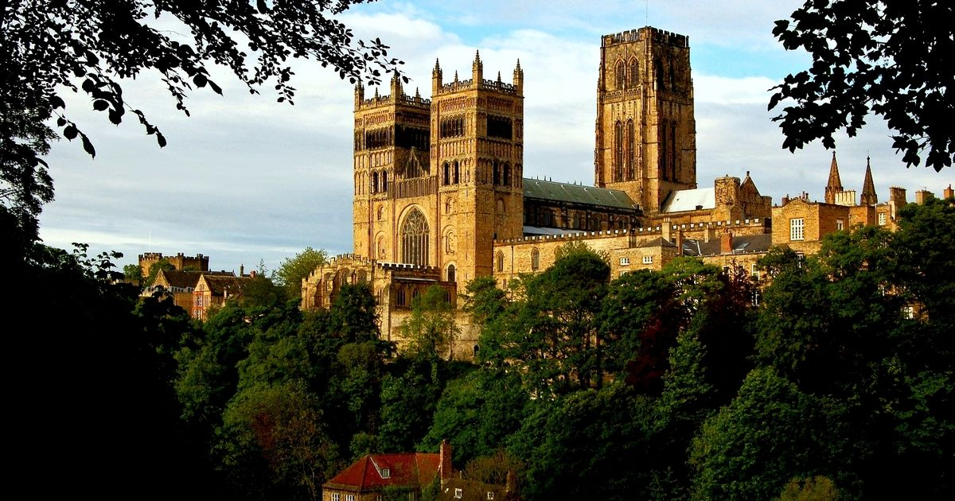
Year 11
Revision Booklet 3 – Paper 2
Norman England 1066-c1100
The Norman Church & monasticism
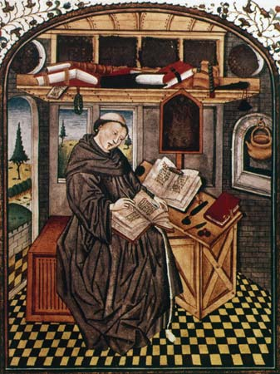

Impact on the Church
Question: Write an account of Lanfranc’s reforms to the church in England. (8 marks)
Good connecting words:
- In response…
- As a consequence of…
- This was significant because…

Aim for 2 P.E.E. paragraphs in 10 minutes:
- Context:
  - Religion was powerful & significant:
    - Matter of life & death: Belief in heaven & hell
    - Religious leaders were as powerful as Kings
    - The Pope was the most powerful person in Europe
    - Parish churches were everywhere in England & everyone went to Mass every week
    - Lanfranc became Archbishop of Canterbury in 1070
  - The Church was wealthy:
    - Largest single landowner in England so got wealthy from rents
    - Abbots & Bishops were feudal lords
    - Indulgences: people left money for prayers to be said after their death
    - The rich left land to the Church
    - Everyone paid a TITHE to the Church (a 10th of your annual income)
    - People were taxed when they died & had to pay SURPLICE FEES to the Church for ceremonies (marriage, baptism, funeral)

- Reasons for the reforms: Six Nuns Playing Marbles (mnemonic)
  - Problems in the church before 1066:
    - Simony: Buying powerful positions in the church
    - Nepotism: Positions in the church being given to friends or relatives
    - Pluralism: clergy who held more than 1 position. A good example was Stigand being both Bishop of Winchester and Archbishop of Canterbury
    - Marriage: Clergy were supposed to be celibate, however marriage was common by 1066

- Consequences of Lanfranc’s reforms:
  - Established SYNODS: Church councils. Spread the message of reform. Bishops were ordered to hold their own councils x2 per year.
  - A new Church hierarchy: Pope-Archbishops-Bishops-Archdeacons-Deans-Parish Priests. More centralised and each level more answerable to the person above. Arch-deacons & Deans were new.
  - Moving Cathedrals to larger towns & cities: 1/3 of Bishops moved.
  - Developing parishes & the role of the parish priest: the number of village churches had increased before 1066 but they doubled 1070-1170.
  - Ended marriage amongst the clergy: if priests were married they could stay married BUT it stopped future marriages.
  - Council of Winchester in 1076 established church courts:
    - Clergy (churchmen) would be tried in bishop’s courts (Synod) & not in secular (non-religious) courts.
    - William supported Lanfranc in this. There were later problems.
    - Lanfranc wanted spiritual offences (blaspheming, failure to attend church, adultery, incest) to be tried in the church court.
  - Church building: ‘shock & awe’: showed that God favoured the new regime & was a permanent reminder of Norman Conquest! (see notes on Durham at the end of this booklet)

To answer the question, put together 2 paragraphs from the information above. A good way would be to do one paragraph on re-organising the church e.g Synods, new hierarchy and moving cathedrals to areas of larger populations. You might end that paragraph like this: “This was significant because it helped the Normans to organise reform more effectively and it strengthened the role of bishops, giving them greater control over their diocese.”
Then a second paragraph on new rules for the clergy, covering the ending of marriage for new clergy and the new church courts to try them. “This was important because being single showed the people that the clergy put their devotion to God before any personal link and the new church courts showed that the clergy were special and could only be tried in a special court.”

Question: Write an account of the relationship between English Kings and the Pope to show why there was tension between the two. (8 marks)
Good connecting words:
- In response…
- As a consequence of…
- This was significant because…
- This increased tension because…

Aim for 2 P.E.E. paragraphs in 10 minutes. Focus on why there was tension. Read the following and pick put the reasons for tension….
- William I’s relationship with the Pope:
  - William I got on well with Pope Alexander II.
  - Pope Alexander II gave William a Papal Banner (flag) to bless his invasion of England in 1066.
  - Both men wanted to reform the English Church.
  - But William got on less well with the next Pope – Gregory VII
  - Gregory wanted English bishops to travel regularly to Rome to report to him. This did not happen.
  - Gregory also wanted William to swear fealty (loyalty) to him. William refused.
  - So William was happy to help in Pope Alexander’s reforms but he was not going to let Pope Gregory interfere with his rights as King.
- William Rufus and his relationship with the Pope:
  - Pope Gregory wanted to make the key appointments in the English Church. He wanted to say who should be Archbishop of Canterbury and Archbishop of York etc. William Rufus refused.
  - The next Pope was Urban II. He agreed not to interfere with English appointments while William Rufus was King.

- Henry I & the investiture controversy:

  - Kings gave symbols of office to bishops when they got the job. They gave them the ring and the staff in a special ceremony.
  - The Pope didn’t like this because it implied that bishops depended on kings rather than the Pope for their spiritual power.
  - This was a problem. Many bishops were also the king’s tenants-in-chief. They needed to pay homage to the king as part of the feudal system.
  - Archbishop Anselm refused to perform homage or be invested (formally given the ring and the staff) by the King. Henry I sent him into exile.
  - In 1107 there was an agreement called the Concordat of London. Henry agreed to give up his right to invest bishops but he could still receive homage from them BEFORE they were invested.

To answer the question, write one paragraph on how some Popes wanted more say over things e.g Pope Gregory with William I and with William Rufus. This created tension because the English Kings wanted to control key appointments and saw the Pope as interfering.
Then write another paragraph on the Investiture controversy. This caused tension because the Pope felt that bishops were given their spiritual power through the Church and not through the King. Even more tension built up when Anselm refused to pay homage to Henry I.

Extra information

1061 - 1073: Pope Alexander II
1073 - 1085: Pope Gregory VII
1086 - 1087: Pope Victor III
1088 - 1099: Pope Urban II
1099 - 1118: Pope Paschal II

Question: Explain what was important about William II’s relationship with the Church and how it affected his time in power. (8 marks)
Top tips
- Write 2 P.E.E. paragraphs in 10 minutes.
- Write about at least two important consequences
- Make sure that you clearly ATBQ!! What was important about……?
- Try to evaluate the level of importance as you go along – very important/slightly important etc.
- You should not need to use the first person but give your viewpoint firmly using detailed evidence to back up your view.

Useful phrases for this type of question
There were several consequences…
Also very important was…
It could be argued that…
This was important because…
This was a major change….

- Control of the Church:
  - William Rufus fell out with William St. Calais – the Bishop of Durham.
  - William St Calais had failed to send troops to help the King with a rebellion. The King charged him with treason.
  - As a member of the clergy, William St Calais felt that he should be tried in a church court. The King refused.
  - The Bishop was put on trial in a secular (state) court and he was declared guilty. He lost his job and was exiled.
  - This shows how determined the King was to keep control of the Church. He had been supported by his nobles throughout the conflict. This was important because it was clear that the Church would be subordinate to the Crown while Rufus was King. It affected his time in power because it deterred others from challenging the King.
  - Later on, William Rufus had a difficult relationship with Archbishop Anselm.
  - Anselm had been a pupil of Lanfranc. He had been reluctant to become Archbishop of Canterbury and had to be forced to take the job.
  - Anselm did not want to submit to a King who had so little interest in the Church. By 1094, Anselm was openly preaching against Rufus and his court.
  - The King felt that he owned the abbeys and that Anselm should not get involved on his affairs.
  - This conflict with Anselm was important because it shows us how unpopular the King was becoming with the clergy. He was being openly criticised. This must have affected his reputation during his time in power.
- Morals of court:
  - The Church disapproved of William Rufus’s morals.
  - William never got married or had children.
  - It is likely that he was a homosexual.
  - His lifestyle led to conflict with the Church.
- Using the Church for profit:
  - When Lanfranc died in 1089 he was not replaced immediately.
  - William Rufus wanted to take the income from the estates previously held by Lanfranc. He made a huge amount of money from this.
  - William Rufus also left bishoprics empty when bishops died so that he could take income from Church lands.
  - William Rufus also reintroduced simony (selling Church positions). Examples include Ranulf Flambard paying £1000 to become the next Bishop of Durham.
  - This was important because it shows how William Rufus exploited the Church. He was more interested in making money than in upholding the reforms of his father. This affected his time in power because he was seen as corrupt and immoral.

Monasticism & language
Question: Write an account of the ways in which the Normans tried to reform the monasteries. (8 marks)
Good connecting words:
- In response…
- As a consequence of…
- This was significant because…
Aim for 2 P.E.E. paragraphs in 10 minutes:
- Context:
  - Monasteries were religious houses where monks & nuns lived. Had existed since Roman times.
  - Most belonged to the Benedictine order
  - Took 3 vows:
    - Poverty: give up all their possessions
    - Chastity: not marry & be celibate
    - Obedience: follow the instructions of the abbot/abbess
  - Most Monasteries had a rich patron who paid for the building but expected some control (secular influence). The Normans wanted to reduce this.
  - Decline in monasticism: due to Viking raids, poverty & the power of the local lord.
  - Many of the traditional practices had declined:
    - Some were not sticking to their vows.
    - Some were wearing rich clothes.
. Normans wanted to reform the monasteries:
    - Lanfranc introduced monastic reforms in 1077:
      - He introduced a new constitution at Canterbury. Laid out strict rules for daily life in a monastery. Stricter rules so that they would seem more pious and be more respected.
      - Reformed the liturgy (words used in religious services)
      - Bring them in line with monasteries in Europe.
      - Clearer hierarchy and defined the role of the Abbot.
      - Replaced Abbots. Only 3 Anglo-Saxon abbots remaining by 1086.
- Revival of monasticism:
  - 1066-1135 the number of monks & nuns went up from c1000 to 4-5000.
  - 1066-1135 the number of religious houses went from 60 to over 250.
  - In 1066 4 cathedrals with monasteries attached: Canterbury, Worcester, Winchester & Sherborne. By 1135 there were 10.
  - Many monasteries became Cluniac monasteries. They had to follow the rules of Cluny Abbey in France. The 1st Abbey was Lewes Abbey. By 1135 there were 24 Cluniac monasteries.

For the question above, write one paragraph on Lanfranc’s reforms (constitution, liturgy, hierarchy etc), then another paragraph on the revival and expansion (see above). Key points to make are that it is brought in line with European practices and that it was a very successful revival, especially in the North.

- Improvements to education:
- People who lived in the new and expanding towns needed better literacy and numeracy skills in order to conduct trade.
- Also Norman barons and knights wanted their children to be educated to the highest standards.
- Schools moved out of the monasteries and became separate buildings.
- There was an explosion in the numbers of schools. By 1100, all cathedrals and several larger churches had schools. There were about 40 schools by 1100.
- Both Archbishop Lanfranc and Archbishop Anselm were keen to reform the education system in England. They promoted education and built libraries.
- The Church schools mainly focused on training boys to become monks or priests.
- Some grammar schools were also set up e.g. in Northampton, Exeter and Lincoln. Pupils stayed in these schools for at least 4 years.
- This period also sees the beginnings of university education, where all the books and lectures were in Latin.
- Things that did not change: most peasants could not afford to pay to educate their children. Most girls were excluded from education.

- Changes to language:
  - Latin became the language of government. It was the official language of the country.
  - Latin was seen as the most important language to teach.
  - Most people spoke either Norman-French or English in everyday life.
  - Norman-French was spoken by the upper classes, clerks and the middle classes in the towns.
  - The peasants still spoke English and they were the majority of the population.
  - A ¼ of modern English words have their root in the French language so the Normans continue to have influence!

Question: Explain the importance of monasteries in Norman England. (8 marks)
Top tips
- Write 2 P.E.E. paragraphs in 10 minutes.
- Write about at least two important areas.
- Make sure that you clearly ATBQ!! What was important about……?
- Try to evaluate the level of importance as you go along – very important/quite important etc.
- You should not need to use the first person but give your view using detailed evidence to back it up.

Useful phrases for this type of question
There were several consequences…
Also very important was…
It could be argued that…
This was important because…
This was a major change….

Example of possible paragraphs:
- Monasteries perform key functions in society:
  - Most had an infirmary (hospital). Part of their duty to care for the sick.
  - Look after the poor. The almoner would look after the poor, provide food.
  - Accommodation for pilgrims.
. Centres of scholarship & learning:
    - Monks were the most educated in society.
    - All books had to be hand written (before the printing press in the 15th century). Monks copied texts in the scriptorium.
    - Built up libraries.
    - They were the historians of the time: Orderic Vitalis & William of Malmesbury were 2 examples.
    - Education: See notes above on reforms.
. Monasteries consolidated Norman power:
- New monasteries were often built next to castles to demonstrate that the Norman domination of England had God’s blessing.
- The Abbots of the monasteries gradually changed from Anglo-Saxon to Norman. Some Anglo-Saxon abbots were removed from their positions. Others simply died and were replaced by Normans.

Question: Read Interpretation B. How convincing is this interpretation of the impact of the Normans on English monasteries? (8 marks)
Interpretation B: Adapted from an article by Hugh Lawrence in History Today, 1986
English monasticism after the conquest was transformed by the aggressive building of new monasteries occupied by monks from France. This was deeply disturbing for English monks, who had to accept new Norman superiors. Tension was heightened by the lack of respect for English customs. But the Normans breathed new life into the English monasteries through new learning from the continent along with different customs.
Top tips
- Pick out at least 2 features from the source and test them against your own detailed knowledge of events.
- Use facts, figures, names and dates to show that the source is convincing or not convincing.
- The source isn’t wrong because it’s an interpretation, so your job is to test how convincingly the historian has used the evidence to support their interpretation.
- 8 marks so spend 10 minutes on this question.
Example: ‘Overall, this interpretation gives an effective summary of changes to monasticism but it overstates the speed at which these changes happened. The ‘aggressive’ pace of monastic building was a key feature of the impact of the Normans. The number of religious houses grew from 60 to over 250. The ‘lack of respect for English customs’ is also convincing as Saxon tombs were demolished at Canterbury….’
‘However this interpretation suggests this transformation began straight after the Norman Conquest. This is less convincing as Lanfranc’s reforms did not affect the monasteries until 1077…..’
Question: How convincing is Interpretation C about monastic life in Norman England? Explain your answer using Interpretation C and your contextual knowledge. (8 marks)
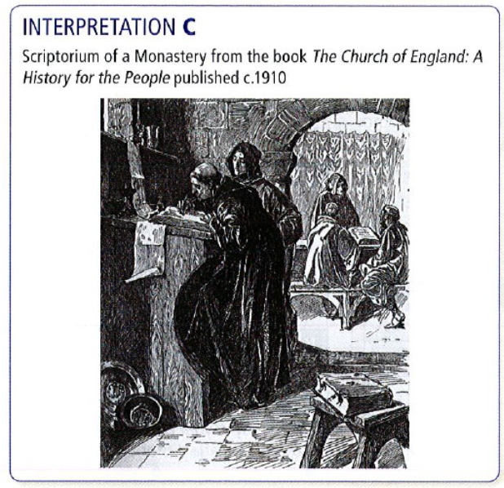
- Activity: Look at what is happening in the picture:
  - A monk is writing out a text in a scriptorium. In the background a monk is teaching.
- Environment: Where is this happening?
  - Inside a monastery. A scriptorium was a special room in a monastery. But teaching tended to happen in a separate building so that is less convincing.
- People: look at the monks’ appearance:
  - This looks convincing: a tonsure, a habit etc.

So your answer might go like this:
Interpretation C is partly convincing. It shows a monk handwriting out a text in a scriptorium. These were rooms in monasteries. All books had to be hand written before the printing press was invented in the 15th century. It could take a scribe up to 18 months to write out a new Bible. The interpretation clearly shows that it was detailed and time consuming work. It is also convincing as the monks are wearing habits and two of them have tonsures (shaved heads).

However Interpretation C is less convincing as it shows teaching going on in the background. In Norman times, schools were moved out of monasteries into separate buildings. This was part of Lanfranc’s reforms as children were no longer allowed in monasteries. This makes the interpretation only partly convincing.

Historic Environment: Durham Cathedral
Please read all your sheets and classwork on Durham cathedral as well as reading the information here.
What does Durham Cathedral reveal to us about Norman England?
Politics – ‘shock and awe’
The big picture:
- Church and cathedral building was a part of the ‘shock and awe’ tactics used by the Normans.
- The scale of the buildings was unlike anything that many English people would have ever seen before.
- Local people would often be forced to labour on these huge building projects.
- Like the Norman castles, cathedrals would often be built on vantage points, both for defensive and symbolic reasons.
- Cathedral building was a part of the wider cultural Normanisation of England.
Does Durham Cathedral reflect these changes?
- The cathedral was built in a strong defensive position – on a hillside, with the river providing protection.
- The cathedral was situated next to the castle, showing the close connection between the Church and political power.
- The cathedral was high above the civilian population of the town, representing its symbolic importance of having power over the people.
- The building was probably constructed using forced labour – another display of Norman power.
- Skilled craftsmen were also brought over from Normandy to build the cathedral.
- The cathedral was the largest building to be built in the north of England since the time of the Roman Empire. No English person alive at that time would have seen anything quite like it before.
- The design of the cathedral was unique in England at that time. Its Romanesque semi-circular arches and massive carved columns are Norman design rather than English. Its ribbed vaulted ceiling was the largest in the Europe at that time. This grandness could be seen as a display of wealth, power and the dominance of Norman culture over Anglo-Saxon culture.

Politics – governing England
The big picture:
- The nature of the feudal system changed considerably under Norman rule.
- Powerful Anglo-Saxon earls were replaced by Norman barons and bishops.
- William was careful to choose those most loyal and trusted to control the less stable parts of England.
- The Church began to play a much larger role in the ruling of England – owning as much as 25% of the country.
- Senior clergymen became very powerful political figures.
- Like the Norman barons, these clergymen would collect taxes and administer justice.
- Under the Normans, partly due to taxes and partly due to pilgrims, the Church became far, far wealthier.

Does Durham Cathedral reflect these changes?
- Durham was an important place for William, as the region could defend against invasion from Scandanavia or raids from Scotland. Also, the area had been under the rule of Tostig, Harold’s brother and was prone to rebellion.
- William replaced the Anglo-Saxon Bishop of Durham, Aethelwine, with William Walcher, a French priest. The next bishop was William of St. Calais, another Frenchman and Benedictine monk. It was under William of St.Calais that the building of the current cathedral began.
- William Walcher became Bishop of Durham in 1071. This was following the Harrying of the North. King William felt that after the rebellions in the north, he needed Norman rulers who he could rely on, like Walcher and St.Calais.
- The medieval Bishops of Durham are often known as Prince-Bishops. This is because they were both secular (non-religious) rulers and religious leaders at the same time.
- The Bishops of Durham ruled much of the land in northern England, and held great power. They collected taxes from the villeins for the land, as well as the tithe for the Church.

Religion
The big picture:
- Lanfranc reformed the Church in England, building great cathedrals dedicated to God’s glory.
- Old Anglo-Saxon places of worship were knocked down and replaced with much grander and more highly decorated churches and cathedrals.
- English people would go on pilgrimages to these new, magnificent cathedrals.
- Many of the Anglo-Saxon clergy were replaced with Norman clergy.
- Church courts were introduced to ensure better behaviour of the clergy.
- Lanfranc also caused controversy by removing relics from many places of worship – seeing them as superstitions, rather than genuine Christianity.
- The Normans believed that the regular clergy (monks and nuns) should truly devote their lives to God, and strictly follow the Rules of St. Benedict.
Does Durham Cathedral reflect these changes?
- The cathedral was built as part of Lanfranc’s reforms, and construction began in 1080. It was built to replace an earlier, less grand, Anglo-Saxon cathedral.
- The design of the cathedral was unique in England at that time. Its Romanesque semi-circular arches and massive carved columns are Norman design rather than English. Its ribbed vaulted ceiling was the largest in the Europe at that time. This grandness could be seen as a testament to how important Christianity was to the Normans.
- William made William Walcher, a French priest, his first Bishop of Durham. Walcher was known for being a very devout and holy man. William’s second Bishop of Durham, William of St. Calais, was a Benedictine monk.
- The cathedral included a monks’ dormitory, where Benedictine monks would live. These monks originally came from Normandy (though, in later centuries, English Benedictines would have also resided there). Benedictine monks had to live very strict and holy lives. Those who broke the Benedictine code/rules would be tried by the church court, and receive punishment in the dungeon (both of which can be seen at the cathedral).
- Durham was a pilgrimage site even before the Normans, as pilgrims would come to visit the relics of the bones of St. Cuthbert. In many places Lanfranc had relics removed, but not at Durham. The bones of St. Cuthbert were considered so holy that they were placed at the centre of the new Norman cathedral. Durham cathedral became one of the most important pilgrimage sites in England in the medieval period.
Society
The big picture:
- Under the Normans the Church began playing a larger social function in medieval society.
- As well as being places of worship, the Church was supposed to provide for the poor and needy in society.
- Churches and monasteries were also some of the few places where there would be people who had some education, including the ability to read and write.
- The Church also had greater influence over justice and lay people (non-clergy) could be tried in church courts for religious and moral crimes.
Does Durham Cathedral reflect these changes?
- As well as being a place of worship, Durham Cathedral also owned a number of almshouses where the poor could receive charity.
- There were many pilgrims who travelled to Durham. Some would be rich and would donate money to the cathedral. Far more would be poor, and some very ill. The monks at the cathedral would be responsible for ensuring that these poor and needy pilgrims were fed and looked after.
- The monks and priests of Durham spent a great deal of time in study. They would write out sacred texts on beautiful illuminated manuscripts. Durham’s collection of manuscripts, known as the Manuscript Treasures is considered one of the finest collections of medieval texts in England. This is a testament to the work of the priests and monks of the period.
- The church court at Durham Cathedral was mainly used to hold trials against monks and priests who stood accused of breaking their codes of behaviour. It was, however, also used to try lay people (non-religious) who opposed the prince-bishops, as to oppose the prince-bishop meant that you were opposing the lord of the land, as well as a servant of God.

Question: ‘The main change the Normans made to the churches was the introduction of Romanesque architecture.’ How far does a study of Durham Cathedral support this statement? (16 marks)
Top tips
- 16 marks so spend 20 minutes.
- This type of question begins with a statement that contains a judgement, and it asks you to explain the extent to which you agree with the statement. In this case, the judgement is about whether or not it was the new style of architecture that was the main change made by the Normans: remember this as you work through the question.
- Start by analysing the statement provided. It says Romanesque architecture was the main change to the churches. So firstly, do you agree? You might choose to argue that, overall, Romanesque architecture was not the main change made to the churches.
- Remember that the question is asking you whether the changed architecture was the main change. The word ‘main’ qualifies the question and makes it more complex. It implies that other things were changed too. So what other changes can you think of?
- A good way to conclude is to pick out the strongest piece of evidence that convinces you that the statement is correct or not. “In conclusion, the fact that--------- is the most persuasive piece of evidence that the statement is overall an accurate one.”

Example:
‘The introduction of Romanesque architecture was one of the most visible changes made by the Normans to the English Church. It is also one of the most lasting. Romanesque architecture features large arches and high stone construction. Widespread building in Romanesque style began quickly after William established control. Canterbury cathedral (begun in 1070) replaced the old Anglo-Saxon church with a distinctly Romanesque church. As time went on the scale of these projects increased reaching a peak with Durham Cathedral which was 143 metres long (equal to St Peter’s) in Rome. There is no doubt that Durham was a key example of the Norman use of ‘shock & awe’. The cathedral was the largest building to be built in the north of England since the time of the Roman Empire. No English person alive at that time would have seen anything quite like it before. The design of the cathedral was unique in England at that time. Its Romanesque semi-circular arches and massive carved columns are Norman design rather than English. Its ribbed vaulted ceiling was the largest in the Europe at that time. This grandness could be seen as a display of wealth, power and the dominance of Norman culture over Anglo-Saxon culture. The awesome size and the Romanesque features underlined the power, wealth and religious zeal of the Normans at the time and through to the present day.
However the Normans made other changes to the church. They were keen to revive monasteries after the instability and decline caused by Viking raids, poverty and an over-reliance on local lords. The number of religious houses grew from 60 to over 250. Lanfranc tightened up the rules. He reformed the liturgy, defined the role of the abbot and laid out a clear structure for daily life. Durham cathedral included a monks’ dormitory, where Benedictine monks would live. These monks originally came from Normandy (though, in later centuries, English Benedictines would have also resided there). Benedictine monks had to live very strict and holy lives. Those who broke the Benedictine code would be tried by the church court, and receive punishment in the dungeon.
Also, under the Normans the Church began playing a larger social function in medieval society. As well as being places of worship, the Church was supposed to provide for the poor and needy in society, for example, Durham Cathedral also owned a number of alms-houses where the poor could receive charity. There were many pilgrims who travelled to Durham. Some would be rich and would donate money to the cathedral. Far more would be poor, and some very ill. The monks at the cathedral would be responsible for ensuring that these poor and needy pilgrims were fed and looked after.
Therefore, although the introduction of Romanesque architecture was one of the most visible changes made to the church by the Normans it wasn’t the main change. The main change made by the Normans to the church was…………….’

Finally….remember that you will have 4 questions on Norman England on paper 2:
Q1 – How convincing….? 8 marks Spend 10 minutes. Write 2 paragraphs (see examples above!)
Q2 – Explain what was important about…… 8 marks. Spend 10 minutes. Write 2 paragraphs (see examples above!)
Q3 – Write an account of……….8 marks. Spend 10 minutes. Write 2 paragraphs (see examples above!)
Q4 – Essay question based on Durham Cathedral. 16 marks. 4 paragraphs (including the conclusion). Write about the factor in the question, 2 more factors then the conclusion.

