Part of a post from the blog of the British Library
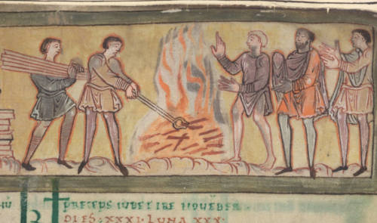
Detail of men by a fire, from a calendar in a scientific collection made in southern England in the 11th century: Cotton MS Tiberius B V/1, f. 8r
While the figures on the right of the image are warming themselves, the figures on the left-hand side are working. They appear to be smiths. There were many different types of smiths in 11th-century England, as explained in Ælfric’s Colloquy, a dialogue exercise designed to help young monks learn Latin. The Colloquy lists smiths, blacksmiths, farriers (who shoed horses), goldsmiths, silver smiths and bronze smiths among the most skilled craftsmen. Indeed, the characters in the Colloquy include a blacksmith who claims that he has the most important job in society, because he makes the tools all the other workers use. The other characters object, arguing that the enslaved ploughman is actually the most important because he grows the food that feeds everyone.
Smiths were clearly an important part of early medieval society. They appear throughout Old English literature, from the mythical figure known as Wayland the Smith to riddles in the Exeter Book.
From a British Library blogpost in 2018
Think!
- Why might metal workers have been important to the Anglo-Saxons?
- What does ‘enslaved ploughman’ mean?
- What is a common family name in Britain today?

