From ‘The Coming of Christianity to Anglo-Saxon England’ by Henry Mayr-Harting
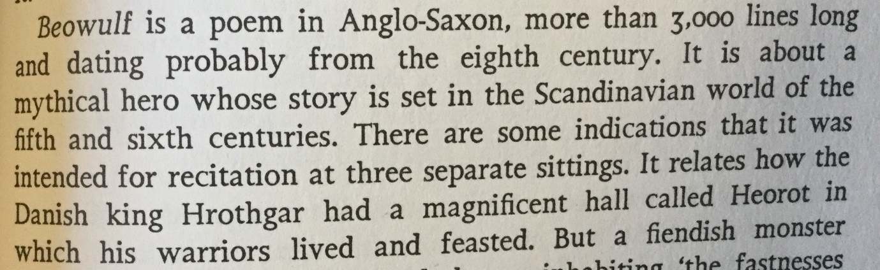
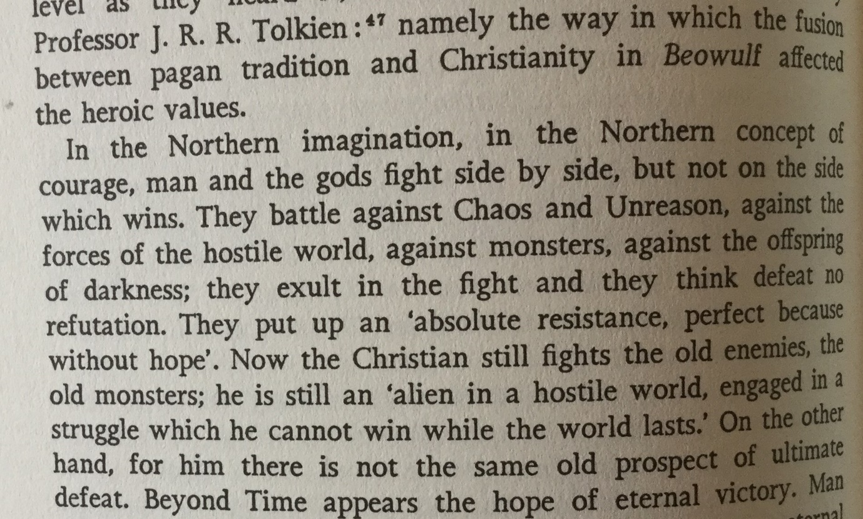

In summary, Henry Mayr-Harting is saying…
The Anglo-Saxons had a tradition of poetry which was more than entertainment. From it we can learn about their culture before and after they became Christian. Poetry taught its listeners about ideas and beliefs important to Anglo-Saxon society.
Did you know…?
This poetry has inspired many future writers, most famously JRR Tolkein, who studied Anglo-Saxon poetry and wrote the Hobbit and the Lord of the Rings.
Think!
- What different things can we learn by using poetry from a time as a source?

