What does the York Minster memorial reveal about women at the time of World War One?
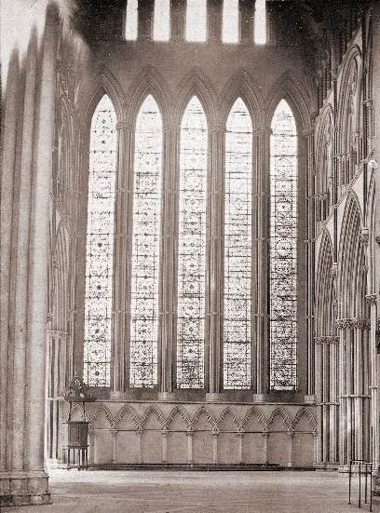
A problem caused by the War
In 1923, there was a problem at York Minster. The famous medieval stained glass had been removed from the windows during World War One to avoid bomb damage. Some of the glass had still not been put back. The Minster did not have enough money to do the job. Even the most famous ‘Five Sisters’ window from the 1200s was in boxes.
Helen Little’s vision
After the War ended, there were many memorials created to remember the millions of men who had died. Helen Little asked herself: “Where is there a national memorial to those of our sisters who, though in far fewer numbers, gave their lives in the service of their country?” One evening, she was walking into the evening service at the Minster …
“Just as I reached the choir door in the dim light I saw two little figures in white standing hand in hand … . I moved towards them, and then recognised my two little sisters, both of whom had died as children. … Both my little sisters were … pointing upwards to the window. I cried out “The Sisters’ Window for the sisters!”
THINK!
- During and after the First World War, there was a rise in the number of people who claimed to have visions of dead relatives and in the number of people trying to speak to the dead. Why do you think this might have happened?
Helen Little’s decision
Helen Little decided to raise the money to restore the Five Sisters window as a memorial to all the women of the British Empire who had died during the War. She worked with a friend called Almyra Gray. Together they amazed everyone. They lived in a time when every letter they sent had to be addressed by hand. Letters for other countries had to be delivered by sea. Despite this, in just nine weeks the women had gifts of money sent to them from 32,000 women across the world. They raised over £3500. The restoration of the window cost £3000. With the leftover £500 they paid for wooden panels painted with the names of the over 1400 women who died. You can still see them in York Minster.
THINK!
- What skills of organisation and management did these women have?
The women of the British Empire who died in World War One
Helen Little and Almyra Gray were determined to remember all women who had died during the First World War, from every part of the Empire and from every area of war work that was done by women. They worked hard to collect the names of the women who had died and found most of them. The women’s names were listed under the area of work they did in the War.
Queen Alexandra’s Royal Naval Nursing Service
Women’s Royal Naval Service
Queen Alexandra’s Imperial Military Nursing Service
Territorial Force Nursing Service
Queen Mary’s Army Auxiliary Corps
Women’s Royal Air Force
Order of St John and British Red Cross (first aid and relief work)
Voluntary Aid (nursing) Detachments
Doctors of various hospitals
Canadian and Newfoundland Army Nursing Service
Australian Army Nursing Service and Australian Red Cross Society
New Zealand Army Nursing Service
South African Military Nursing Service
Colonial Nursing Association
Mercantile Marine Stewardesses (merchant ship workers)
Munitions Workers (weapons and explosives-making)
Women’s Forage Corps (food for horses)
Women’s Land Army (farming and food production)
Women’s Legion Motor Transport (drivers)
Serbian and Friends’ (Quakers) Relief work for victims of war
Women’s Emergency Canteens and Young Men’s Christian Association (support for soldiers)

THINK!
- Women also worked as posties, engine drivers, milk-deliverers, business managers and much more. Why do you think that nursing was more dangerous?
Some women on the memorial
The women remembered include 19-year old Betty Stevenson. Betty drove a truck of supplies for troops. She was killed during an air attack and is buried in France. There is also Mary Carter who worked long hours with poisonous chemicals making weapons in Leeds until he was killed in an explosion at the factory. Meanwhile, Elizabeth Ross was a doctor who died of disease while trying to help war victims in Serbia.
THINK!
- In 1914, most people thought that the ideal place for a woman was at home, running the household, having children and looking after family members. How do these women challenge these ideas?
Over to you!
There is so much more to learn about women at this time. You could research the campaign for women’s votes, or read a book by Vera Brittain called ‘Testament of Youth’ (in which she about her experience of war and how it shaped her) or research online some more of the women on the York Minster panels. For example: Dr Elizabeth (Elsie) Impey from Birmingham, Nurse Lorna Rattray from New Zealand, or Nurse Nellie Spindler from Wakefield.
Teacher notes: ‘What does the York Minster memorial reveal about women at the time of World War One?’

What is a slot-in?
A slot-in is a short story from the past that is rich in historical concepts. You can use a slot-in as part of a longer sequence, or as cover work, or in those moments where you need something short.

The concept focus of this enquiry
The enquiry question here is: ‘What does the York Minster memorial reveal about women at the time of World War One?’’ The story the students will read is written to reveal the activities of a range of women in the period. The focus is upon diversity and challenging stereotypes/misconceptions, including that all women went back to doing nothing after World War One. It is written to hook the students’ interest via the story of the Empire memorial.

Curriculum links
The past of women should be everywhere in our curriculum and this will help to make that possible. This story could be slotted-in to your curriculum as part of a sequence on:
- The First World War,
- Remembering the First World War,
- Women in the early 20th Century,
- The impact of Empire on Britain.

Activity suggestions
You might just want students to read this story, make a connection to a wider topic and move on. However, you might decide to use this material for a whole lesson with activities. Here are a few suggestions of activities around which you could build an enquiry focused on the question.
Focus on diversity:
- Give students a map of the British Empire. Get them to mark on it where women on the York Minster memorial came from. This should show some of the geographical diversity of the contribution, although students should also notice that the organisations are very white.
- Students can list the diverse roles that the memorial reveals. They could research what each one of these might have entailed.
- Students could also identify some of the qualities that all these roles would have required, such as courage, tenacity etc.

- Students could research the six women who are named on the slot-in and then compare and contrast their backgrounds and experiences. This is, again, putting the focus on individuals and not stereotypes.
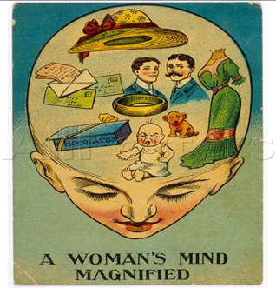

- You could then give students this famous image from 1905 ‘A woman’s mind magnified.’ Students could challenge this source as an accurate portrayal of how all women thought by using evidence from the York Minster memorial and the work of Helen Little and Almyra Gray.

Extra background for teachers
World War One was unlike any war that had gone before. Millions of people were involved in it. National governments demanded, and got, huge efforts from the people of their countries to help them win the war. The British government ruled 300 million people around the globe and called on people from every part of it, including women. Millions of people died or were wounded. Most of the recognised war dead were men, although women probably made up most of the civilian war dead. Women were not allowed into frontline roles in the British armed forces on equal terms as men until 2018.
Nursing was more dangerous due to disease and that some nurses were close to the front line. The home front was not so vulnerable as in World War Two, although munitions work was very dangerous to health.
At the time, most people thought that the ideal place for a woman was at home, running the household, having children and looking after family members. However, during the War years women were needed to take on many very varied roles.
Most women survived the War. Most women in Britain still did not have the vote in 1918. After the War, majority public opinion expected girls to grow up to be wives, mothers and to care for the war-damaged. There is much debate among historians about how much of a difference experiences during World War One made to the advance of women’s rights in Britain. We do know that the lives of many individual women (and men) were transformed by the experience of living through the ‘Great War’.
Where to link to
The contribution of all women to the war effort is not yet well researched. An excellent read about the contribution of Empire troops is David Olusoga’s ‘The World’s War’.
Resources about non-British women’s involvement in World War One can be found at: https://historiana.eu/#/historical-content/key-moments/world-war-1
Flora Sandes is an example of a British woman who became a high-ranking soldier. She fought in the Serbian army. https://www.historic-uk.com/HistoryUK/HistoryofBritain/Flora-Sandes/

