Gold objects and beautiful books
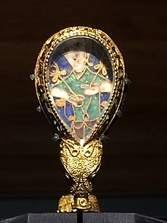
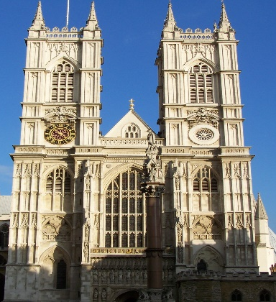
Westminster Abbey was built by Edward the Confessor. It was in the style more often used in mainland Europe, for example in Normandy. The Anglo-Saxons did not always build in stone. Even royal halls were timber. They loved beautiful jewellery and other portable objects. Gold was often used and books were richly decorated. The Alfred jewel is a famous surviving example of their work.

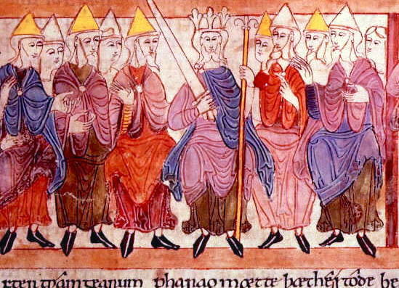
Charters of royal assemblies (the Witan)
Charters are written grants of rights. Charters survive from royal assemblies. Anglo-Saxon kings called assemblies of nobles from time to time. They were consulted, could offer advice and would attend to be close to the king, appeal to the king and be close to other powerful people. Good service would lead to grants of more land. Assemblies could be held wherever the King was present. There were divisions between rich men competing to be closest to the king. An exile (person who had left) from the king’s court could leave the country and try to get support from overseas to restore their power in England against their noble rivals.

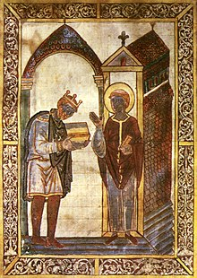
Æthelstan presenting a book to St Cuthbert,
Image of King Athelstan presenting a book to an Anglo-Saxon saint. The Church was very important to all aspects of life. For example, kings were crowned by the archbishops, saints were asked to pray for people’s souls, the church was a large landowner, God’s anger was thought to be a cause of bad harvests, oaths (promises) were important and made before God, and the Church controlled education. The art and culture of the Anglo-Saxon church was celebrated in its own time and some of its treasures survive today in the form of beautifully illustrated church books.

The royal family tree
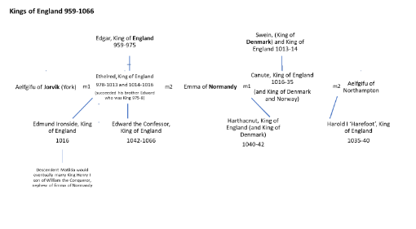
The kings of England before 1066 were married to women from other places. The relationships with other royal families and rich noble families were complicated. The succession was complicated too. The throne did not automatically pass to the dead king’s eldest son.

The Burghal Hidage
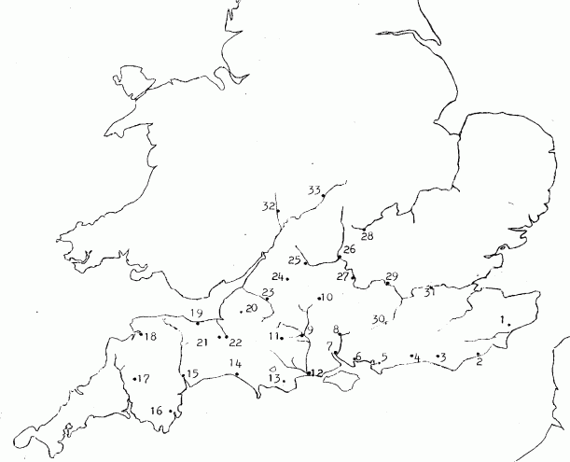
This is a list from the time of King Alfred, or his son King Edward, in the later 800s or early 900s. It is a list of the places that had been strengthened (fortified) against the Viking attacks. Each fort or town had land and men to defend it. The amount of land and men was worked out by the length of the walls that needed to be defended around the fort or town. Archaeology has shown that the walls of Alfred’s forts match those listed in the Burghal Hidage. It was all very logically planned.

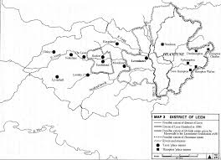
The County Hidage
The Anglo-Saxon kings became very good at organising people for war. To do this they kept records of the amount of land that was owned and how much people owed the king. By the mid-900s a system or organised ‘shires’, each with a shire town, began to emerge. This system of shires was extended to each area as the Kings of Wessex became Kings of all England. (The shire counties survive today - how many can you name?)

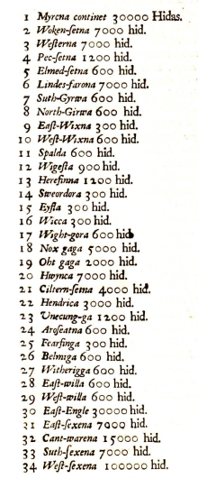
The Tribal Hidage
This is a list from the 6oos or 700s (historians are not quite sure). It comes from central England. It is a list of what the kings of Mercia (in the centre of England) could demand from every group of people they ruled. The kings were demanding money as taxes and also that each area should raise troops for warfare.

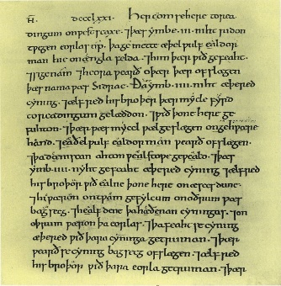
The Anglo-Saxon Chronicle for 893
Written by a monk it records how in 893 King Alfred ‘divided his army in two, so that always half of its men were at home and half out on service, except for those who were to garrison the towns.’ Alfred clearly could use the men he ruled for military service.

Archaeology in villages in Northamptonshire
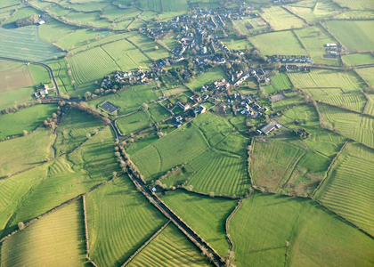
Surveys and excavations seem to show that the big open fields were laid out before 1066. The big fields and the villages seem to have been created on top of earlier abandoned Saxon sites where the fields were smaller and the houses more spread out. This reorganisation would have made farming more efficient. Land farmed in common was easier to organise for war. There was also plenty of food in England in years of good harvest. (In World War Two the British government organised similar big farming projects to feed the people.)

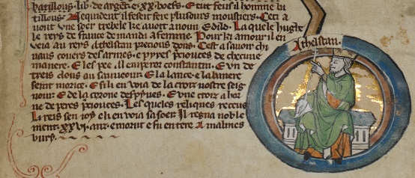
Laws of Athelstan
King Athelstan’s laws said that no horses were to be sold abroad. Other law codes said that a fighting man (called a ‘thegn’) was required to bring to battle his own equipment, such as helmets, chainmail, swords and horses. These were expensive items and the thegns were not poor farmers.

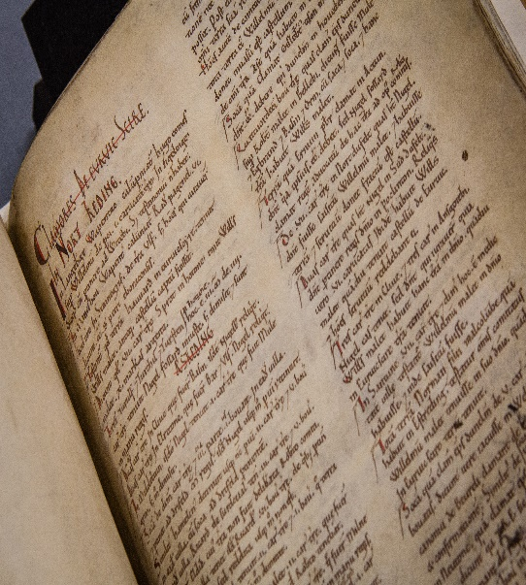
Domesday Book as a whole
This large survey of most of England was carried out for William the Conqueror in 1086. It records who owned what and where. It shows that the vast majority of people in England lived and worked on the land. Four-fifths of people people were peasants, including about 1 in 10 people who were slaves. London was the largest city. York (or Jorvik) was an Anglo-Scandinavian city and the second largest. Winchester was a royal centre. There was no fixed capital. The King had to move about to control the country and to avoid exhausting the food supplies in one place. Domesday can only have been created using detailed records put together by the Anglo-Saxons. Historians estimate that there were more than 2 million people in England. English kings could rule and control the nation (the country) right down to the local village level.

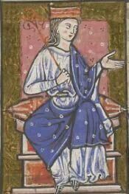
Part of the Will of Earl Aelfgar of Essex (940s)
“First I grant to my lord two swords with sheaths, and two armlets … and three stallions (horses) and three shields and three spears.” One of the swords was worth 120 pieces of gold and had nearly 2 kg of silver on the sheath. That made the sword and sheath worth about 5500 silver pence, at a time when you could buy an ox for 30 pence and a slave for 240 pence.

Land grants 931-934
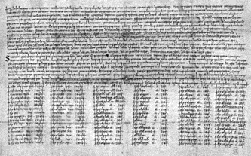
These surviving grants of land from King Athelstan show that rich people got the rewards. Throughout the 10th century a few 1000 wealthy people owned big landed estates. They served the King and were rewarded with land and the power that came with it.

Place names
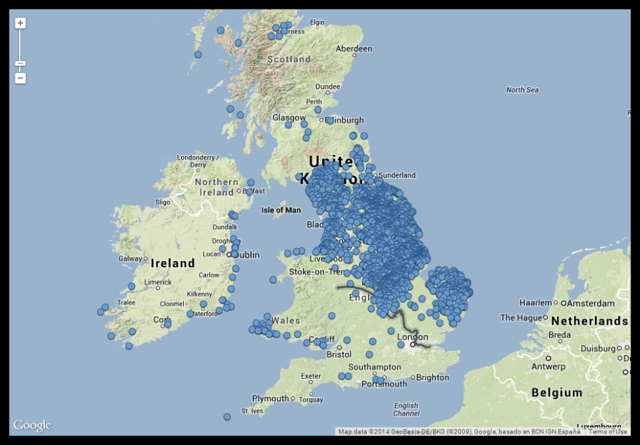
In the south-west of England place names do not show Viking influence. Whereas, once you get into the Midlands and move north, there are many places that end in -by (such as Selby and Burnby), or -thorpe (such as Ousethorpe and Bugthorpe). There are just two examples of place name endings that are Viking in origin.

Domesday Book entries for the north of England
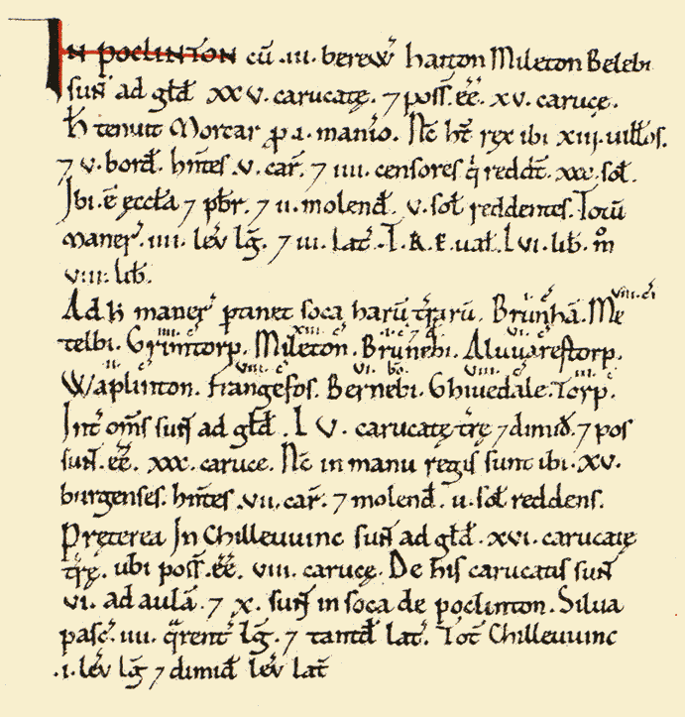
Instead of ‘hundreds’ of land, there are ‘wapentakes’ (that is ‘weapon-takes’). Instead of ‘hides’ of land, the land was measured in ‘carucates’. This area was Anglo-Scandinavian and the presence of the Vikings was clear in the language used.

Surviving silver coins from the time
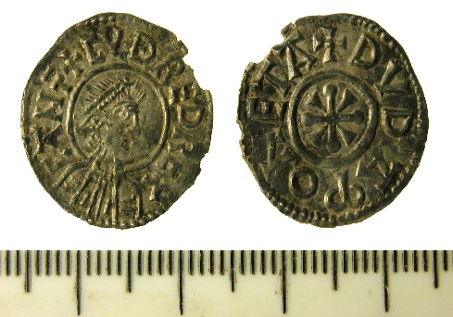
These show that the kings had control of the coinage, it was high quality and there was a lot of it. This is important as paying in coin (rather than bartering with (swapping) goods) is a sign of an advanced and rich society. It also meant that the geld (the tax) could be collected as money, not goods. There was also plenty of money to collect as geld tax. The coins show that the kings had control because every 5 or 6 years all coins were called in and ‘re-minted’ to ensure their quality and value. This must have taken considerable organisation.

