From ‘Domesday: a search for the roots of England’ by Michael Wood
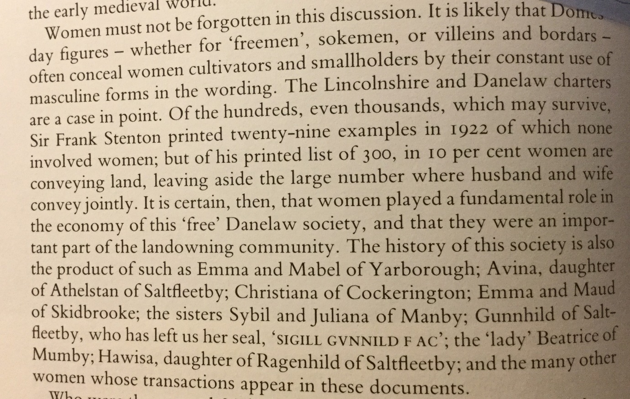

In summary, Michael Wood is saying…
Women were important land-owners in Anglo-Saxon England.
Important to know…
Historians in the 1800s and most of the 1900s did not regard women as important in society and, therefore, were not interested in studying their past and telling their stories.
Think! What does this new information reveal about Anglo-Saxon society that could change views?

