How did York experience the Norman Conquest?
“In the city of York in the time of King Edward [the Confessor], besides the shire of the archbishop [of York], there were six shires. One of these has been laid waste for the castles. In 5 shires there were 1418 inhabited messuages [households].”
This is the beginning of the entry for York from the Domesday Book. It was written for William I (the Conqueror) in 1086. Even in translation it is quite hard to understand. It was also not meant to be a full description of the city. Nevertheless, it is one of few surviving sources we have. So, it is one of the few sources we can use as evidence to understand how York experienced the Norman Conquest. Using it, and other surviving sources (church documents, old histories called chronicles and archaeological remains), historians of this period have made suggestions about what York was like and how it was affected by the Conquest.
Picture of Baile Hill in central York
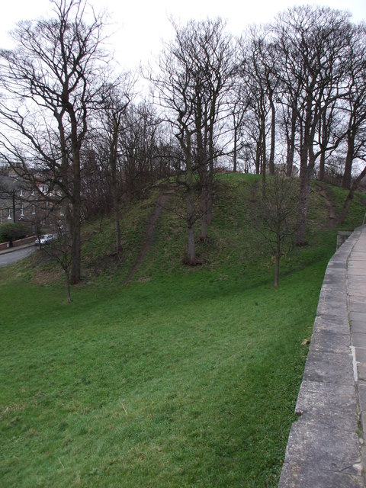
How familiar would you have found Norman York?
Of course, there are many things about modern York that are very different from York in 1086. However, if we could get into a time-machine and travel back to the Anglo-Scandinavian city of Jorvik (as York was known) what would we recognise?
Firstly, York had already had a Minster for over 400 years. It was not the building we see today. In 1066 there was an Anglo-Scandinavian stone Minster that seems to have been badly damaged in the rebellion against William in 1069. It was patched up in 1070 on the orders of the new Norman archbishop, Thomas of Bayeux, and then rebuilt on a larger scale in the Norman style from 1080-81. Other religious places that still shape York were also already in existence. For example, St Mary’s Abbey, Christ Church (now Holy Trinity Micklegate), St Crux (at the bottom of the Shambles), All Saints’ Pavement and St Peter’s Hospital (later called St Leonard’s). The remains of this hospital are still there by the central library and under the Theatre Royal.
Jorvik was the most important place in Yorkshire, with two or three mints. These were places that made coins for the King and for the Church. There might have been about 10,000 people living in the city at the time. William ordered two castles to be built in 1067 and 1069. We call them Clifford’s Tower and Baile Hill. Jorvik had markets and Domesday Book tells us that the Count of Mortain had two stalls in the meat market known as the Shambles. Wander down the Shambles today and you can still see the meat hooks and broad window sills (or shammels) on which butchers displayed meat for sale.
There was a wooden bridge on the site of the modern Ouse bridge and ramparts and ditches where today we find the City (Bar) Walls and the remains of the moat. You might know that the Walls end at the Red Tower and do not restart until Jewbury. This is because the land in between in the River Foss basin was flooded by the Normans. The area was known as the King’s Fishpool. If you want to know how large this was, ask older local people about the big flood of Christmas 2015 when, weirdly, the floodwater covered about the same area as the old King’s Fishpool.
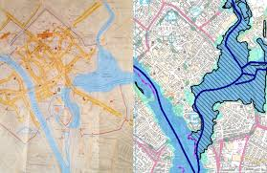
A map of medieval York on the left. The large area of blue on the right. is the area of the King’s Fishpool.
The map on the right is of York in 2015 showing the extent of the Christmas flooding.

How had York experienced the Conquest?
The Norman chronicler, Orderic Vitalis says that William punished the north for the rebellions against him 1067-69 by ordering that England north of the River Humber should be made uninhabitable. That is, impossible for anyone to live in. It could be that over 100,000 people died of starvation as a result. Refugees are said to have fled to the south from the violence. This, so-called, Harrying of the North, is said to have destroyed York with sword, famine and flames. This is chilling if true. As is the image the chronicles give of William the Conqueror celebrating Christmas in the ruins of the city. But, would the king and his court been able to live in the ruins of a city he had just destroyed? And, why has no evidence of a terrible fire been found by archaeologists?
Domesday Book does tell us that one of the six shires (parts) of the city was cleared to make way for the castles. Certainly, those citizens who lost their homes and property as a result of this must have suffered. We also know that 145 French men had taken over houses and did not have to pay tax. One can imagine that this would not have been popular with the locals. Although York as a city was paying more tax, the population seems to have dropped. Many households were empty, or the people were so poor they could not pay tax. Land and property seems to have been in the hands of fewer people in the city as a result of the Normans arriving. Historians of the period are now unsure if York suffered significantly more than other towns and cities across the country, but we can be certain that it declined as a result of the Norman Conquest.
Meanwhile the Church stayed privileged. The Archbishop of York controlled the tax of more that one of the six shires from his Palace. The Church was exempt from paying tax. Local church people and stone-masons probably did well from William’s love of the Church and the Norman’s enthusiasm for building churches.
THINK!
- Why are historians so uncertain about how York was affected by the Norman Conquest?
- We have no sources left to us from the people of York. How does this affect our knowledge?
Over to you!
- If you live in the York area you could do a city walk to find these remains, including visiting the crypt of York Minster to see what remains of the Norman cathedral.
- This is a good website for further research about York: http://www.historyofyork.org.uk/timeline/norman

Teacher notes: ‘How did York experience the Norman Conquest?’
What is a slot-in?
A slot-in is a short story from the past that is rich in historical concepts. You can use a slot-in as part of a longer sequence, or as cover work, or in those moments where you need something short.
The concept focus of this enquiry
The enquiry question here is: ‘How did York experience the Norman Conquest?’ The story the students will read is written to explain what remains of the period and what these remains reveal about the consequences of the Norman Conquest for York. The text use key terms such as ‘shires’, ‘Conquest’ and ‘mints’ in context and with in-text explanation to help students to become familiar with tricky concepts by reading.
Curriculum links
This slot-in will be of most interest to teachers in the York area. History KS3 curricula are so packed, it can be difficult to bring in a local dimension. Yet, students have an entitlement to know about the local past. The way the city is today is shaped by its past and is part of their identity. In a city such as York, whose economy is partly dependent on the heritage industry, young people need to know about the historic environment which they share with tourists and which may provide future employment.
This story could be slotted-in to your curriculum as part of a sequence on:
- The Norman Conqest,
- Sources as evidence,
- Medieval life.
Activity suggestions
You might just want students to read this story, make a connection to a wider topic and move on. However, you might decide to use this material for a whole lesson with activities. You could:
Use local maps and images
You could give students a map of modern York city centre with images of the sites today and get them to plot the places mentioned in the text as being of Norman origin. It is also possible to find images (usually artists’ impressions) showing what sites might have looked like.
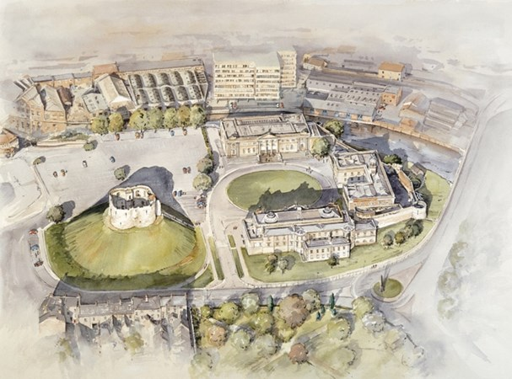
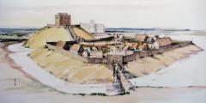
For example:
Here is Terry Ball’s illustration of one of York’s Norman castles.

And a drawing of the same site today
Students could research more about each site and put together a Norman York trail.

Use more local extracts from the Domesday Book
On ‘Open Domesday’ or using the Penguin publication of the Domesday Book, you can easily extend the extract of York and find extracts of the villages in the surrounding area that students know about today. Putting together short descriptions from Domesday would enable the students to draw some conclusions about the impact of the Harrying of the North on the surrounding area. For example, Fulford dropped in value and ownership had passed to a Norman.
Use York as specific evidence for the consequences of the Conquest
Perhaps you have an assessment piece of work that requires students to work with the consequences of the Norman Conquest. This slot-in would enable them to use the specific example of York as evidence for different aspects of the Conquest, such as the damage to the North, the taking of property by Normans and the support of the Normans for the Church.
A summarising exercise
You could ask students to write a summary answer to the enquiry question by precising the information to a single paragraph. You could frame this as writing the introduction panel to a gallery in a local museum about the topic.
Thoughts to challenge
Students, understandably, are often not aware of the past of their built environment. Helping them to see that the past has shaped the present in this physical way is an important way for them to start to engage with their local communities. Decisions are made all the time about changing the built environment. Knowing the implications of these decisions is an important part of being a local citizen. For example, does it matter if Baile Hill is levelled and built upon as we need more houses? Does knowledge of the King’s Fishpool help us to understand how we should develop a flood resilient modern city? Should we tell the story of how ordinary York people have suffered as well as the ‘nice and/or juicy bits’ of history for the tourists?
Where to link to
Open Domesday is at: https://opendomesday.org/
Domesday resources for can be found at: https://yorkclio.wordpress.com/2017/05/15/teaching-the-domesday-survey/
A good narrative history for the period is ‘The Norman Conquest’ by Marc Morris.
More resources on York can be found via: https://yorkclio.wordpress.com/york-stories/

