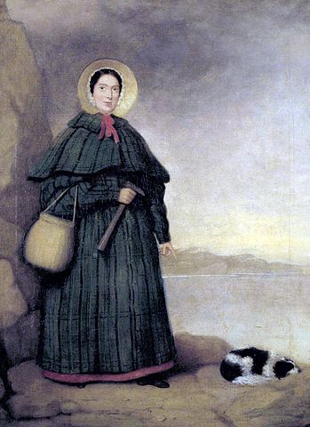
Why did scientists ignore Mary Anning?

She sells sea shells by the seas shore,
The shells she sells are seashells, I’m sure.
So if she sells seashells on the sea shore,
Then I’m sure she sells seashore shells.

This Edwardian tongue twister is all we have left to remember the work of Mary Anning.

http://www.nhm.ac.uk/nature-online/online-exhibitions/art-themes/caught_in_oils/more/anning_more_info.htm

Who was Mary Anning?
Mary was a self-taught fossil hunter who worked on the beaches of Lyme Regis during the first part of the 19th century. Mary’s father had sold small fossils that were exposed on the cliff face as a way of making extra money. When he died unexpectedly Mary was forced to find a way of making a living for her family. At the age of 12, Mary successfully excavated her first dinosaur, an ichthyosaurus. Mary went on to excavate fossil remains of plesiosaurus, a pterodactyl and many others. She sold these for cash to the scientific community as a way to keep her family from poverty.

What was remarkable about Mary?
Mary had no formal education and had taught herself everything. She had even taught herself to read and write, as well as study the scientific papers written on the subject of fossils. Mary faced much doubt and resistance from established fossil hunters who could not believe that an uneducated women could be so skilled at discovering, excavating and identifying fossil remains. Many scientists bought fossils from her, then took the credit for the discoveries. As a women Mary was not able to join the Geological Society of London. Anning’s work was not published, apart from a letter she wrote to the magazine editor of the Magazine of Natural History in 1839 querying one of his claims.

Despite this lack of public acknowledgement, Mary’s fossil finds were crucial to scientific understanding.
Lady Harriet Silvester visited Mary in 1824 and wrote afterwards:
“ By reading and application she has arrived to that greater degree of knowledge as to be in the habit of writing and talking with professors and other clever men on the subject, and they all acknowledge that she understands more of the science than anyone else in the kingdom.”

Mary’s finds provided some of the ground work for Charles Darwin’s book on evolution called The Origins of the Species published in 1859. In this work, Charles Darwin sets out the theory that all species have evolved over millions of years.

Think
- What obstacles did Mary have to overcome in her life?
- Why do you think scientists at the time struggled to believe that Mary had excavated the fossils?
- To what extent do you think Mary did overcome these obstacles?
- What does Mary’s story reveal about attitudes towards women in Victorian England?
- Why were fossils and the theory of evolution so unsettling to Victorian people, especially the Church?

How do we remember Mary Anning today?
Mary Anning’s work was largely unrecognised in her lifetime. She died at the age of 49 from breast cancer. However, if you visit the Natural History Museum you will find that Mary Anning’s fossils are exhibited in the marine reptiles’ gallery. In 2010, one hundred and sixty-three years after her death, the Royal Society included Anning in a list of the ten British women who have most influenced the history of science.
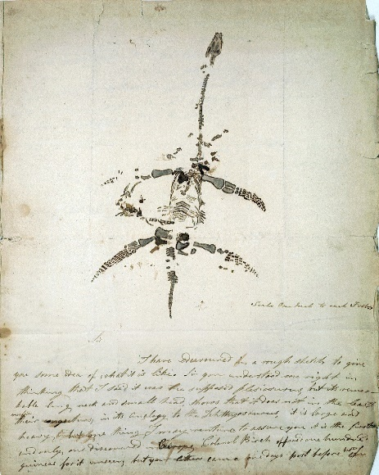

Work of Mary Anning (1799-1847)
Public Domain, https://commons.wikimedia.org/w/index.php?curid=11526193

Over to you!

You can listen to the novelist Tracey Chevalier talking about the life of Mary Anning on Great Lives on Radio 4. A link to the podcast is here :
https://www.bbc.co.uk/programmes/b091v0c7

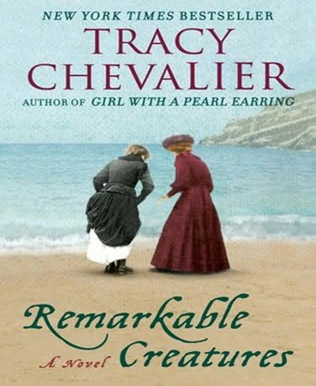
You can also read the novel Remarkable Creatures by Tracey Chevalier based on Mary Anning’s life which, although historical fiction, is firmly rooted in research.

Teacher notes: ‘Why did scientists ignore Mary Anning?

What is a slot-in?
A slot-in is a short story from the past that is rich in historical concepts. You can use a slot-in as part of a longer sequence, or as cover work, or in those moments where you need something short.

The concept focus of this enquiry
The concept focus of this enquiry is on the second-order concepts of historical significance and change and continuity. The enquiry question here is: ‘Why did scienctists forget Mary Anning?

This slot in is written to make it clear to students that attitudes from the past can reveal evidence useful to historians.

Curriculum links
We have a duty to reflect the past of diverse people in our history curriculum. We also have such a restricted amount of curriculum time to teach a large amount of past. This story could be slotted-in to your curriculum as part of a sequence on:

- Victorian life. It can show how difficult life could be for poor families. Explore the impact the death of Mary’s father has on the family and their reliance on parish relief in order to survive. Mary works from a very young age. She receives no education. Remind students that compusory education was only introduced in 1870. Explore the poor relief system. Why did families fear poverty so much?

- As part of a wider enquiry into women’s rights. Link to the experiences of other women who were trying to make their way in an academic world. Note that Emily Garrett Anderson was unable to qualify as a Doctor in England and had to finish her studies in Paris in 1867. In 1869 Girton College was established by Emily Davies but women still had to ask permission to attend lectures. Before this date women had been unable to attend University. Ask your students to consider when Mary Anning would have been able to get full credit for her work?

- A final idea is to consider how typical Anning’s experiences as a women in the scientific world were. You could bring this right up to the minute with the current debate about the treatment of women in science. Compare Anning’s experiences to these other individuals:
  - Joceleyn Bell (1943-) discovered pulsars but the Nobel Prize was given to her male PHD supervisor, with no mention of Jocelyn.
  - Rosalind Franklin (1920-1958) was responsible for much of the X-ray crystallography research that was critical to the discovery of the famous double helical DNA structure.Tragically, Franklin died from ovarian cancer in 1958, aged just 37. Four years later Francis Crick, James Watson and Maurice Wilkins, were awarded the Nobel Prize in Physiology or Medicine and famously did not mention Franklin in their acceptance speech
  - Lise Meitner (1878-1968) was an Austrian physicist and the second woman to obtain a doctorate in physics at the University of Vienna in 1906, and the first woman in Germany to assume position of a full Professor of Physics in 1926. The annexation of Austria by Nazi Germany in 1938 forced Meitner to flee Germany due to her Jewish descent. Meitner and Otto Hahn discovered nuclear fission in 1939, yet the 1944 Chemistry Nobel Prize was awarded only to Hahn who downplayed Meitner’s involvement. This was later described in Physics Today as “a rare instance in which personal negative opinions apparently led to the exclusion of a deserving scientist”.

Activity Suggestions
You might just want students to read this story, make a connection to a wider topic and move on. However, you might decide to use this material for a whole lesson with activities.

You could teach a mini thematic on the History of Scientific thought. Students could put breakthroughs in scientific understanding in chronological order. Introduce the concept of factors that cause progress and regress. E.g. science and technology, religion and communication. Anning was not able to communicate throught the meduim of scientific papers – to what extent did this hold scientific thought back?

Misconceptions to dispel
Students often make the assumption that women in the past didn’t have any scientific ideas. Certainly, far fewer women than men are remembered in the History of Science. Use Anning’s story to show the barriers that were put in the way of women who wanted to contribute to the academic debate. Ask students to consider how important the University system and academic publication was to ensuring scientific recognition. Ensure students understand that women were not allowed to participate in either of these areas. Raise the idea that some great breakthroughs in thought have most likely been over-looked as a result.

Where to link to

As well as the ‘In Our Time’ and the Tracy Chevalier book suggested for the students, you could also think more broadly about the impact of lack of societal support for women’s ideas. A key text would be ‘A Room of One’s Own’ by Virginia Woolf.

