How did a woman born in North Yorkshire become a Serbian war hero?

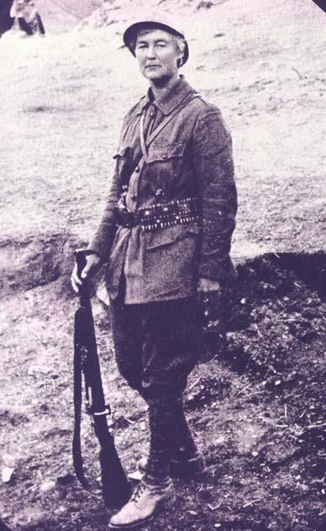
Who was Flora Sandes?
Flora was the only British woman to officially serve on a frontline in World War One. She was born in Nether Poppleton, North Yorkshire on the 22nd January 1876 and moved to rural Suffolk at a young age. She was not your typical 19th century woman; she was highly educated and enjoyed riding, drinking, smoking and shooting. She longed for adventure and moved to London as soon as she could.

THINK! How is this behaviour different from how women were expected to behave in the 19th Century?

1914

Flora was 38 when war broke out in 1914. She was desperate to give service. She had trained as a nurse with the First Aid Nursing Yeomanry and so, when the war started, she volunteered for the St John’s Ambulance. The unit she was with was sent to Serbia.

For the first year she nursed wounded soldiers around the Kragujevac area of Serbia and she became fluent in Serbian. She then transferred to the Serbian Red Cross, which placed her on the frontline with the Serbian infantry regiment of soldiers who were fighting the Austro-Hungarian forces. The Serb army, unlike the British army, allowed women to fight in the frontline alongside men.

How did she become a hero?
In late 1915, Serbia was losing against the Austro-Hungarian Empire. The Serbian army had to retreat in large numbers through the Albanian mountains following a brutal attack by the Austro-Hungarian army. Flora refused repeated orders to abandon the Serbian forces she was with and to withdraw to safety. Eventually she was the only woman left as the remaining nursing staff had fled or been killed in the fighting. She did not have enough equipment to be useful as a nurse. Not wanting to be sent away from the frontline, she hoped to be accepted into the Serbian Army. She expected rejection but was warmly welcomed into the ranks by General Milos Vasic. This British woman became a soldier in one of the few European armies that allowed women to fight on the frontline alongside men.

Soon afterwards she became involved in fighting and she proved herself on the battlefield. She was quickly promoted to the rank of Corporal. She was wounded by a grenade in battle. She reportedly assured her men that it took a lot to kill her, and that she would be back in ten days. It in fact took her six months to recover, re-join the ranks and return to the front line. She continued to fight until the end of the war and was awarded Serbia’s highest military honour, the Order of the Karadjordje Star. She was also promoted to rank of Sergeant Major.

THINK! What was the definition of a World War One hero? How does Flora expand that definition?

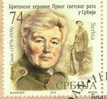
Remembering Flora Sandes

In Britain Flora Sandes is largely unknown, but in Serbia she remains a celebrated hero. In 2009, the authorities in the Serbian capital Belgrade named a street after her. In 2015 her face appeared on a special issue of Serbian postage stamps that celebrated the British support for Serbia in World War One.

THINK! Why do you think Flora hasn’t really been recognised or celebrated in her home country?

Recently, more people in Britain have taken an interest in Flora. Her legacy has opened people’s eyes to the abilities of women and their equal standing in the world. Her actions and the relationships she formed with the men fighting on the front line have inspired others to fight for the right to serve Britain at the front. Helping to change perspectives and restrictions previously placed on women. In 2018 the final restrictions on women serving alongside men in the British armed forces were finally lifted.

THINK!
- What does this story contribute to our knowledge of the changing attitudes towards women during and after World War One?
- How do you think the story of Flora Sandes could have been used to support the cause for the inclusion of women in the military in 2018?

Over to you

Flora was not the only woman who played an important role in the war effort of World War One. How many different examples can you find of women’s contribution to the war effort 1914-1918?

What evidence can you find that other women have worked in wartime or in peacetime and changed ideas and events with their contribution?

Teacher notes: ‘How did a woman born in North Yorkshire become a Serbian War Hero?’

What is a slot-in?

A slot-in is a short story from the past that is rich in historical concepts. You can use a slot-in as part of a longer sequence, or as cover work, or in those moments where you need something short.

The concept focus of this enquiry

The enquiry question here is: ‘How did a woman born in North Yorkshire become a Serbian War Hero?’ The story the students will read is written to reveal the extraordinary story of Flora Sandes, the only British woman to officially serve on a front line in World War One. The aim is to broaden students understanding of the contribution of British women in World War One and to think how an individual can challenge assumptions. The slot-in is written to hook the students’ interest via the story of Flora Sandes. Many people remember the war as one of sacrifice by a male generation, and this story would help to inform and highlight that there is more to this story. This is therefore an enquiry into historical diversity. It also links to modern women being able to serve in British frontline forces.

Curriculum links
The past of women should be everywhere in our curriculum and this will help to make that possible. This story could be slotted-in to your curriculum as part of a sequence on:
- The First World War,
- Remembering the First World War,
- Women in the early 20th Century

Activity Suggestions
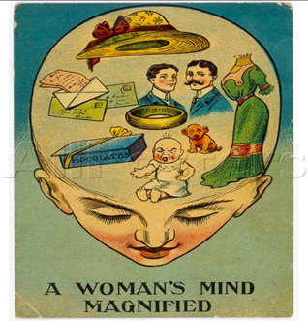
You might want students to read this story, make a connection to a wider topic and move on. However, you might decide to use this material for a whole lesson with activities. Here are a few suggestions of activities that you could build an enquiry, focused on the question.

- Use the first think box as a starter, show some other sources from the time such as the 1905 “A women’s mind magnified” (see picture) and get them to consider how Flora was different
- Students could then read the story and do think, pair, share on the think questions at the end.
- Then students could consider how she challenges / does not challenge notions of hero status.
- There could be a class vote and students could be asked to justify their perspectives in a classroom discussion.

Finally, slot-ins always have an ‘over to you’ section. These are to encourage students that their learning is ongoing and something for which they can take responsibility. This has a focus on women in World War One.
- Students could research other women who fought or served their countries during the war. (From the over to you section)
- They could then consider how they think the story of women in World War One should be told today and plan a the key messages and examples they would want to include in a modern TV documentary.

Misconceptions to dispel

The First World War did feature women and they played an instrumental role in a number of different roles. Victory, or defeat, was not entirely a male story. The role of women has similarities and differences from country to country. These roles were shaped by the cultural and political beliefs within countries, but also by the necessities of war. Just as with men, women were a very diverse group and had diverse and complex roles and responses to the war.

Extra Background for Teachers

World War One is still known as the Great War for a reason, it was unlike any war the world had ever known. Millions of people were involved including women. The ability and willingness of many of the belligerent countries to engage their women in ‘total war’ was not predicted in the years before 1914 and helped to prolong the conflict. Most of the recognised war dead were men, although women probably made up the most of the civilian war dead. Some women did die in conflict. The women of the British Empire who died have a memorial in York Minster that was constructed due to the efforts of other women in the early 1920s. Women were not allowed to fight in the British army on exactly the same terms as men until 2018.

In 1914, most people (including women) thought the ideal place for a woman was in the home, running the household and caring for their children and husband. However, during the war years the demands of ‘total war’ meant that women took on many different roles. In Britain, these may have been farming in the Land Army, nursing in the VAD (wealthier women), making shells as munitionettes (working women) and in the WAAC as the back-up for the army. However, some women were determined to do their part in the fighting and disguised themselves as men to fight on the frontlines.

After the War, majority public opinion expected women to be wives, mothers and to care for the war-damaged. There is much debate among historians about how much of a difference experiences during World War One made to the advance of women’s rights in Britain. We do know that the lives of many individual women (and men) were transformed by the experience of living through the ‘Great War’.

Where to link to

Kate Adie discusses Flora Sandes on a Great Lives podcast: https://www.bbc.co.uk/programmes/b0076hd1
Flora Sandes Biography by Louise Miller: A Fine Brother: The Life of Captain Flora Sandes https://www.amazon.co.uk/Fine-Brother-Captain-Flora-Sandes/dp/1846882451
For more on the Serbian front and Flora https://www.bbc.co.uk/news/resources/idt-sh/A_forgotten_soldier

