What were the consequences of Harvey Milk’s message of hope?
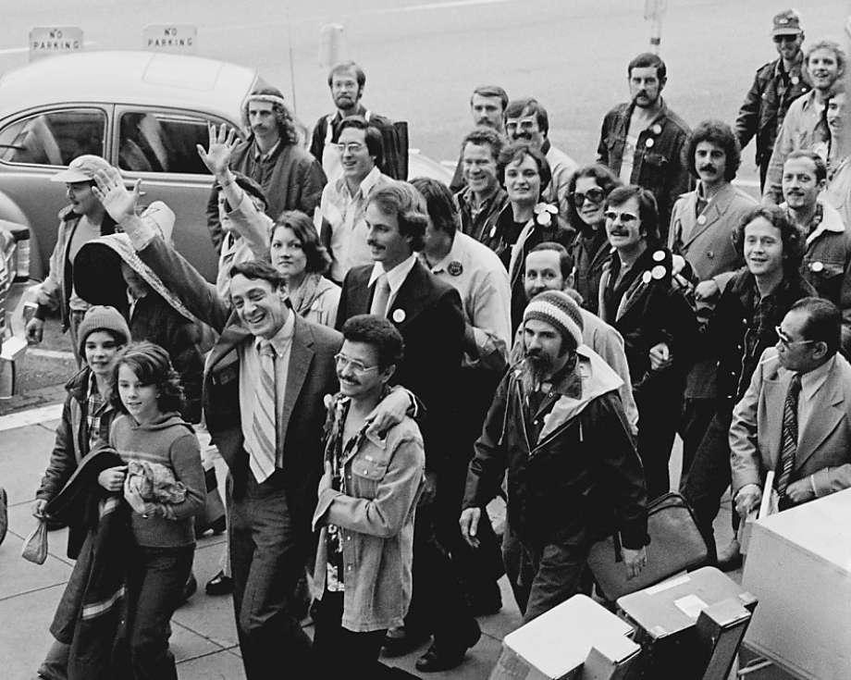
What is happening in this picture?

This photograph was taken after Harvey Milk became the first openly gay man to be elected to the San Fransisco Board of Supervisors on the 9th January 1978. The image shows the walk to City Hall from the Castro neighbourhood where Milk lived. The people surrounding Harvey Milk are not just from the LGBTQ community. We can also see women, children and black people supporting Harvey Milk as a person who protected their rights too. This is a powerful image because it depicts the diversity of support Harvey Milk received and the positive relationships he had built up in the six years he had lived in San Francisco.

What is the story behind the picture?
Discrimination in the USA was not limited to black people. LGBTQ communities in America also faced hostility from parts of society. In the 1950s and 1960s, the FBI kept lists of people they believed to be gay; where they would go out to eat, drink and dance, and socialise. Consequently, many gay-friendly bars were shut down and customers were arrested. Meanwhile, the US Post Office kept track of addresses of people receiving pro-LGBTQ mail, universities expelled teachers who were suspected of being gay, and in 1952 the American Psychiatric Association included homosexuality as a mental disorder, a decision not reversed until 1973.

Growing up in an atmosphere of intolerance, Harvey Milk was part of the fight against homophobia in America. In 1972 he moved from New York to the Castro district in San Francisco, an area with a large LGBTQ community. San Francisco itself had been home to a large number of gay men expelled from the military since the end of the Second World War in 1945. The state of California legalised homosexual activity in 1976, but it was still unlawful in many areas of America.

In 1973 Harvey Milk stood for election as a City Supervisor in San Francisco. Although he won by far the most votes in the Castro District, he did not win enough votes across the state to be elected. After several further unsuccessful attempts in elections, he won election as a City Supervisor in 1978. After his election, Harvey Milk fought against the California Proposition 6 ballot. This aimed to ban LGBTQ people from working in California’s state-funded schools. It was stopped after a being rejected by a public vote following campaigning led by Harvey Milk, the LGBTQ community and other significant figures.

What happened as a result?

In November 1978 Harvey Milk was shot and killed. The immediate reaction to Harvey Milk’s murder was one of outrage. When his assassin was convicted of manslaughter, rather than murder, the decision sparked a riot around the City Hall. The Police responded with brutality, storming a bar in the Castro Village and causing $1,000,000 of damage.

Harvey Milk was the first LGBTQ elected official in the USA and many others have since followed his example. Many US LGBTQ politicians have had success, especially at a local level, as communities come together to vote for someone who will champion their rights. All 50 US states have since been served by openly LGBTQ politicians at some level and 46 states have elected LGBTQ politicians to their state legislatures. However, there is still a long way to go. No President, Vice-President or any Supreme Court justices have been openly LGBTQ*. Only 12 of the 50 states have elected LGBTQ members to the national Congress in Washington DC, many of whom were “outed” involuntarily.

*Historians argue that James Buchanan, the 15th President of the US (1857-1861), was gay. While there is evidence to support this claim, it is often disputed.

THINK!

- What does the story of Harvey Milk’s election campaign and assassination reveal about attempts to achieve a more tolerant USA and the campaign for LGBTQ rights in particular?
- Harvey Milk was an individual. What other factors for change can you find in this story?

Over to you!
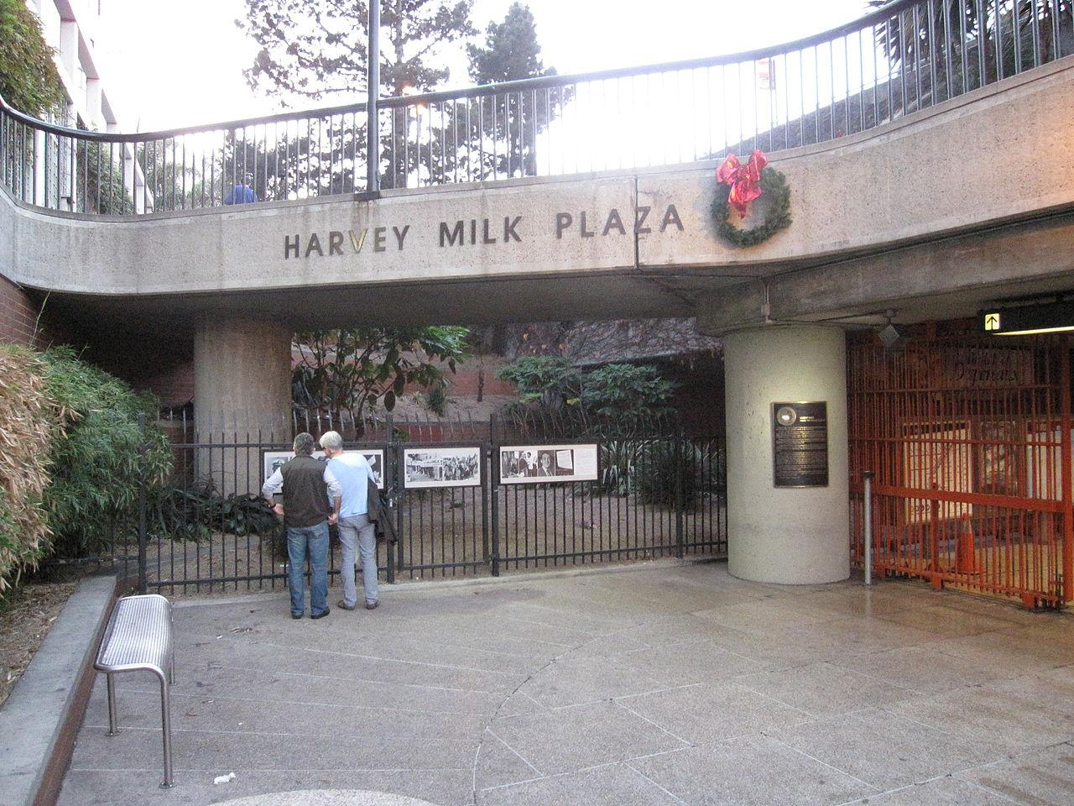
Here is an image of a Subway Station named after Harvey Milk in 1980. Other community buildings including railway stations, schools and streets also bear his name. Look up the areas where they are and when they were dedicated. What does this suggest about the wider significance of Harvey Milk and how it has developed?
Teacher notes: ‘What were the consequences of Harvey Milk’s message of hope?’

What is a slot-in?

A slot-in is a short story from the past that is rich in historical concepts. You can use a slot-in as part of a longer sequence, or as cover work, or in those moments where you need something short.

The concept focus of this enquiry

The enquiry question here is: ‘What were the consequences of Harvey Milk’s message of hope?’ Students will engage with the story of a key individual in 20th century LGBTQ history. They can assess the significance of his actions, his achievements and his assassination in raising the profile of LGBTQ discrimination in the USA. Moreover, it lends itself well to a consequences activity.

It would be a useful lesson or activity as part of a wider Civil Rights enquiry; Milk can be compared convincingly with Rosa Parks, Martin Luther King and Malcolm X as leaders in the struggle for minority rights.

Curriculum links

- Civil Rights
- The USA post-1945
- People and protest through time

Activity suggestions

You might want to do an activity comparing different protests and their impacts. Using pictures to analyse and asking students to think of questions they want to know about what is happening in the pictures. E.g. When are you? Where are you? What is this person doing?

Give a piece of text with a narrative about Harvey Milk and the consequences of his message of hope and assassination to the students and ask them to explain how they would relate the picture to the historical context.

Play and extract of Milk’s famous speech of hope to students and ask students to listen to the use of language and style. They could compare it with another speech such as ‘I have a dream’ to develop a wider understanding of the use of powerful speeches in the story of people and protest in the 20th century.

Misconceptions to dispel

Whilst today, especially in the UK, being LGBTQ is something that many young people will come across in their daily lives, this is a relatively recent situation. In the 1970s attitudes were different. Teachers might need to explain that the USA was a country that possessed widespread hostile attitudes and laws toward the LGBTQ community. Large parts of the USA were (and still are) very socially conservative, with interpretations of Christianity that are hostile to the LGBTQ community. Many attempts to pass laws designed to help minority groups, such as LGBTQ, met (meet) strong organised resistance.

In terms of teaching this enquiry, there are some possible pedagogical errors to avoid. A focus solely on Milk can lead to a “great man” version of history, with a disproportionate emphasis on individual accomplishments. It is a prerequisite of this enquiry that it be taught within a wider political and social context, as part of a narrative of collective action as a force for change.

Extra background for teachers

LGBTQ history is rarely taught in schools and is only recently gaining ground in university study. However, research on a diverse range of time periods and regions is beginning to flourish. LGBTQ History Month has been celebrated in America since 1994, and in Britain it coincides with the repeal of Section 28, which prohibited the promotion of homosexuality by local authorities. Values and attitudes vary across time and from place to place. For example, in China, every emperor in the Han Dynasty had at least one same-sex partner.

The sexual revolution of the 1960s transformed the historiography of LGBTQ peoples. Social and intellectual historians, particularly those of the Annales school, took up the history of sexuality. The term homosexuality was a 19th-century construct. Hence some historians have challenged sociologists such as Foucault who have applied terms like homosexual, heterosexual and bisexual to historical figures such as the Emperor Hadrian, Michelangelo and Lord Byron.

Where to link to

LGBT History Month is celebrated every February; lgbthistorymonth.org.uk features resources on teaching the history of LGBT peoples.

