What does Josephine Butler’s story tell us about attitudes towards women in Victorian Britain?
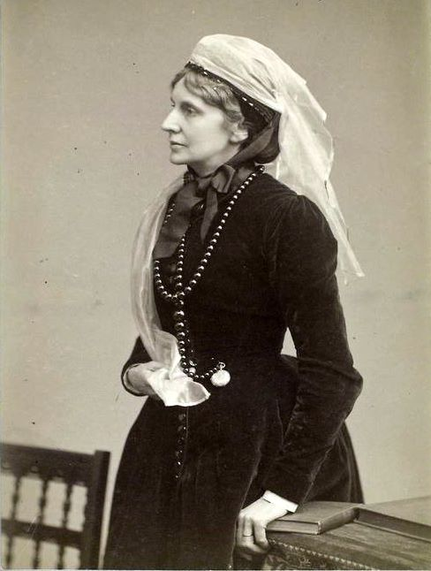
Who was she?
Josephine Butler was a middle-class feminist and social reformer in the 19th Century who played a major role in improving conditions for women. After the death of her daughter in 1863, Josephine got heavily involved in charity work, in particular, women's rights.

Prostitution in Victorian England
There is no way of knowing the true number of prostitutes in Victorian England (1837-1901). However, in 1791 there were estimated to be 50,000 prostitutes in London. However, in Victorian England, as well the word referring to women who sold their bodies, prostitute also referred to women who had illegitimate children. Some people even thought of women as prostitutes if they didn't behave or dress in a respectable way. Women who were prostitutes were seen as 'fallen women’ with no morals. Many experienced violence and suffered sexually transmitted diseases such as chlamydia and syphilis.

How did Butler become involved in helping vulnerable women?
Josephine first came into contact with vulnerable women when she heard of the case of a young girl who was in prison, facing charges of murdering her own baby. The working class girl’s child had been fathered by an upper-class man, a tutor at Oxford, who had refused to support her. Josephine and her husband were outraged. They challenged leaders at Oxford to take action. They refused. The Butlers took the girl into their home as a maid. This incident highlighted to Josephine the injustice and double standards of a society that labelled women struggling with poverty and the dominance of powerful men as sinners. After moving to Liverpool, Josephine began visiting the local workhouse where she sat with women, many of whom were in the workhouse as punishment for prostitution or having children outside of marriage. These experiences shaped Josephine’s strong views about prostitution.

What were the Contagious Diseases Acts?
The government were worried about the spread of diseases amongst the population, and were especially worried that so many soldiers and sailors were getting syphilis due to sleeping with many women. There was also a worry that these men would then pass it on to their wives and, via them, to their children.
Because of this, the government passed laws during the 1860s which they thought would stop the spread of the disease. These became known as the Contagious Diseases Acts. These laws allowed police officers in army and port towns to arrest women they suspected were prostitutes so that male doctors could examine them for signs of diseases such as syphilis. They had the power to force women into examinations. If a woman was found to have the disease they were locked up in hospitals until they were cured, sometimes this took up to a year. Some people, including Josephine Butler, were angry that the Contagious Diseases Acts punished women who worked as prostitutes and not the men who used them, even though it was these men who spread the disease to the wider population.

The campaign against the Contagious Diseases Acts
Josephine was angry about the effects of the Acts on working class women. She felt that the forced examinations of women were an outrageous abuse by the powerful on the powerless. She knew that women worked as prostitutes because of their difficult situations in life. In 1869, Josephine and her friend Elizabeth Wolstenhome formed the Ladies’ National Association for the Repeal of the Contagious Diseases Acts (the LNA). Together, they campaigned for the repeal of the Acts. Josephine and the other members of the Association campaigned tirelessly, travelling the country giving lectures and lobbying the government.

Conclusion
Organisations like the LNA attracted the support of feminists but also those more generally concerned with personal liberty. Between 1870 and 1885, 17,365 petitions against the acts showing 2,606,429 signatures were presented to the House of Commons. In 1886, the Acts were finally repealed.

Think!
- How much of an impact do you think Butler's middle-class status had on the success of her reforming ideas and actions? What other parts of her life and qualities helped her?
- What do the Contagious Diseases Acts reveal about different attitudes to menn and women in sexual behaviour in Victorian England?

Over to you!
Watch the ‘Forgotten Feminist’ documentary on Youtube for further research.
Read the source below – how could you use this source as evidence for the situation of women in 19th Century Britain? What would be its limitations?

“It is men, only men, from the first to the last that we have to do with! To please a man I did wrong at first, then I was flung about from man to man. Men police lay hands on us. By men we are examined, handled, doctored. In the hospital it is a man again who makes prayer and reads the Bible for us. We are had up before magistrates who are men, and we never get out of the hands of men till we die!”

Teacher notes: ‘What does Josephine Butler’s story tell us about attitudes towards women in Victorian Britain?’
What is a slot-in?

A slot-in is a short story from the past that is rich in historical concepts. You can use a slot-in as part of a longer sequence, or as cover work, or in those moments where you need something short.

The concept focus of this enquiry

The enquiry question here is: ‘What does Josephine Butler’s story tell us about attitudes towards women in Victorian Britain?’ The story the students will read is written to show the inspiration and motivations behind Josephine Butler’s campaign against the mistreatment of women through the Contagious Diseases Act.

History teaching of women in the 19th and early 20th centuries often focuses on the beginnings of the suffragette/suffragist movement. The inclusion of Josephine Butler’s story gives students the opportunity to learn about other issues that impacted the female experience in addition to the campaign for the vote. The campaign against the Contagious Diseases Act also taps into prejudice against disadvantaged and working class women. This should lead to a broader understanding of the experience of women and the difficulties they faced. It can be linked to modern feminist issues. Teachers could highlight the difference in the experience of women in the first and third worlds and compare this to the disparity in the treatment of working class women and middle/upper class women in the 19th century.

Curriculum Links

This slot in could be used to compliment study of:

- The Industrial Revolution
- Medicine through Time
- Women’s Rights
- Crime and Punishment, including Whitechapel
- 19th Century politics
- Victorian society.

Activity suggestions
You might just want students to read this story, make a connection to a wider topic and move on. However, you might decide to use this material for most of a lesson with activities. You could:
- Set the “Over to you” activity as a research task for homework.
- Put the students into groups and get them to research other campaigns that Butler was involved in. Each group could research a different topic such as Abolition, Corn Laws, 1832 Reform Act, Women’s Suffrage and Human Trafficking. They could then present the information back to the class.
- Get them to take the role of a campaigner in the Association campaigning for the repeal of the Contagious Diseases Act. They have to write a pamphlet or a speech calling for the Act to be repealed. Make it clear that it must contain historical detail.
- Use the “Think” questions as a basis for small group discussions.

Useful places to link to for teacher knowledge…
https://www.theguardian.com/artanddesign/2006/sep/21/art1
http://www.bbc.co.uk/history/historic_figures/butler_josephine.shtml
https://www.english-heritage.org.uk/visit/blue-plaques/butler-josephine-butler/
https://mhm.hud.ac.uk/digitalvictorians/josephine-butler-the-forgotten-feminist/

