How does Maria Botchkareva challenge our stereotypes of the fighting in World War One?
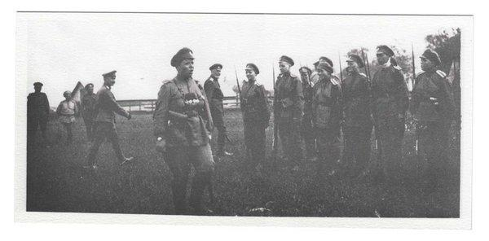

What is happening in this picture?

This photograph was taken in early 1917, following the abdication of Tsar Nicholas II, ruler of Russia. A woman called Maria Botchkareva gained permission from the new Provisional Government in Russia to form an all-female women’s infantry battalion. This image shows the training and recruitment process where Botchkareva, through a process of intense training, reduced the numbers from an initial 2000 recruits to 300 of the finest and most fearsome soldiers in the Russian army. The ‘1st Russian Women’s Battalion of Death’ was the first organised group of female soldiers to fight for Russia. They were sent to the Eastern Front in mid-1917. Many women were proud and happy to be able to offer their services to help Russia’s war effort, particularly after the abdication of the Tsar in March 1917. However, whilst Botchkareva was the first female infantry captain in the Russian Army, we can see in the picture she was watched over by male superior officers. This was nevertheless a very important moment in military history. The formation of the ‘1st Women’s Russian Battalion of Death’ was the first time that a large European power allowed women to fight in the frontline. Yet most people do not know the story and think of the First World War as fought only by men.

What was the back story?

Maria Botchkareva was just 19 when war broke out in 1914, but had already had two abusive marriages. She was a strong supporter of Tsar Nicholas II, and wanted to fight for her country. She attempted to join the army twice and was turned down as she was a woman. This prompted Botchkareva to write a telegram to Tsar Nicholas II, seeking his permission and blessing to join the Russian Imperial Army. He gave permission and, in late 1914, Botchkareva became the first female infantry solider in the Russian forces, serving with the 25th Infantry Batallion.
During her initial training, Botchkareva was mocked, abused and frequently referred to as ‘baba’ (weak or scrawny female in Russian). However, she gradually won the support and respect of her fellow soldiers by demonstrating outstanding acts of bravery in battle on the Eastern Front. Botchkareva rescued two injured soldiers at the same time from No Man’s Land, and this brought praise. She was recognised as a brave and decorated soldier. Fellow soldiers began to call her ‘Yashka’, which was an endearing term to describe a close comrade or friend. Her bravery was also shown by her approach to the serious injuries she received. These resulted in paralysis, partial blindness and having to learn how to walk again. Her swift return to the front line, which was greeted with great cheers from numerous different battalions, showed she was accepted and valued as a superior soldier and hero.

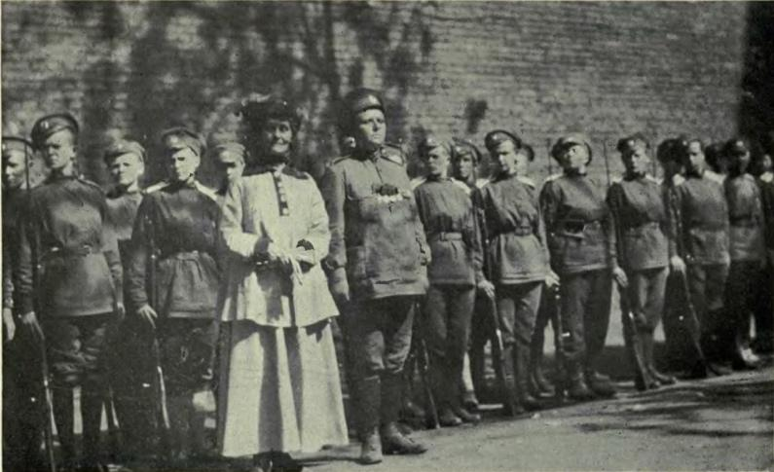
What happened as a result?

Botchkareva become renowned amongst the Russian forces as a symbol of bravery, equality and modernity. She strongly challenged the concept of an all-male army, and began to spread her influence globally, as she got to know, for example, the suffragette Emmeline Pankhurst. (They are both in this picture.) Yet, her story was lost in recorded history following the seizure of power by the Bolsheviks in October 1917. They did not agree with her support of Tsarism, nor with her views on female empowerment. After being invited to the White House to meet President Wilson, and to Buckingham Palace to meet King George V, she returned to Bolshevik Russia only to be executed by firing squad. She was written out of history for being on the wrong side and for being a woman.

Think!

In what ways does the story of Maria Botchkareva challenge stereotypes?
Why should people today be interested in her story?

Over to you!

Women took on a wide variety of roles in World War One. What can you find out about them? Here’s an interesting place to start with this: https://www.iwm.org.uk/history/12-things-you-didnt-know-about-women-in-the-first-world-war. What advice would you give to someone planning to tell the story of women in World War One to ensure that they do not unfairly stereotype women and that they do recognise the diversity of women and women’s roles?

Teacher notes: ‘How does Maria Botchkareva challenge our stereotypes of the fighting in World War One?’

What is a slot in?
A slot-in is a short story from the past that is rich in historical concepts. You can use a slot-in as part of a longer sequence, or as cover work, or in those moments where you need something short.

The concept focus of this enquiry
The enquiry question is ‘How does Maria Botchkareva challenge our stereotypes of the fighting in World War One?’ The story the students will follow concerns the rise of a female infantry soldier in a predominantly male force. The focus is upon a turning point, as well as a lost story that adds to our understanding of diversity. The text provided allows students to grasp a basic understanding concerning the events surrounding the common misconception that the Great War had an exclusively male frontline.

Curriculum Links
We have a duty to reflect the past of diverse people in our history curriculum, yet a fixed curriculum in many schools does not allow for a great deal of diversion. This story can easily be placed in topics such as:
- The Great War
- Female Empowerment and Suffrage
- Russia in Revolution

Activity suggestions
Students could read the text for additional background information concerning the Great War, the Eastern Front, Female Suffrage or Revolutionary Russia.
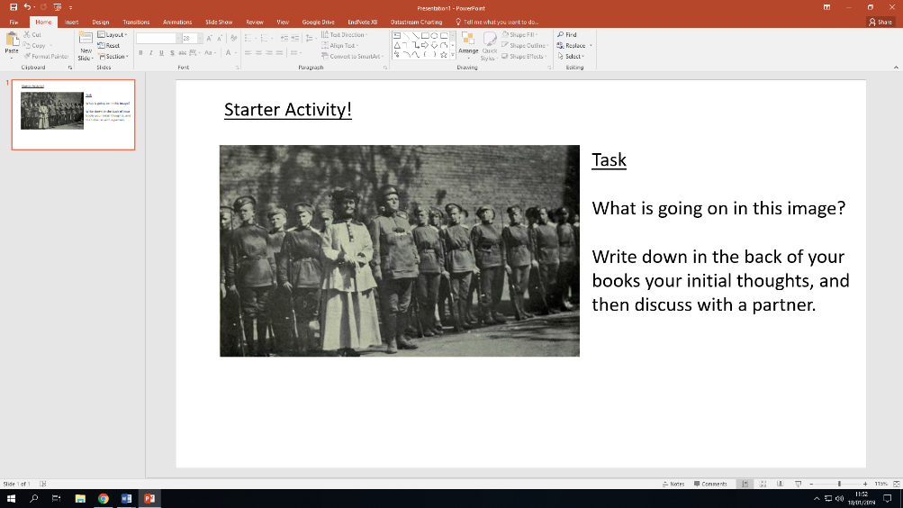
The images have utility as starter activities, where initial thoughts can be recorded in the back of students’ books and then discussed with a partner in a think-pair-share. They could also be used as a further challenge activity for more able students to develop their background knowledge and investigative skills.
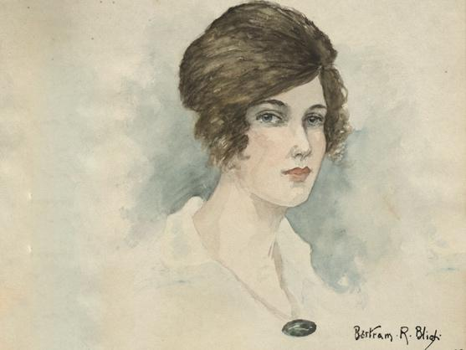
The story of Botchkareva could be used alongside another historical case study to compare and contrast the experiences of women in the front line. A good example of another female case study is to direct students towards is that of Florence Blythe-Brown. She worked as a nurse in a London military hospital.

Students could write a paragraph to summarise the story of Botchkareva and how her story challenges stereotypes about fighting in World War One, or could be used by women in the UK to campaign for rights. Our slot-in has an ‘Over to you’ section, where students are encouraged to embark upon individual research in order to further their knowledge of the topic.
Misconceptions to dispel
Traditional common ‘folk’ history suggests that ‘the men’ went off to fight for their country, and that they went in droves. Although the volume is indeed correct, the idea that only men, and white men at that, were involved in front-line fighting is incorrect. This activity and information sheet will help to dispel this misconception.

Extra background for teachers
Female history is a growing area of historic enquiry; dispelling and correcting misconceptions of gendered history (such as participation in the Great War). Historical diversity is expanding within university curricula and needs to in school history too.

World War One is still known as the Great War for a reason, it was unlike any war the world had ever known. Millions of people were involved including women. The ability and willingness of many of the belligerent countries to engage their women in ‘total war’ was not predicted in the years before 1914 and helped to prolong the conflict. Most of the recognised war dead were men, although women probably made up the most of the civilian war dead. Some women did die in conflict. The women of the British Empire who died have a memorial in York Minster that was constructed due to the efforts of other women in the early 1920s. Women were not allowed to fight in the British army on exactly the same terms as men until 2018.

In 1914, most people (including women) thought the ideal place for a woman was in the home, running the household and caring for their children and husband. However, during the war years the demands of ‘total war’ meant that women took on many different roles. In Britain, these may have been farming in the Land Army, nursing in the VAD (wealthier women), making shells as munitionettes (working women) and in the WAAC as the back-up for the army. However, some women were determined to do their part in the fighting and disguised themselves as men to fight on the frontlines.

After the War, majority public opinion expected women to be wives, mothers and to care for the war-damaged. There is much debate among historians about how much of a difference experiences during World War One made to the advance of women’s rights in Britain. We do know that the lives of many individual women (and men) were transformed by the experience of living through the ‘Great War’.

Where to link to
Shero.wordpress.com has a good information page on Maria Botchkareva. Her personal diaries Yashka: My life as a peasant, soldier and exile is particularly good for her background story and information on the social situation in revolutionary Russia. The National Archives have detailed information on the role of women in the First World War, albeit not for frontline action, but as auxiliaries.

