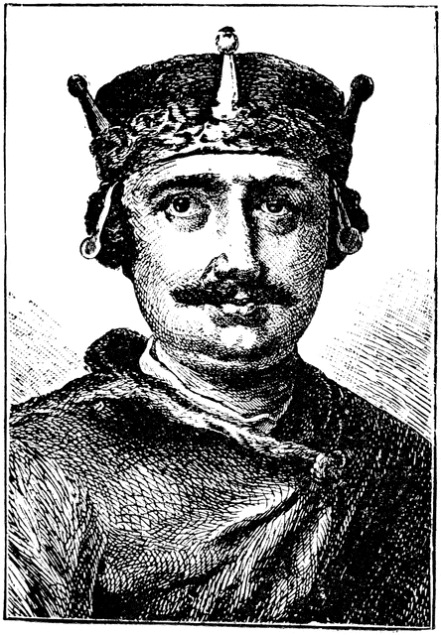
After William the Conqueror’s death, his eldest son inherited the family lands in Normandy and the barons wanted the military strength of his second son William Rufus on the throne so he rushed from France to Westminster to be crowned in 1087. He made himself popular straight away by giving local areas money for the poor and giving a lot of his father’s wealth to the church. William II’s court was very fancy and very different to the military style of his father’s. To fund the fashions and big building projects buildings William needed money. He found ways to tax inheritance money from young barons, and took money for the Archbishop of Canterbury by not replacing him when he died. When a new Archbishop of Canterbury was eventually appointed, they argued over money resulting in William II asking his barons to decide whether he or the Pope (Head of the Roman Catholic Church) should have more power; the English barons chose their King in England over Pope Urban II in Rome, Italy. This didn’t stop the first Crusade (military campaigns to take places like Jerusalem from Muslims to be controlled by Christians) being very popular with English Knights in 1095 as an example of the power of the Roman Catholic Church; anyone who went would have all of his sins forgiven.
William II 1087-1100
William II was hit by an arrow in an accident whilst hunting; interestingly his younger brother Henry apparently left his brother’s dead body to rush to be crowned King, to prevent their elder brother claiming the throne! Henry I was initially popular with the barons because he got rid of many of the taxes his brother had raised. Henry I spent most of his reign abroad in France fighting. In his absence he left Roger of Salisbury in charge. We recognise today some of the tax traditions that Roger began such as the creation of Lords of the Exchequer. Unfortunately, Henry I’s only son William died in a shipwreck leaving just his daughter Matilda as heir to the throne, a first for the Normans. She was married to Geoffrey Plantagenet of Anjou in France – a rival of the Normans. When Henry died in 1135, the English barons really didn’t like the idea of the throne being inherited by a woman whose husband was a rival of the Normans. So, the barons in London accepted Henry’s cousin Stephen’s claim to the throne. Matilda and her husband promptly declared war.
Henry I 1100-1135
Empress Matilda
The fifteen years of Civil War that followed are known as the Anarchy; the barons and the bishops switched between Stephan and Matilda a few times and eventually Matilda handed over the fighting to her son, Henry Anjou who continued to fight for his family’s claim to the throne. Henry married Eleanor of Aquitaine (who by the age of 30 had personally led troops on the Second Crusade – so a great leader herself!) and their huge force of over 3,000 French Knights and soldiers landed in England in 1153. Stephen gave in and named Henry as his heir; he died the following year so King Henry II was crowned in 1154.
Stephen 1135-1154

The second king Henry had a temper unlike his namesake grandfather and could swing between calm and rage in an instant. This was most shown in his relationship with Thomas Becket; initially his best friend and advisor. Henry II asked Becket to become Archbishop of Canterbury in 1162, hoping to combine his political and church roles to give the King more power. Reluctant at first, Becket eventually agreed but to Henry’s surprise he then promised to serve God over the King! Years of arguing followed; over the power of the church or the king to control land, raise taxes and put people on trial in church or royal courts. Eventually Becket triggered Henry’s temper by excommunicating from the church all the bishops who had supported Henry during their argument. This led to four of Henry’s knights interpreting his rage an order to kill Becket, so they travelled to Canterbury Cathedral where they found Becket and killed him by slicing off the top of his head. The whole of Europe was scandalised by his murder and it was a great turning point in Henry’s reign, motivating him to submit to the power of the Roman Catholic Pope and try to gain forgiveness for the death of his friend.
Henry II 1154-1189
Whilst Henry II had been ruling, his wife had turned against him and plotted many revolts; including by their own sons! In his final years, Henry II tried to reform the justice courts of England by properly introducing trial by jury but that wasn’t what people would remember him for after the scandal of Becket’s death. Henry wanted his third son John to be his heir but John sided with his elder brother Richard and rebelled against their father. Henry named Richard as the next king just before his death in 1189. Richard I was delighted to be able to use his power to fundraise for his Crusades in the Holy Land (Israel/Palestine). He couldn’t actually speak English and returned to the country only once during his reign. The high taxes he used to fund his religious wars led to rich merchants of London forming a town council and electing their first mayor – something they still have now. England was run in Richard’s absence by his brother John and barons advising him. When Richard was captured and ransomed by the German Emperor in 1194, the wool trade of London paid most of his ransom fee. He never made it home before he died on the battlefield in 1199. Once again the barons had a choice; Richard’s twelve-year-old nephew Arthur or his brother John…
Richard I 1189-1199

Questions:
KING: | William II | Henry I | Stephen and Matilda | Henry II | Richard
TAXES: |  |  | Didn’t do much because they were busy…
CHURCH: |  |  | Didn’t do much because they were busy…
LAWS: |  |  | Didn’t do much because they were busy…
EXT: Other fun facts? |  |  | The Anarchy…

EXTENSION:

Which King raise the most taxes?

Which King had the most power over the church?

Which King was most like William the Conqueror?

What was the main cause of conflict during this period?

