How were the disabled treated as a consequence of World War One?
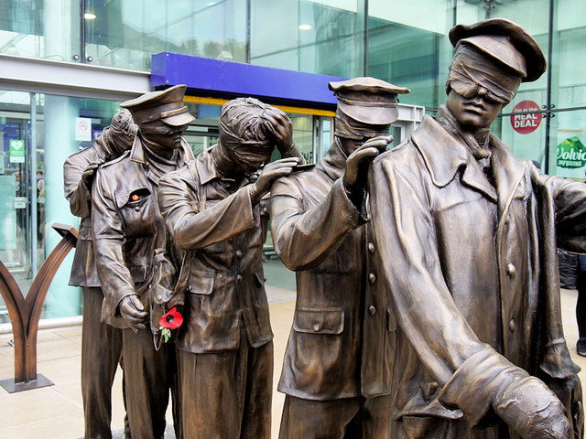
Gas! GAS! Quick, boys! — An ecstasy of fumbling,
Fitting the clumsy helmets just in time;
But someone still was yelling out and stumbling,
And flound'ring like a man in fire or lime ...
Dim, through the misty panes and thick green light,
As under a green sea, I saw him drowning.
In all my dreams, before my helpless sight,
He plunges at me, guttering, choking, drowning.

What can we learn from this image and poem?
The image shows a memorial that was erected in October 2018 at Piccadilly station in Manchester. What does the memorial suggest about the impact that the First World War (1914-18) had on the soldiers who fought in it? The extract is from Wilfred Owen’s famous poem: ‘Dulce et Decorum Est’. What does this reflective poem written in 1920 suggest to you about the use of gas in World War One?

What exactly was a gas attack?
Gas attacks were used to injure and kill enemy soldiers in the trenches during World War One. Gas was released to blow on the wind. Slow moving gas clouds very effective at injuring unsuspecting soldiers. The idea of a gas attack was also terrifying. The types of gas used ranged from disabling chemicals like tear gas, to poisonous gases such as phosgene, chlorine, and mustard gas. Poison gas was first used on the Western Front in April 1915. The use of poison gas was a war crime even in 1915. It went against the 1899 Hague Declaration Concerning Asphyxiating Gases and the 1907 Hague Convention on Land Warfare. These two laws banned the use of poison or poison weapons in warfare. Its use was unexpected and so the soldiers were not prepared. There was a rush to make gas masks and get them to the soldiers to protect them from this frightening new weapon that both sides began to use. As soon as gas was detected, soldiers would have to quickly fit their gas masks. Failure to do so led to injury and death.

Back home the effects of gas attacks were not completely understood. Those not killed often had long lasting physical and mental side effects for years to come. Can we ever empathise with something we have not experienced? We cannot precisely imagine what it must have been like, and the poem, written by a soldier at the front who had seen gas attacks, acts as a window into the past for us.

Think! Why could it have taken 100 years to put up a memorial to those injured by the gas attacks during World War One?

What is the wider story?
Chemical warfare was a large part of the First World War, but there were also many other causes of mental and physical damage to people who fought, or were near the violence. Some survivors lost limbs, lost parts of faces, were left blind or deaf, could not breathe properly and/or had post-traumatic stress. Before the First World War there had been a common view that disability, mental or physical, was a sign of weakness. Before modern times, disability was often associated with evil and God’s punishment. From the time of the Tudors in England people with disability were increasingly seen as a burden on society. By the 1800s, people who twisted the ideas of Charles Darwin saw disabled people as ‘imperfect humans’. The war helped to change some of these views. It was clear that the disabled had been heroic. These fighting heroes deserved care.

What happened as a result?
One example of a response was for blind people. The blind returning soldiers needed employment. They were trained by other members of society so that they developed skills such as type writing and boot repairing. Blind Veterans UK was set up in 1915 (then it was called St. Dunstans) to train, rehabilitate and support soldiers blinded by war. Since 1915 they have helped over 15,000 soldiers and they still work with war veterans today. In 1931 they trained the first four guide dogs for the blind to be used in Britain; named Flash, Judy, Meta, and Folly. This is just one example of pioneering work to support people with disabilities.

THINK!
- This is a story about changing perceptions of disabilities. What role did war play in this change?
- Why do you think historians may talk of World War One as a turning point in the history of disability?

Over to you!

Why not research online to find out in what other ways World War One was a turning point in medicine? Or you could research for other reasons why attitudes to disability changed so much in the 20th century.
A Day With Blinded Soldiers https://www.youtube.com/watch?v=AZqsmmRgXPk
will help you to research how blindness has been treated in the past and how it is understood today.

Teacher notes: ‘How were the disabled treated as a consequence of World War One?’

What is a slot-in?
A slot-in is a short story from the past that is rich in historical concepts. You can use a slot-in as part of a longer sequence, or as cover work, or in those moments where you need something short.

Concept Focus
The aim of this slot-in is to address a consequence of the First World War. Men and women returned from the battlefields with mental and physical damage. Their presence in society changed some previous assumptions about disability.

Curriculum Links
Diversity is crucial to an engaging and supportive curriculum, but there is so little time to cover so much. This slot-in about an aspect of disability and WW1 can be used as part of a study of:
- Medicine Through Time
- The First World War
- Life in 20th Century Britain.

Activity suggestions
For activities to enable you to set this slot-in in a lesson about the history of disability follow this link: https://yorkclio.com/2018/05/19/hidden-in-plain-sight-resources-for-teaching-the-history-of-people-with-disability/. You could collect a set of images of injuries and treatments from World War One to make a gallery about the impact of the War on the history of medicine.

Further knowledge
There were, of course, many disabled veterans in other countries. German war veterans had better pensions than British veterans in the 1920s. However, the impact of the Depression on Germany and the rise of Nazism led to the erosion of rights and provision. There is a terrible room in Auschwitz-Birkenau full of prosthetic limbs. Some of the owners of these would have lost limbs fighting in World War One years before their lives were destroyed during World War Two. Even if you do not use the resources on the YorkClio with students, a read through them will provide you will much more knowledge about the history of disability to inform your teaching. There are also other slot-ins available.

Where to link to… This is useful from the BBC: http://www.bbc.co.uk/guides/zs3wpv4 As is this from the British Library: https://www.bl.uk/world-war-one/articles/medical-developments-in-world-war-one

