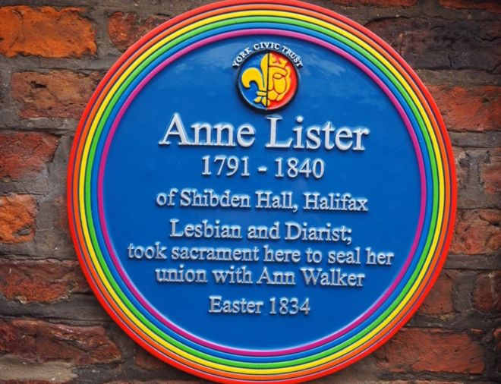
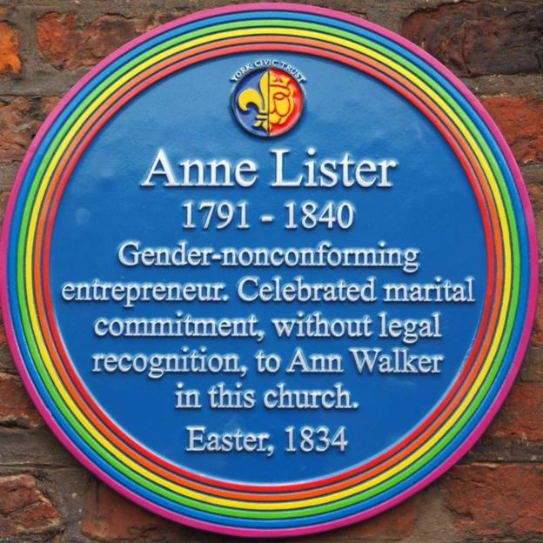
How does Anne Lister challenge popular ideas about early 19th century British women?
How are these two plaques different?
The plaque on the left was put up on the wall in a York churchyard in July 2018. There followed a protest which included a petition signed by over 2500 people. York Civic Trust, York LGBT Forum, York LGBT History Month and the Churches Conservation Trust were accused of erasing the true past. They apologised and said that a new plaque would be put up which: “will reflect as accurately as possible Anne’s own view of herself …will where possible be based on the words Anne chose to describe herself, her actions and her lifestyle.” The new plaque, on the right, was unveiled to replace the old one in February 2019. (This one had the rainbow the right way around too.)
THINK! Why do you think the wording of the first plaque provoked a protest? What does ‘erasing of the true past’ mean?
Who was Anne Lister?
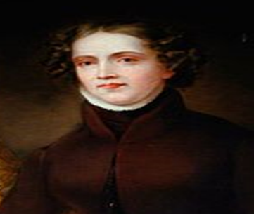
Anne Lister was a wealthy woman at a time when most people were poor. She was born into one of the leading land-owning families in Halifax. You can still visit her family home, Shibden Hall. Anne went to Manor School in York. All her four brothers died young and so she inherited the family estate in 1826. In this she was unusual, but not exceptional. It meant that Anne did not have to marry to be financially secure. This again made her unusual, but not the only example of such a woman.
She was a local businesswoman, local politician, landscape and building designer, mountaineer, intrepid traveller and she left 27 volumes of diaries written in code.
She died, aged 49, of fever caught while travelling in Georgia. Her wife had her body embalmed and brought it back to Yorkshire for burial.
What do her diaries reveal?
Parts of Anne’s diaries were written in a code she made up from algebra and the Greek alphabet. The code was cracked by her descendent, John Lister, fifty years after her death. He read them, got very alarmed and hid them again.
The diaries were only rediscovered in the 20th century when Shibden Hall opened as a museum. The non-coded parts give a detailed account of life in Halifax and other parts of Yorkshire in the Georgian era (about the same time as Jane Austen). Anne was curious about everything, from the state of politics in Prussia to the details of the weather. We learn that she loved hard exercise, always wore black and that she was fascinated by travel and places; visiting the site of the Peterloo Massacre soon after it happened. She successfully influenced her tenants to vote as she wanted them to do.
The code used for one sixth of the diaries was only rebroken in the 1980s. It revealed the detail of Lister’s passionate lesbian love-life. Her biographer, Helena Whitbread, says: “It is groundbreaking stuff, absolutely explicit, every action is described. It’s very saucy and very riveting.” In 2011, the United Nations World Heritage Organisation (UNESCO) added the diaries to their Memory of the World register, calling the diaries “a comprehensive and painfully honest account of lesbian life.”
It seems clear, as she wrote in code, that Anne felt the need to keep her sex life private. Nevertheless, her unconventionality was a source of comment and she was known by locals as ‘Gentleman Jack’. She may even have influenced the novels of the Brontë sisters, who lived nearby at the same time. Yet, she was seen as odd and talked about, not outcast. Historians debate how unusual her active lesbian sex life was at the time. The current view, held by, for example historian Sharon Marcus, is that it was not uncommon for the time. It was to be 180 years after Anne and Ann regarded themselves as married before the state accepted marriage between people of the same sex. Nevertheless Anne and Ann lived together at Shibden Hall.
Anne’s travels were extensive. To travel one had to be very rich for the time. Again, a woman travelling was unusual, but not exceptional. Women with wealth and class privilege, such as Anne, often wrote about how fortunate they felt that they had freedom to travel, unlike many of the women they encountered on their journeys.
Despite what academic historians know, if most people think about women in early 19th century Britain, they probably think of the Bennett sisters in Jane Austen’s ‘Pride and Prejudice’ or working women toiling very hard in the mills and mines.
THINK! In what ways does Anne Lister challenge these ideas?
Over to you!
Here is a British Library article about gender roles in the 19th century. https://www.bl.uk/romantics-and-victorians/articles/gender-roles-in-the-19th-century It will give you more context to the Anne Lister story.
Teacher notes: ‘How does Anne Lister challenge popular ideas about early 19th century British women?’
What is a slot-in?
A slot-in is a short story from the past that is rich in historical concepts. You can use a slot-in as part of a longer sequence, or as cover work, or in those moments where you need something short.
The concept focus of this enquiry
The enquiry question here is: ‘How does Anne Lister challenge popular ideas about early 19th century British women?’ The story the students will read is written to help them make a judgement about the different ways that Anne Lister was / was not typical of women of her time.
Anne Lister’s story is revealing about both the life of a wealthy and independent woman and about living as a lesbian. She has been described as ‘the first modern lesbian’. Interest in her life in recent years has been part of the writing of history of women who love women.
Curriculum links
We have a duty to reflect the past of diverse people in our history curriculum. We also have such a restricted amount of curriculum time to teach a large amount of past. This story could be slotted-in to your curriculum as part of a sequence on:
- Women in 19th century Britain,
- Minority rights,
It could also be slotted-in to the English curriculum as part of the context to studying the works of Jane Austen and/or the Brontë sisters.
Activity suggestions
You might just want students to read this story, make a connection to a wider topic and move on. However, you might decide to use this material for a whole lesson with activities. You could:
- Spend time with the blue plaque. They are a very useful way to support students to understand about historical significance. Plaques are put up to people who are regarded as significant. They are a type of interpretation and they say as much about the values and ideas of the people putting them up as they do about the person. Here is a website about London blue plaques that may be useful: https://www.english-heritage.org.uk/visit/blue-plaques/. You could also explore the reasons for the protest in more depth using this report: https://www.bbc.com/news/uk-england-york-north-yorkshire-47404525. It’s an interesting story, as the people who put up the plaque were clearly trying to recognise the past of the LGBT community, but they did not do it well. They apologised and put it right. This seems to be an example where the protest quickly acknowledged had its intended impact. However, why was the initial mistake made?
- Anne’s diaries are widely available and you could use carefully chosen extracts to trace her travels onto a map, comparing the names of places she visited with those that exist today. You could also use extracts to give students a picture of life in West Yorkshire as the industrial revolution was well underway. Likewise, you could use extracts of her local political life, including getting her tenants to vote for her preferred candidate in the general election. All of these are examples of using primary source material to get a better understanding of life in Britain in the early 19th century.
- In order to enable students to think more deeply about the enquiry question, you could adapt the British Library article (see‘Over to You!’ section). They could annotate the article to show how Anne’s life was, or was not, typical.
- If students are studying Austen or Brontë, you could show them an extract of a dramatization of the life and expectations of women e.g. the Bennett sisters from Pride and Prejudice and get students to think about why the women’s stories are so different. Anne is richer, does not have money worries requiring a husband. Jane Austen was writing to sell books and for the mainstream. Anne was living an unconventional life, much of which she hid, and even so she was sometimes the target of unwanted hostility. Anne is in the industrial north. Anne is a very different personality… and was real!
- You could also introduce students to why Anne Lister’s story has only recently become more known, including with a TV drama in 2019. The diaries were hidden – why? Academic historians have worked on them since the 1980s. The study of women in the past, and especially queer women, was not the subject of university work until the 1960s. Being gay was not acceptable in society in the same way it is now until relatively recently. Students can be unaware how some rights are recently won and hard won.
Misconceptions to dispel
As well as teaching students to understand that gay rights have not always been so well established, there are other misconceptions to be aware of relating to this story. One is that gay people have exactly the same rights as straight people. For example, gay marriage is still not accepted by the Church of England.
In some ways there is more unusual about Anne due to her status as a wealthy and independent woman than there is because she was gay. Few people in the UK were so wealthy. Most were workers living in a rapidly industrialising Britain. Few women inherited as they had brothers who took precedence.
Extra background for teachers
Every February is designated LGBT history month. You can find out more here: https://lgbthistorymonth.org.uk/ The purpose of having a month is to raise awareness that the past of LGBT people has been neglected in the past. Ideally this past is not neglected and that’s where a slot-in can help. In a busy curriculum, it is a way of making sure that the past of people from minority groups still features in your lessons. You will find several freely available on the www.yorkclio.com site.
Where to link to
You can find out more about Anne Lister by reading her biography by Angela Steidele called ‘Gentleman Jack’. The author Jeanette Winterson has written an interesting article about here here: http://www.jeanettewinterson.com/journalism/about-anne-lister/ Help with putting Anne’s life into context can be found via the Jane Austen society here: https://www.janeausten.co.uk/womens-lives-in-georgian-england/ This article also references some further recommended reading.

