What does the story of Lady Eleanor Davies reveal about England in the first half of the 17th Century?
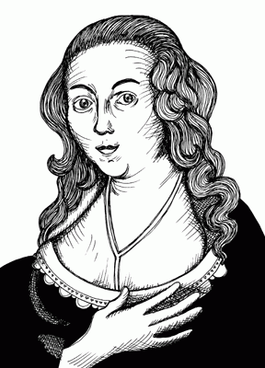
Who was Lady Eleanor Davies?
In some ways this is an easy question to answer. Lady Eleanor Davies was born Eleanor Touchet and she was the daughter of a Lord. That made her from the top level of society in a world where your position in society really mattered. In 1609 her father arranged her marriage to Sir John Davies. He was not so high-born, but was rich and ambitious. Both John and Eleanor were strong characters. Their marriage was troubled. At the time men had the power in marriages. For example, John insisted on marrying their 10 year-old daughter to an Earl.
In 1625 Lady Eleanor had a vision that the world was to end in 19½ years’ time. She wrote her vision down and spoke about it. Her husband burnt her writings. She had a vision calling him Judas (the man who betrayed Jesus) and prophesying (predicting) his death. He died. She married again. It was not a happy marriage. Her new husband burnt her writings. She cursed him. He fell ill. Lady Eleanor made public prophesies and became famous. She described herself as a female Daniel. (Daniel was a prophet in the Old Testament of the Bible.) She prophesied the assassination of the Duke of Buckingham, favourite of King Charles I. She prophesied the death of the King’s first child and the healthy birth of the future King Charles II in 1630. When she prophesied the King’s execution, she was put on trial. (Note: that was in 1633 and Charles I was executed in 1649.) The Bishops wanted to put her in Bedlam madhouse. Instead she was fined and imprisoned. Her high-born daughter organised a petition for her release. She damaged Lichfield Cathedral and was put in Bedlam, and then in prison again. The Archbishop of Canterbury burnt her writings in public. After the Civil War began, she continued prophesying and Parliament put her in prison in 1646. She met Cromwell in 1648 and he was more tolerant of people like her, so she lived in peace to her death in 1652.
THINK! What can you learn about the early 17th century in England from Lady Eleanor’s story? What do you find usual / unusual? What questions does the story raise?
Why does Lady Eleanor’s story intrigue historians?
Roy Porter, a historian of the history of medicine, is very interested in Lady Eleanor’s story and what it reveals about the time in which she lived. In the 19th century in Britain, women were often labelled as “mad” if they did not behave acceptably for the times. That is, if they were very independent, or openly intelligent and questioning, or openly interested in sex. Women described as being ‘melancholic’ or ‘hysterical’ were thought to be disordered, and, from the later 1700s, were usually put in madhouses, known as asylums. However, Roy Porter points out that Lady Eleanor’s story is different and that the early 1600s were not the same as the 1800s. Ideas and beliefs were different and so were attitudes towards women.
Roy Porter became interested in the debates about whether to put Lady Eleanor in the madhouse or in prison or to let her be free. He suggests this is an example of how the 1600s were a time of changing ideas and attitudes.
In medieval Europe people believed that women (and men) could be inspired by something beyond this world. Sometimes there was talk of possession by the devil, but there were also mystics and visionaries seen as saintly and holy. For example, a woman called Julian of Norwich lived in the 14th century and was visited for her wisdom and visions. (You can still visit her cell in Norwich today.) We also know that there were ‘fools’ and ‘jesters’ at Court who were valued for their wise words and the way they saw things differently. For example, ‘Jane the Fool’ for Queen Mary I.
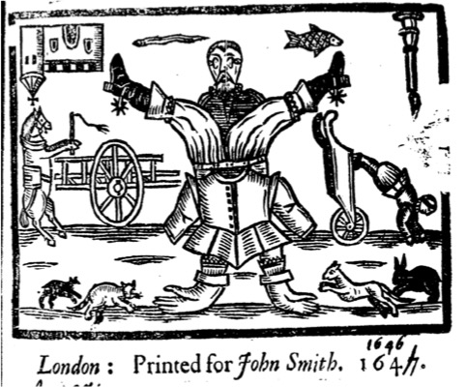
In the 1600s, some people saw Lady Eleanor’s ‘strangeness’ as inspired by the devil and dangerous to the church. The bishops did not like it when people who were not priests spoke out. Other religious people at the time, the Puritans, believed that anyone, not just priests, could be ‘chosen’ by God. However, some people no longer used religion to explain Lady Eleanor. Some thought of her as a danger to the country, a criminal. Some thought she was different, but should be free. Beliefs about acceptable behaviour were changing and so there was more variety of views in the 1600s.
Lady Eleanor herself described her feelings in a very bodily, religious way, for example she felt crucified. She called herself a prophet and was not afraid to use her voice. She did not reach out to other women. She had two troubled marriages, she had a child with learning disabilities who drowned and her brother was executed for sexual scandal. Lady Eleanor had personal circumstances that might be as important to understanding her as the wider culture and beliefs of her time.
THINK! What evidence can you find that ideas in the 1600s were like medieval times? What evidence can you find that ideas were changing? What evidence can you find to argue that Lady Eleanor’s story does not tell us much about England in the early 17th century?
Over to you!
Why not do some internet research about other women regarded as ‘strange’ to find out about their times? For example, Joan of Arc, Jane the Fool or Anne Lister.
Teacher notes: ‘What does the story of Lady Eleanor Davies reveal about England in the first half of the 17th Century?’

What is a slot-in?
A slot-in is a short story from the past that is rich in historical concepts. You can use a slot-in as part of a longer sequence, or as cover work, or in those moments where you need something short.

The concept focus of this enquiry
The enquiry question here is: ‘What does the story of Lady Eleanor Davies reveal about England in the first half of the 17th Century?’ It is intended to help students to explore the ideas and beliefs of a time in the past very different to our own. By doing this they should improve their sense of period. A good sense of period is important to being a good historian and it is quite hard for students to gain. Approaching the ideas and beliefs of a time through the experiences of one person can be an accessible way for students to engage and learn.

Curriculum links
This ‘slot-in’ would be useful as part of the study of:
- Stuart England and the era of the Civil War
- Women in Britain over time
- Medicine at the time of the Renaissance
- The history of mental health in Britain
And as context to topics such as:
- The Restoration
- The Industrial Age
- Women in Britain since 1800

Activity suggestions
‘Slot ins’ can be given to students in class or for homework as they are. However, you might want to use section of the content in a lesson and here we give some activity ideas.
Lady Eleanor was high born and that made her experience very different from that of most women of her time. You could develop an activity to investigate the different roles and situations of women in Stuart society. To help you there is: https://www.historyextra.com/period/stuart/stuart-britain-what-was-life-like-for-ordinary-people/ and https://www.english-heritage.org.uk/learn/story-of-england/stuarts/ and for HA members https://www.history.org.uk/secondary/resource/7001/women-education-and-literacy-in-tudor-and-stuart
You might be wanting your students to understand how in many ways the 1600s were a time when there were still ‘medieval ideas’ but also a time of change to a different way of thinking that we would associate with more diversity of religious beliefs, the ideas of thinkers such as Descartes and Locke and the development of natural sciences. If so, you could give students a summary description of ideas about religion and philosophy and the human mind and body that dominated in the later middles ages and then the change of ideas that was taking place (here’s a brief outline: https://eurohistorymed.weebly.com/1600s.html) You can then ask students to spot the influence of older and newer ideas in Lady Eleanor’s story.
If you want to set Lady Eleanor’s story in the context of thoughts about mental health through time, then you will find a resource for a one lesson thematic study at www.yorkclio.com/blog/

Misconceptions to dispel
Roy Porter is at pains to point out that Lady Eleanor’s story can not be understood simply by thinking of her as a woman. That was part of what informed her life story, but she was also from a wealthy background, living at a time of changing ideas, through a time of civil war and with her own personal circumstances that shaped her as a person. This complexity is important for students to understand. Lady Eleanor cannot be fitted neatly into a discreet category and that is useful. Keeping the past messy and complex for students, while making it accessible, is a great challenge for history teachers, but one which gives due respect to people who lived in the past and helps them to understand that human society is always hard to explain.
Lady Eleanor’s story is partly concerned with ideas about mental health and how it should be defined. It is important for students to understand that mental illness as we define it today is different from how it was defined in the past. It is also important for them to understand that mental illness is something that is, and always has been, part of the human condition.

Where to link to
As well as the links given above, you might also want to read “The Prophetic Body: Lady Eleanor Davies and the meanings of madness” by Roy Porter in 1994. He also wrote a general history of mental health called “Madness: a brief history” in 2003.

