How did The Retreat Hospital transform approaches to mental health?
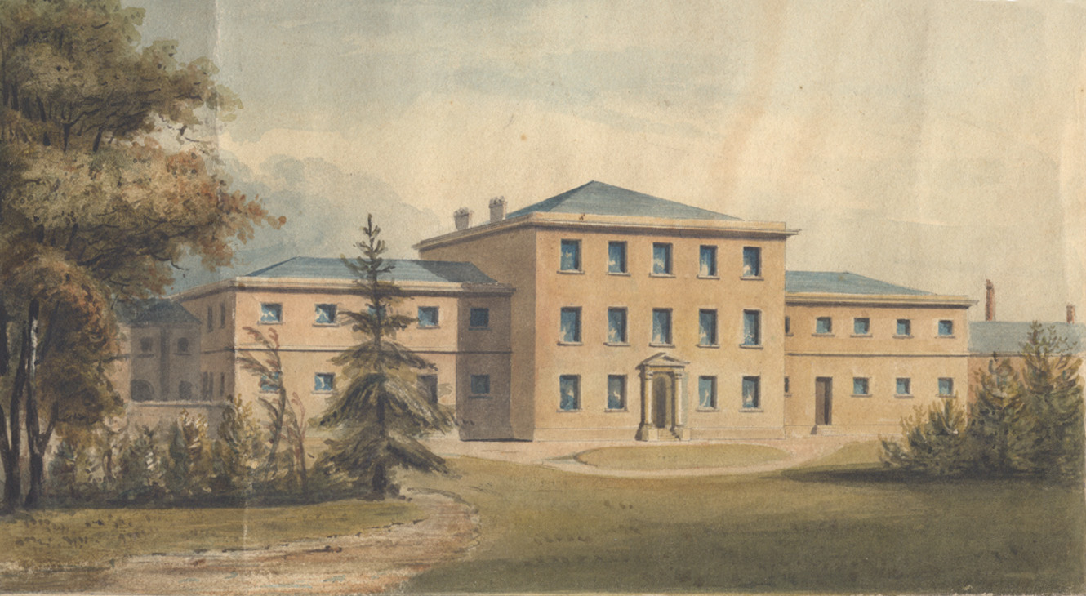
This building in York still exists today. It looks very much as it did when this watercolour was painted in 1812. It looks rather ordinary. The painting is of the Retreat Hospital, a hospital (or asylum as it was known) for mentally ill people. When the Retreat opened in 1796 is was revolutionary. That is, it took a very different approach to the treatment of mentally ill people. You will now find out how it transformed ideas about treating mental illness way beyond York.
- THINK! Where else have you come across the words ‘revolutionary’ and ‘revolution’? What other words might they be linked to?
Why was the Retreat opened?
In 1790 a woman did in York Lunatic Asylum. A lunatic asylum was a place for people who were mentally ill and the York one had opened in 1777. The woman’s name was Hannah Mills and she was a Quaker. Quakers still exist today and they are a religious group who believe in living lives that reflect the idea of God in everyone. They are also known as Friends. None of the Friends Hannah knew, nor any other of her friends and family, had been allowed to visit her for the last six weeks of her life. After her death, Quakers did go into the York Asylum and they were horrified at what they found. The mentally ill people were being treated cruelly.
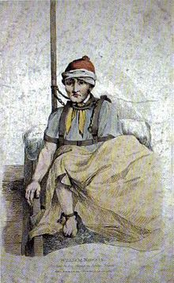
Some Quakers were wealthy, and all Quakers were committed to taking action when they found something wrong in society. A York Quaker called William Tuke led a six-year campaign to raise money and support to open the Retreat on a hill in the fresh air on the outskirts of York. Quakers believed that everyone should be treated with kindness and as an equal. That meant that Retreat patients were nursed with homeliness, respect and care. They were rarely restrained and never beaten. They were encouraged to do something useful and the hospital was run as a community with everyone eating together.
Why was this such big news?
It is quite shocking to us that kind and respectful treatment of people with mental illness was big news. But it was! At the time people were called names such as ‘mad’, ‘lunatics’ and ‘hysterics’. They were often restrained, sometimes in cages, treated worse than animals, beaten, kept hungry and, at Bedlam Hospital in London, people even paid to come and stare at the inpatients. Famous writers Samuel Pepys, Jonathan Swift and Charles Dickens, all talk about trips out to see Bedlam. The picture to the right is of James (William) Norris, Bethlem Patient, 1815
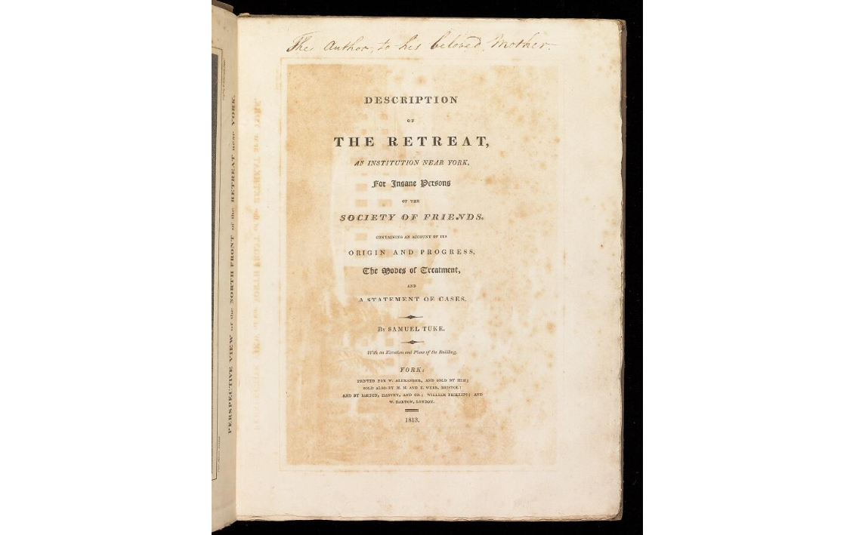
In 1813, William Tuke’s grandson, Samuel, wrote a book called a ‘Description of the Retreat’. It made the Retreat and its care famous. People read the book and travelled long distances to visit the hospital to see how it worked for themselves. They were impressed. This was a time of questioning old ideas known as The Enlightenment. The Retreat Visitors’ Book records names including members of the royal family Russia, the prison reformer Elizabeth Fry and people from the Seneca tribe of northern America. The Retreat became a model for other hospitals across Europe and in North America. Textbooks on psychiatry (the medical study of mental illness) now mention the unique role played by the Retreat in reshaping ideas to mental illness.
Julia Unwin of the Joseph Rowntree Foundation: "It is perhaps easy for us looking back … not to recognise the true impact of this extraordinary leap forward in the care of mentally ill people and the bravery of Tuke in pioneering it."
THINK!
- The Retreat was a turning point in the treatment of mentally ill people. That is, it was a moment of change. What factors caused that moment of change?
- What does this story reveal about life and beliefs in Europe in the late 1700s?
Over to you!
The history of mental health and its treatment is not one you usually study in school. However, it is studied by historians. You can find out more about Bedlam here: http://www.bbc.com/culture/story/20161213-how-bedlam-became-a-palace-for-lunatics. You can find out about the role of the NHS, founded in 1948, here: https://peopleshistorynhs.org/encyclopaedia/mental-health/. A general short history is here: http://broughttolife.sciencemuseum.org.uk/broughttolife/themes/menalhealthandillness
Teacher notes: ‘How did The Retreat Hospital transform approaches to mental health?’
What is a slot-in?
A slot-in is a short story from the past that is rich in historical concepts. You can use a slot-in as part of a longer sequence, or as cover work, or in those moments where you need something short.
The concept focus of this enquiry
The enquiry question here is: ‘How did The Retreat Hospital transform approaches to mental health?’ The story the students will read is written to show that events have causes and consequences. The focus is upon a turning point moment in the history of mental health.
The history of mental health is rarely taught in schools. However, as we are all aware, mental health is a very important topic in contemporary society. Introducing students to the idea that ideas about, and treatment of, has changed and developed over time is important if they are to understand the world around them.
Curriculum links
We have a duty to reflect the past of diverse people in our history curriculum. We also have such a restricted amount of curriculum time to teach a large amount of past. This story could be slotted-in to your curriculum as part of a sequence on:
- Britain in the industrial revolution period,
- Revolution as a concept,
- Public health and medicine through time.
Activity suggestions
You might just want students to read this story, make a connection to a wider topic and move on. However, you might decide to use this material for a whole lesson with activities. You could:
- Take the concept of revolution and exploring the etmology, drawing students attention to the different ways the concept is used by historians. What other revolutions have they heard of? This is also a useful point to introduce / remind students about the concept of a turning point moment.
- To identify the factors at work in this story: Quaker faith, individual leadership, wealth and influence, travel and communication, time of questioning (the Enlightenment). Historians don’t simply rank factors, but there are interesting questions you can ask. For example, which factors worked in which part of the story of the Retreat. How did the factors connect to cause the founding of the Retreat and then the influence of the Retreat – two separate things. It can be useful to do some thinking of this sort about factors with a relatively straightforward story.
- A full copy of Samuel Tuke’s description is online. In the appendices there are accounts from visitors. You could print some of these and ask students use this source material to delve deeper into what it was about the Retreat that impressed visitors.
- You will find a one lesson thematic activity and resources on the history of mental health free to download, adapt and use from www.yorkclio.com/blog/ that will enable you to fit this slot-in into its historical context. Students could also use the links in the ‘over to you’ section to learn more about how much of an impact the Retreat had.
- It may be possible for students to research the history of the local asylum. Local history societies may have materials. The records of asylums and prisons are one of the few ways we can get to hear the individual voices of the working poor of the 19th century.
Extra background for teachers, including misconceptions to dispel
Students, understandably, can be quite limited in their understanding about how factors cause change. For example, they may not easily grasp the role that religion did (and still does) play in motivating people who follow a religion to act out their beliefs in the world. This is made clear in this story. At the same time, they can be inclined to keep causes distinct. Again, this story shows connections. For example, William Tuke, however keen to help his Quaker faith made him, would have been less able to act without money, education, connections and personal confidence. Likewise, however much people were interested in new ideas, it would have been less likely that the Retreat would have had such an impact before the days of easier communication via cheaper printing, not to say peace in Europe after the Napoleonic Wars ended in 1814 (with an interruption to peace in 1815).
Where to link to
You can find out more about UK Quakers and their story here: https://www.quaker.org.uk/times/. Some of the archives of the Retreat have been digitised and made available via the website of the Wellcome Library. ‘Madness: A Brief History’ by Roy Porter is a good summary of the history of psychiatry and mental illness in Western cultures. Teaching History 173 has an article by Ruth Lingard and Helen Snelson discussing how to teach the history of disability more generally and providing links to more resources.

