The story of the restoration of the Five Sisters’ window in York Minster
The context

Helen Little (Helen Drage Beckwith before she was married) was born in 1872. She was a rich women, the wife of a Colonel, so had a comfortable life. In 1922, Helen Little began to be concerned about the fact that there were no memorials for women who had died in World War One, but, in her view, more than plenty for the men. She had always loved the Five Sisters’ window because of its simplicity and quiet dignity. In the war all the stained glass of York Minster had to be taken away because of fear of being bombed. There were zeppelins that were not as advanced as the bombers of World War Two, but felt just as threatening since they were the new technology of the time.

Helen Little’s vision

After the war, York Minster tried to restore the medieval stained glass windows since it had one of the largest collections in the world. However, they struggled to raise enough money to restore all the windows.

Helen Little attended Evensong one day and whilst she was listening, had a vision. The text of the letter she wrote about the vision is next to this panel.

This vision inspired her to restore the window and she first approached Chancellor Austen with her idea. At his suggestion she consulted Mrs. Edwin Gray, who had for many years been a leader of women’s movements, both in York and nationally.

The women’s action

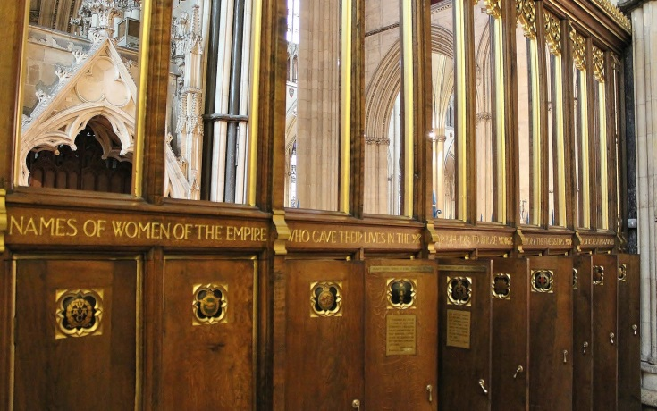
Mrs Gray at once joined with her, and the two, without any committee, brought the idea to life and were mainly instrumental in raising the necessary money. They raised it in less than three months, despite the fact that the Minster had been trying to raise this money for at least a year. It is quite an incredible feat that they raised £3500 from over 32,000 women across the Empire in such a short time, with no digital communication. Helen Little’s idea had raised enough to restore the window in memory of the women of the British Empire who had died. It had also raised enough to paint the over 1400 names onto wooden memorial panels that can still be seen in York Minster today. The panels are not complete record of every woman who died, but they do acknowledge the sacrifice of women from all walks of life.
The York Minster women’s memorial panels

Helen Little’s letter about her vision

Sir, during the early part of the war I was present when the first trainloads of wounded arrived at Cairo from Gallipoli, and was witness to the untiring devotion under great difficulties of the nurses and other women who gave themselves up, entirely regardless of their own health, in some cases with fatal results, to alleviate the suffering of the men. After the war was over, when memorials on all sides were being erected to our brothers, I often thought that our sisters who also made the same sacrifice appeared to have been forgotten. Ever since my first entrance into York Minster in 1909, the Five Sisters’ window … has appealed to me irresistibly. On November 30, 1922, I had the following vision: I was going into Evensong… Just as I reached the choir door in the dim light I saw two little figures in white standing hand in hand in the middle of the North Transept: one beckoning to me, the other pointing upwards to the window. I moved towards them, and then recognised my two little sisters, both of whom had died as children. As I followed the little pointing finger I saw the window move slowly backwards as if on hinges, revealing the most exquisite garden with wondrous flowers I had never seen before. In the midst of the garden was a great tree under which were five women sat weaving. In the distance at the bottom of the garden a stream flowed, and a number of girls and women appeared by it and came gliding up the garden in misty grey-blue garments. They came nearer and nearer, when suddenly the window swung slowly back, blotting out the garden. I looked down and saw that both my little sisters were pointing upwards to the window. I had risen in my sleep, and was standing when I woke, and cried out, my words being heard by my husband: “The Sisters’ Window for the sisters.”
Yours faithfully, Helen D. Little

