What further knowledge do you need to understand it in more depth?

What can you work out about women and WW1 by studying this image carefully?

Maria Leontievna Bochkareva (front, right) and Emmeline Pankhurst (front, left) with members of the Russian “Women‘s Battalion of Death” In 1917.
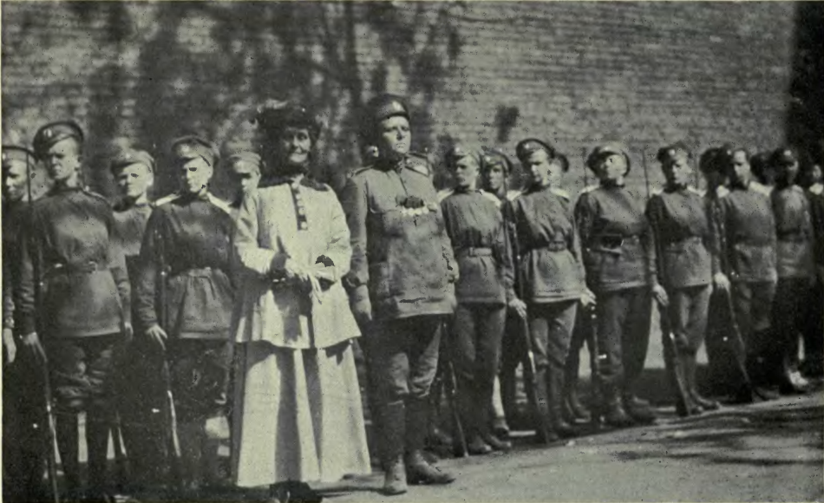

What further knowledge do you need to understand it in more depth?

What can you work out about women and WW1 by studying this image carefully?

Portrait of the Romanian Second Lieutenant Ecaterina Teodoroiu (1894-1917) in 1916.
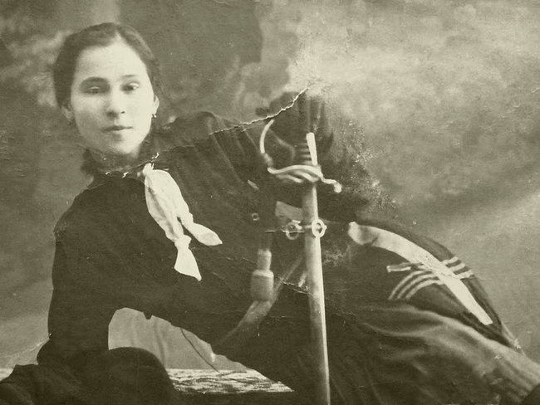

What further knowledge do you need to understand it in more depth?

What can you work out about women and WW1 by studying this image carefully?

Russian reconnaissance aviators Princess Evgeniya Shakhovskaya (1889-1920) and Vsevolod Abramovitch (1890-1913). Shakhovskaya became the first military pilot in history.
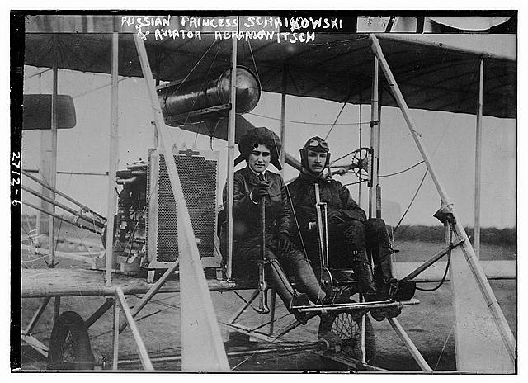

What further knowledge do you need to understand it in more depth?

What can you work out about women and WW1 by studying this image carefully?

Members of the Women’s Royal Naval Service Signal School in Portsmouth (United Kingdom) using communications equipment.
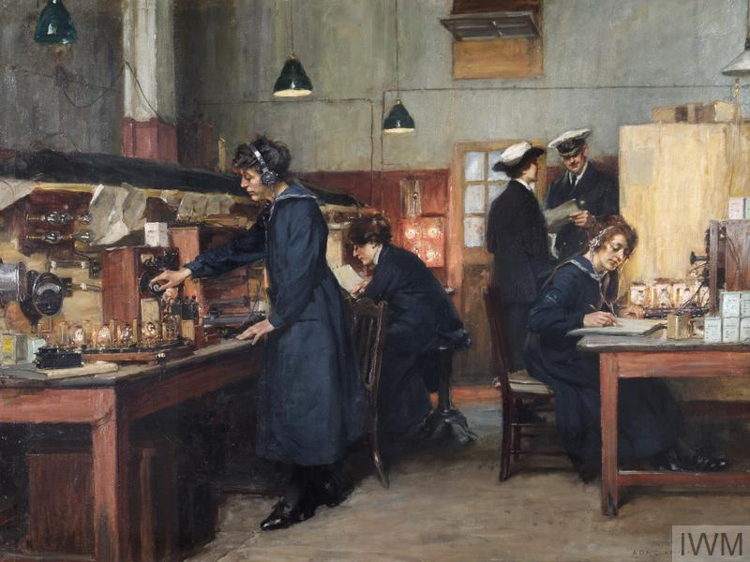

What further knowledge do you need to understand it in more depth?

What can you work out about women and WW1 by studying this image carefully?

Two nurses depicted with soldiers, probably in the European Balkan Region, 1916.
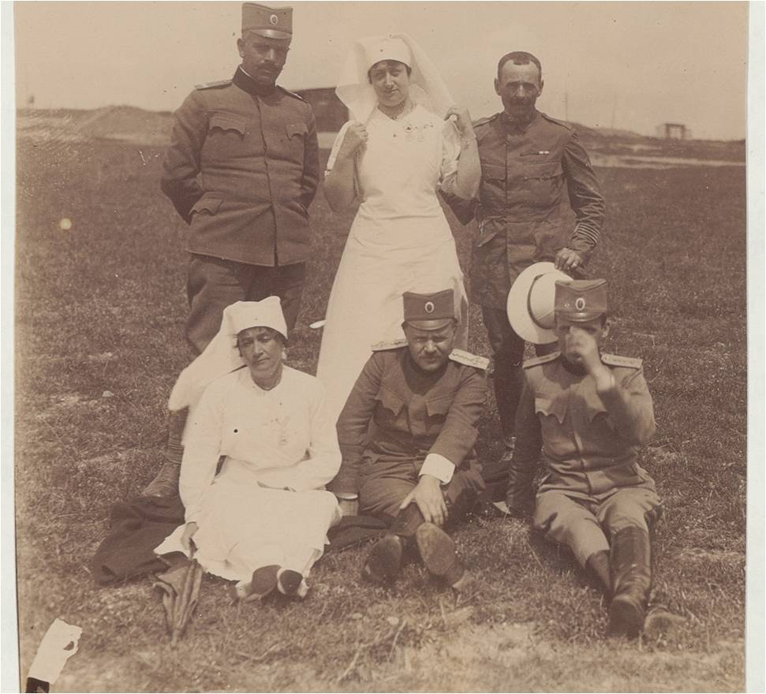

What further knowledge do you need to understand it in more depth?

What can you work out about women and WW1 by studying this image carefully?

Heidelberg Section (Germany) of the Red Cross at the railway kitchen in Stryj (present-day eastern Poland), around 1915.
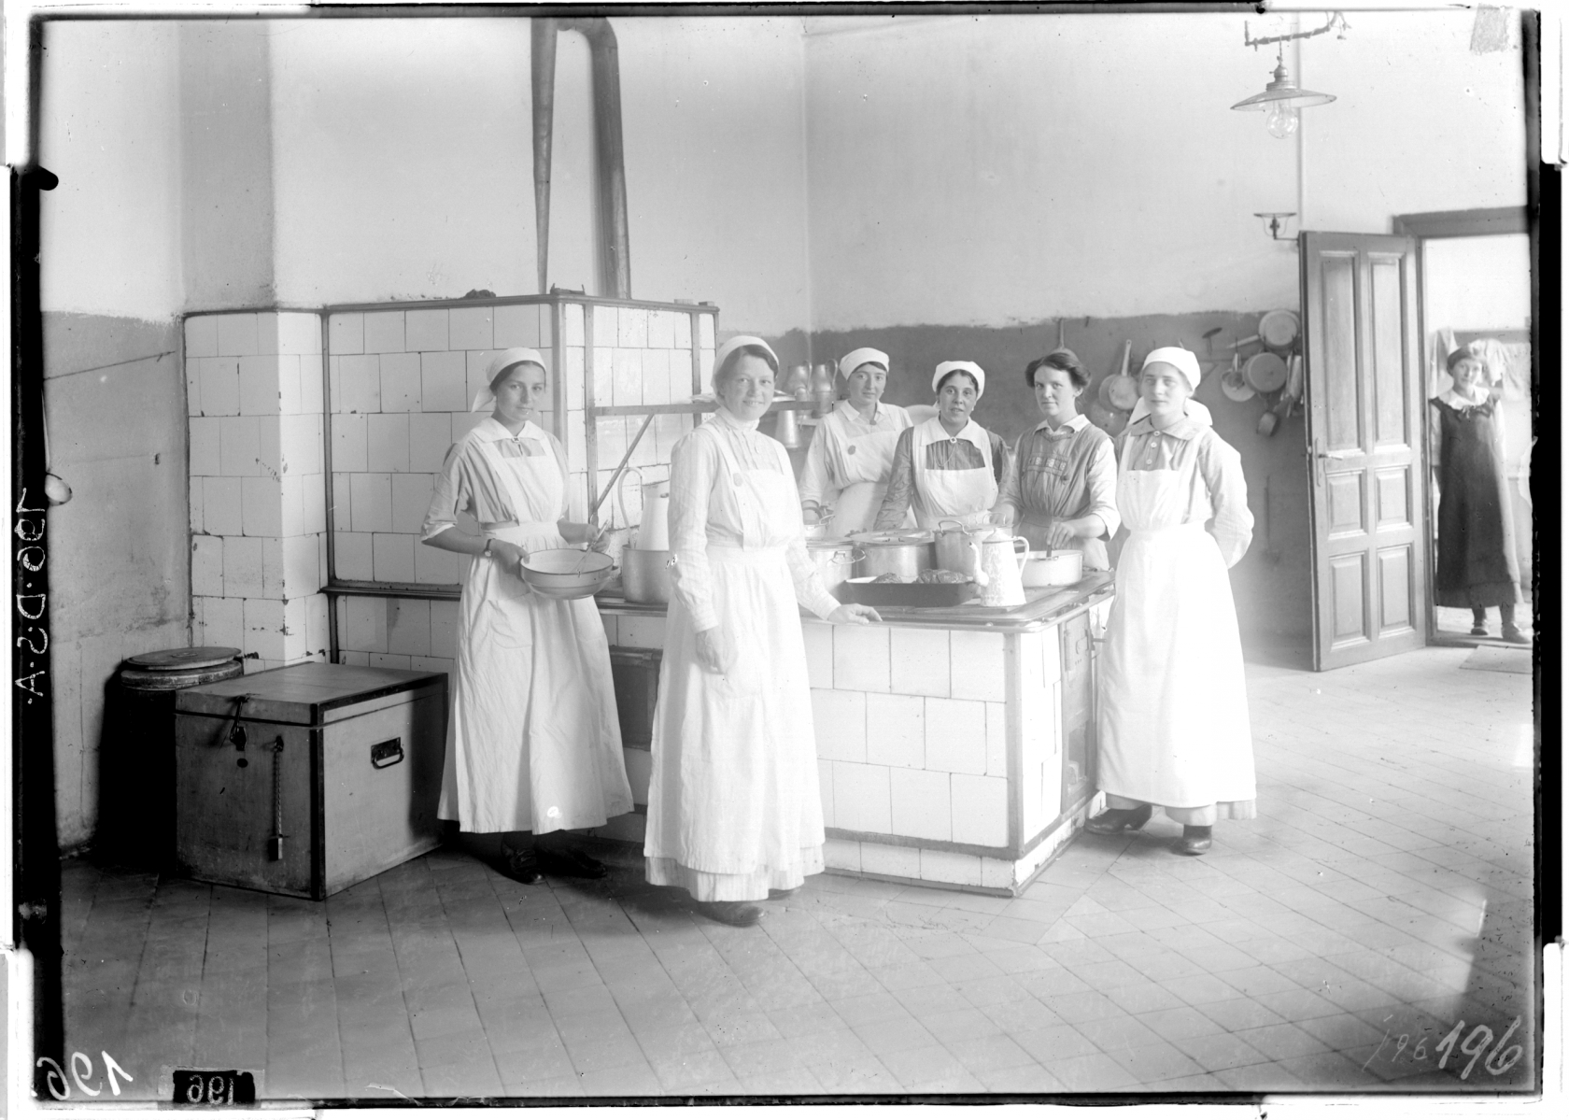

What further knowledge do you need to understand it in more depth?

What can you work out about women and WW1 by studying this image carefully?

“To the Women of Britain,” issued in 1915. To the Women of Britain, Parliamentary Recruitment Committee, 1915.
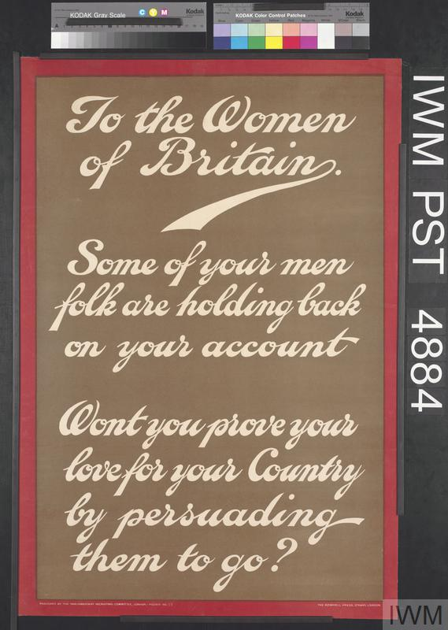

What further knowledge do you need to understand it in more depth?

What can you work out about women and WW1 by studying this image carefully?

“I wish I were a man,” issued in 1917, USA.
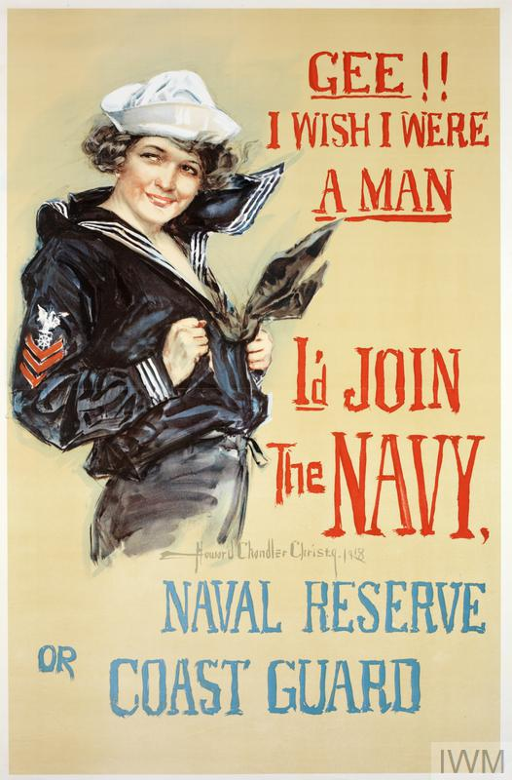

What further knowledge do you need to understand it in more depth?

What can you work out about women and WW1 by studying this image carefully?

“Germany’s future lies in our children. Contribute to Germany’s Appeal for the Protection of Babies and Infants.”
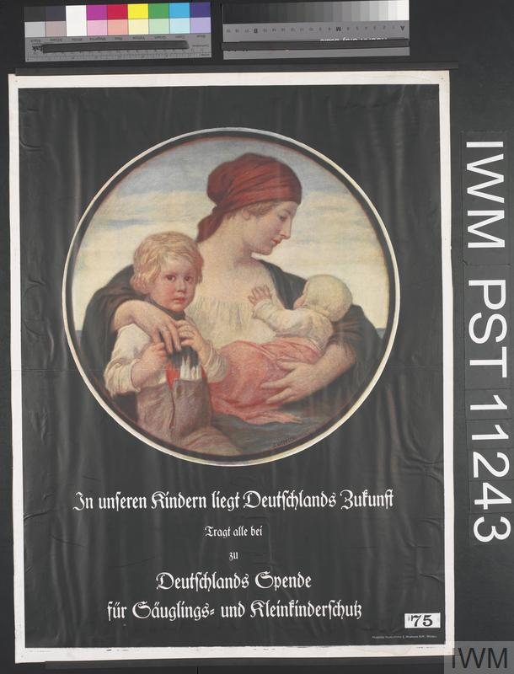

What further knowledge do you need to understand it in more depth?

What can you work out about women and WW1 by studying this image carefully?

"Postcard sent by a French woman to her fiancé in 1915. Patriotic image depicting Marianne with the French flag, indicating “To the Flag! Follow the Tricolour Flag announcing a glorious dawn.”
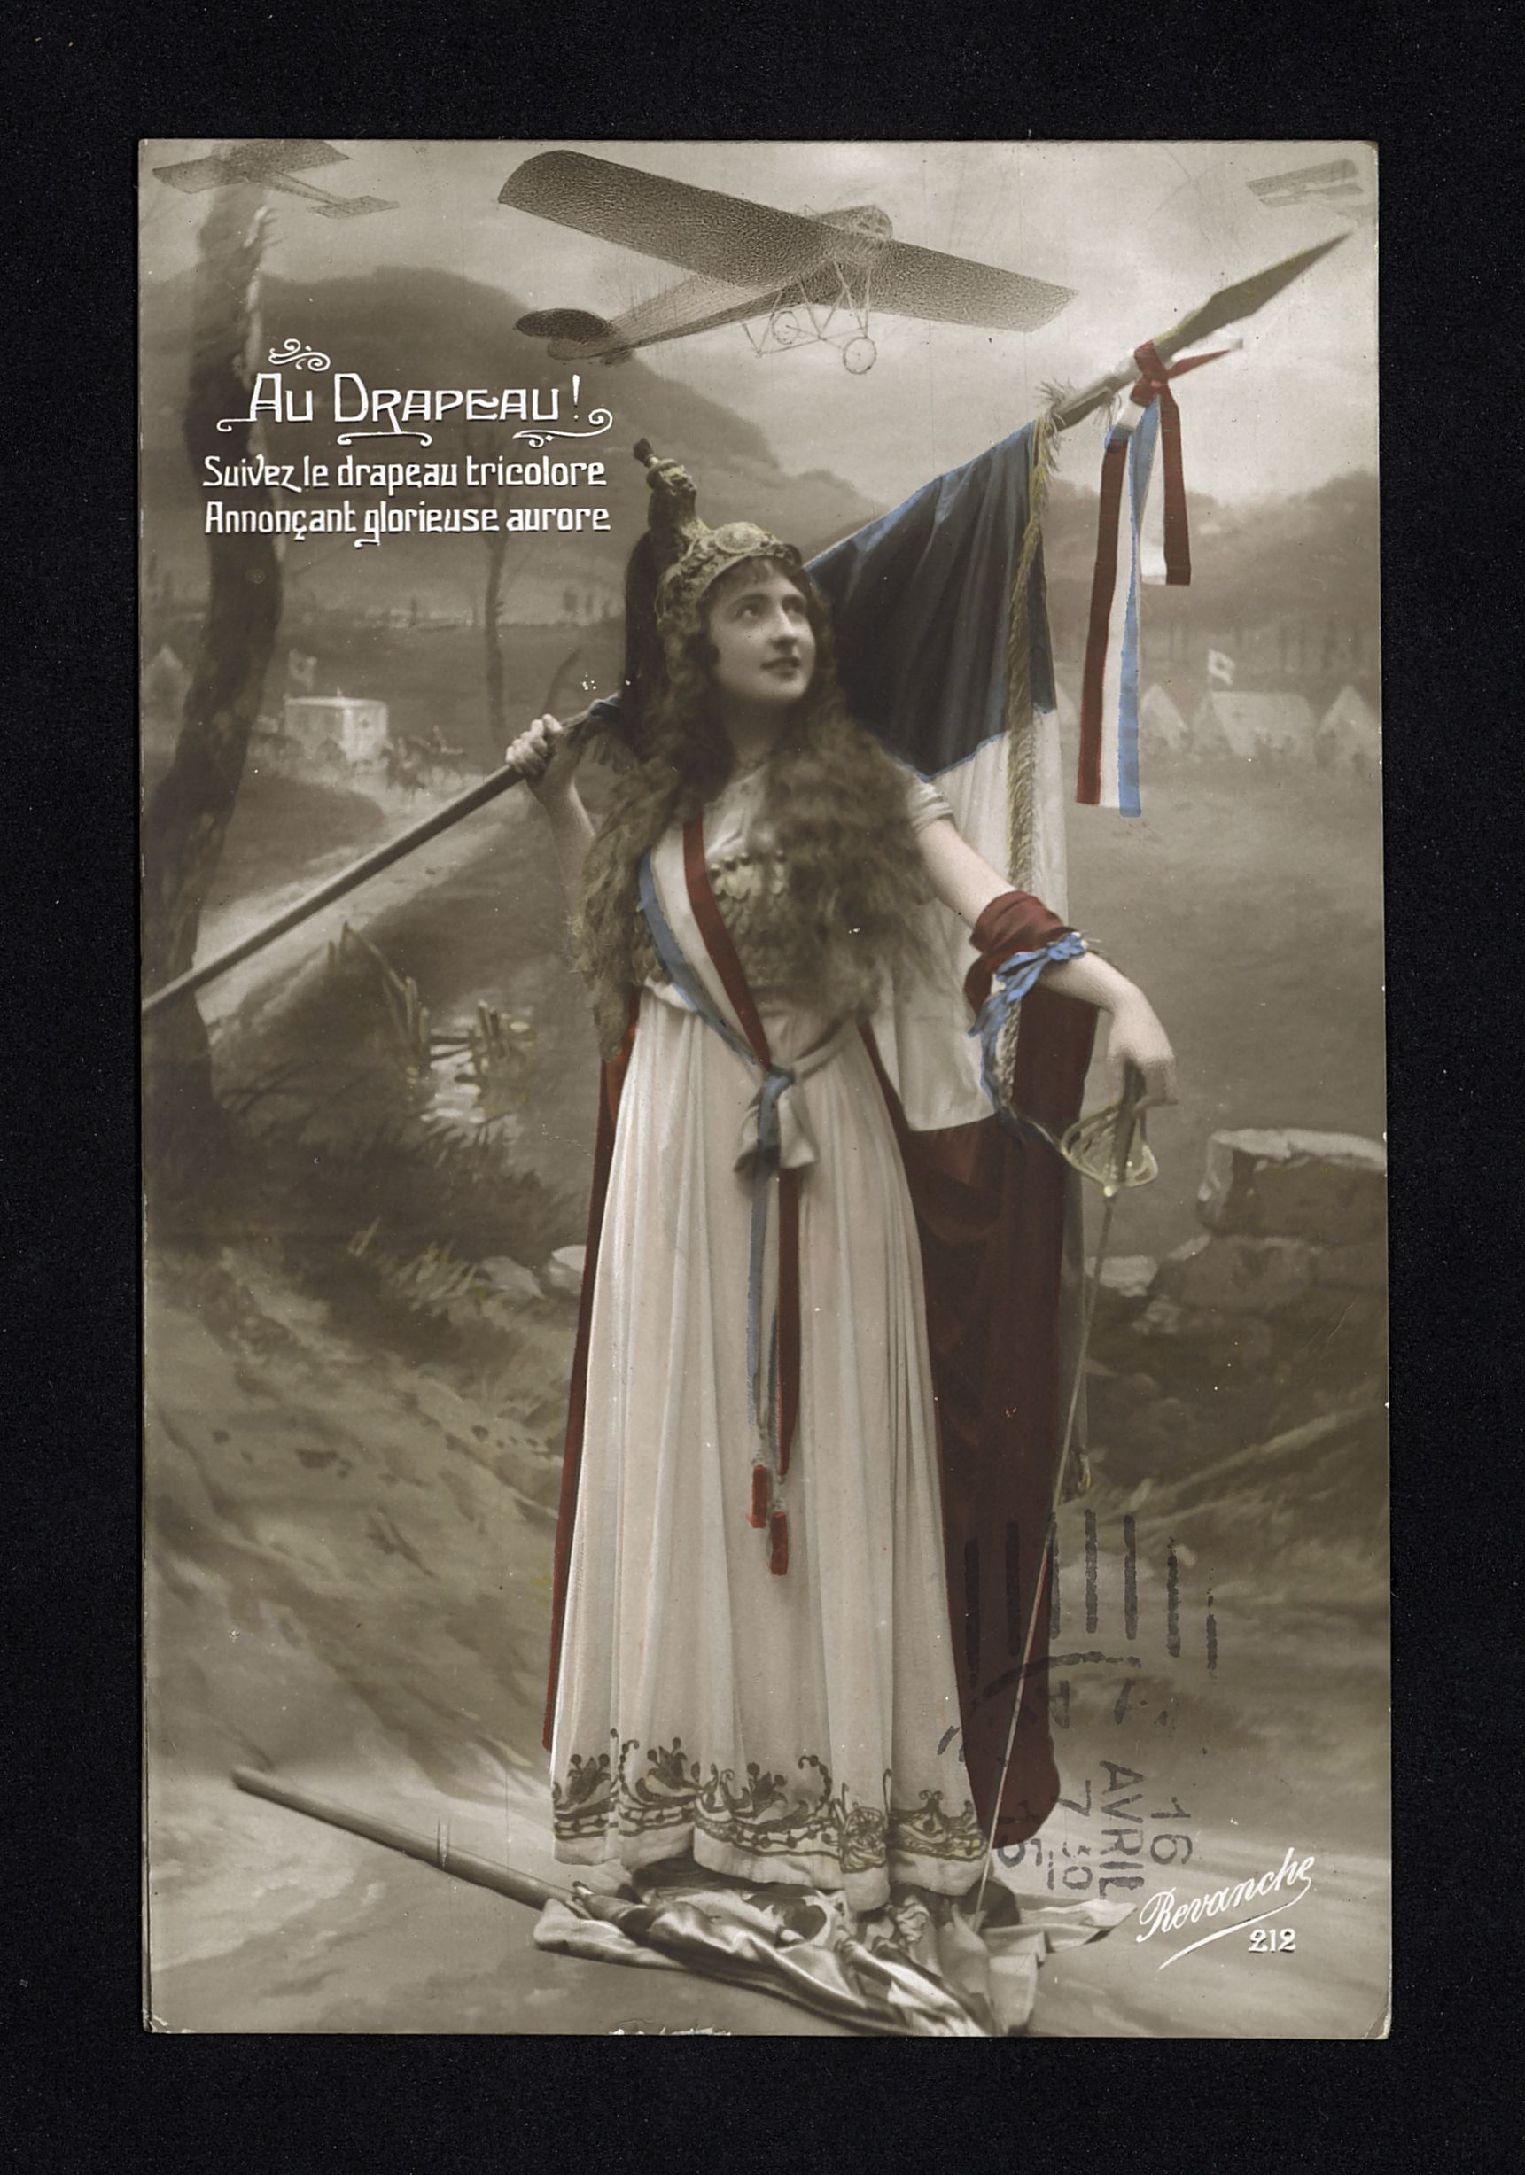

What further knowledge do you need to understand it in more depth?

What can you work out about women and WW1 by studying this image carefully?

Armenian refugees making fly-nets in 1917
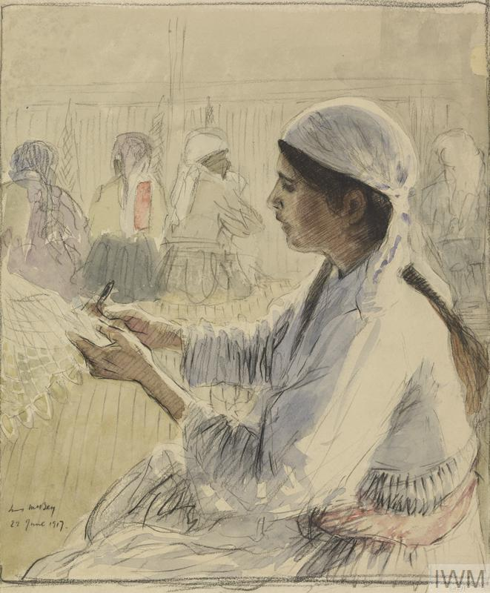

What further knowledge do you need to understand it in more depth?

What can you work out about women and WW1 by studying this image carefully?

A crowd of civilians queuing for food in the United Kingdom in 1918. Food rationing on sugar and other goods was introduced between late 1917 and mid-1918.
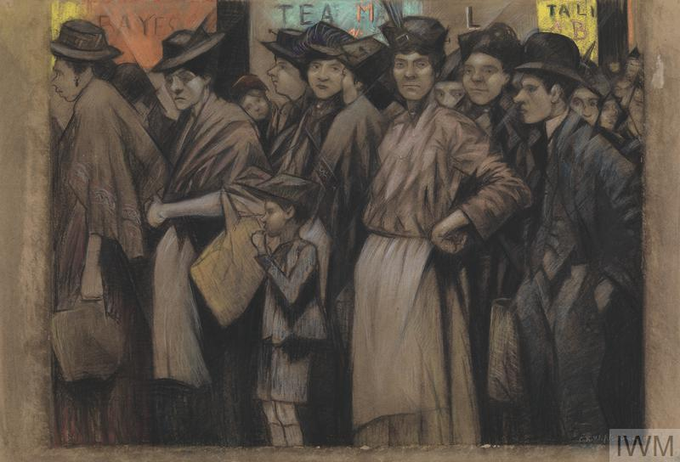

What further knowledge do you need to understand it in more depth?

What can you work out about women and WW1 by studying this image carefully?

A family that sought refuge in cellar belonging to the Pommery (Champagne) estate in Reims, France, 1916.
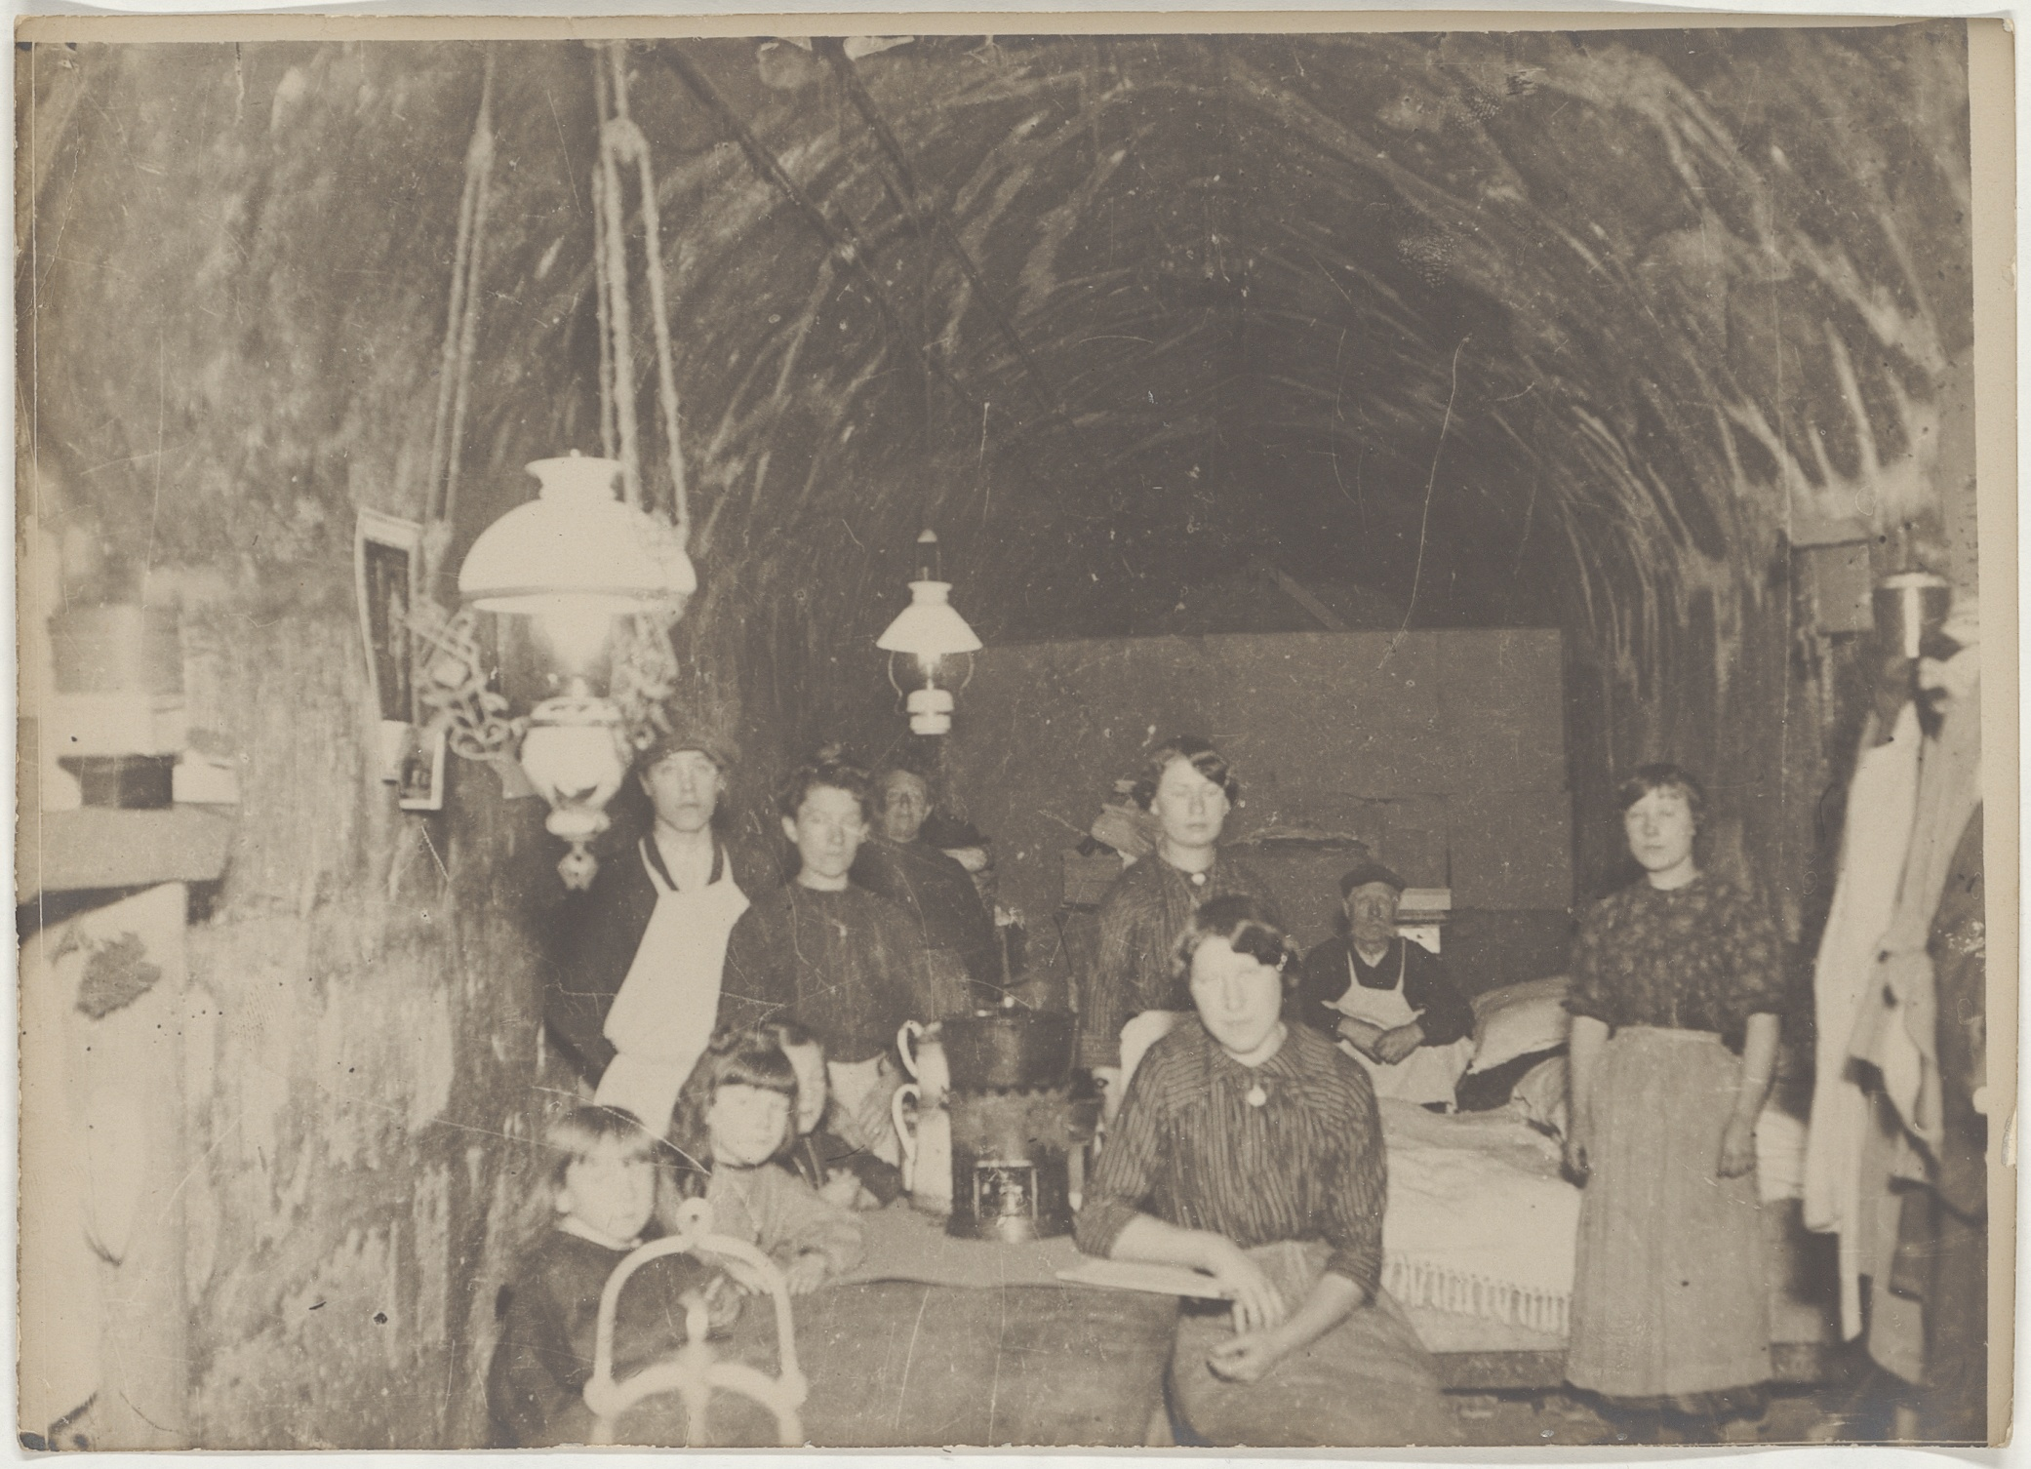

What further knowledge do you need to understand it in more depth?

What can you work out about women and WW1 by studying this image carefully?

A silk mill in the Veneto region (north eastern Italy) in 1918.
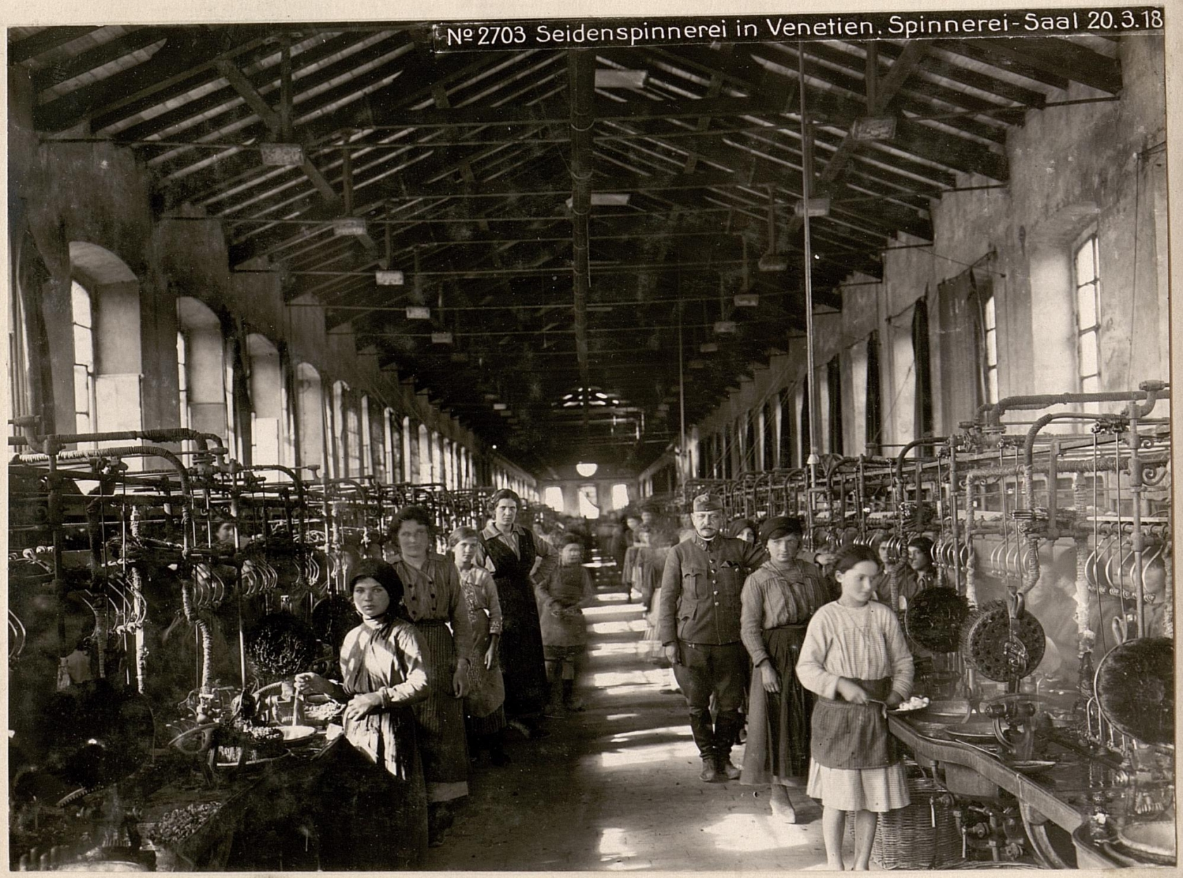

What further knowledge do you need to understand it in more depth?

What can you work out about women and WW1 by studying this image carefully?

Female workers in a bricks factory in South Wales during the First World War.
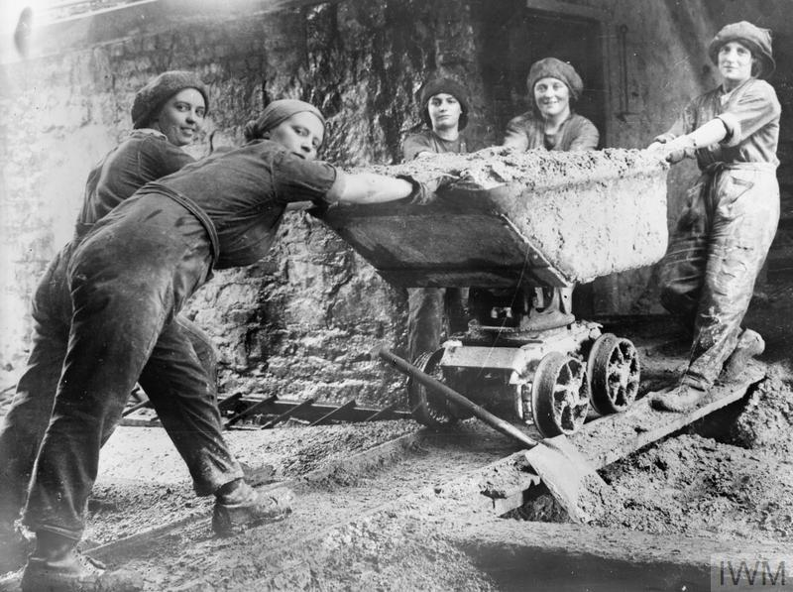

What further knowledge do you need to understand it in more depth?

What can you work out about women and WW1 by studying this image carefully?

Endell Street Military Hospital in London was established in 1915, and employed solely female suffragist doctors (political movement in favour of the introduction of women’s suffrage). Both founding doctors were former members of the Women’s Social and Political Union, part of the suffragist campaign in the United Kingdom. The hospital was ordered to close in 1919.
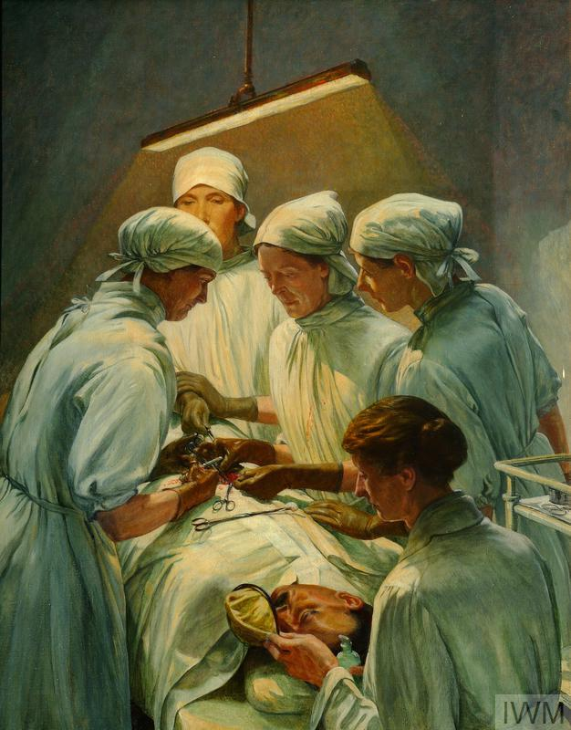

What further knowledge do you need to understand it in more depth?

What can you work out about women and WW1 by studying this image carefully?

Women of the British Army Auxiliary Corps at the beach in Le Touquet-Paris-Plage in 1918.
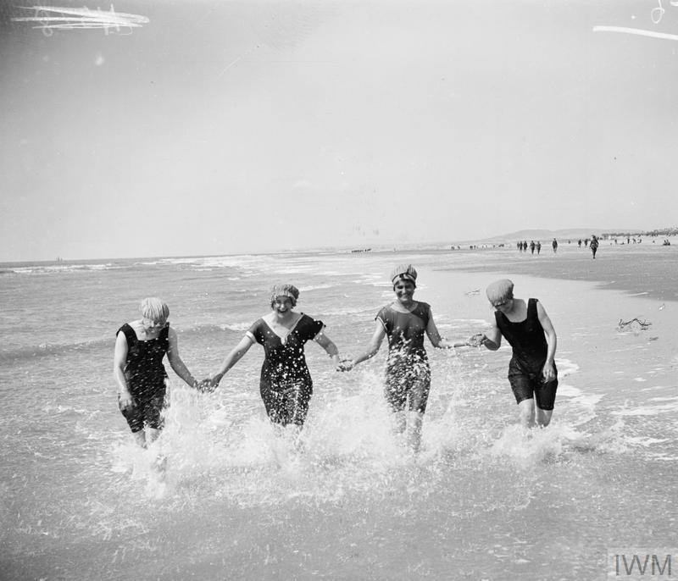

What further knowledge do you need to understand it in more depth?

What can you work out about women and WW1 by studying this image carefully?

British propaganda postcard, 1915. Edith Cavell was a British nurse, arrested and shot by the German occupying forces on a charge of helping British and allied soldiers to escape from German occupied territory.
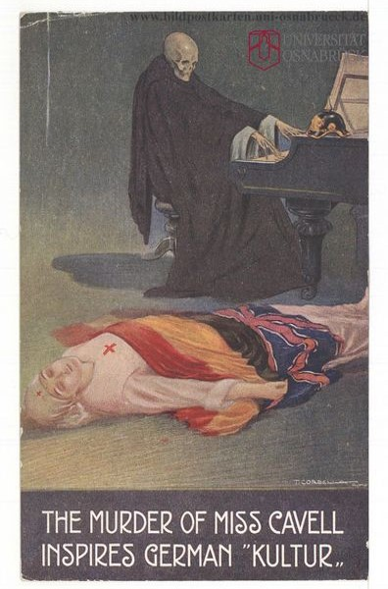

What further knowledge do you need to understand it in more depth?

What can you work out about women and WW1 by studying this image carefully?

People of the Ledro valley in Trentino (now northern Italy) living as refugees in Bohemia (now Czech Republic) from 1915-1918.
