Annette Prevost – Queen Alexandra’s Royal Naval Nursing Service
Annette Prevost had a comfortable start to life, as she came from a rich family, her ancestor James Prevost was a military hero. Annette was born in Bombay and perhaps trained as a nurse there. In 1914 she joined Queen Alexandra’s Royal Naval Nursing Service.
As a nursing sister Annette Prevost worked at Chatham Hospital. Conditions there were very different from her family home. The nurse’s quarters were busy and crowded, even though each nurse had their own room, there was only one tiny sitting area for them all. There was no dining room, so meals were eaten in a narrow corridor near the toilet and larder, which were clos together. One inspector wrote: “The bed pans, knives and forks and dishes used for dinner, are washed in the same sink; on the occasion of our visit we found the bottom of the sink occupied by knives and forks in the process of cleaning. The sink had earlier been used for washing bed pans.”
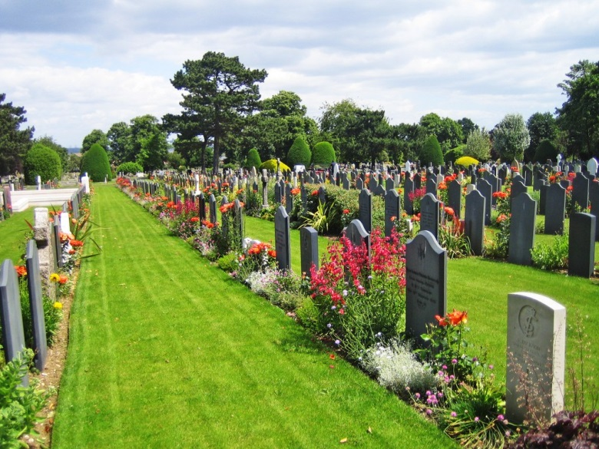
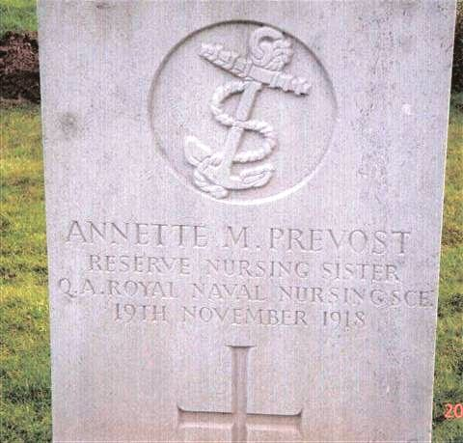
Annette survived the war, but died on the 19th November 1918 of Spanish flu. She is buried in Gillingham, Kent and remembered in York Minster.
Sources: Commons Licence

