Elizabeth Impey – Doctor – part 1
Elizabeth Stephens Impey, known as ‘Elsie’ was born on 29th May 1877 at Longbridge Place, near Birmingham. The Impey’s were Quakers and she was the second of seven children. One of her brothers served in the Royal Flying Corps and her youngest brother was a battery officer on the Western Front, serving in the 78th and 79th Brigades of the Royal Field artillery.
Elsie first went to school in Weston-Super-Mare and later moved to The Mount School, York. Afterwards, she trained for two years at Madam Bergman Österberg’s Physical Training College at Dartford, Kent. At school she showed skill and aptitude in her studies. She was described as possessing an unconquerable spirit and that, along with her fine courage and remarkable physical health, remained her leading characteristics up to the last few moments of her life. She spent six years living at home between 1897 and 1903 where she taught physical drill exercises to school children and families.
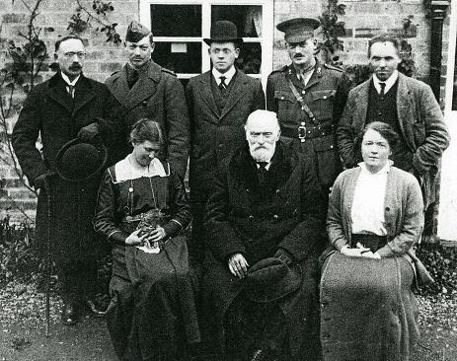
In 1904 she decided to begin medical training at the University of Birmingham. She had much assistance from her aunt, Dr. Annie E. Clark, who was one of the pioneers of women in medicine.
The Impey family in 1915
Elizabeth Impey – Doctor – part 2
Elsie started studying medicine partly due to her interest in India and her knowledge of their great need of Women’s Medical Service. It’s no surprise that, when she got the offer of work as Medical Officer at the Dufferin Hospital for Women in Lahore in November 1915, she snatched the opportunity and set sail for India. She was seen off by her father and other family members on December 18th 1915 from Tilbury Docks. She was fully aware of the risks of her voyage while German submarines were pursuing harmless vessels.
Her journey remained unaffected for just under two weeks and two postcards were sent on the 28th December from Malta. However, disaster struck two days later, just off the coast of Crete, on the 30th December. At 1.10 p.m., Lieutenant Commander Max Valentiner struck the boat with a torpedo and the ship began sinking. A woman, who managed to survive the tragedy, was sat next to Elsie and she says that Dr. Impey told her not to run straight for the door and helped her get her lifebelt. They then separated and the lady next saw Elsie planted firmly at the top of the companion-way, helping everyone up with her one free hand. She helped many to boats and saved 59 passengers. When she could do no more to help she waved goodbye to some of the survivors and dived into the sea, but she was not seen again.

Memories of Elsie Impey – Doctor
Her family, heartbroken by her death, were comforted by kind words they received about Elsie and her death.
One women wrote: ‘Your daughter was a brave woman; we all consider she dies a heroine’s death.’
Another said: ‘It was very generous of Dr. Impey to give me the assistance she did, when practically all were looking after themselves.’
On 8th February 1916, Warwickshire North Monthly Quaker Meeting recorded ‘the courage and self-sacrifice shown by our friend at such a dread moment.’
A book by H. Winifred Sturge and Theodora Clark, ‘The Mount School York’, (Elsie’s secondary school) describes her ‘calming the fears of the others; then standing at the head of the companion ladder to help the women and children on to the slippery deck; all the time thinking last of herself and her own safety.’ They go on to say, ‘truly as they said, “a brave woman,” and one of whom we may be well proud.’
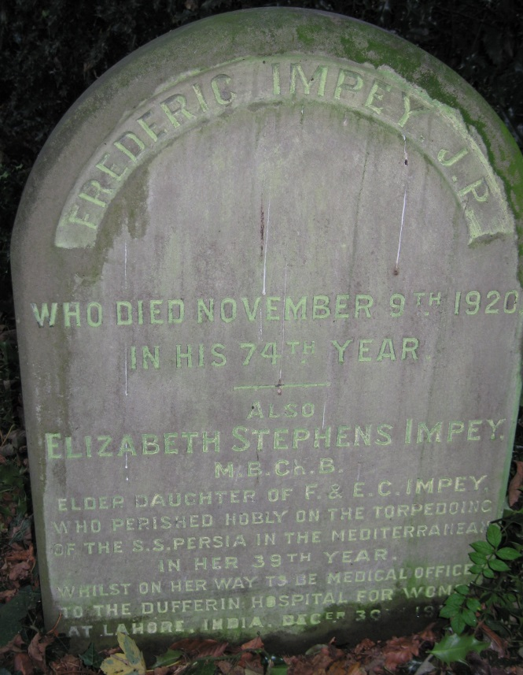
Elsie’s name is recorded in Cofton Hackett Churchyard on her father’s gravestone and on the York Minster memorial panels to the women of the British Empire who died in World War One. She also has a memorial stone at Longbridge Meeting House that records the time and manner of her death.
Frederic and Elizabeth Impey’s gravestone in Cofton Hackett Churchyard
(Sources: Commons Licence)

