George’s Marvellous Medicine? What does the treatment of George III reveal about the understanding of mental illness in the 18th Century?

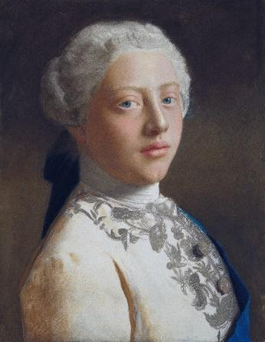
Who was George III’?
George III took the throne when he was just 22. Unlike his father and grandfather he had been born in England and his first language was English. George spent most of his life in the south-east of England and earnt the nickname ‘Farmer George’ for his down-to-earth approach to life and interest in farming.

Why was the King given the nickname ‘Mad King George?
Half way through his reign, at the age of 50, George had his first attack of mental illness which lasted four months. George experienced hallucinations, had fits, foamed at the mouth and talked nonsense. Nobody really knows what this disease was. Modern day psychiatrists and doctors have suggested it could have been a disease called porphyria, or a form of bipolar disorder.
The court doctors tried to treat him using their usual methods. It is important to remember that doctors at the time had little understanding of mental illness and did not have separate treatments for a sick mind. Instead George’s doctors blistered his skin and gave him medicines to encourage him to be sick. They kept him in an unheated room and finally they used a strait-jacket or kept him gagged and tied to a chair. These treatments all worked on the Ancient Greek theory that George’s body had four humours (blood, phlegm, yellow and black bile) and that they needed to be rebalanced. Once the humours were in balance, the King’s mind would be healed.
A new type of treatment?
On the 5th December 1788 the court doctors admitted defeat and allowed the King to be treated by a man called Francis Willis. Willis was unusual, as he specialised in ‘lunacy’, which was the Georgian term for mental illness. When Willis first arrived he was looked down on by the other doctors because he dealt with the mentally ill. This was seen as a disreputable job, more like a jailer than a doctor. Willis immediately began a more humane course of treatment.
Here is a description of Willis treatment of the King:
“He laid aside all false pretences, all petty vexations, all unnecessary restraints; no violence need be apprehended, and that no suspicion should be shown. The King had been denied a razor at his toilet, and a knife and fork at his table. These were at once restored to him and in Dr Willis’ presence were freely used. The good effects of this altered treatment speedily appeared. As yet the delusions continued unabated, but far greater calmness and composure, as also better health, were attained.”
THINK! How did Willis treat George differently from the treatment he had been given by the court doctors?

Willis used his new found fame as a doctor of mental illness to promote a new method of treatment called The Moral Treatment. In this treatment patients were given clear rules and rewarded when they showed good self-discipline rather than using violence or harsh medical treatments such as blood–letting.
George was also encouraged to take a change of air in order to improve his health and for the next fourteen years he visited Weymouth in Dorset to bathe in the sea. The King would be wheeled down to the edge of the shore line and would be ducked under the water by an attendant. As a consequence of this, sea bathing and seaside holidays became very fashionable in the Georgian period. Below is a picture showing women bathing in the sea at Brighton.
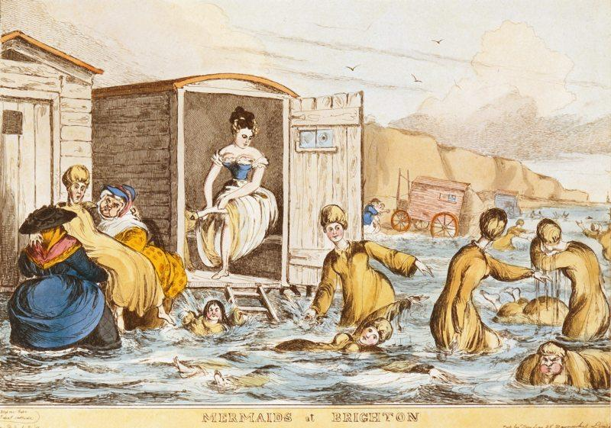
After his first bout of illness George made a good recovery. However, he continued to have attacks of mental illness during his reign. George spent the last decade of his life shut away from public life. During this period the king showed symptoms of dementia and was babbling and confused. The king was also blind and possibly deaf. His son, the Prince of Wales ruled for him. This period is known as The Regency. He was kept isolated from his family. A portrait made at the end of his reign shows a dishevelled King, with long hair and beard. George died in 1820 at the age of 81.
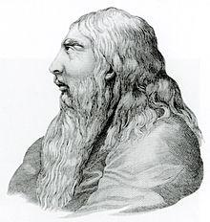
Was George poisoned?
In 2005 a lock of George’s hair was analysed by scientists. The hair contained high levels of arsenic, a deadly poison which also has the side effect of causing mania. A likely source of arsenic was ‘James’ Powders’, a common medicine regularly given to George. Researchers concluded the arsenic from the medication treating his illness actually made it worse.
THINK! What evidence can you find that doctors’ treatments had not changed for centuries? What evidence can you find that ideas were changing? In what ways is Willis’ treatment of the King a turning point in the treatment of mental illness?
Over to you!

You can read more about George III here: http://www.bbc.co.uk/history/historic_figures/george_iii_king.shtml
Watch this! Alan Bennett wrote a play about the treatment of George III called ‘The Madness of George III’ in 1991 and in 1994 it was turned into a film.
You can read about George’s doctor Francis Willis here: https://www.karger.com/Article/FullText/479815

Teacher notes:
What is a slot-in?
A slot-in is a short story from the past that is rich in historical concepts. You can use a slot-in as part of a longer sequence, or as cover work, or in those moments where you need something short.
The concept focus of this enquiry
The enquiry question here is: What does the treatment of George III reveal about the understanding of mental illness in the 18th Century? The story the students will read is written to show that events have causes and consequences. The focus is upon a turning point moment in the history of mental health.
The history of mental health is rarely taught in schools. However, as we are all aware, mental health is a very important topic in contemporary society. Introducing students to the idea that ideas about, and treatment of, has changed and developed over time is important if they are to understand the world around them.
Curriculum links
We have a duty to reflect the past of diverse people in our history curriculum. We also have such a restricted amount of curriculum time to teach a large amount of past. This story could be slotted-in to your curriculum as part of a sequence on:
- Britain in the industrial revolution period,
- Revolution as a concept,
- Public health and medicine through time.
Activity suggestions
You might just want students to read this story, make a connection to a wider topic and move on. However, you might decide to use this material for a whole lesson with activities. You could:
- Study George’s story through the lens of the substantive concept of Kingship,
Students could research and draw out a timeline of George III’s life and episodes of mental illness. When does he have most power and when does he have least? Who rules the country when he is indisposed? What problems will this pose to the monarchy? Use this opportunity to introduce the changing nature of Kingship in Georgian times and the growing power of the role of government ministers like Pitt. The King’s son the Prince of Wales was notoriously hard drinking and dissolute which forced George III to confide in Pitt. For example, parliament granted the King £5000 (3/4 million in today’s money) to buy the silence of a woman the Prince had become involved with. (The cartoonists of the day, such as Gillray and Hogarth, were vicious in their portrayals of the King and his son.) What do they tell us about the changing relationship between government and monarchy in the eighteenth century?
You could also use this study if you are teaching the GCSE unit of Health and the People.
This is a great example of a turning point in the treatment of illness. It is worth drawing out that it is at this point that mental illness is finally being seen as distinct from the illness of the body. It is a useful example of a challenge to the treatment based on the theory of the four humours. Willis’ methods received criticism and resistance from the court doctors demonstrating that change did not happen immediately. However, the endorsement of the King would have done much to speed up acceptance of this new method of treatment. You can also make wider links to the work of Samuel Tuke and The Moral Treatment of the mentally ill in asylums such as The Retreat (there is a separate slot-in available on this.)
Taking it further:
You will find a one lesson thematic activity and resources on the history of mental health free to download, adapt and use from www.yorkclio.com/blog/ that will enable you to fit this slot-in into its historical context. Students could also use the links in the ‘over to you’ section to learn more about how much of an impact the Retreat had.
- It may be possible for students to research the history of the local asylum. Local history societies may have materials. The records of asylums and prisons are one of the few ways we can get to hear the individual voices of the working poor of the 19th century.
Extra background for teachers, including misconceptions to dispel
Recent work on the public perception of mental health and the rise of mental health issues with young people will mean that students may find it difficult to comprehend that having a sympathetic attitude towards mental illness is a fairly recent phenomenon.
George III’s early treatment is typical of the time. The theory of the four humours was still followed by many doctors. This led to a rise in the sort of treatments that were designed to control the balance of humours in the body. Having too much black bile humour in the body was thought to cause mental illness (we still use phrases such as ‘black looks’ and ‘black thoughts’). There was a rise in weekly treatments such as purging, bleeding, blistering and making people vomit to get rid of black bile. Asylums were opened in other British cities by the end of the 18th Century. This is reflected in the treatment the King receives before 1788 and the arrival of Willis.
George III became ill at the time of a watershed moment in the treatment of mental illness. Willis’s methods reflect a new interest in mental health and the training of specialist doctors. In 1800, about 10,000 people were in asylums and by 1900 there were about 100,000 inpatients. There was a trade in caring for people who would previously have been kept secretly at home. However, these asylums also led to the growth of the study of mental illness by doctors and the separate branch of medicine called psychiatry developed. In response to a scandal of poor treatment at the York asylum, a family of Quakers called Tuke set up an asylum called ‘The Retreat’ in 1796. The Retreat did not focus on medical interventions, but instead created a family atmosphere, occupying patients’ time, focusing on good rest, diet and kindness to restore a rational state of mind. George’s treatment from Willis mirrors this new, compassionate method of treatment.
Where to link to
‘Madness: A Brief History’ by Roy Porter is a good summary of the history of psychiatry and mental illness in Western cultures. Teaching History 173 has an article by Ruth Lingard and Helen Snelson discussing how to teach the history of disability more generally and providing links to more resources.

