Lorna Ferris - Serbian Relief Fund
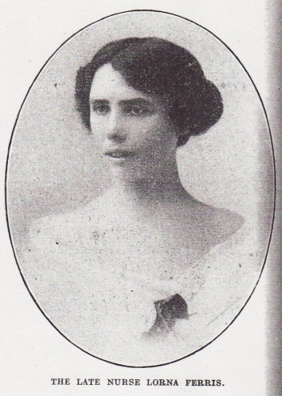
Lorna Ferris worked as a nurse for many years and went to work in a hospital in Serbia in 1915. Despite the hardship involved in her work, Lorna was described as having a cheerful personality and being a good nurse by her friends and co-workers. She was very good at Serbian and had a gift for languages, which made her popular with the Serbian soldiers there. Even when she was ill in hospital she was described as being cheerful and friendly, and was missed by many people.
Who was Lorna?
Lorna was born on 14th February 1888 in Newbury, Berkshire and was the daughter of Henry and Amelie Ferris. Henry was a coach builder and Lorna came from a hard working family. Lorna first appears on the 1901 census as a 13 year old with 3 siblings: Charles, Elsie and Henry. Lorna does not appear to be on the 1911 census ten years later, and one theory for why this might have been is that she, like many other young women, avoided the census as a protest for the women’s suffrage movement.

What did Lorna do in the war?
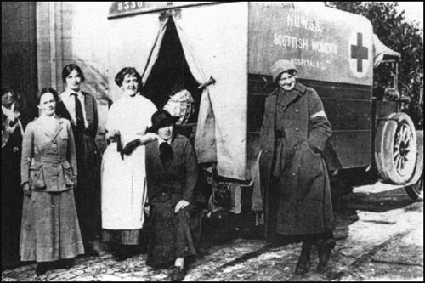
Lorna trained as nurse at the Dreadnought Seaman’s Hospital and also spent a year at the Samaritan Free Hospital in London. Lorna would have seen one of the first women to become part of the medical staff there, as women were only employed in that position at the hospital during World War One due to shortages of male doctors. In 1915, when Lorna was 27, she went to serve as a nurse in Serbia, and she served in the Serbian Relief Fund. The Fund was set up in response to the huge human losses and destruction that Serbia had suffered during the first year of war when it was invaded by Austria-Hungary.
Women of the Serbian Relief Fund

What happened to Lorna?
There was a typhus epidemic throughout Serbia. Lorna worked in a hospital set up by the Scottish Women’s Hospital Committee, just outside Kragujevec, and was employed by Mabel Stobart. She worked in terrible conditions, with the threat of typhus and other diseases, as well as with shortages of equipment and provisions. The hospitals were very crowded and the nurses and doctors had to work long hours often with lack of food. Less than a year after she arrived in Serbia, Lorna died of typhus on the 4th of July 1915.

How is Lorna remembered?
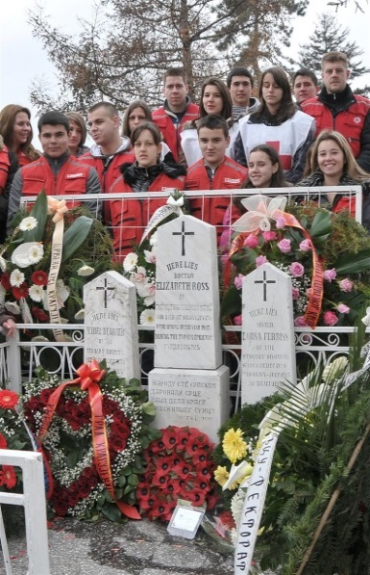
Lorna was given a Serbian Red Cross award and was one of the first people to have an English burial service in a Serbian church. In the village close to where Lorna was buried there is a memorial service held there every year on her birthday for her and two other medical staff. Under their gravestones reads “they gave their hearts to the people of Serbia.”
One of the annual graveside commemorations.

(Sources: Commons Licence)

