Nelly (or Nellie) Spindler - Queen Alexandra’s Imperial Military Nursing Service
‘A woman among 10,000 men’
Nellie was born in Wakefield in 1891. She was the eldest daughter of George and Elizabeth and she had three siblings.
She worked as staff nurse at Whittington Military Hospital from November 1915 to May 1917. She then travelled to Abbeville in France to work in the Stationary Hospital. This hospital was positioned between a railway line and an ammunition dump.
On the 21st August 1917, bullets began to rain down on the hospital tent. The wounded men began to panic. The nurses attempted to remain calm, to show the men there was nothing to fear.
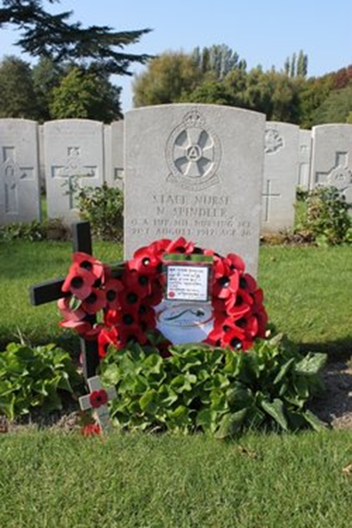
However, at 11am Nellie was hit in the chest by a piece of shrapnel. It sliced through her body, narrowly missing her heart. Within three minutes she was unconscious. Within twenty she was dead. She died in the arms of fellow colleague, Nurse Wood, also from Wakefield.
After she died, her group began the terrible journey to Belgium from France. They got there before the sun had set. Nellie was then buried in the 2nd largest cemetery in Belgium. It is called Lijssenthoek.
She was one of only two women to be buried in Belgium during the First World War. She is also remembered in York Minster.

