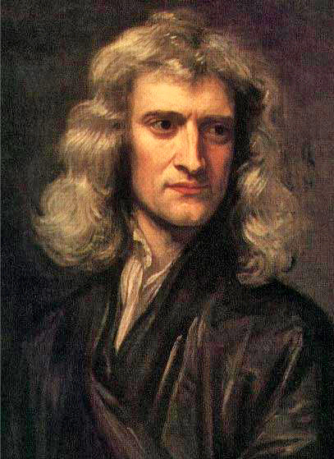
Sir Isaac Newton
I was born in 1642, the year that a terrible civil war began in England. By the time I was born, my father was dead. My mother survived the experience of giving birth. Probably 10% of women died in childbirth and my mother may have prayed to St Margaret, the patron saint of pregnant women and made her will before I was delivered. In my time, 60% of children did not live as far as their 16th birthday, so I was lucky to survive. We had enough to eat and money to live well, most people did not. Bad weather for several years could bring starvation to the people.
My mother left me to be brought up by her parents. We did not like each other, but my grandfather did ensure that I had an education and went to school. My mother wanted me to return home and run the family estate, but I hated it and persuaded her to let me go to Cambridge in 1661. I was a poor student, who had to pay his way by serving wealthier students. Around me England was recovering slowly from the trauma of civil war, Cromwell had died in 1658, the Republic had ended and King Charles II had returned to be restored as monarch in 1660. The body of Cromwell had been dug up to be executed on King Charles’ orders. Opposition groups were persecuted. I ignored it all and became an isolated student with a great interest in philosophy, mathematics and science, and I studied new ideas which encouraged us to reason things out to make sense of the world. Sometimes I would sit motionless for hours, thinking.
I changed your world. My work on prisms, the laws of motion and calculus is still taught to you in Maths and Physics lessons. In 1665 I had to go back to Lincolnshire because of the plague and it was there that my previous thinking connected to seeing an apple fall and so I defined the law of gravity, changing understanding of our world and the solar system. In 1672 I was made a fellow of the new scientific group, the Royal Society, in London as a result of developing the first reflecting telescope.
You have to understand that in my time belief in God and his control of the world was still accepted by us all. We were superstitious. I spent a lot of time working on religious studies, alchemy and astrology. Some people did not like the new scientific ideas at all. Fortunately, King Charles II supported this new thinking and so the Royal Society came into being in 1660. We were free to experiment, and to pursue scientific knowledge. No church authorities could not stop us because the King supported us. This Royal Society continues to be a leading group of scientists in your time.
I hated Roman Catholicism. I thought it enslaved people and that Britain should be a place of intellectual and political freedom. I represented Cambridge at Parliament in 1688. This revolutionary Parliament declared that King James II’s promotion of Roman Catholicism meant he should give up the throne and it welcomed King William III from the Netherlands and his wife Queen Mary II (who was King James’ daughter) as the new joint monarchs. This event is known in your time as the ‘Glorious Revolution’. The monarch was allowed to choose ministers and still had much power, but by 1701 it was decided the monarch had to be a Protestant and Parliament had to agree to their rule. Our Parliament, like yours, had a House of Commons and a House of Lords. The Lords were most important in my time. The Commons were wealthy men elected only by wealthy men. Our Parliament had no political parties. Parliament passed laws and the monarch’s ministers and the church’s bishops were part of it, as they are in your time too. Governing, that is, the day-to day ruling, was done by the monarch seeking advice of ministers who discussed ideas with Parliament.
By 1695 my work had made me one of the most famous people of my day and I moved from Cambridge to London. I worked at the Royal Mint and was responsible for restoring the quality of the silver coins used in the country. This helped solve the financial crisis of the 1690s. This job made me a very wealthy man. By 1705 I became President of the Royal Society and, in that year, I was created Sir Isaac Newton by Queen Anne. I was not an easy man to get on with, but I did restore the reputation and the finances of the Royal Society.
By the time I died in 1727 I was a national hero. Unlike King George I, who died the same year, I was buried in Westminster Abbey. My coffin was carried by six men of the House of Lords. Over my 82 years of life the country had been through civil war, a political revolution and the restoration of a Protestant monarchy and royal court. There had been expensive wars, but by 1727 the country was strong and there was less likelihood of starvation. England and Scotland had been united into one kingdom, overseas trade had grown, the City of London had started its growth as the world’s centre of investors and finance, the plague had left England, St Paul’s Cathedral had been built and coffee-houses and Handel operas had become all the rage. My reputation as one of the world’s greatest ever scientists continues in your time.

Timeline:
N:1642, 1658, 1660, 1688, 1701, 1727
P: 1642, 1661, 1665, 1672, 1695, 1727

