Why did Irish people rebel against British rule in 1798?

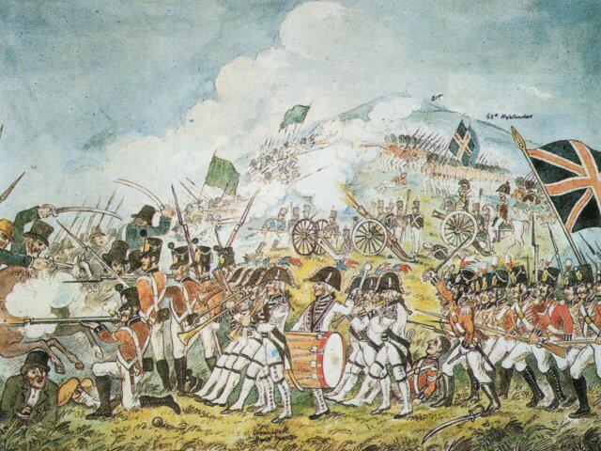
What can we learn from this image?
We can see soldiers, uniforms, drums, swords, guns, flags and fighting. The image shows the rebellion in Ireland in 1798, which was fought between Irish rebels and those loyal to the British government. To understand the image you need to know that the Irish rebels were fighting for independence from British rulers, who had ruled Ireland since the 12th century. Many ordinary Irish people felt discriminated against by the British who had introduced laws to oppress Irish Catholics. Most people in Ireland were Roman Catholic, but the minority group of Irish Protestants mostly supported Britain (which was a Protestant nation). At this time British Protestants believed that Roman Catholics were not equal to them, because of their beliefs. This division went back to the time of the Tudors. It caused a lot of tension in Ireland between the two different communities. In 1798 the two sides started actually fighting about religion and who should govern Ireland. Most of the Irish Protestants were loyal to the British government, and the rebellious Irish Catholics were represented by an organisation called the United Irishmen.

The United Irishmen
The United Irishmen (UI) were a secret society. To become a member of the UI you had to take an oath of loyalty, want to fight for Irish independence and be proud of Irish history and culture. They did not want the British to govern Ireland and wanted to abolish the penal laws. These laws restricted Irish Catholics voting, worship and ownership of land. The membership of the UI was actually both Catholic and Protestant, joined together by a vision of an independent Ireland. The leaders were inspired by the French Revolution (which had removed the French monarchy) and had championed ideals of quality, freedom and brotherhood.

The Orange Order
The Orange Order were an Irish Protestant organisation that were very proud to be ruled by Britain. They saw Ireland’s identity as an important part of Britain and wanted to defend British control. They saw Ireland as Protestant because it connected them to the British people. The Order and the UI could be very violent when clashing with each other. One example was ‘houghing’ which was slicing the back legs off cattle to disable the animal.

Think: why do you think this was used as a strategy to attack each other?

The start of rebellion
Troops from Britain were sent to help the Orange Order to destroy the independence movement led by the United Irishmen. The United Irishmen resisted and there was all-out violence. In southern Ireland the rebels fiercely fought to control the area, they even created their own government. However, once the British arrived a campaign of terror was unleashed. Rebels were killed by hanging and some were even burned alive in their homes. One gruesome torture technique used by the British troops was ‘pitch-capping’. This involved pouring boiling hot tar into a cap, putting it onto the victim’s head and then ripping it off. This ripped off hair and skin. The British troops were better fighters than the UI, with better weapons and more effective leadership. Consequently, the British troops crushed the Irish rebels.

What happened as a result?
The rebels were rounded up and executed. Every time a United Irishman attempted to spark a second rebellion, the British were quick to destroy any opposition to British rule. The rebellion resulted in devastation across Ireland for Irish Catholics. The United Irishmen never recovered, and the cause of Irish independence appeared lost. It marked the end of the Irish Parliament, where they had a small say in how Ireland was governed. From 1798 Ireland was ruled directly from Westminster. The British government no longer trusted the people of Ireland and kept the oppressive laws in place against them.

THINK!
- Can you list all the reasons for rebellion?
- How would supporters of the United Irishmen remember the rebellion?
- Would this be different from how the Orange Order remember the rebellion? Why?
- How would you present this story so that people from both communities could learn about the past without rekindling bad feeling?

Over to you!
Theobald Wolfe Tone was one of the most high-profile leaders of the United Irishman. He was inspired by the French Revolution, what it stood for and how the French won independence from their kings. Wolfe Tone tried to negotiate French support for the rebellion. This failed. Why not find out more about him and why he failed?

Teacher notes: ‘Why did Irish people rebel against British rule in 1798?’

What is a slot-in?
A slot-in is a short story from the past that is rich in historical concepts. You can use a slot-in as part of a longer sequence, or as cover work, or in those moments where you need something short. A slot-in can also add breadth and diversity to your curriculum.

Concept Focus
The aim of this slot-in is to address the circumstances of the 1798 rebellion and to understand the events, causes and key players on both sides of the rebellion.

Curriculum Links
Students will learn about an example of a failed attempt at independence from a colonial power. It was the role of one event in a long struggle and highlights continued religious oppression into the modern period.
- Irish history
- Religious history of the British Isles
- The development of the British Empire
- The United Kingdom: relationships with Ireland
- The French Revolution and Napoleonic wars

Activity suggestions
- There are a lot of primary sources for this period that could be compared for historical perspectives on the rebellion:
  - Theobald Wolfe Tone (the UI leader) has a memoir showing key UI ideology, events and relations within the secret movement.
  - There are other diary extracts by other leading members.
  - Martha McTier (the sister of a key United Irishmen) and Mary Ann McCracken are two women whose letters are key to understanding the ideology of the movement.
  - Two Protestant women, Elizabeth Richards and Isabella Brownrigg witnessed the Wexford rebellion and recounted their experiences of the fighting.
  - Jonathan Swift’s The Story of the Injured Lady is a fantastic short story which shows the Irish perspective of British-Scottish relations and Britain’s relationship with Ireland. The Irish believed the Scots were favoured and given more freedom and rights to govern, something that was hugely resented.
- A debate could be staged from different perspectives of why people rebelled - eg religious, political, their actions in the rebellion

Misconceptions to dispel
The Troubles were, of course, not the first time there was violence in Ireland. The current tensions over the Irish border and Brexit can be seen as part of a long history of tensions between Irish people and British rulers stretching right back to the time of the Normans.

Extra background for teachers
Some historical background is provided in the ‘where to link to’ section.

Where to link to
https://www.theirishstory.com/2017/10/28/the-1798-rebellion-a-brief-overview/#.XoYM5YhKjic
http://www.bbc.co.uk/history/british/empire_seapower/irish_reb_01.shtml

