What can Margaret Clitheroe tell us about religion in the 1580s?
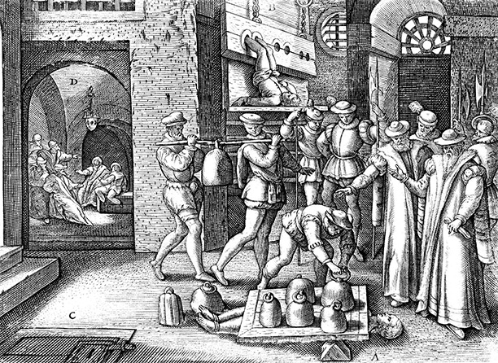
What do you notice in this engraving?
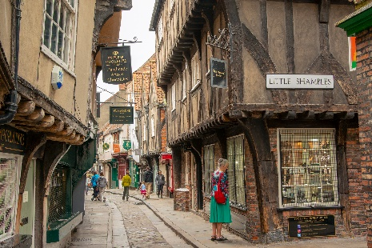
Study this engraving very carefully. It shows the execution of Margaret Clitheroe from York, in 1586. Margaret Clitheroe was executed because she was a fervent (that is, a very faithful and keen) Roman Catholic. What does this suggest about the religious situation in England in the 1580s?
What happened to Margaret Clitheroe and why?
Margaret Clitheroe was born in 1556 as Margaret Middleton; her father was well-respected as he was the sheriff of York and was also a Church warden for St Martin’s in Coney Street. She followed Protestantism from 1558 when Elizabeth became Queen. She didn’t learn to read or write as a child. Margaret married local butcher John Clitheroe when she was 15 years’ old; she moved to live with him in the Shambles. The Shambles was a hub for York’s butchers: the blood from animal carcasses would run in a stream down the centre of the road.
In the early 1570s, Margaret was converted to Roman Catholicism. York had a small number of prominent Catholics – it is likely that she was converted by one of their wives. This made Margaret’s home life complicated, as her husband was responsible for reporting Roman Catholic worshippers to the Protestant authorities. She was arrested at least twice for her religion; she refused to attend the Protestant Church services.
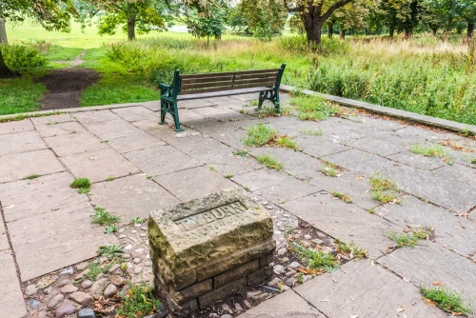
From 1581, it became treason (punishable by death) to be a Roman Catholic priest. Five priests were hung on the Knavesmire in 1582 and 1583. Margaret made secret pilgrimages to the gallows where they had been executed. Margaret wanted to play her part in aiding Roman Catholic priests, which led to her creating a secret hiding room in her Shambles home. This was used for priests to hide in; these were frequently called ‘priest holes’.
In 1586, her priest hole was revealed and Margaret was arrested. Her trial took place in the Guildhall, but she refused to plead. If she had pleaded, her children would have been forced to be witnesses and could have been tortured. She also refused to convert back to Protestantism, which may have saved her life.
Her punishment was to be pressed to death. On 25th March 1586 whilst only wearing a light linen underlayer of clothing, Margaret Clitheroe was taken to the Ouse Bridge and laid down, with a rock the size of a man’s fist placed under her back. A door was then placed over her, before ‘seven or eight hundred weight at the least’ was loaded onto the door, crushing her ribs. She had been pregnant at the time of her death. Her body was left on Ouse Bridge for six hours, before being buried near a dunghill.
Margaret Clitheroe’s death was a warning of the stark punishments which awaited ordinary people if they opposed Elizabeth I’s religious settlement. She was one of only three women to be killed for religious reasons in Elizabethan England.
What is the bigger story?
When Elizabeth I became Queen in November 1558, her people were divided on the issue of religion. Although her father, Henry VIII, had officially started the English Reformation, it was her younger brother Edward VI who turned England into a staunchly Protestant country. By the time of his death in 1553, English prayer books were completely in English, Roman Catholic worship was outlawed and churches were stripped of their colour and ornaments. This position rapidly changed with the accession of Mary I, Elizabeth’s older sister, who was equally fervent about the Roman Catholic religion. She rapidly restored the authority of the Pope in religious matters, brought back Roman Catholic worship and practices and declared Protestants heretics; burning almost 300 of them during her 5 year reign.
Elizabeth therefore had to tread a difficult path. In 1559, she passed her Religious Settlement: this declared that everyone had to attend Protestant Church services, but allowed Roman Catholics to continue to worship in the privacy of their own homes. She permitted bishops to marry, but removed the Pope’s power and created the position of ‘Supreme Governor of the Church of England’ for herself.
There was a significant amount of conformity to Elizabeth’s settlement, particularly in the early part of her reign. However, shortly after her Catholic cousin, Mary Queen of Scots, arrived in England in 1568, she faced the Northern Rebellion. This rebellion had significant popular support in the North of England – it was only due to the loyalty of the Duke of Sussex that it was defeated, with 500 rebels put to death.
In 1570, the Pope excommunicated Elizabeth; this meant he officially removed her from the Roman Catholic Church, permitting other monarchs to overthrow her if they could. He ordered all English Catholics to rise up and remove Elizabeth from power. By 1586, Elizabeth had faced four serious rebellions, three of which had foreign support. This caused Elizabeth to tighten the restrictions against Roman Catholics.
She started to ‘crackdown’ on Catholics in 1571, announcing fines (called recusancy fines) against Catholics who didn’t attend Protestant church services. These were not widely enforced until 1581, when the fine was increased to £20 (approx. £5,000 today). She also made it treason to be a Roman Catholic Priest in England or to harbour one, as Margaret Clitheroe did. This was because Elizabeth genuinely believed that Catholics posed a threat to her authority – and even to her life.
Her cousin, Mary Queen of Scots, was Catholic and her heir to the throne. She was the ready-made replacement for Elizabeth and had the support of Philip II of Spain, as well as the Pope. From 1568, she was in England, though under house arrest. In 1586, evidence emerged that she was involved in the Babington Plot to kill Elizabeth; Mary Queen of Scots was beheaded in February 1587.
THINK!

- What does Margaret Clitheroe’s story tell us about some ordinary people’s reactions to Elizabeth I’s religious policy?
- How important do you think it is that people remember this past?
- Why is this story so remembered?
- How does this religious context help explain why Elizabeth I felt threatened?

Over to you!

You can find out more about the death of Margaret Clitheroe and Catholic threats to Elizabeth I by searching online. The BBC website is often a good place to start for basic historical information too.

Teacher notes: ‘What can Margaret Clitheroe tell us about religion in the 1580s?’
What is a slot-in?
A slot-in is a short story from the past that is rich in historical concepts. You can use a slot-in as part of a longer sequence, or as cover work, or in those moments where you need something short.
The concept focus of this enquiry
The enquiry question here is: ‘What can Margaret Clitheroe tell us about religion in the 1580s?’ The concept focus is considering the consequences of challenges to Elizabeth’s settlement. Her story offers an in-depth consideration of the human impacts of Elizabeth’s laws against Catholicism. It shows the consequences of Elizabeth’s actions, as well as providing some important context for local history within York. It also contextualises some features of York which remain today, including the Shambles.
Curriculum links
This story could be slotted-in to your curriculum as part of a sequence on:
- local York history,
- Elizabeth I’s religious settlement / religious turmoil,
- History from ‘below’.

Activity suggestions
You might just want students to read this story, make a connection to a wider topic and move on. However, you might decide to use this material for a whole lesson with activities. You could:
- Print off copies of the picture at the top and ask students to write words and phrases around it to describe what they can see.
- Get students to analyse the extent of the consequences of Elizabeth’s religious policy, using Margaret’s story as a focus point.
- Use Margaret’s 1970 canonization to explain why her death was remembered so clearly by the Roman Catholic Church.
- Get students to research other religious martyrs in Elizabethan England.
- Use Margaret as a micro history to understand the macro changes of Elizabeth’s religious policy.
- Use the engraving at the top of the Slot-In to explore the provenance and answer the question, ‘How useful is the engraving of Margaret Clitheroe’s death for understanding Elizabeth I’s religious policy?’

Misconceptions to dispel
Margaret was technically born a Catholic, though she was raised as a Protestant from 1558. Her father was an important businessman in the city and played a significant role in his local parish.
Her death was in no way related to the Babington Plot or the execution of Mary Queen of Scots. There is no evidence to show that Margaret wanted to overthrow Elizabeth I.

Where to link to
There are lots of websites which cover the story of Margaret Clitheroe. HistoryofYork website has an excellent summary of her story.

