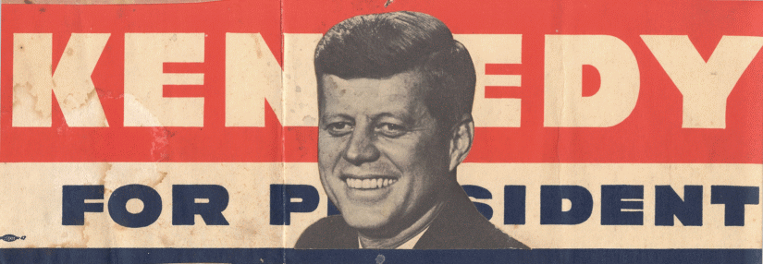

Why did Kennedy win the election?

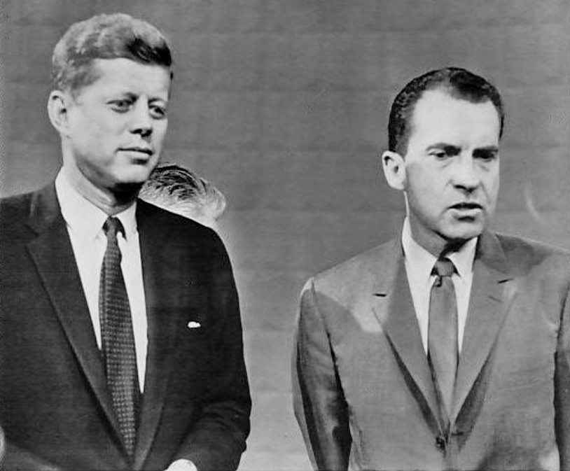

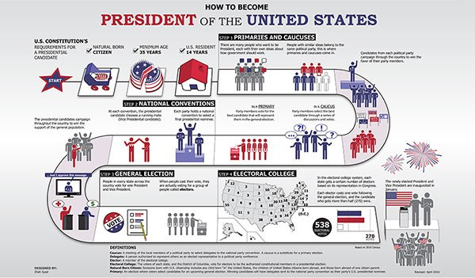
Review of lesson content

- What was his full name?

- Who was his father? Why was he important?

- Who was his wife?

- Who was his older brother? What role did he have on the campaign trail?

- What religion was he and why was this a problem?

- What role did he play during the wall?

- What political offices had he held previously?

- What illnesses did he suffer from and why might this be a problem?
Statement of Senator John F. Kennedy announcing his candidacy for the Presidency of the United States, January 2, 1960.
“I am announcing today my candidacy for the Presidency of the United States. The Presidency is the most powerful office in the Free World. Through its leadership can come a more vital life for our people. In it are centred the hopes of the globe around us for freedom and a more secure life. For it is in the Executive Branch that the most crucial decisions of this century must be made in the next four years--how to end or alter the burdensome arms race, where Soviet gains already threaten our very existence--how to maintain freedom and order in the newly emerging nations--how to rebuild the stature of American science and education--how to prevent the collapse of our farm economy and the decay of our cities--how to achieve, without further inflation or unemployment, expanded economic growth benefiting all Americans--and how to give direction to our traditional moral purpose, awakening every American to the dangers and opportunities that confront us.
These are among the real issues of 1960. And it is on the basis of these issues that the American people must make their fateful choice for their future.
In the past 40 months, I have toured every state in the Union, and I have talked to Democrats in all walks of life. My candidacy is therefore based on the conviction that I can win both the nomination and the election.
I believe that any Democratic aspirant to this important nomination should be willing to submit to the voters his views, record and competence in a series of primary contests. I am therefore now announcing my intention of filing in the New Hampshire primary and I shall announce my plans with respect to the other primaries as their filing dates approach.
I believe that the Democratic Party has a historic function to perform in the winning of the 1960 election, comparable to its role in 1932. I intend to do my utmost to see that that victory is won.
For 18 years, I have been in the service of the United States, first as a naval officer in the Pacific during World War II and for the past 14 years as a member of the Congress. In the last 20 years, I have travelled in nearly every continent and country--from Leningrad to Saigon, from Bucharest to Lima. From all of this, I have developed an image of America as fulfilling a noble and historic role as the defender of freedom in a time of maximum peril--and of the American people as confident, courageous and persevering.
It is with this image that I begin this campaign.”
- What does Kennedy’s rhetoric suggest about his view of winning elections?
- What is the tone of the speech?
- What does it suggest his next actions are likely to be?
Robert Dallek, Camelot’s Court: Inside the Kennedy White House.

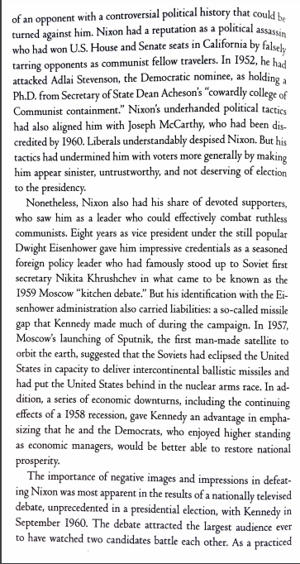

Questions:

- How did the Kennedy team believe elections were won?
- Who did Kennedy liken himself to?
- Who was Kennedy’s main opponent?
- What were Nixon’s tactics? What example is given?
- Did this work for Nixon?
- Why was Nixon popular?
- What was the ‘kitchen debate’?
- What gave Nixon a disadvantage?
- What gave Kennedy an advantage?

Robert Dallek, JFK: An Unfinished Life
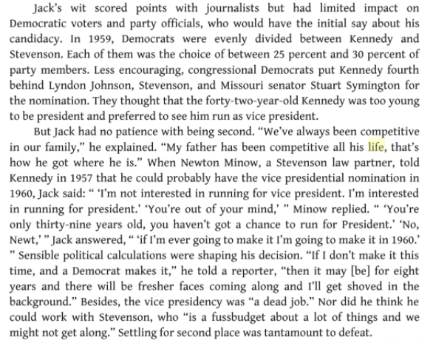

Questions:

- What made Jack popular?
- Why was this perhaps a downfall?
- What happened to Kennedy in 1959?
- How did his childhood affect his run for president?
- What were Kennedy’s arguments for running in 1960 for president?
- How did he view vice-presidency?

David Pietrusza, 1960: LBJ vs. JFK vs. Nixon: The Epic Campaign that Forged Three Presidencies.
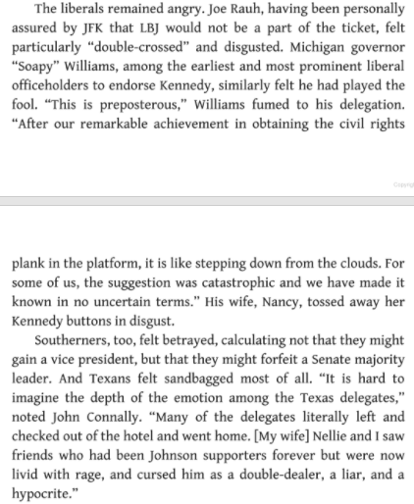
Questions:

- Why were the liberals angry?
- How would this affect Kennedy’s chance for presidency?
- How did the Southerners feel?
- What were Texans specifically upset about?
- What were the main upsets between the liberals and the Southerners?
- How might this affect Kennedy/Johnson’s election chances?

