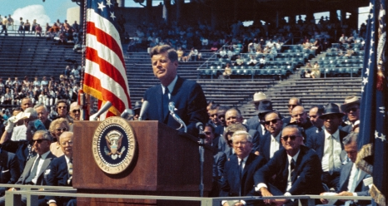

Did Kennedy successfully forge a new frontier?

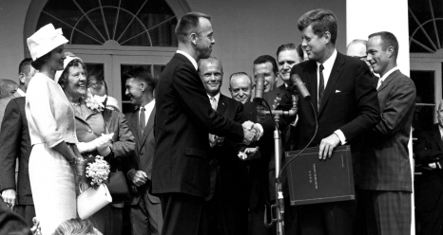

Give a summary of Kennedy’s ideas and how he turned these into policies:

- Science and space:

- Peace and war:
- Ignorance and prejudice:
- Poverty and surplus:

Do you think he was successful in forging a ‘New Frontier’? Answer below:
- No major new domestic legislation – much of what Congress passed was not New Frontier legislation but extensions of existing programmes.
- BUT Kennedy had at least put ‘poverty and surplus’ firmly on the national legislative agenda, despite uncooperative Republicans and conservative Southern Democrats.
Review of lesson content

Kennedy’s Acceptance Speech, 1960.

“The New Deal and the Fair Deal were bold measures for their generations – but this is a new generation…. Too many Americans have lost their way, their will, and their sense of historic purpose. It is a time, in short, for a new generation of leadership – new men to cope with new problems and opportunities…. I stand tonight [in Los Angeles] facing west on what was once the last frontier. From the lands that stretched 3000 miles behind me, the pioneers of old gave up their safety, their comfort and sometimes their lives to build a new world here in the West…… Their motto was not ‘every man for himself’ – but ‘all for the common cause’…… We stand today on the edge of a New Frontier – the frontier of the 1960s – a frontier of unknown opportunities and perils…. The New Frontier of which I speak is not a set of promises- it is a set of challenges. It sums up not what I intend to offer the American people, but what I intend to ask of them…. Beyond that frontier are the uncharted areas of science and space, unsolved problems of peace and war, unconquered pockets of ignorance and prejudice, and unanswered questions of poverty and surplus…. The choice our nation must make [is]……between the public interest and the private comfort.”

John Kennedy’s acceptance speech, July 1960.

Questions:

- What is Kennedy outlining here for presidency?
- Why do you think he used the term ‘New Frontier’?
- Robert D. Marcus quotes "Kennedy entered office with ambitions to eradicate poverty and to raise America’s eyes to the stars through the space program”, does this come across in his speech?
- Do you think he will be successful in achieving this after the struggles of his Democrat election support?

“And so, my fellow Americans: ask not what your country can do for you – ask what you can do for your country. My fellow citizens of the world ask not what American will do for you, but what together we can do for the freedom of man”
- What does Kennedy’s inaugural address tell us about what people could expect from his presidency?

- What is the nature of his leadership?

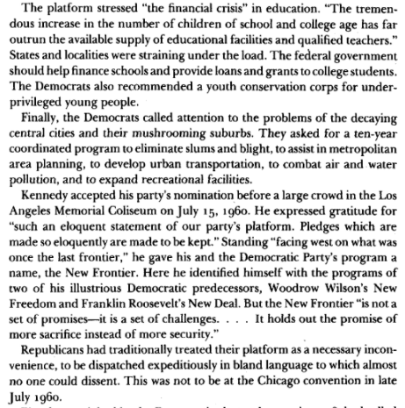
Promises Kept: John F. Kennedy’s New Frontier by Irving Bernstein.

Questions:

- What did Kennedy stress in his acceptance speech?
- What did the Democrats ask for?
- Where did he gain the idea of a ‘New Frontier’?
- Which predecessors did Kennedy look up to?
- How did the Republicans treat this?
- Overall, what can you, as the reader, gain from this piece of text?

Kennedy: The New Frontier Revisited by Mark J. White.

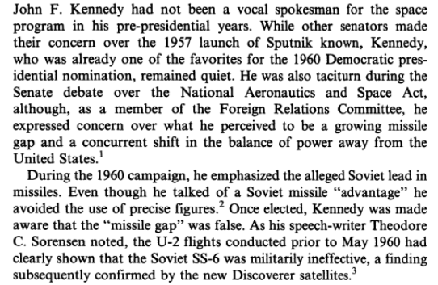

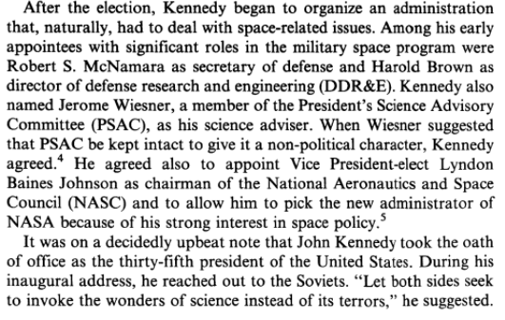

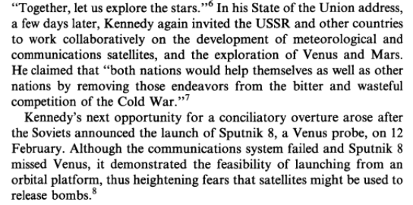

Questions:

- What did Kennedy express concern about?
- How did these concerns playout in his presidency?
- How did Kennedy try to begin his presidency in terms of Americas foreign presence?
- What was the ‘missile gap’?
- Why was it a threat?
- What was ‘Sputnik’?
- What were Kennedy’s fears after the launch of Sputnik?
- Does the Kennedy/Johnson administration seem concerned about the Soviet Union?

