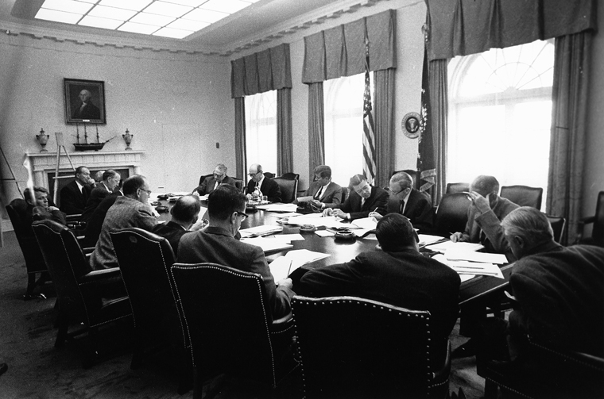

Why did Cuba become a Cold War ‘hot spot?

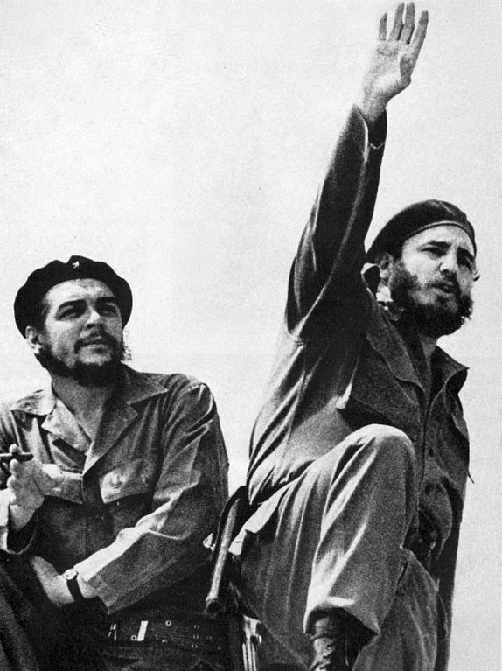

- Why was Batista so popular in America?
- Why was Castro not favoured by America?
- How did Castro gain control in Cuba?
- What did Castro do once he was in power?
- How did Cuba and the US fall out?
- What happened at the Bay of Pigs invasion 1961?
- Why was it a disaster?
- Why was the disaster so significant?
- What lessons were learnt from the Bay of Pigs?
Review of lesson content

Robert Dallek, Camelot’s Court.

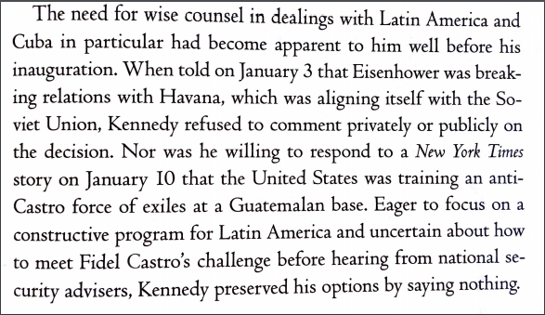

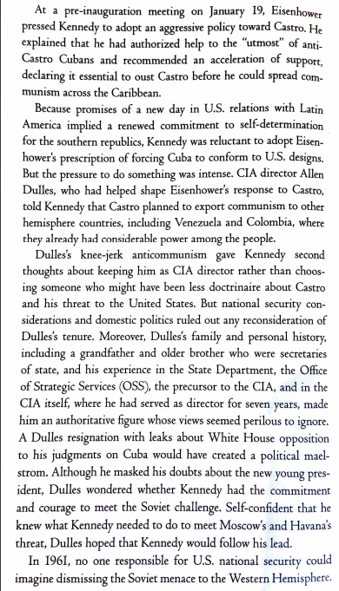

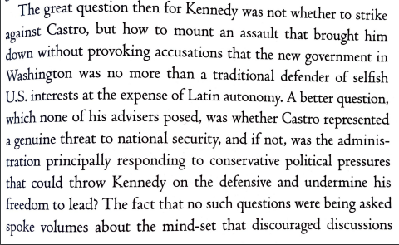

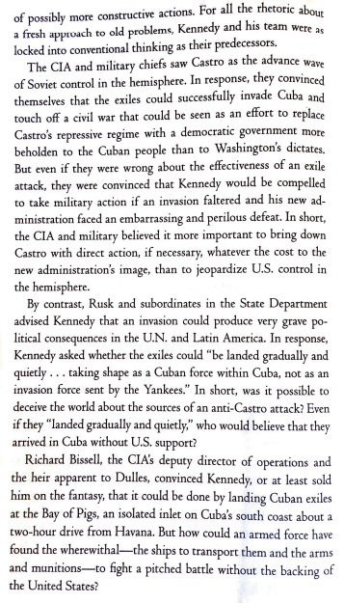

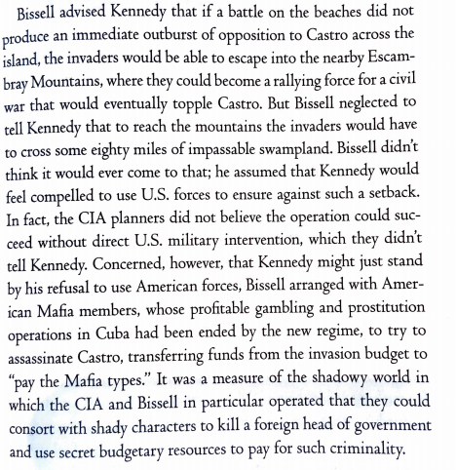

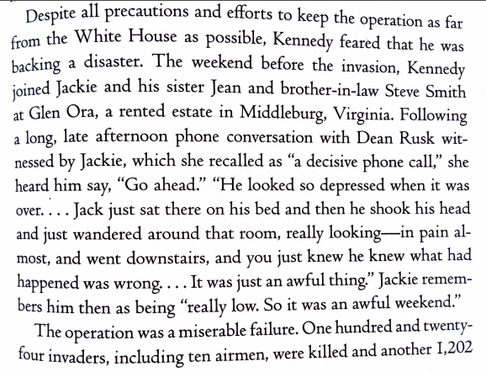

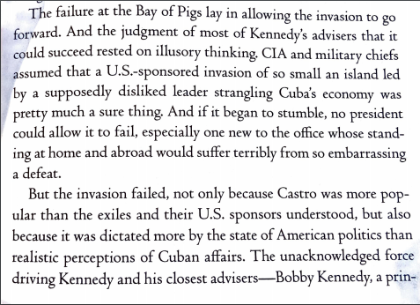

Questions:

- Who had initiated the downfall of relations with Cuba?
- What did Eisenhower propose and how did Kennedy feel about this?
- What was Kennedy worried about before and in his early days of his presidency?
- How limited do you think Kennedy was by his advisors?
- What did the CIA and military want to do despite Kennedy’s worries?
- When Bissell was describing the plan to Kennedy, did it sound successful?
- How does the author portray the CIA and military directors when talking about preparations for the invasion?
- Who did Bissell transfer funds to and what were they supposed to do?
- How much, do you think, Kennedy knew of the Bay of Pigs invasion?
- Why did the invasion fail?

