Dragged or pushed – Why did Kennedy get involved in Vietnam?

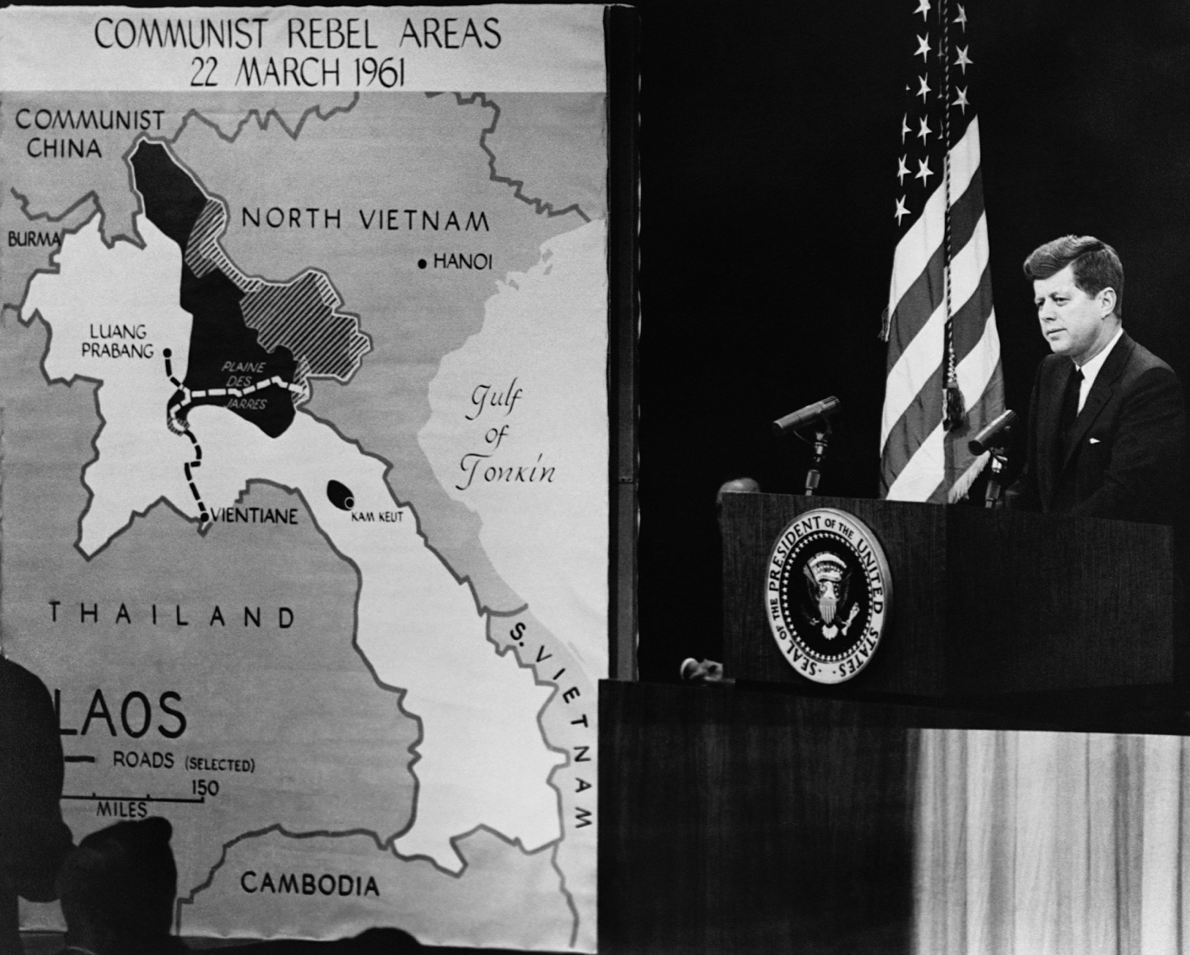

- List the 4 key events of US military advisors in Vietnam.
- What are the three main arguments for Kennedy being pushed into the Vietnam War?
- What geo-political/Cold War developments that were playing out at the time?
- What is the Quagmire theory?
- What was Ngo Dinh Diem role in Vietnam and his involvement with Kennedy?
- What do you believe was the main event which triggered the increase involvement in Vietnam? Or was it a combination of events?

Review of lesson content

“Cornerstone of the free world in South East Asia, the keystone of the arch, the finger in the dike. Burma, Thailand, India, Japan, the Philippines and obviously Laos and Cambodia…would be threatened if the red tide of communism overflowed in Vietnam…(which was) a proving ground for democracy in Asia…and a test of American responsibilities and determination in Asia…where the relentless pressure of the Chinese Communists must be stopped…No other challenge is more deserving of our effort and energy…Our security may be lost piece by piece, country by country.”
Kennedy’s speech to American Friends of Vietnam, 1956
Questions:

- What does Kennedy’s rhetoric suggest about his commitment to Vietnam?
- What is the tone of the speech?
- What does it suggest Kennedy’s next actions will be?

Robert Dallek, Camelot’s Court.

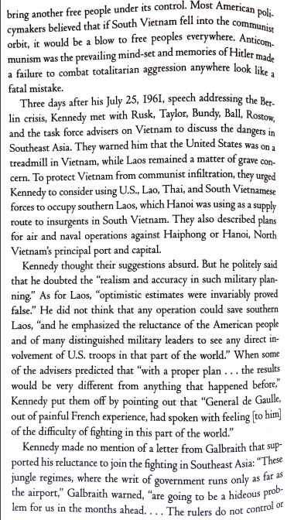

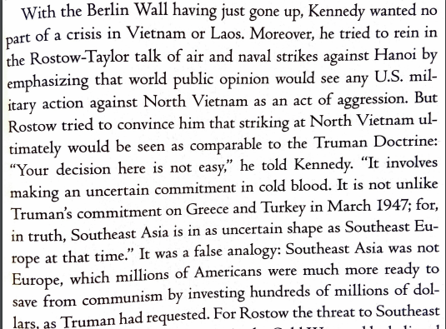

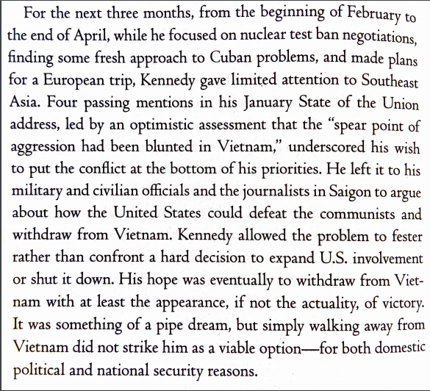

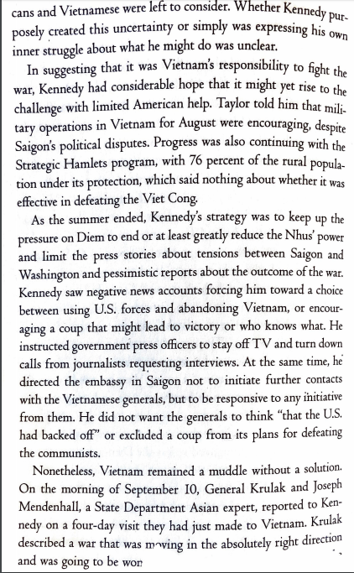

Questions:

- How did the Berlin Crisis affect Kennedy’s decisions towards what to do in Vietnam?
- When did it become apparent that the U.S. was going to become involved in Vietnam?
- Was Kennedy promoting direct involvement in Vietnam in the early stages and why/why not?
- Why was ‘walking away’ from Vietnam not a viable option for Kennedy?
- How had Kennedy’s attitude changed from the beginning of the book to the end?

David E. Kaiser, American Tragedy: Kennedy, Johnson and the Origins of the Vietnam War.

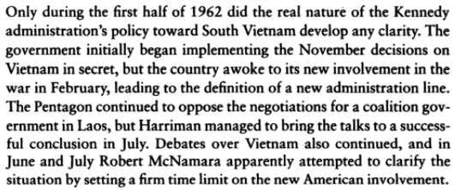

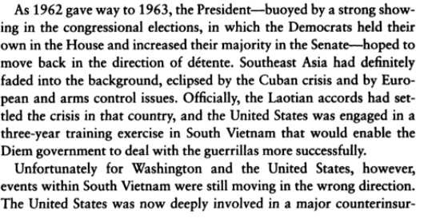

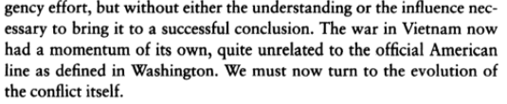

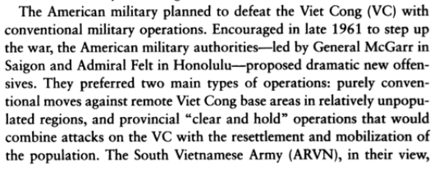
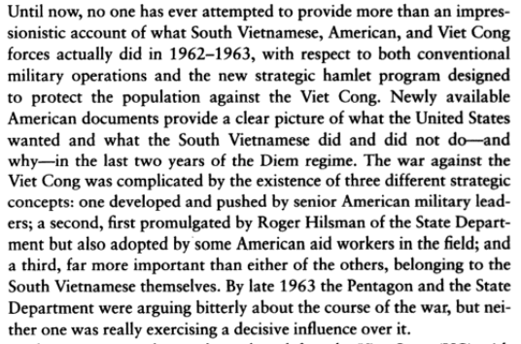

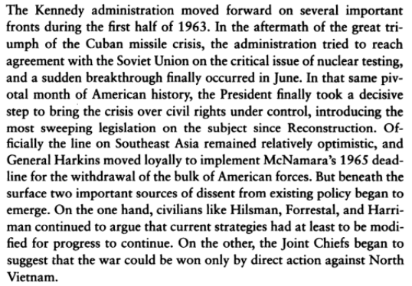

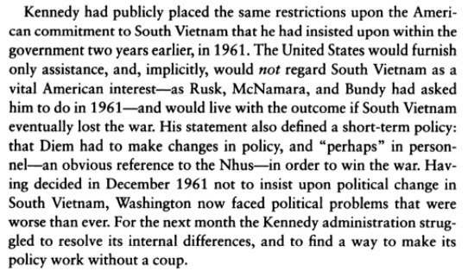
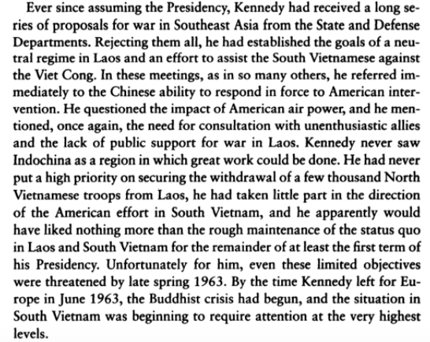

Questions:

- What else was happening in 1962 which would have diverted the Kennedy administrations attention?
- How might a majority in the House of Representatives and the Senate affect how the government works?
- Why did the Vietnam war take on momentum without the US even realising?
- Was the Vietnam War an offshoot of the involvement in Laos?
- What influences did Kennedy have on his decisions? – What were the divides amongst the administration?
- What was the Buddhist crisis in 1963?
- Was it President Kennedy who escalated involvement in Vietnam?
- How does the Kennedy administration’s attitude towards Vietnam change from the beginning of the extract to the end?

