York had been a long-term supporter of the King, and in April 1642 when the London mob became too dangerous, King Charles I moved; himself, his family, his advisers, and the centre of politics, to York. In effect making York the capital.

While many local people were pleased to have the King in York, there was still some support for the Parliamentarians. This was especially true for the Puritans in the area, who were victim to many attacks from the Royalists.

Not just contented with the city hosting him, the King also wanted to use the people of York within his army, to boost numbers against the newly forming Parliamentarian Model Army. In July 1642, the King also started to strengthen the walls and repair military posts.
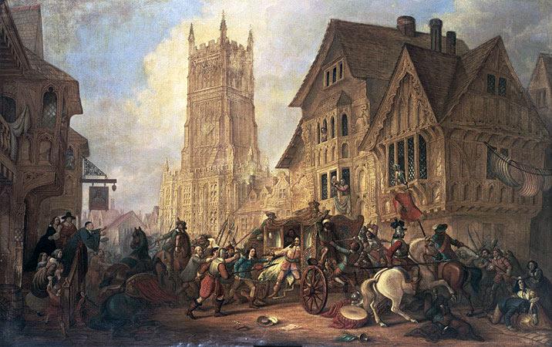

When the King moved to a more secure base in December 1642, he left the Marquis of Newcastle in charge of York, with the job of turning it into a northern military centre for the Royalists. 5,000 Royalist soldiers were kept inside the city, and the Queen Henrietta Maria visited in March 1643 to boost the Royalists spirits, as well as bring weapons food and money.

However, the local gentry family, the Fairfaxs, supported Parliament and wanted to take back the city from the King’s control. In April 1644 Thomas Fairfax attacked the Royalist troops, capturing or killing 2000 of the 3000 royalist troops stationed outside the city.

Within days the Scottish troops had also joined the Parliamentarians troops around the city. This forced the Marquis of Newcastle to ration food and use fear to stop his soldiers from surrendering.

The surrounding Parliamentarian soldiers used fire and battery guns to try and break down the city walls. The city was under siege from April- July 1644, but Newcastle hoped if the Royalists could survive long enough, Prince Rupert would bring reinforcements and rescue the Royalist trapped inside the city.

However, instead of being rescued, the Royalist army faced a devastating defeat at the Battle of Marston Moor, on the 2nd July 1644. This was the first major defeat for the Royalist since the start of the Civil War. Newcastle had moved his troops out of the city to meet Prince Rupert’s reinforcements, however when they met with Fairfax’s Parliamentarians troops 11KM North of the city, the Royalists quickly realised they were outnumbered. Over 4,000 Royalists were killed of the 18,000 of Newcastle’s and Prince Rupert’s armies.

When the injured Royalist troops were allowed back into the city, many local citizens tried to escape as they no longer wanted to be trapped within the city.
Finally, on the 16th July 1644 the Royalists surrendered the city and Thomas Fairfax was able to take the city

