Working with archival material in GCSE history
Teacher Pack
Heather Sherman, York College and Explore York Libraries and Archives

Working with archival material in GCSE History: teacher pack

I have developed this resource with the support and permission of Explore York Libraries and Archives. It is intended to be very much a working resource for you as a teacher, and your students. Any activities/ questions are suggestions and can be used/ adapted to suit your teaching and your students.
All photographed materials are under the copyright licence of City of York Council/ Explore Libraries and Archives Mutual, who have given permission for them to be used for educational purposes.
Included are:
- A teacher pack (this document) that links the research to the OCR, AQA and Edexcel GCSE History specifications. There are suggested activities/ questions to use with students to develop their thinking and link national history to a local context.
- A blank copy of the sources (separate sources) for use to design your own activities/ resource pack for students. Please use any of the glossaries/ questions/ activities that I have designed below when creating your own resources, or create your own, or use a mix of both!
The suggested activities/ questions are not intended to be an exhaustive list. Please adapt/ add to them to suit your students.
I hope you find this material valuable in your teaching. If you have any feedback that you’d like to pass on then please get in touch: hsherman@yorkcollege.ac.uk
My thanks go to Julie-Ann Vickers, Civic Archivist at Explore York Archives for her invaluable input and support in navigating the archives and supporting the creation of this resource.
Thank you,
Heather Sherman
Tutor of Modern History, York College

Where these resources link to different GCSE specifications

I have identified where the documents link to the following GCSE specifications, although you may find other areas of the specification where they might be useful.
  - OCR B:
- Section: Industrial Britain c.1700-c.1900
- Enquiry: Revolution! Why were there such huge changes in the people’s health, 1750-1900?
- Content links: Urban living conditions in the early 19th century – housing, clean water and waste.
  - Examples: Urbanisation and slums, water supplies in towns and cities and its effects e.g. cholera.
and
- Content links: Public health reform in the 19th century including the PHAs and local initiatives.
  - Examples: Other government action, local initiatives.
  - AQA
- Paper 2 Section A: AA Britain: Health and the people c.1000 to the present day.
  - The development of the Germ Theory and its impact on treatment of disease in Britain and everyday treatments and remedies.
  - Improvements in public health: public health problems in industrial Britain; cholera epidemics; the role of public health reformers; local and national government involvement in public health improvement including the 1848 and 1875 Public Health Acts.
  - Edexcel:
- Paper 1: Thematic study and historic environment (1HI0/11) – Medicine in Britain c.1250 – present:
  - c.1700-c.1900: Medicine in the 18th and 19th century Britain.
  - 2. Approaches to prevention and treatment – Public Health Act of 1875.
  - 3. Case studies – Fighting cholera in London 1854 – significance of Snow.

Reproduced from an original held by City of York Council/ Explore Libraries and Archives Mutual: Y/HEA/4/2 General Board of Health cholera precautions from the 1850s
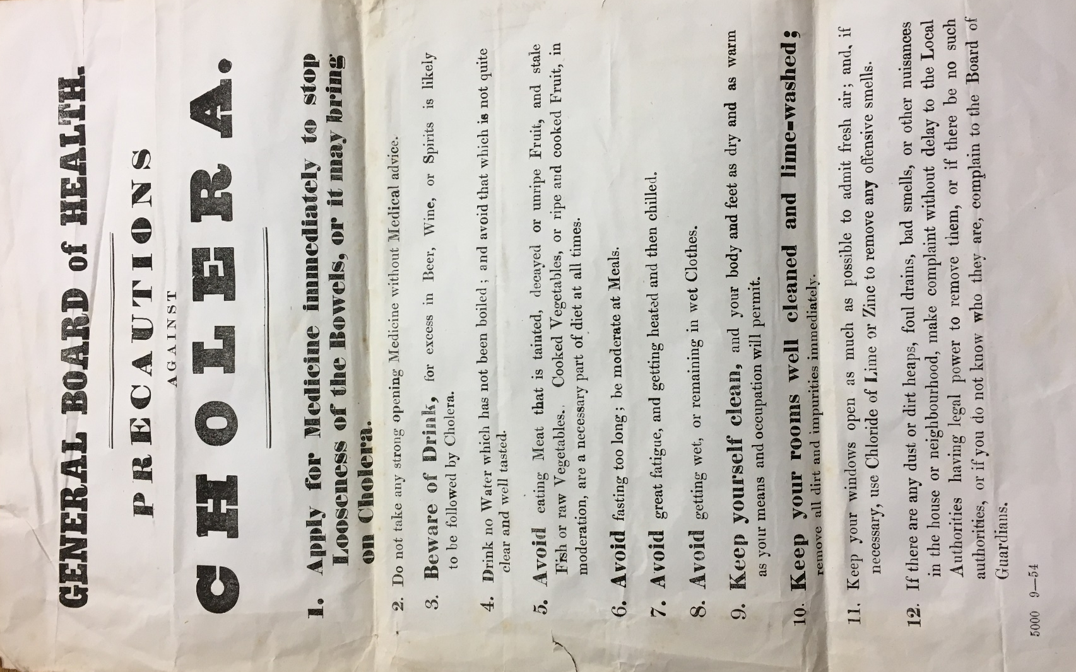
  - Glossary to support students:
- Fasting: when someone stops consuming all or some types of food and drink
- Chloride of lime: a white powder used as a disinfectant.
- Chloride of zinc: used as a disinfectant
- Lime washed: a type of paint made from lime and chalk with mild antiseptic properties
- Board of Guardians: a group of people who administered the Poor Law in the UK between 1835 and 1930.
- General Board of Health: The 1848 Public Health Act established the General Board of Health who had responsibility for giving advice on public health issues such as epidemics and disease prevention.
  - Activity for all
- Highlight/ underline/ write out any words or phrases that are unfamiliar/ you don’t know the definition of. Then look them up together/ as a class/ ask teacher to define.
  - Suggested activities for OCR B and AQA
Using a copy of the source:
- Read point 12. What public health problems with living conditions does the source point out?
- Using your own knowledge about sewers and water supply in this period, how might these problems affect the water supply?
- Do you think this source shows that the Public Health Act of 1848 was effective/ ineffective/ a mix of both in improving the people’s health? Why?
- Which of the ‘precautions’ from the poster do you think will be the most likely to improve people’s health? Why?
- How successful do you think putting advisory posters up would be in dealing with a cholera outbreak? Link to you own knowledge to explain your answer.
- Which of the ‘precautions’ from the poster do you think show that the miasma theory was still influential?
  - Suggested activities for Edexcel
- Which of these precautions do you think would help prevent someone from catching cholera?
- How effective do you think these precautions would have been in preventing someone from getting cholera and why? Use your own knowledge to support your explanations.
- Which of these precautions do you think would help treat someone who had cholera and why? Use your own knowledge to support your explanations.
- How effective do you think these precautions would have been to treat cholera and why? Use your own knowledge to support your explanations.
- Do you think this source shows that the Public Health Act of 1848 was effective/ ineffective/ a mix of both in improving the people’s health? Why?

Reproduced from an original held by City of York Council/ Explore Libraries and Archives Mutual, York: Y/HEA/4/2 General Board of Health precautions from the 1850s relating to the removal of nuisances
*This may need to be blown up to A3 for students to be able to read the small text in the document
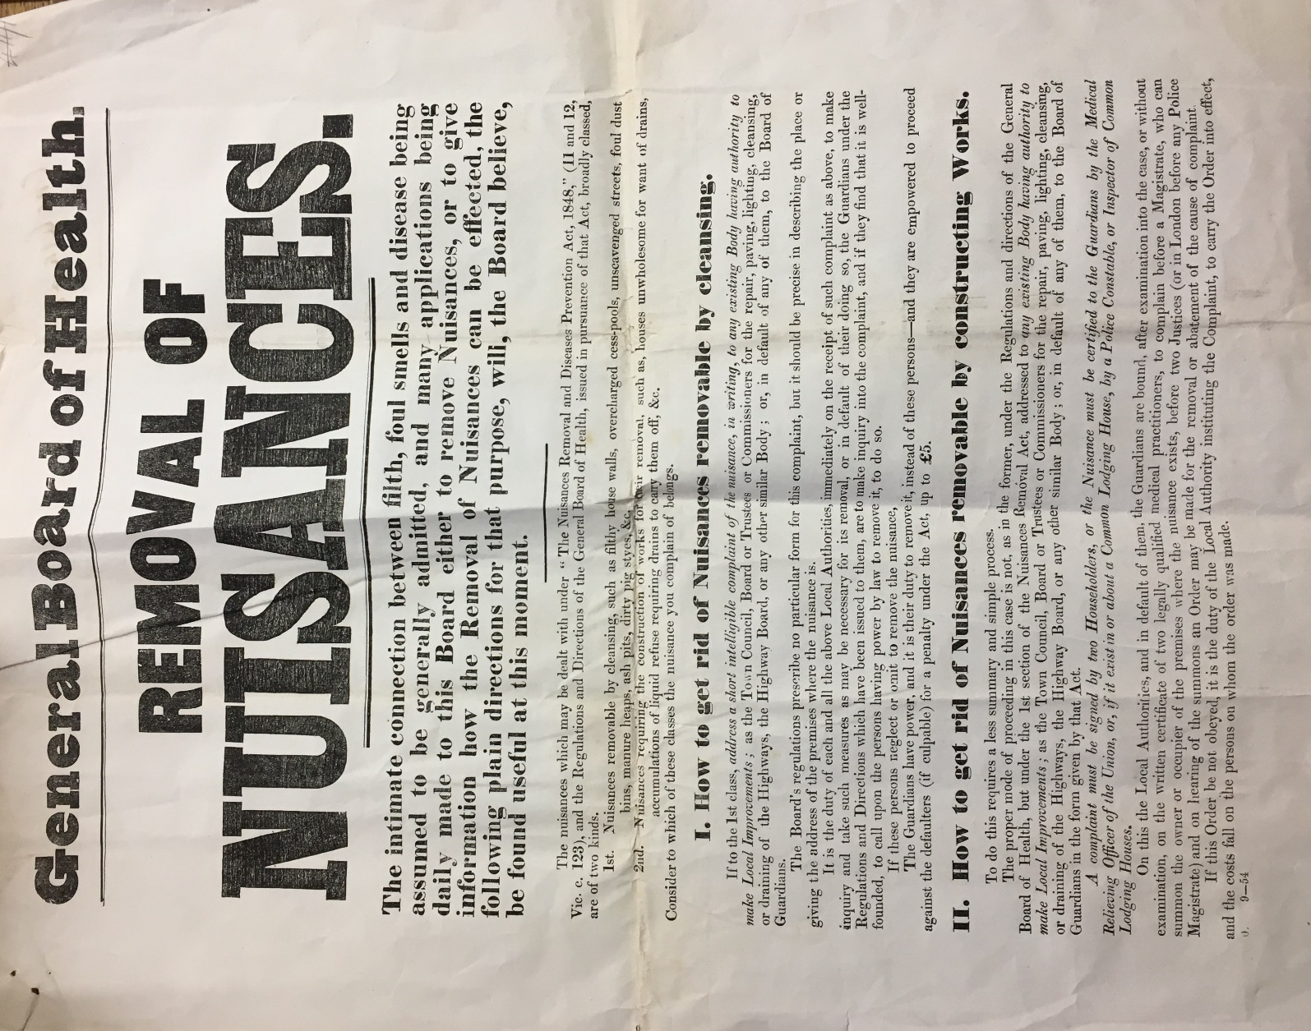

Some of the wording of this source might be harder for some students to understand. Therefore, it may be worth using short extracts from the source with some and using other parts as stetch and challenge activities.
  - Glossary to support students:
- Nuisance: Something about a property/ area that is harmful to health e.g. rubbish piles in the street.
- General Board of Health: The 1848 Public Health Act established the General Board of Health who had responsibility for giving advice on public health issues such as epidemics and disease prevention.
  - Activity for all
- Highlight/ underline/ write out any words or phrases that are unfamiliar/ you don’t know the definition of. Then look them up together/ as a class/ ask teacher to define.
  - OCR B and AQA
  - OCR B and AQA
- Using the source and your inference skills, can you give two examples of what is being done to make improvements in public health?
- Under section 1 the source says that the local authority (local government) must make enquiries to deal with the build of nuisances “immediately…to make inquiry and take such measures as may be necessary for its removal.” From what you know about local government action, do you think that they would have acted swiftly to clean up the nuisances or not? What own knowledge supports your judgement?
- What parts of the 1848 Public Health Act is this notice enforcing?
  - AQA
- The first part of the source states that “The intimate connection between filth, foul smells and disease being assumed to be generally admitted”. What do you think this means?
- What theory of disease does this quote show was still very influential? Why?
  - Edexcel
- This poster outlines what the local government should do to get rid of nuisances in the city. What public health problems would the removal of nuisances help to prevent?
- What parts of the 1848 Public Health Act is this notice enforcing?

  - Reproduced from an original held by City of York Council/ Explore Libraries and Archives Mutual, York: Y/HEA/2/5/5 Report on the health of York from 1884
This document was written by the Medical Officer of Health and published in the newspaper ‘York Herald’.
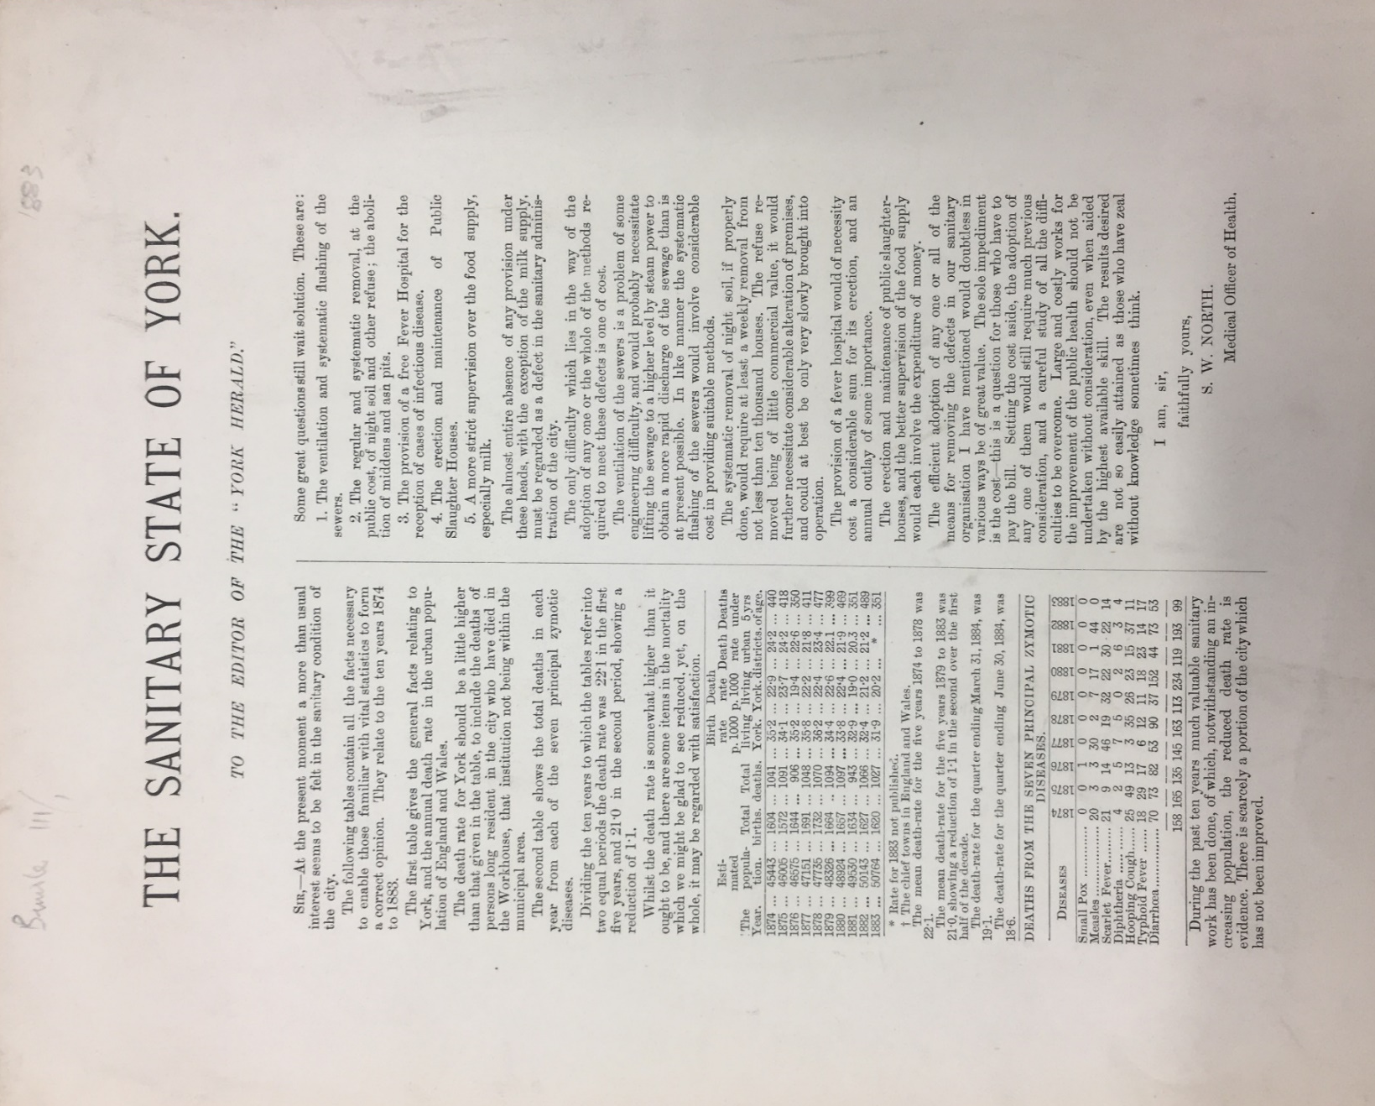

  - Glossary for students:
- Medical Officer of Health: someone who worked at a regional level to notify the local government of disease outbreaks, made sure people were following sanitary by-laws and made sure that houses were fit for human habitation.
- Zymotic disease: infectious, contagious diseases
- Middens: heap of rubbish or human waste
- Ash pits: a place where people put ashes from their fire and household rubbish.
- Zeal: energy or enthusiasm
  - OCR B
- What problems with the sewers in York does North identify in his report?
- What does he suggest the local government of York need to do to improve the sewers/water supply?
- What does North identify as the main reason for improvements to public heath not to be carried out?
  - AQA
- What public health problems are identified in North’s report for York?
- Which of these public health problems do you think was the most dangerous and why?
- What suggestions does North make to improve public health in York?
- North is suggesting to the local government that they need to go further and make more reforms to improve public health in the city. Why do you think he sent his report to a local newspaper to publish?
- Do you think this report shows the implementation of the 1875 Public Health Act was effective or ineffective? What parts of the report do you think show this and why?
  - Edexcel
- What public health problems are identified in North’s report for York?
- Which of these public health problems do you think was the most dangerous and why?
- What suggestions North makes do you think would help prevent future disease outbreaks in the city of York? How would they help prevent them?
- What suggestions that North makes do you think would help treat future disease outbreaks in the city of York? How would they help treat them?

  - Reproduced from an original held by City of York Council/ Explore Libraries and Archives Mutual, York: Y/HEA/2/5/3:
  - From the collection - City of York Report on the compulsory notification of infectious diseases
This is from a collection of ad hoc reports that were compiled in relation to particular public health issues, such as outbreaks of infectious disease.
I have included the whole of Dr Airy’s report for teacher reference but have selected 3 short passages and cropped them at the end for use with students.

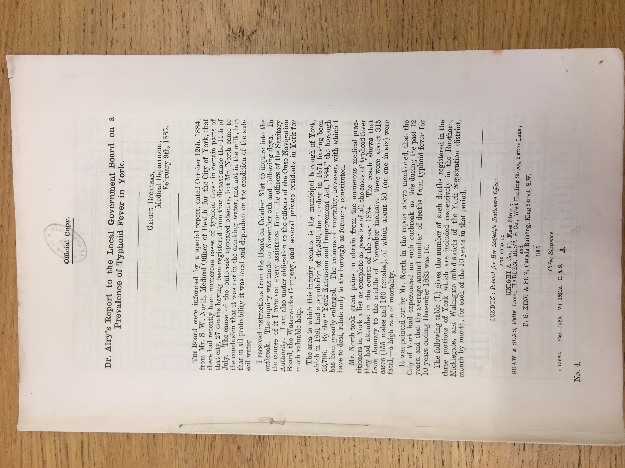
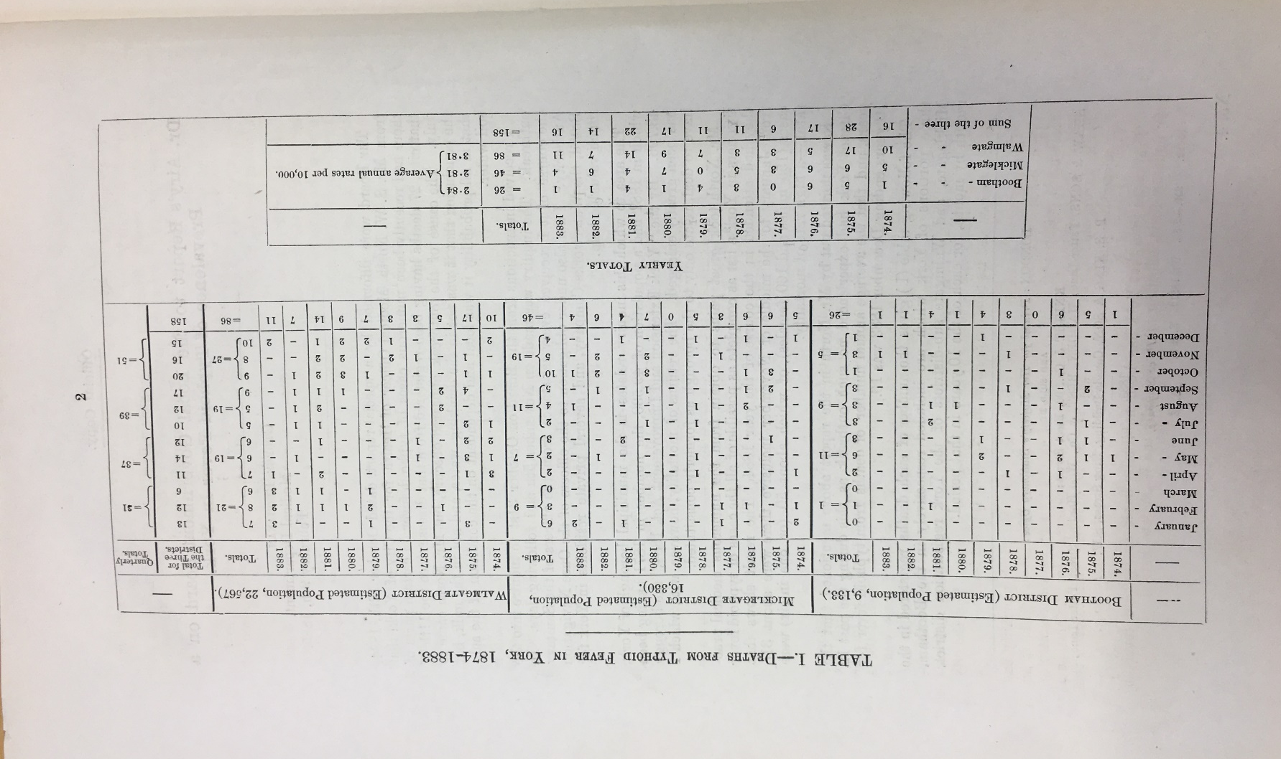
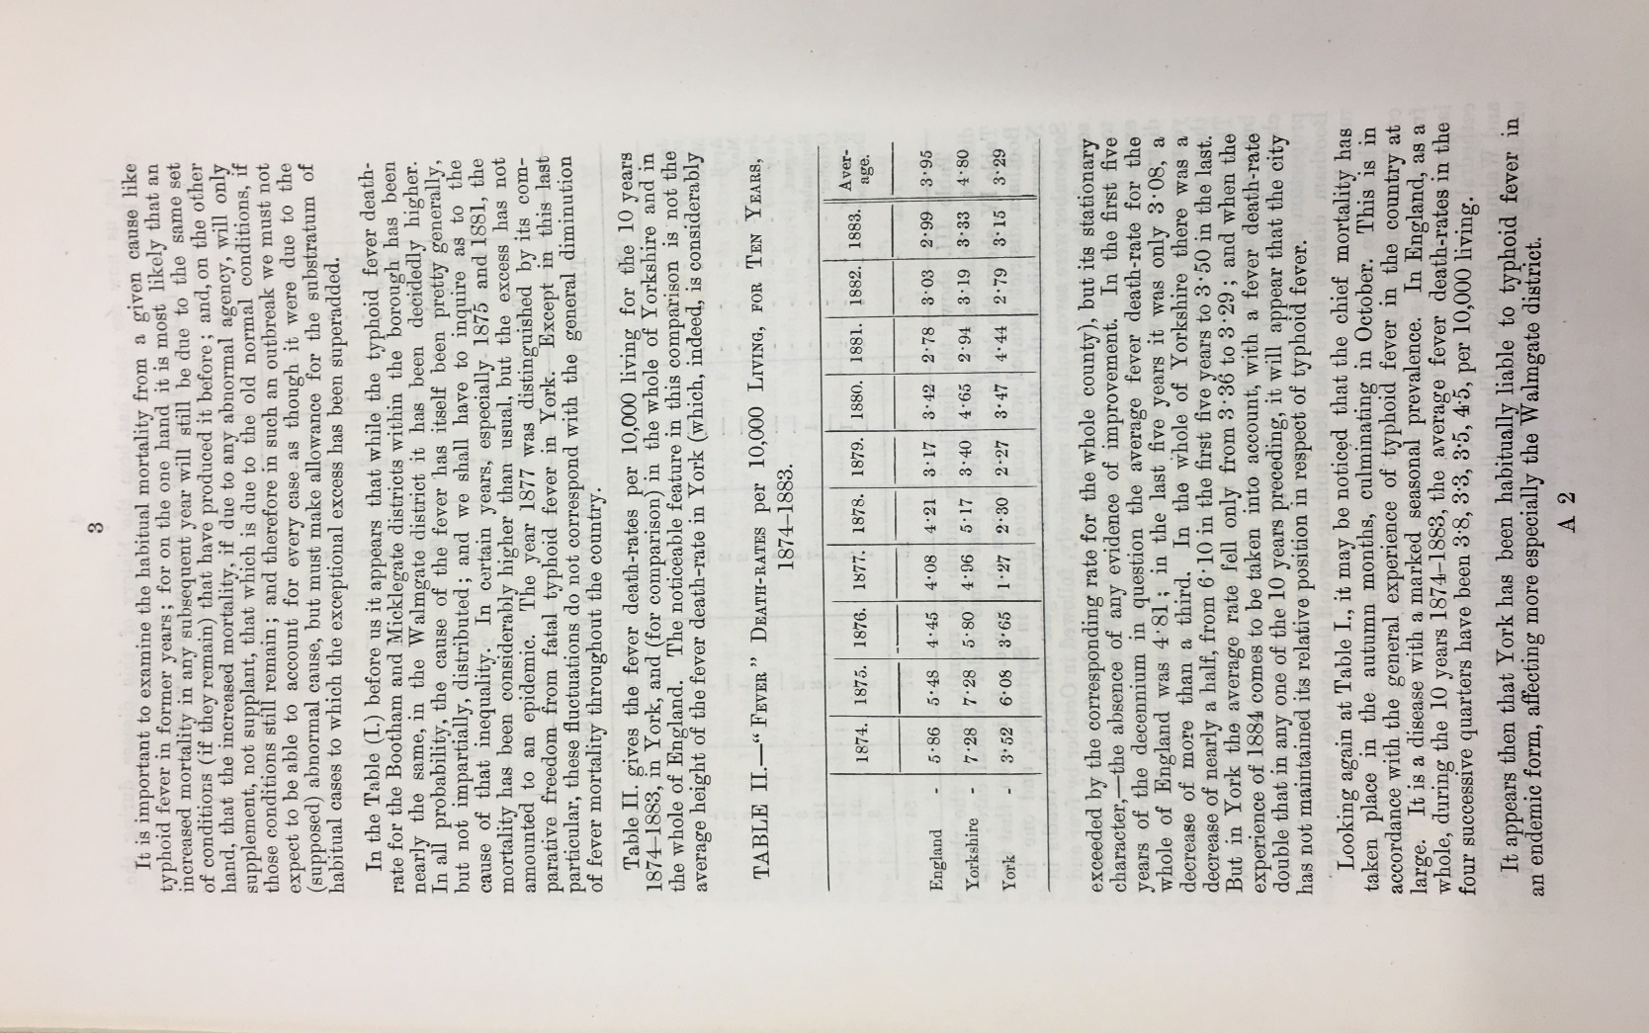
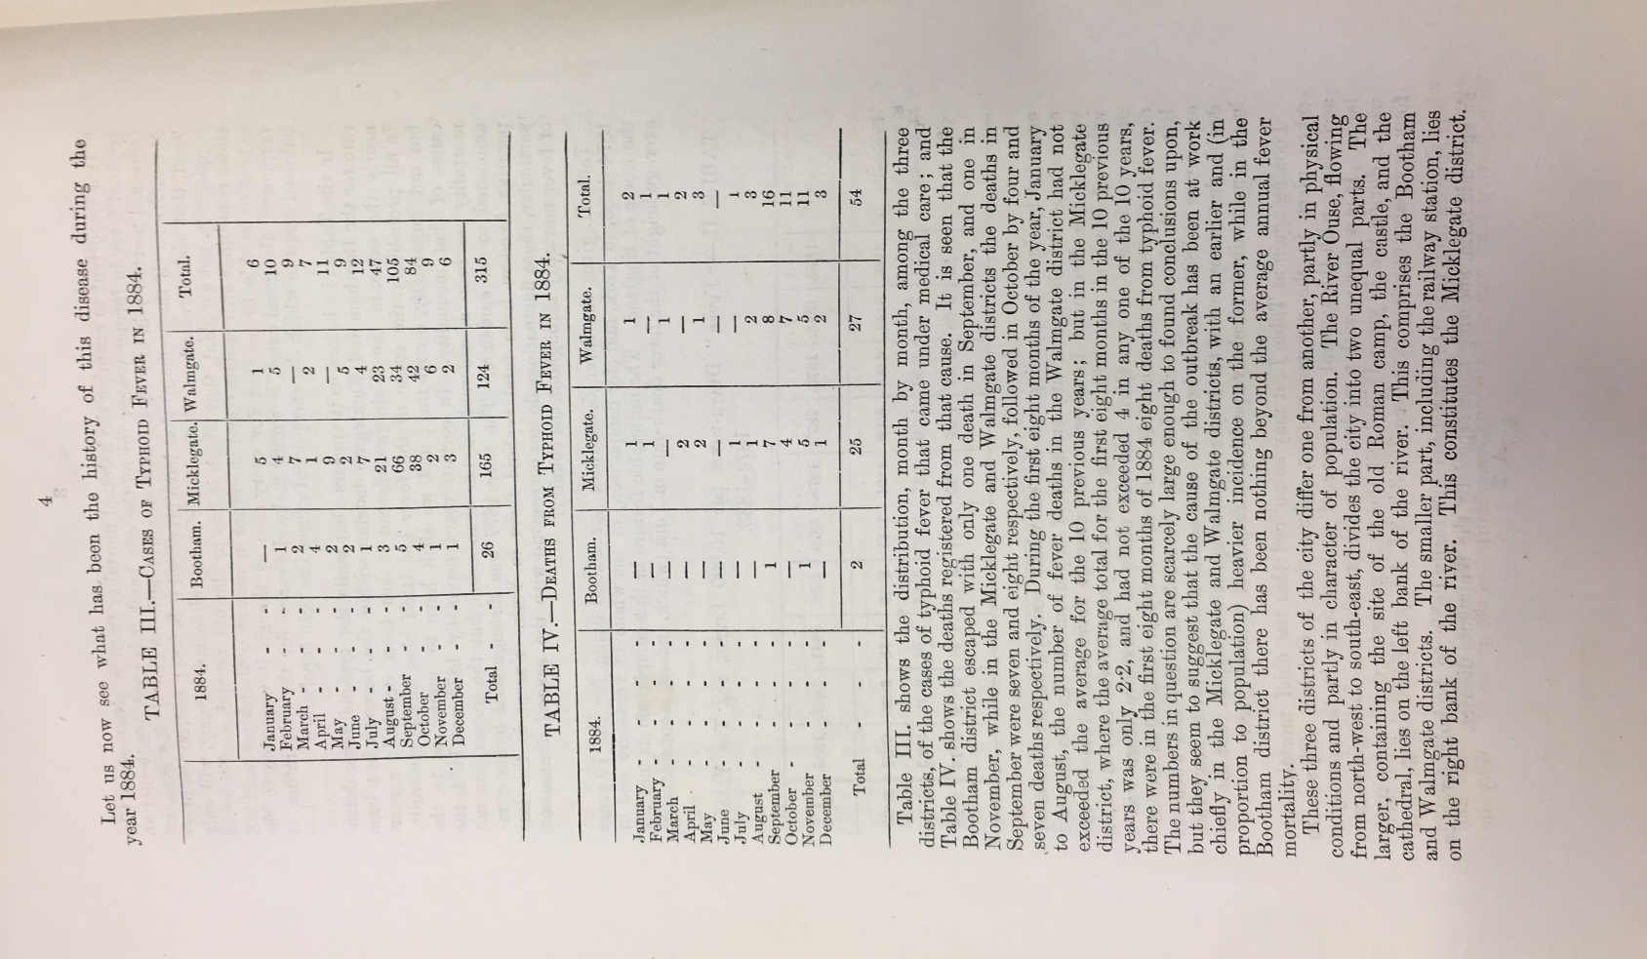
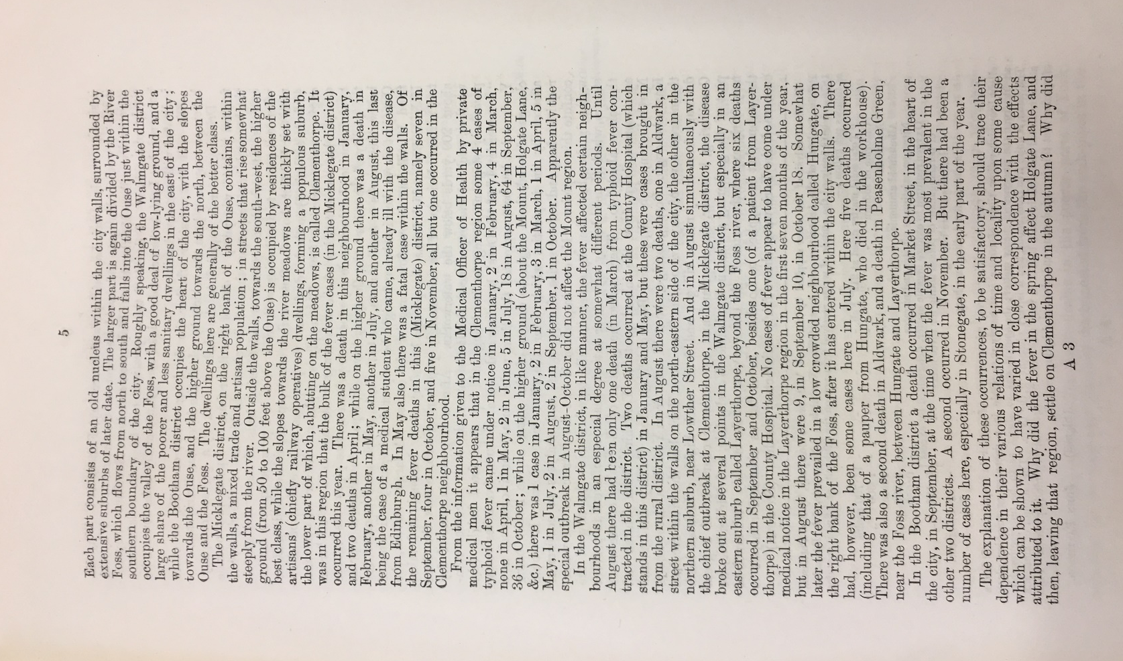
Apologies for the poor photographic quality of this image. If you require a typed transcript of this page, please email me.
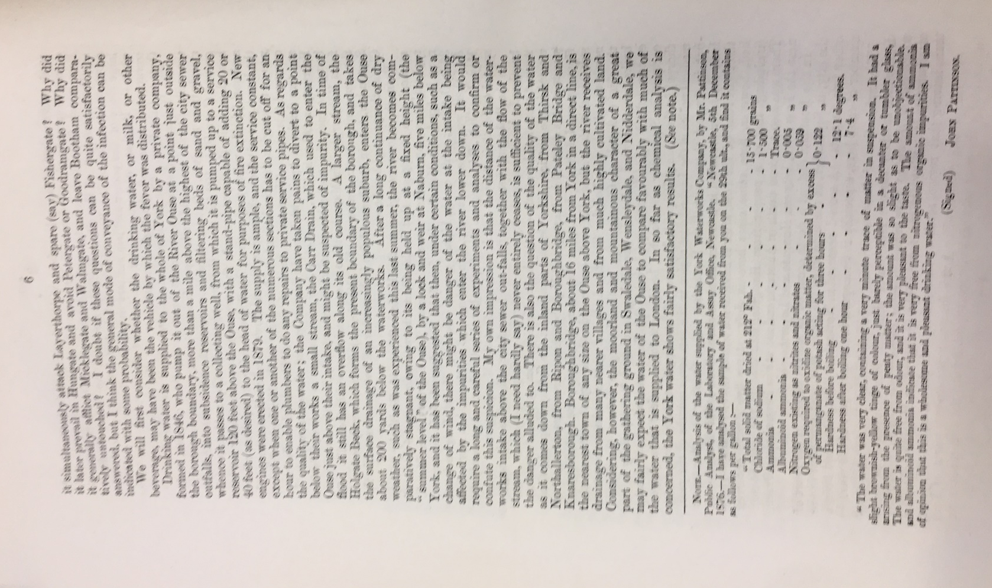

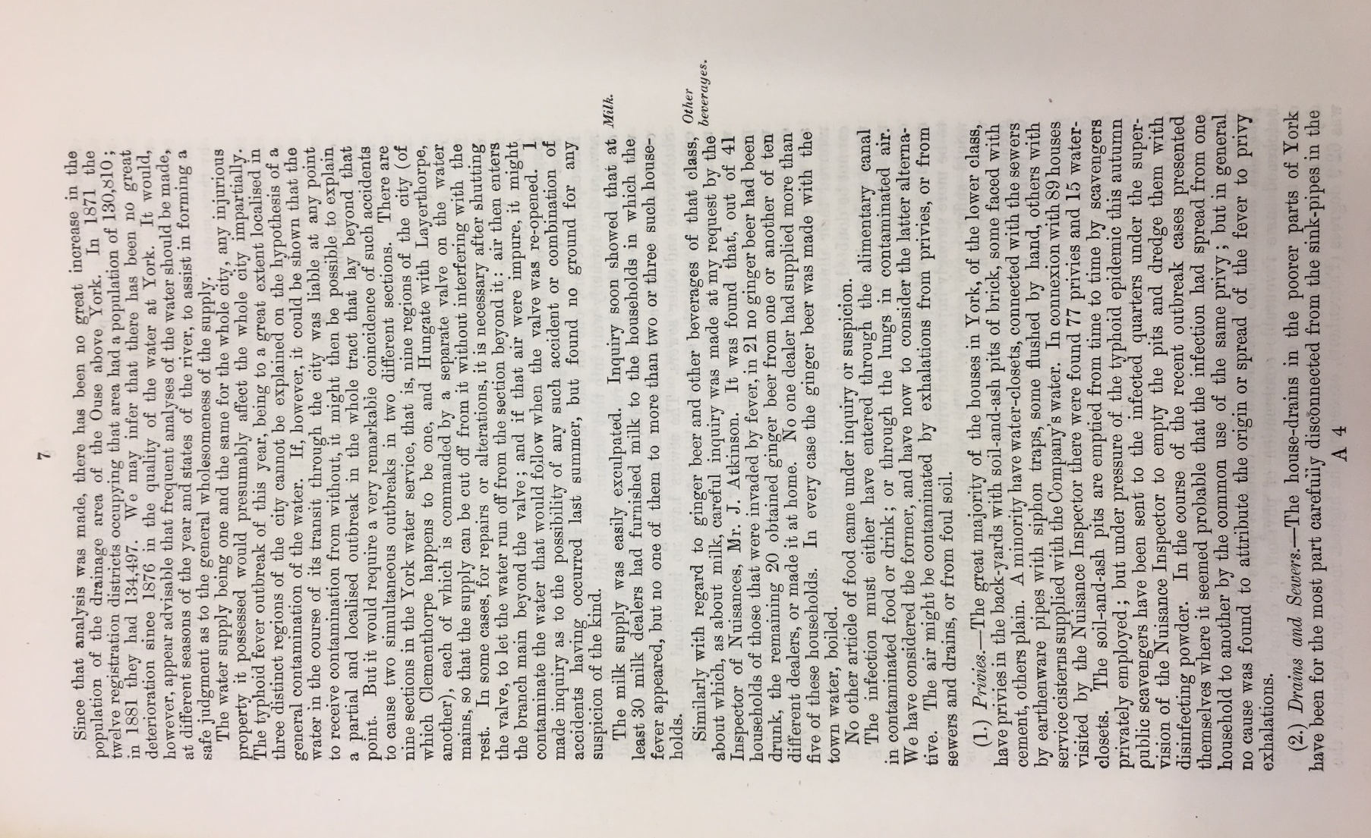

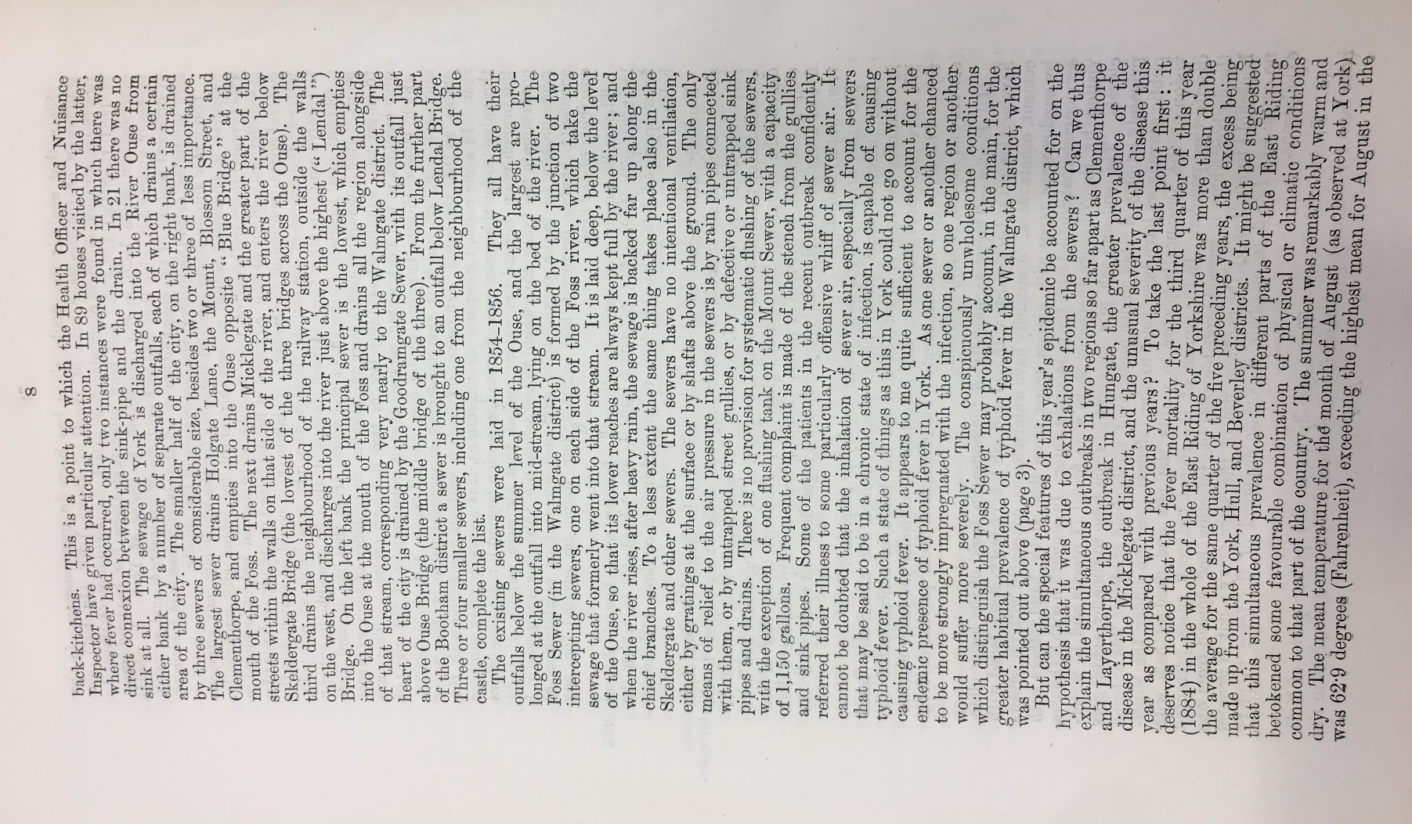
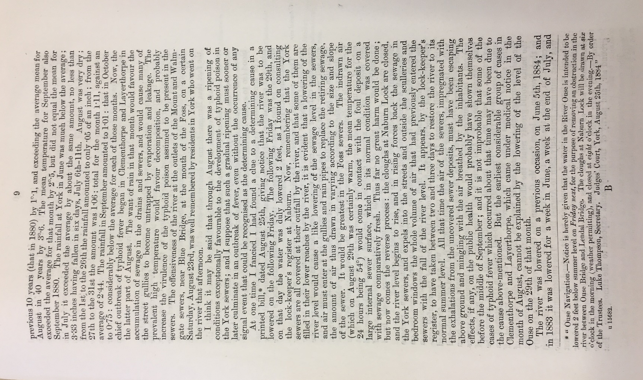
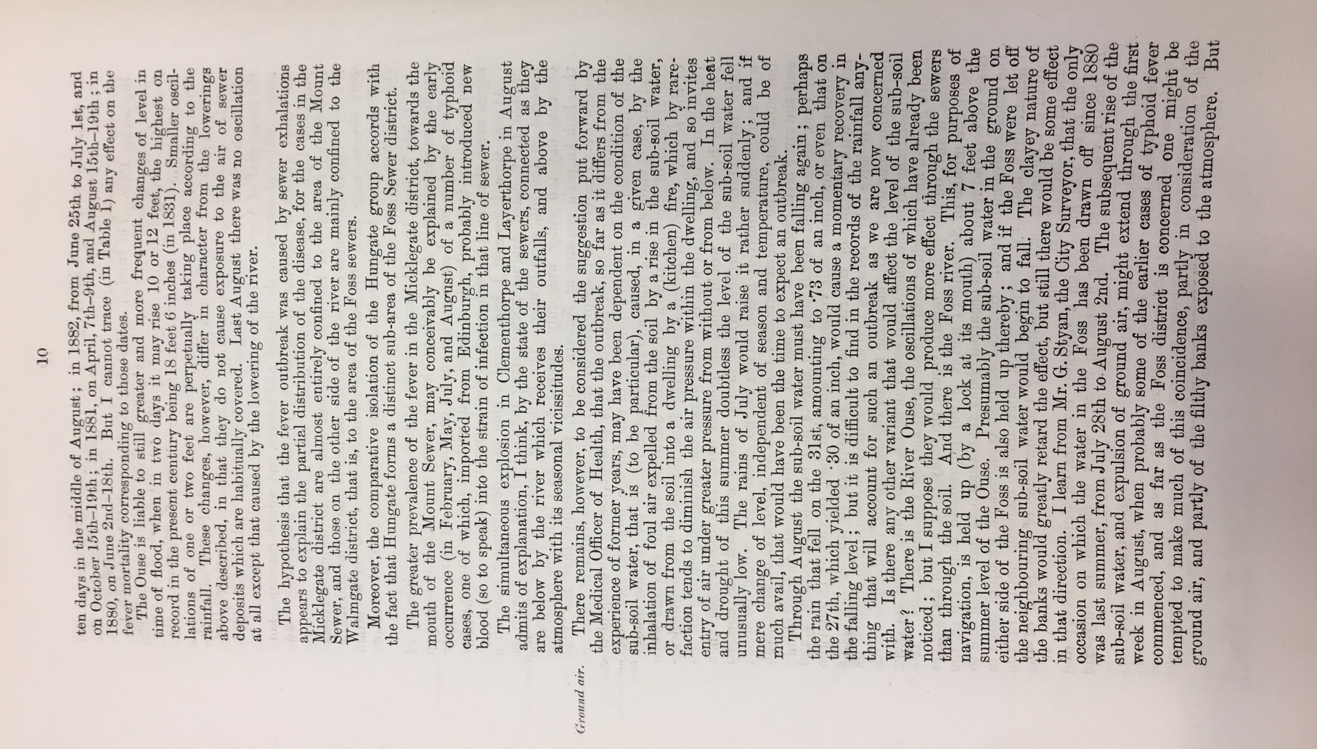
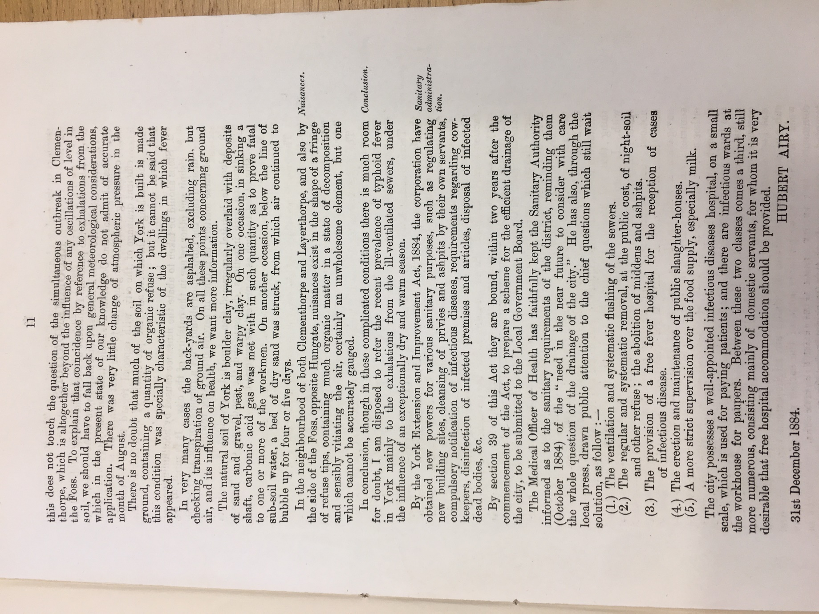
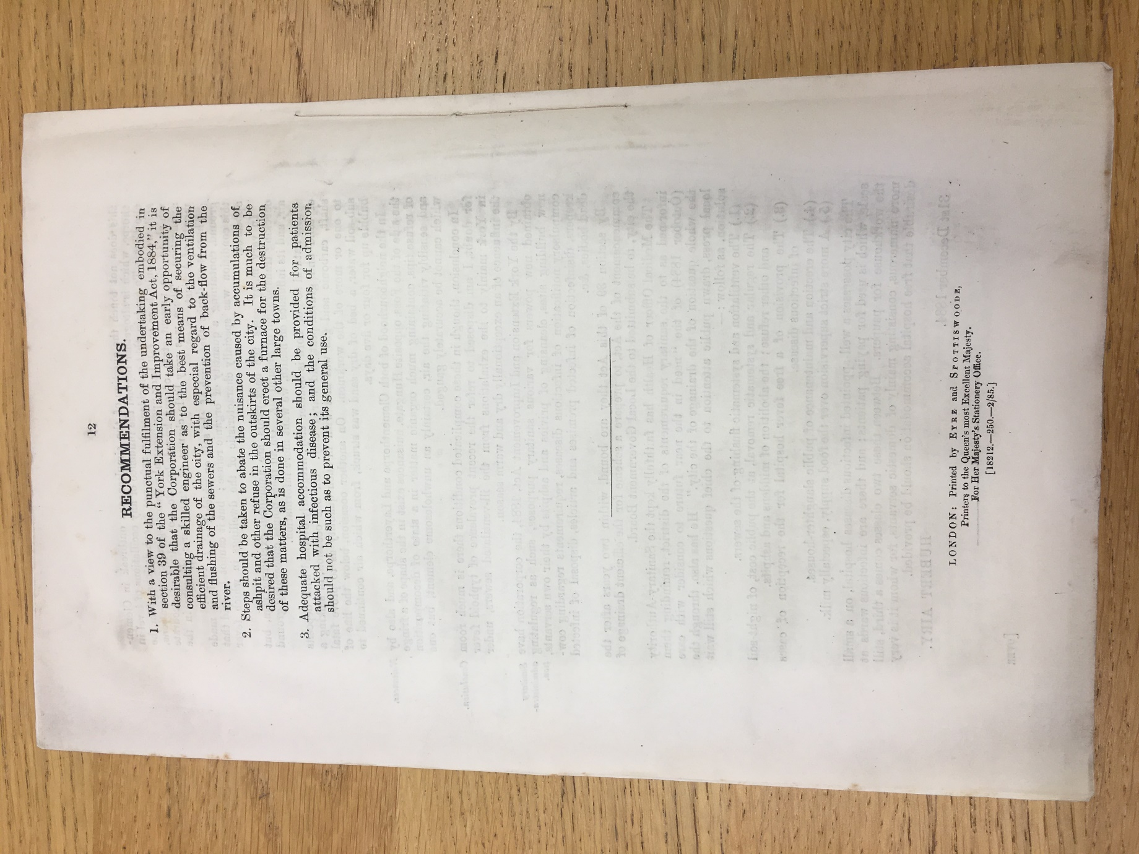
  - Doctor Airy’s Report on Typhoid Fever
Written in December 1884 and published in February 1885
  - What is typhoid fever?
- Typhoid fever is highly contagious. An infected person can pass the bacteria out of their body in their poo (stools) or, less commonly, in their pee (urine).
- If someone else eats food or drinks water that's been contaminated with a small amount of infected poo or urine, they can become infected with the bacteria and develop typhoid fever.
- Typhoid fever is most common in parts of the world that have poor sanitation and limited access to clean water.
- Taken from https://www.nhs.uk/conditions/typhoid-fever/
  - Glossary
- Sub soil water: Water which has accumulated in the earth immediately below the surface soil.
- Local Government Board: Set up in 1871. Took over some public health functions from the Privy Council as well as overseeing the implementation of the Poor Law.
The report on typhoid in York was commissioned by the Local Government Board (central government authority) after a report by a local Medical Officer of Health reported on the typhoid outbreak.
Dr Airy studied medicine at Cambridge University and worked as a medical inspector for the Local Government Board. He was also a pioneer in the study of migraines.

  - Title page

  - Page 8
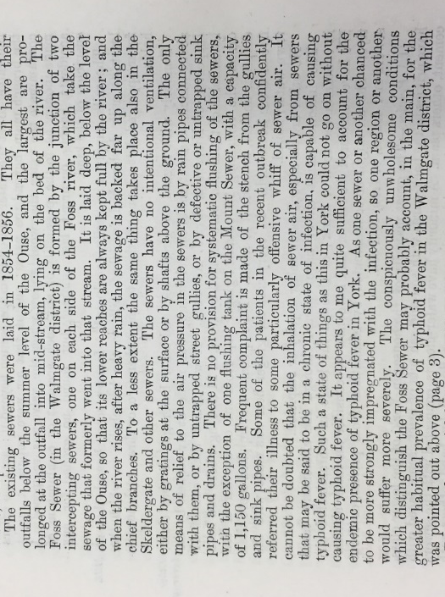
  - Page 9
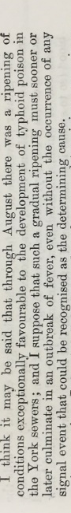
  - Page 11

Page 12
Questions for all:
What does Dr Airy identify as the main cause of Typhoid Fever in York? Have a look at the highlighted section from page 8 to help. (Foul air from the sewers)
  - OCR
- What can you infer from Dr Airy’s report about the living conditions in York?
  - AQA
- Is Dr Airy influenced by the miasma theory or the germ theory in identifying the cause of typhoid fever in York?
- Why do you think that Dr Airy is still using the miasma theory to explain the cause of typhoid fever rather than the germ theory?
  - Edexcel
- What does Dr Airy suggest that the local government of York so to prevent an outbreak of typhoid fever in the future?
- Do you think that these suggestions would have helped prevent an outbreak of typhoid fever in the future? Explain your view using your own knowledge to support your judgement.

1848 Public Health Act
- It set up a General Board of Health who reported to parliament.
- Based in London. Lord Morpeth, Lord Shaftesbury and Edwin Chadwick were the three original members of the board.
- Through the act, local authorities were empowered to set up local boards of health (LBH) when:
  - 10% of rate payers asked for one
  - The death rate was greater than 23 per 1000
- LBH were allowed to appoint a medical officer of health (MOOH), and had to pay his wages out of the rates
- Local boards of health were to manage local sewers, drains, wells, slaughterhouses, refuse and sewerage systems, burial grounds, public baths, recreational areas and parks.
- Local Boards of Health could raise taxes and buy land to finance projects.
- The act was permissive – it only applied if certain conditions were met (see bullet point 3).

1875 Public Health Act
Codified and consolidated previous public health laws and was the most comprehensive public health legislation to date.
- Every part of the country had to have a public health authority
- Every public health authority had to have at least one medical officer of health and one sanitary inspector. They had to ensure that laws on food adulteration, housing, water supply and cleansing were enforced.
- Local authorities were given wider powers to lay drains, sewers, build reservoirs, and oversee parks, public baths and public toilets.
- Gave local authorities the power to make by-laws* that controlled building standards and plans, e.g. they could control street width.
*A by-law is a regulation made by a local authority.

