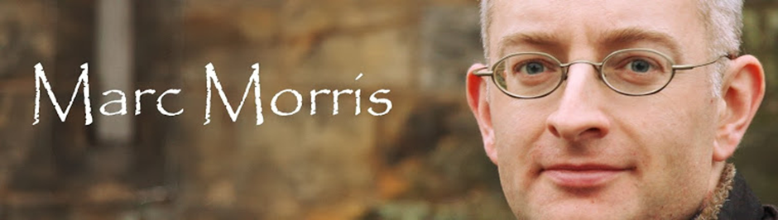
Thursday, 28 November 2013
Eleanor of Castile
Eleanor of Castile is one of the most interesting English queens of the Middle Ages, not so much for the events of her life, which are difficult to recover, but because of the magnificent series of monuments that were built to celebrate her memory – the so-called Eleanor Crosses.
Eleanor died on 28 November 1290 at Harby in Nottinghamshire. From there her body was carried first to nearby Lincoln, and then south to Westminster. This journey took twelve days, and, at each place that her cortege rested for the night, an elaborate stone memorial, originally surmounted by a devotional cross, was later erected. Remarkably, three of these monuments survive, at Geddington and Hardingstone (both in Northamptonshire) and at Waltham (Hertfordshire). The one that stands outside Charing Cross station is a modern replica. Eleanor was also commemorated with three separate tombs – one in Lincoln Cathedral for her viscera, another in Blackfriars, London, for her heart, and a third for her body in Westminster Abbey. Only the last survives, but it too is a work of striking sophistication, surmounted by a gilt-bronze effigy that shows the queen with her hair worn down and her eyes wide open.
The instigator of this unparalleled display was Eleanor’s husband, King Edward I (1239-1307). Edward was arguably England’s greatest medieval monarch – not only, as his tomb at Westminster proclaims, ‘the Hammer of the Scots’, but also the conqueror of Wales, a reformer, a legislator and a builder of mighty castles. It is no surprise that the king who held the biggest parliaments and led the largest armies of the English Middle Ages should also be responsible for what has been called ‘the most magnificent funerary display ever accorded an English monarch’.
Eleanor and Edward had married 36 years earlier, in 1254, when he was 15 and she was not quite 13 years old, and since that time they had been virtually inseparable. Edward, in addition to visiting every corner of Britain, had also travelled to France, Spain, Italy, Sicily, North Africa and the Holy Land, and in each case Eleanor had travelled with him. Another testament to their closeness is the fact that Eleanor bore Edward at least 15 (possibly 16) children, and (unusually) there is no credible evidence of infidelity on either part.
Because they were so rarely apart, and because he was such a masterful monarch, her personality is rather obscure (medieval queens who opposed their husbands tended to attract more comment). From Eleanor’s financial accounts we can see that she enjoyed the typical aristocratic pastimes of her age – romance literature, chess and hunting. More unusual was her taste for exotic fruits and water gardens, doubtless acquired during her youth in Spain and not entirely forgotten.
What little contemporary comment we do have about Eleanor is far from positive. ‘A Spaniard by birth’, wrote the annalist at Dunstable Priory, ‘she acquired many fine manors’. He was referring to Eleanor’s practice of snapping up property from those who found themselves financially embarrassed. The queen arguably needed more land to support her status, but the way she and her ministers went about obtaining it were both ruthless and underhand. Moreover, Eleanor often targeted manors whose owners were indebted to Jewish moneylenders (Leeds Castle in Kent was acquired in this way) which, in a profoundly anti-Semitic age, served to compound her notoriety. ‘There is public outcry and gossip about this in every part of England,‘ wrote the archbishop of Canterbury in 1286.
Thus at the time of her death Eleanor was deeply unpopular across the country, and hence the need on Edward’s part to repair the damage. The purpose of the crosses was to encourage those who saw them to pray for Eleanor’s soul. To this end they were a great success. As the memory of the real Eleanor faded, later generations looked at the crosses and assumed that she must have been an outstandingly good queen. From the sixteenth century this idea was bolstered by an unreliable, romantic legend that Eleanor, during her stay in the Holy Land, had selflessly sucked the poison from a wound that Edward had suffered at the hands of Muslim assassin. In the nineteenth century Eleanor was written up as an example of the Victorian ideal – pious, faithful, modest and devoted. Only the more painstaking researches of the recent years have exposed the darker and less becoming side of her character.
Yet for all her apparent faults, we can say one thing in Eleanor’s favour, which is that her husband clearly adored her. Despite the doubts of some historians, we can be confident that the primary cause of the crosses was profound grief of the king at the lost of his most constant companion. A few weeks after her death, Edward wrote a letter to the abbot of Cluny in France, requesting prayers for the wife ‘whom in life we dearly cherished, and whom in death we cannot cease to love’.
